Green Shirt

By TJ Couch

* About: A green-shirted man goes on, moving right until he can’t move right any more. He jumps on and punches enemies along the way.
* Platform: HTML
* Characters:
  + Blue-shirted man (who becomes green-shirted man): main character
    - Properties: Health
    - Behaviors: Platforming, punch (creates punch object), camera follow
    - Interactions: Hit by red or blue enemy deals damage and knocks back, dies at 0 health (restarts game)
  + Red enemy, blue enemy
    - Properties: Health, direction
    - Behaviors: Platforming, walk back and forth
    - Interactions: turns around when he hits player or waypoint, takes damage from punch, dies at 0 health
  + Princess: end goal
    - Properties: none
    - Behaviors: none
    - Interactions: win game when player touches her
  + Punch
    - Properties: duration
    - Behaviors: none
    - Interactions: deals damage to enemies and blocks when hit, dies when duration is 0
  + Waypoint
    - Properties: none
    - Behaviors: none
    - Interactions: turns enemies around when touched
  + Block
    - Properties: solid
    - Behaviors: none
    - Interactions: collides with platforming stuff
  + Breakable block
    - Properties: health, solid
    - Behaviors: Platforming
    - Interactions: collides with platforming stuff, loses health when hit by punch

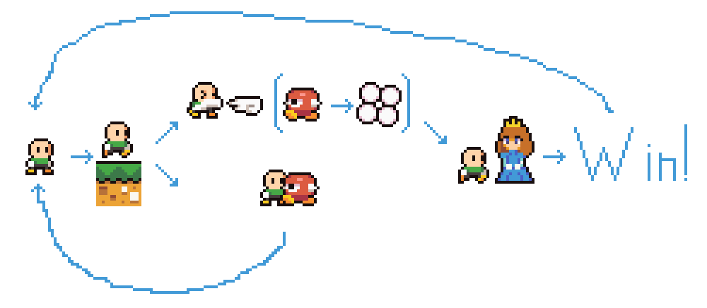

Snapshots: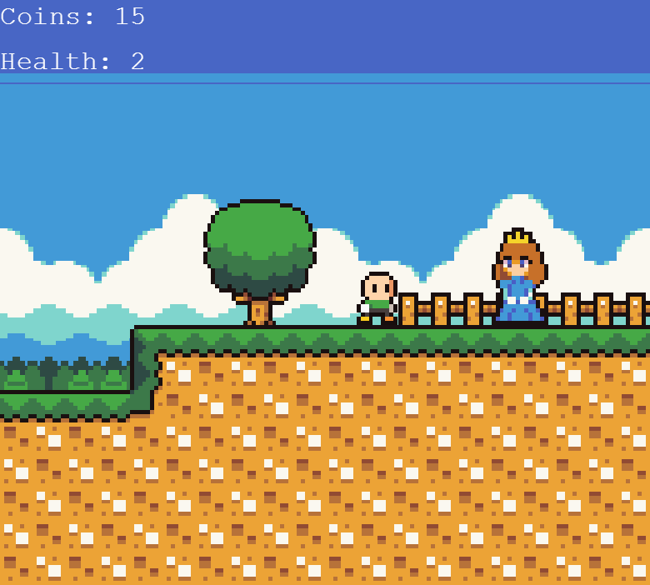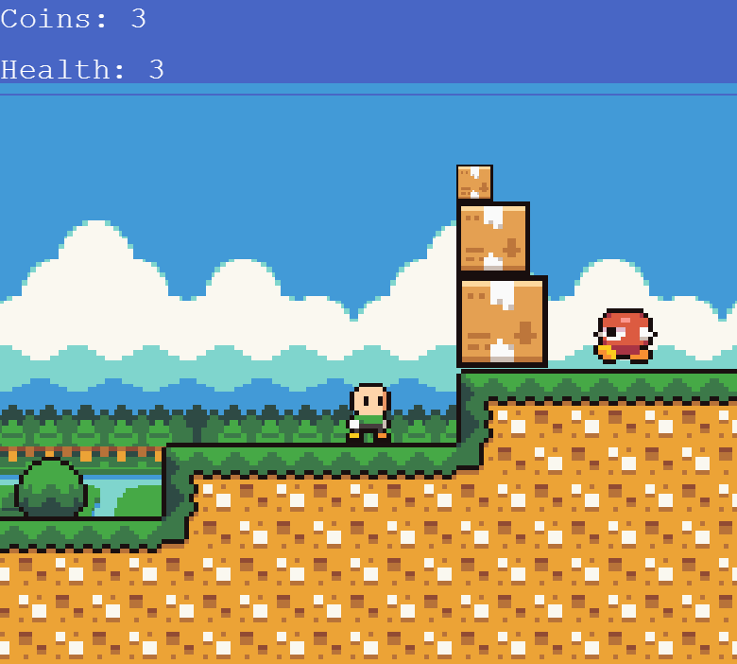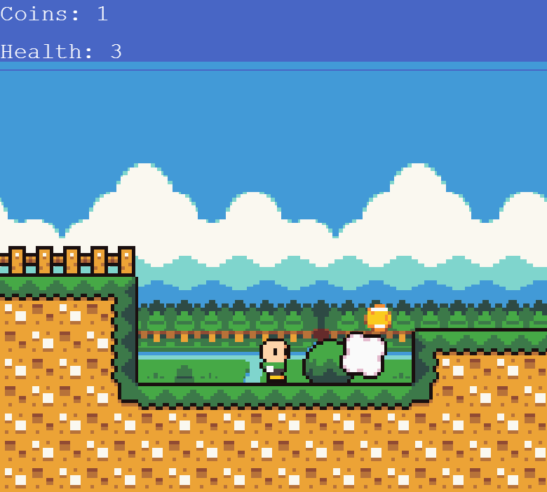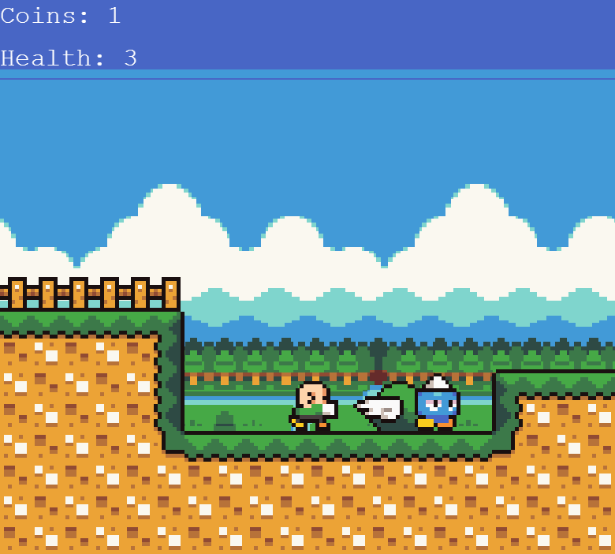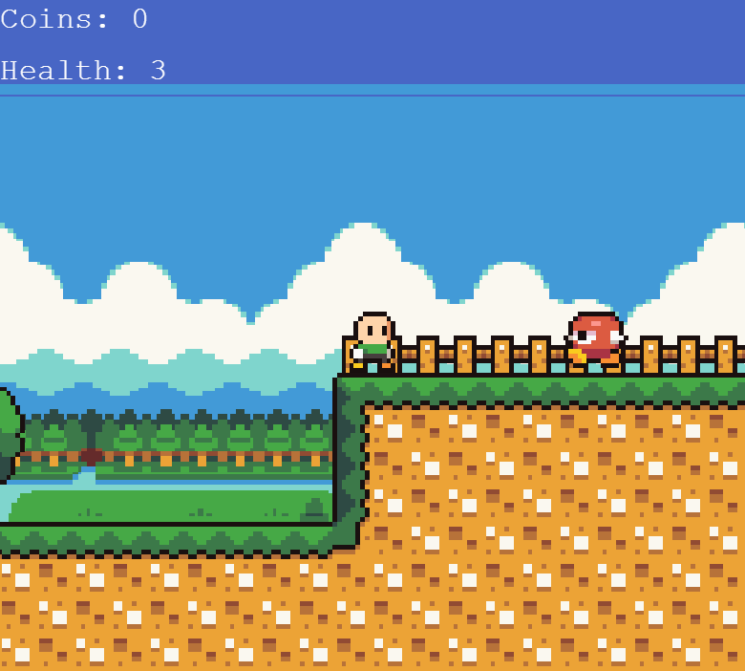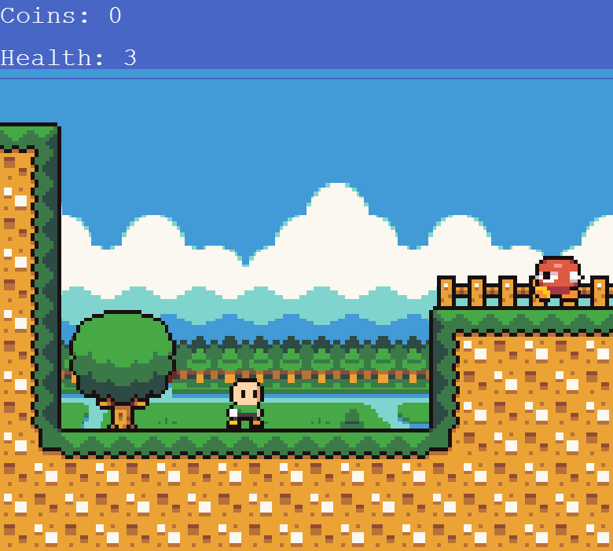

Game Rules:

Event Sheet 1:

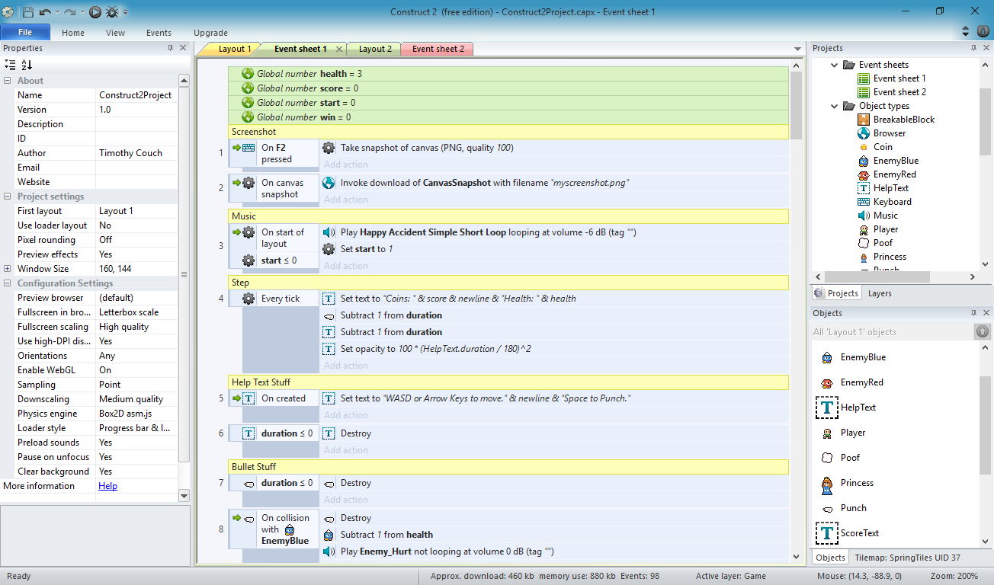

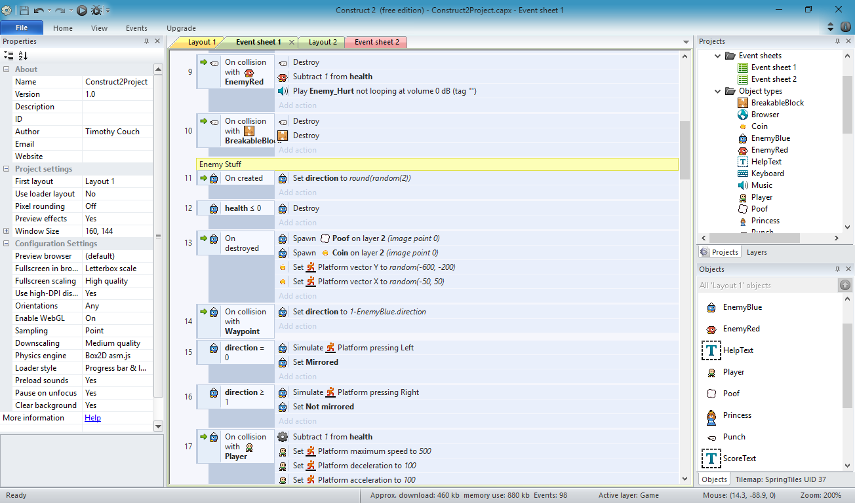

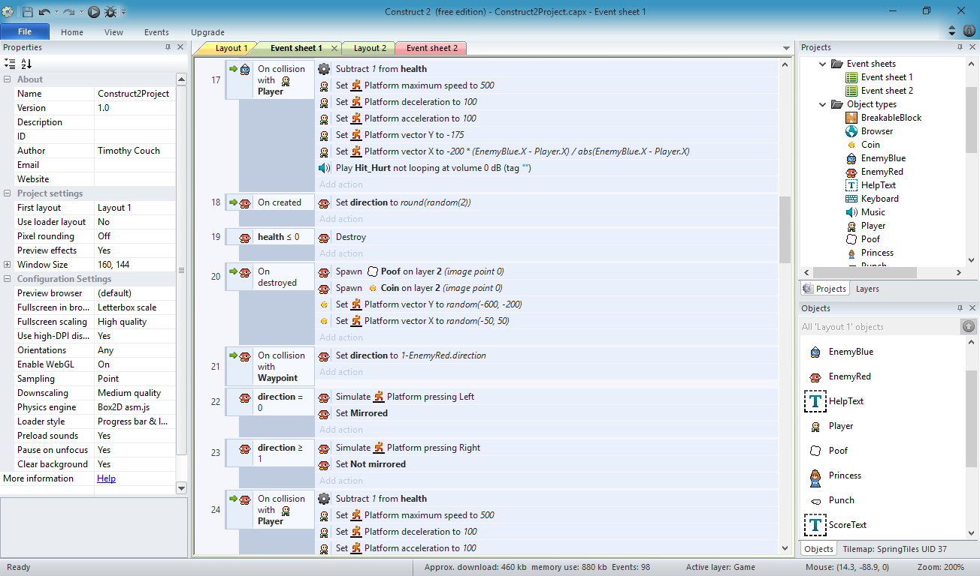

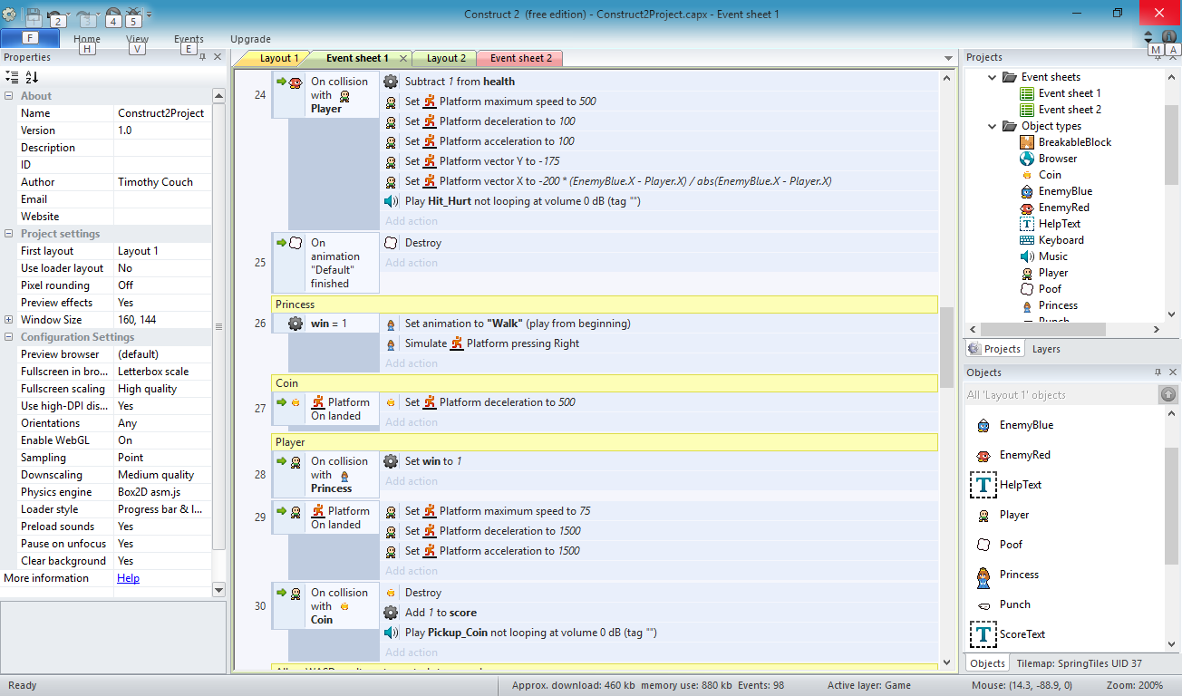

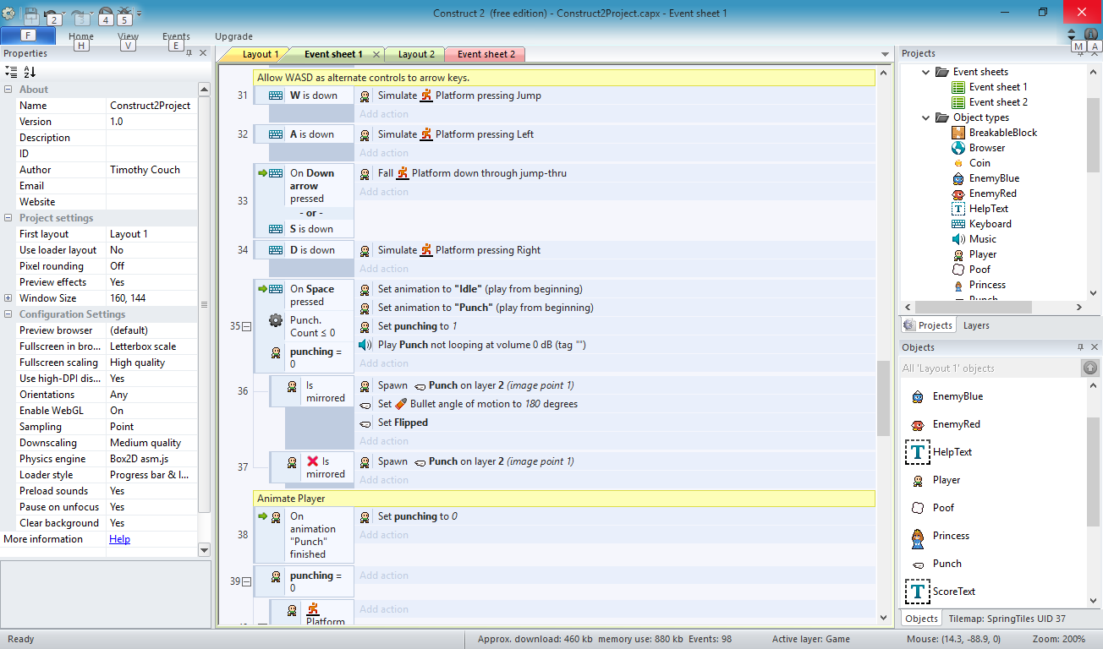

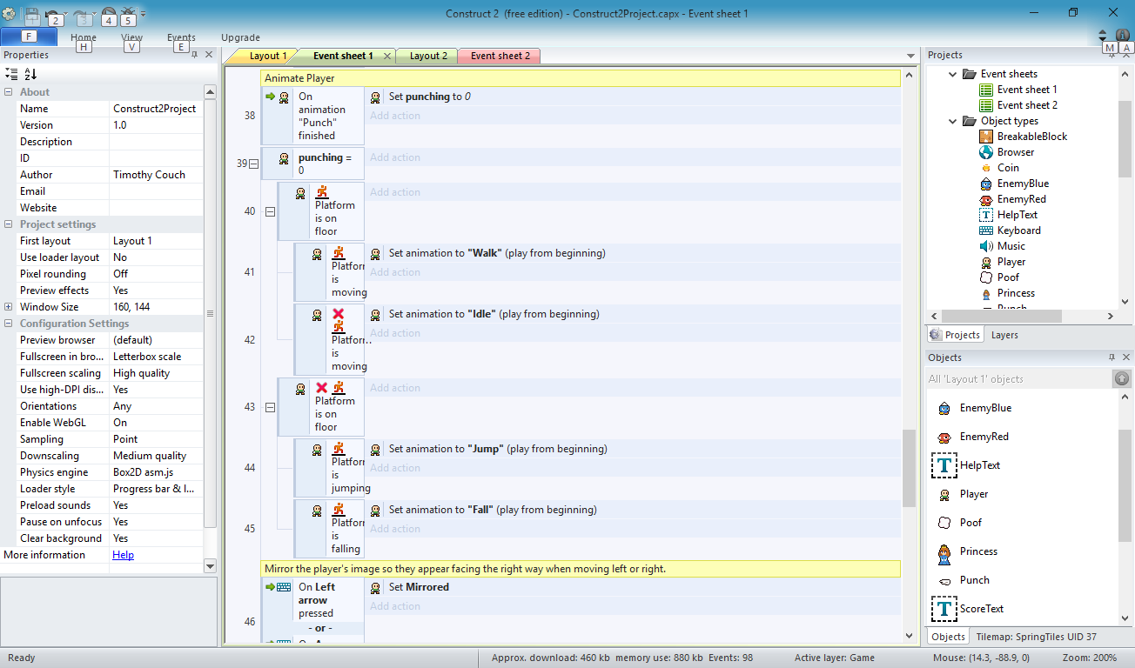

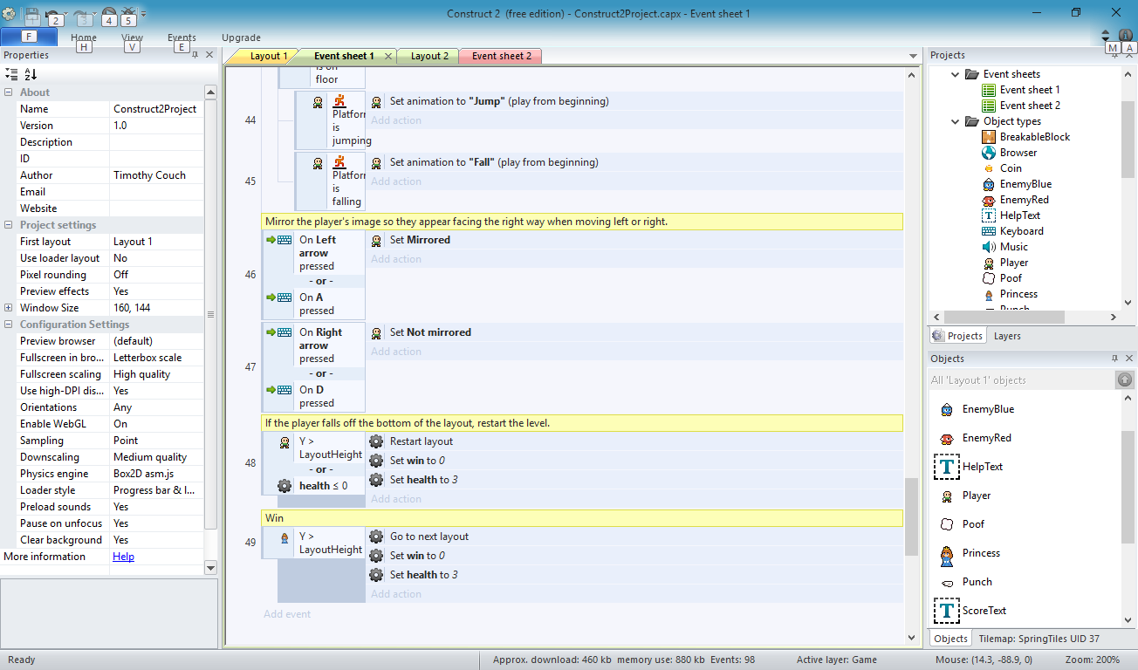

Event Sheet 2:

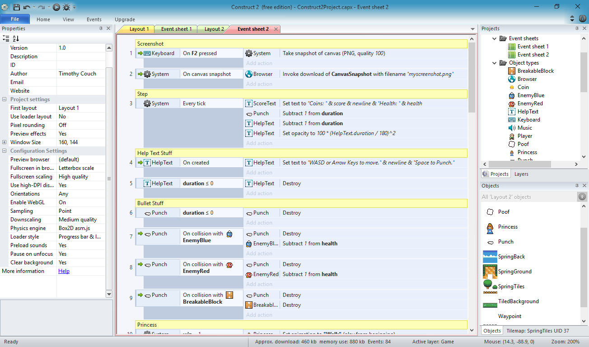

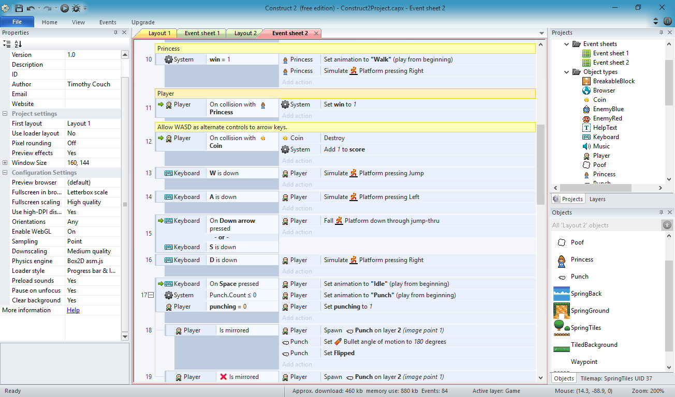

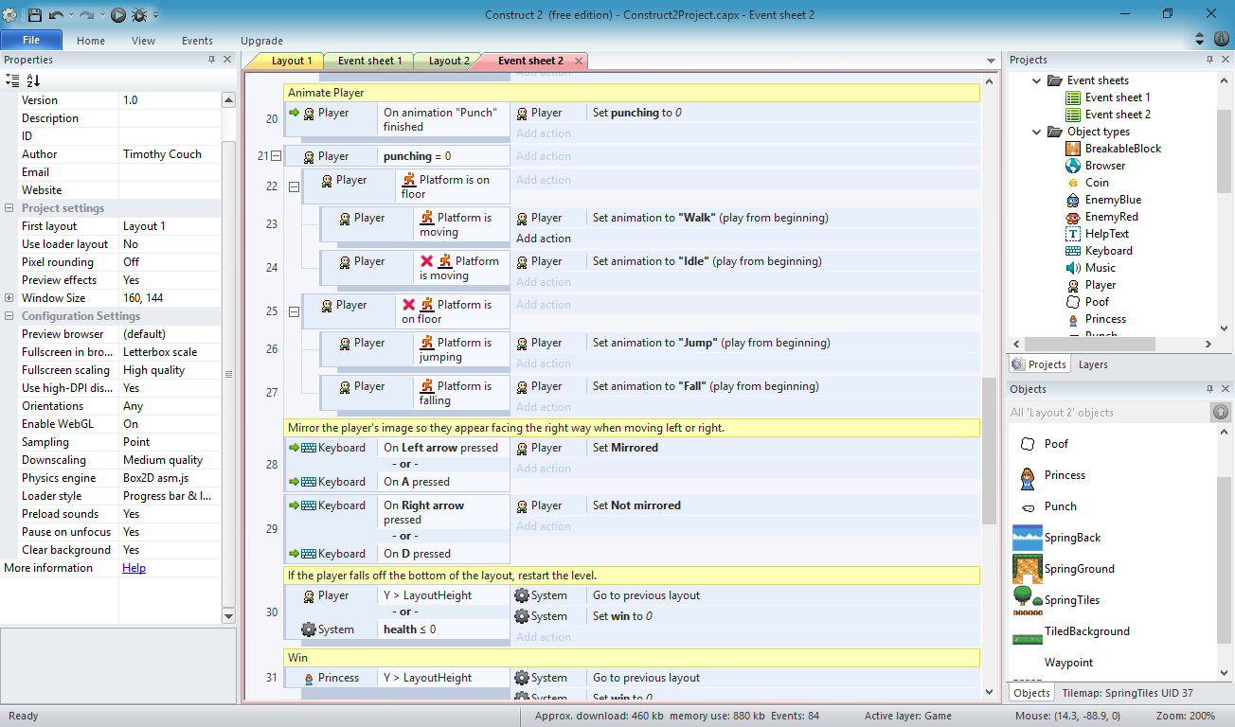

Credits:

Main Character: <http://opengameart.org/content/classic-hero>

Main Character and Enemies: <http://opengameart.org/content/classic-hero-and-baddies-pack>

Environment: <http://opengameart.org/content/seasonal-platformer-tiles>

Items/Objects: <http://opengameart.org/content/items-and-elements>

Princess: <http://opengameart.org/content/bushly-and-princess-sera>

Background Music: <http://opengameart.org/content/happy-accident>

Coin Get Sound: Generated from BFXR <http://www.bfxr.net/>

Punch Sound: Generated from BFXR <http://www.bfxr.net/>

Hurt Sound: Generated from BFXR <http://www.bfxr.net/>

Impact Sound: Generated from BFXR <http://www.bfxr.net/>