# Lecture 22: Lists



## CMPT 120-D400 Surrey, Fall 2022



What is a **list**? What is a **literal list**?

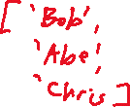

What is a **tuple**? We don’t be discussing them in this course, but it’s useful to know about them



**What types of values can a list contain**? Can a list contain other lists?

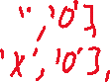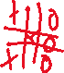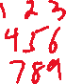

What list is this?   
**[]**



In Python, **are strings lists**?

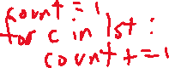

How do you calculate the **length** of a list?

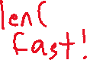

What is **list indexing**?



Here’s a list of strings. What are its non-negative index values?



L = ['Pim', 'Charlie', 'Alan', 'Glep']

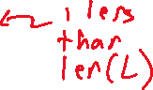

What does L[4] return?



Here’s a list of lists:

table = [[5, 6], [2, 1], [3, 9], [10, 4]]



What statement prints [3, 9] from this list? What statement prints just the 3?

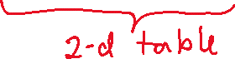

Here’s L again:

L = ['Pim', 'Charlie', 'Alan', 'Glep']



What does this expression evaluate to?

L[3][1] + L[1][3] + L[2][2]

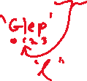

What is the idea if **negative indexing**? What are the negative index values for this list?



L = ['Pim', 'Charlie', 'Alan', 'Glep']

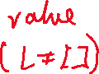

Are the rules of **list** indexing essentially the same as for strings?

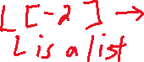

L = ['Pim', 'Charlie', 'Alan', 'Glep']



What do these expressions evaluate to?



'Pim' in L



'alan' in L



'Jacob' in L



'Charlie not in L'



'Smormu' not in L



not ('Pim' not in L)



L in L



L[0] in L



lst = [1, [2, 3], 4]



1 in lst



2 in lst



[2, 3] in lst



What is a **slice** of a list?



lst = [9, 4, 3, 8, 2]

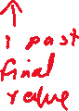

lst[2:4]



lst[1:4]



lst[1:5]



lst[1:700]



If lst is a list and lst[begin:end] is a valid slice, what’s the length of lst[begin:end] ?



lst = [9, 4, 3, 8, 2]



lst[:4]



lst[4:]



lst[:]

