# Introduction to Algorithms



What is an **algorithm**?



What is **computer science**?



What are some features of algorithms studied by computer scientists?



What is the **search problem**?

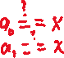

How does the built-in list **index** function work? How does it signal a value was not found?



What is the **idea** of linear search?

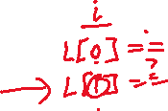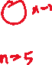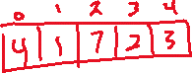

How can linear search be **implemented** in Python?

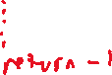



Does the order of the elements in lst matter to linear_search?



What is reverse linear search? When is different than regular linear search? Why might you use it?

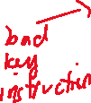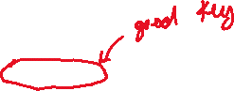

What are some other ways you could implement linear search?

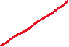

What is **binary search**? What does it assume about the list it’s searching?

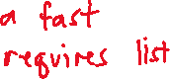

How would **binary search** find 5 in this list?



[0, 2, 3, 4, 8, 9, 9]

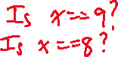

How can you implement **binary search** in Python?

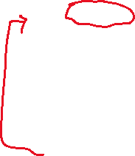

How does the performance of **linear search** and **binary search** compare?



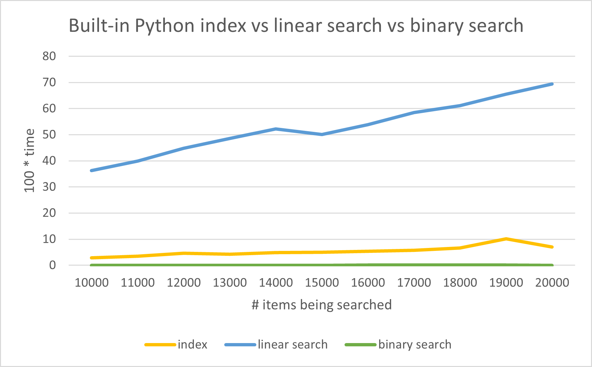

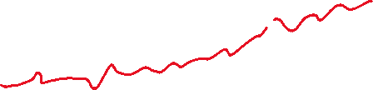

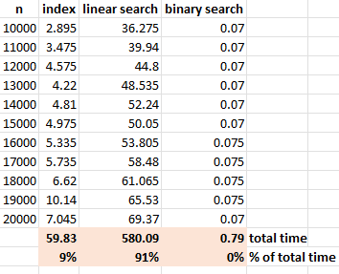

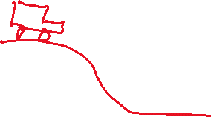

Why do computer scientists often **not** use **actual time** when analyzing the **theoretical** performance of an algorithm?

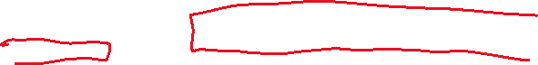

What is a **key instruction**? What is the usual key instruction for **search** algorithms?



If you do **linear search** on a list of **100** elements, what is:

* The **best case** number of comparisons?



* The **worst case** number of comparisons?

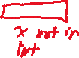

* The **average case** number of comparisons?



If you do **linear search** on a list of **n** elements, what is:

* The **best case** number of comparisons?



* The **worst case** number of comparisons?



* The **average case** number of comparisons?



Which of the three cases do we usually assume practice?

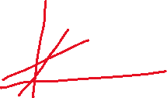

If you do **binary search** on a list of **n** elements, what is:



* The **best case** number of comparisons?



* The **worst case** number of comparisons?



* The **average case** number of comparisons?



How much smaller is compared to ?

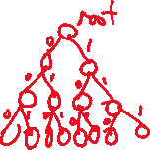

|  |  |
| --- | --- |
| n |  |
| 16 | 4 |
| 32 | 5 |
| 64 | 6 |
| 128 | 7 |
| 1048576 | 20 |



In the **worst case**, about how many comparisons does **binary search** do on a list of length **1 million**?

## Sorting



What is the **sorting problem**?

How does Python’s **built-in list sort** function work?

What is **selection sort**? How does it work?

How can you implement **selection sort** in Python?

What are some ways **selection_sort** differs from the built-in list sort?

What is **merging**? How would you merge these two lists together:  
  
[1, 3, 6, 9, 11]  
  
  
  
[0, 4, 8, 9]

How can we merge two lists in Python?

What is **mergesort**? How would it sort this list:

[9, 5, 2, 8, 1, 2, 7]

How do the running times of built-in list sort, selection sort, and mergesort compare?

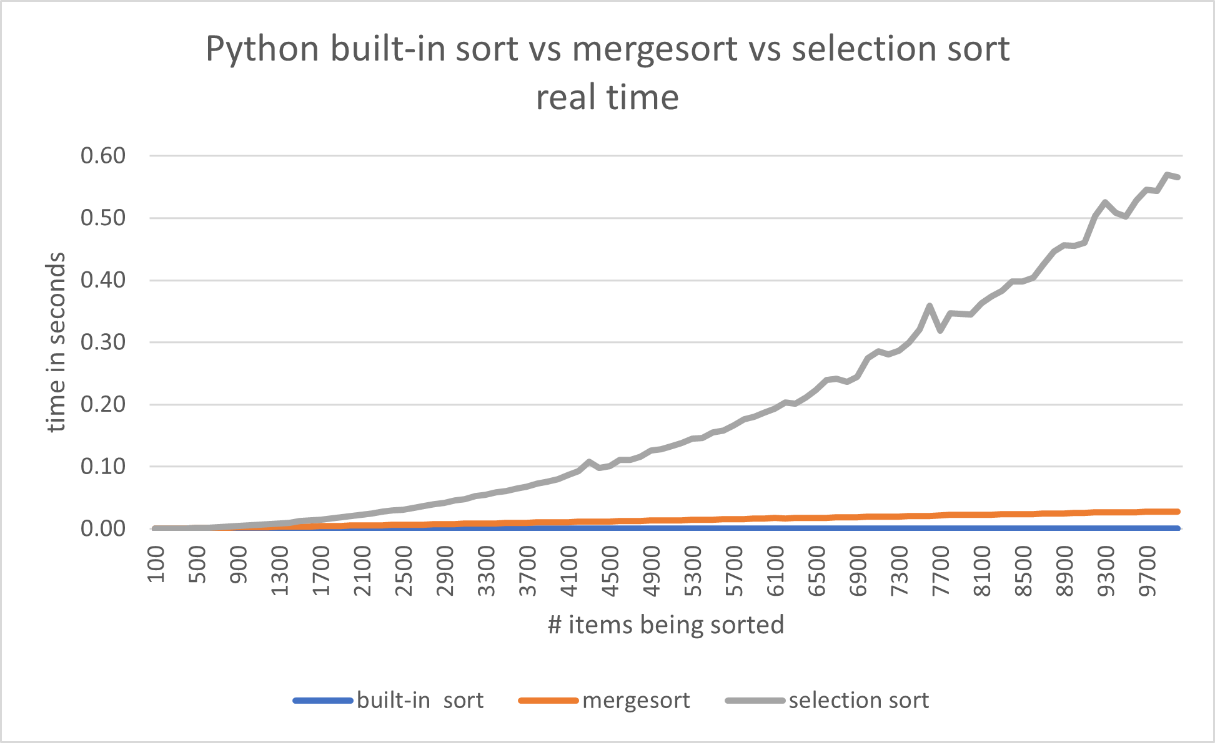

The time it takes for **selection sort** to sort **n** items is proportional to what mathematical expression?

The time it takes for **mergesort** to sort **n** items is proportional to what mathematical expression?

Suppose it takes 10 seconds for **selection sort** to sort **n** items. About how long would it take to sort **2n** items? **3n** items?

Suppose it takes 10 seconds for **mergesort** to sort n items. About how long would it take to sort 2n items?

What kind of sorting algorithm is Python’s built-in list sort?

In practice, which sorting algorithm should you usually use in Python?