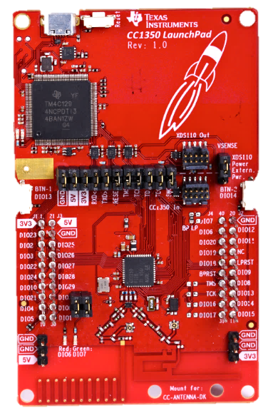

**No cost 2.4GHz PCB antenna**

**Connectors for GND and external 3.3V and 5V**

**40-pin BoosterPack connector**

**8Mbit serial (SPI) flash memory**

**2.4GHz RF matching network**

**External RF switch**

**Jumpers to isolate debugger from MCU, Power, UART and JTAG**

**User Button 2**

**External debugger connector**

**Use this when debugging external targets with XDS110**

**External Power for debugger**

**No cost sub-1GHz PCB antenna**

**Sub-1GHz RF matching network**

**External antenna connectors**

**Red and Green LEDs**

**Jumpers for LEDs**

**CC1350 Wireless MCU**

**User Button 1**

**XDS110 Debugger**

**Target MCU Reset button**

**USB Connector**