Interpreting Sensor Data with Machine Learning
CSE 575 Project Proposal

Team Members | ASU email | Primary Role
Blair Brownlie-Edward | bbrownli@asu.edu | GNN Implementation Specialist
TJ Davis | tjdavi50@asu.edu | GRU Implementation Specialist
Johnny Richardson | jmrich38@asu.edu | Linear Regression Implementation Specialist
Varsha Giridharan | vgiridha@asu.edu | Random Forest Implementation Specialist
Sai Shaket Kalivarapu | skaliva1@asu.edu | Neural Network Implementation Specialist

Problem Description and Motivation
Wireless sensor networks can be used to collect measurements to observe environmental conditions, but, as is the case with real-world data, these measurements can be incomplete or unreliable. Measurements may go missing due to network interruptions, hardware failures, temporary sensor outages, etc., and recorded measurements may also be affected by noise or by other real-world environmental effects on the sensors. As a result, analyses conducted on these readings may lead to unreliable conclusions if these data quality issues are ignored.

Our project aims to address two connected problems: reconstructing missing sensor measurements and identifying anomalous sensor behavior. This is a combination of two of the provided project problems in the List of Possible Projects: P4, Learning from Sensor Data, and P12, Anomaly Detection. P4 is about learning from multiple correlated time series to impute missing values, identify patterns, and predict trends. P12 asks how rare or unusual instances can be detected. We will connect these problems by first reconstructing missing sensor measurements and then using reconstruction errors to identify anomalous behavior.

The dataset used in the work of Deshpande et al. contains temperature, humidity, light, and battery-voltage measurements from a 54-node sensor network. Because it is a real-world dataset, it includes missing measurements, noise, and other outlier values from failed or low-battery sensors. However, these measurements have spatial, temporal, and cross-variable correlations. Prior work shows that these correlations can be modeled to estimate missing readings from the measurements that remain available to us. Distributed regression is one such model proposed by Guestrin et al. (2004). It uses kernel linear regression and correlations among nearby sensor measurements to create a global model of the physical process, with local basis functions used to model the sensor field rather than treating each reading independently.

The central idea of our project is that missing-data reconstruction and anomaly detection can be treated as two applications of the same learned model of normal sensor behavior. When a measurement is missing, the model's predicted value can be used to reconstruct it. When a measurement is available, the difference between the observed and predicted values can instead be used to quantify how anomalous the observation is.

- Research Questions
- How accurately can classical statistical methods and nonlinear machine-learning methods reconstruct artificially masked measurements in multivariate sensor time-series data?
- Can standardized reconstruction residuals be used to detect anomalous sensor behavior?

Proposed Approach

Phase 0: Data Preparation
We will begin with a shared data-preparation pipeline so that every model is trained and evaluated under the same conditions. Measurements will be cleaned while preserving genuine missing values, aligned to consistent time intervals, and associated with their sensor locations so that spatially and temporally related observations can be used as common model inputs. The data will then be divided chronologically into training and testing segments rather than randomly shuffled. This preserves the temporal structure of the dataset and reduces leakage between highly correlated neighboring measurements.

Phase 1: Missing Sensor Data Reconstruction
In Phase 1, we will compare classical statistical methods with nonlinear machine-learning methods for sensor-data reconstruction. Candidate classical methods include spatial prediction, linear regression, kernel regression, and Gaussian methods. Candidate nonlinear methods include random forests, neural networks, and, if time permits, temporal neural models such as LSTMs or GRUs. The final set of methods may be narrowed as development progresses so that the selected models can be evaluated carefully.

To create an evaluation set with known ground truth, valid measurements in the held-out data will be artificially masked while their true values are retained for scoring. Each model will attempt to reconstruct the same masked targets using a consistent set of available information. All models will use common preprocessing, chronological data splits, masking procedures, targets, and evaluation metrics. Reconstruction performance will be compared primarily using mean absolute error (MAE) and root mean squared error (RMSE). If time permits, we will also vary the amount or duration of missing data to determine how reconstruction performance changes as less information is available.

Phase 2: Residual-Based Anomaly Detection
In Phase 2, we will reuse one or more Phase 1 predictors as models of expected sensor behavior. For sensor $i$ at time $t$, the residual will be calculated as the difference between the observed value $y_{i}\left(t\right)$and the model-predicted value $ŷ_{i}\left(t\right)$. A large normalized residual may indicate that a reading does not fit the behavior expected from related measurements. This approach is also motivated by the P4 papers. Distributed Regression identifies outlier and faulty-sensor detection as future work and suggests flagging readings that lie far from regression predictions (Guestrin et al., 2004). Model-Driven Data Acquisition similarly identifies fault and outlier detection as areas requiring further development (Deshpande et al., 2004).

Reliable ground-truth labels for sensor faults may not be available throughout the dataset. If necessary, controlled anomalies will therefore be introduced into held-out valid measurements to provide known labels for evaluation. Candidate anomaly types include isolated spikes, persistent offsets, gradual drift, and stuck-sensor behavior. The resulting detector can then be evaluated using precision, recall, and F1-score. A detected anomaly will not automatically be labeled as a faulty sensor, since unusual readings can also reflect a real-world environmental event or model error. Our primary goal is to detect anomalous sensor behavior without claiming its physical cause unless supporting evidence is available.

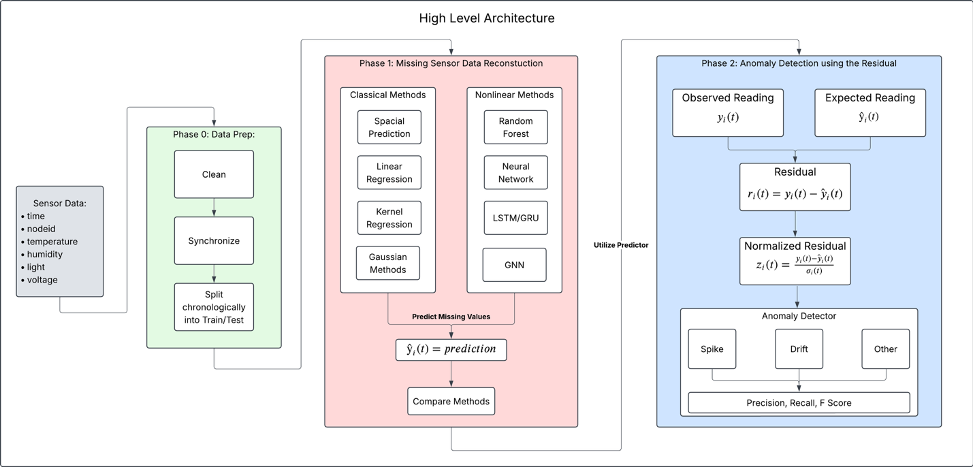
Figure 1. Proposed project workflow from sensor-data preparation through missing-value reconstruction and residual-based anomaly detection.

Experimental Design and Evaluation
The primary comparison in Phase 1 will be between reconstruction methods operating on the same prediction problem. Each team member or subgroup may focus on a different algorithm, but the models will share the same train/test split, target measurements, masking pattern, and evaluation code. This will make differences in performance easier to interpret as differences between the models rather than differences in preprocessing or test conditions.

We will begin by masking individual known measurements and measuring reconstruction error. A possible extension is to mask increasingly large fractions of the test data or contiguous periods from individual sensors to simulate temporary sensor outages. If feasible, we may also withhold an entire sensor during a held-out interval to test how effectively spatial and cross-sensor relationships can compensate for a failed node. These experiments will help us evaluate not only which model reconstructs values most accurately, but also how robust each method is as missingness becomes more severe.

For Phase 2, residuals from the reconstruction model will be converted into anomaly scores, with normalization used where appropriate to account for expected model uncertainty or typical prediction error. If controlled anomalies are used, anomaly type and magnitude can be varied to determine which behaviors are easiest or hardest to detect. Precision, recall, and F1-score will be used to evaluate detection performance.

Milestones
- 9/30: Finalize the project topic, roles, research questions, and proposal; submit the proposal and incorporate instructor feedback.
- 10/9: Finalize the cleaned and synchronized dataset, chronological train/test split, masking procedure, shared features, baseline model, and common evaluation code.
- 10/16: Develop the first classical and nonlinear reconstruction models and generate preliminary MAE/RMSE results.
- 10/23: Refine the initial models, implement additional candidate methods as time allows, and begin missingness or sensor-outage experiments.
- 10/30: Compare Phase 1 models, analyze reconstruction results, finalize the shared codebase, and select the model or models to carry into residual analysis.
- 11/6: Implement residual calculation and normalization; finalize the anomaly-evaluation protocol and, if needed, controlled anomaly injection.
- 11/13: Develop and evaluate the anomaly detector using precision, recall, and F1-score.
- 11/20: Run final experiments, produce final figures and tables, draw conclusions, and complete and practice the presentation.
- 11/23/26: Be prepared to present the completed project.

References
1. Guestrin, C., Bodik, P., Thibaux, R., Paskin, M., & Madden, S. (2004). Distributed regression: An efficient framework for modeling sensor network data. In Proceedings of the 3rd International Symposium on Information Processing in Sensor Networks (IPSN 2004) (pp. 1-10). ACM.
2. Deshpande, A., Guestrin, C., Madden, S. R., Hellerstein, J. M., & Hong, W. (2004). Model-driven data acquisition in sensor networks. In Proceedings of the 30th International Conference on Very Large Data Bases (VLDB 2004) (pp. 588-599).
3. Cai, Y., Tong, H., Fan, W., & Ji, P. (2015). Fast mining of a network of coevolving time series. In Proceedings of the 2015 SIAM International Conference on Data Mining (pp. 298-306). SIAM.
4. Pandit, S., Chau, D. H., Wang, S., & Faloutsos, C. (2007). NetProbe: A fast and scalable system for fraud detection in online auction networks. In Proceedings of the 16th International Conference on World Wide Web (pp. 201-210). ACM.
5. Akoglu, L., Tong, H., Vreeken, J., & Faloutsos, C. (2012). Fast and reliable anomaly detection in categorical data. In Proceedings of the 21st ACM International Conference on Information and Knowledge Management (pp. 415-424). ACM.
6. He, J., Tong, H., & Carbonell, J. G. (2010). Rare category characterization. In Proceedings of the 10th IEEE International Conference on Data Mining (pp. 226-235). IEEE.

