Use Cases

Scenario 1- Employee submits hours

1. Employee accesses portal

2. Employee enters in login information

3. Employee logs in

4. Employee records their hours for the day

Scenario 2 – Employee submits sales

1. Employee accesses portal

2. Employee enters in login information

3. Employee logs in

4. Employee records their sales for the day

Scenario 3 – Admin adds an employee

1. Admin accesses portal

2. Admin enters in login information

3. Admin logs in

4. Admin enters in new employee info

Scenario 4 – Admin changes employee pay status

1. Admin accesses portal

2. Admin enters in login information

3. Admin logs in

4. Admin changes employee from salary to hourly status or vice versa

Scenario 5 – Admin adjusts employee pay

1. Admin accesses portal

2. Admin enters in login information

3. Admin logs in

4. Admin enters in new pay rate for employee of given info

Scenario 6 – Payroll on Fridays

1. Employee hour submission is collected

2. Employee overtime is calculated

3. Employee sales commission are calculated

4. Total pay for each employee is calculated

5. Each person is paid

6. All metrics are restored to default value

Conceptual Model

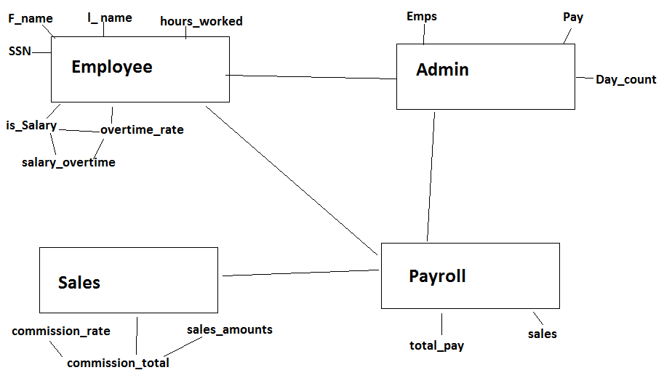

Sequence Diagram

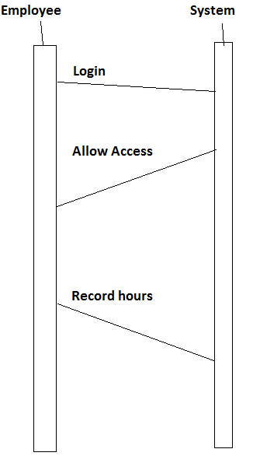

Design Class diagram

