Homework #8 Thomas Dolan

8.6.a

> steroid <- read.table(file.choose())

> names(steroid) <- c("Y","X")

> steroid.lm <- lm(Y~X+X^2,data=steroid)

> summary(steroid.lm)

> plot(steroid, steroid.lm)

> abline(lm(Y~X+X^2,data=steroid))

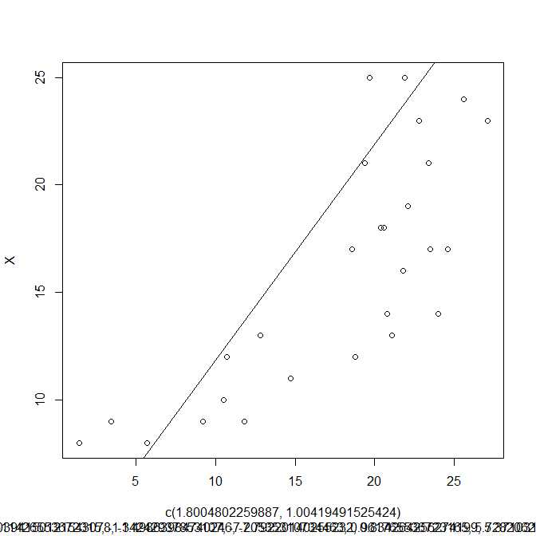

> summary(steroid.lm)$r.squared

[1] 0.6174318

The quadratic regression function seems to not be a good fit for the data

8.6.b

> MSE=(summary(steroid.lm)$sigma)^2

> MSE

[1] 19.66105

> MSR = (anova(steroid.lm)$"Mean Sq"[1])

> MSR

[1] 793.2805

> P = (anova(steroid.lm)$"Pr(>F)"[1])

> P

[1] 1.195934e-06

H0: β1 = β11 = 0, Ha: not both β1 and β11 = 0. MSR = 793.2805, MSE = 19.66105, F∗ = 793.2805/19.66105= 4.0324, F(.99; 1, 25) = 7.770.If F∗ ≤ 7.770 conclude H0, otherwise Ha. Conclude H0.

8.6.d

s{pred}=10.83823, -2.09779890 ≤Yh(new)≤ 23.77427

> predict(steroid.lm, steroid, interval="predict", level=.99)

fit lwr upr

15 10.83823 -2.09779890 23.77427

8.6.e

H0:β11=0,Ha:β11=0. SSR(x^2|x) = 793.28,SSE(x, x^2) =491.53, F∗=(793.28/1) ÷(491.53/25) =15596.8367, F(.99;1,25)=7.770. If F∗≤7.770 concludeH0, otherwise Ha. Conclude Ha.

8.6.f

Y = 1.8 + 1.004X + 1.008016X^2

8.7.a

> res <- steroid.lm$resid

> plot(res,steroid.lm$Y)

> plot(res,steroid.lm$X)

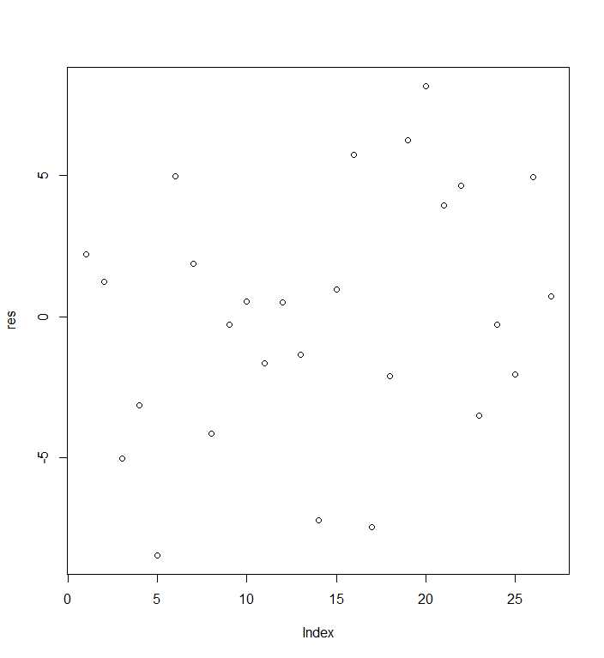

8.7.b

> pureErrorAnova(steroid.lm)