Print Name(s): ____Lu, Stanley ; Dolan, Thomas__________
(last, first)
Group Project Homework
We certify that we have done this work totally within our group. We have not talked with any current or former students outside our group about the problems or reviewed answers with anyone outside our group. We have not looked at former students’ work on these or similar problems (sometimes called “files”).

Signature(s): _________________________________________________

Recall the instructions from Homework 2 relative to screen shots: Use the picture editor to focus on just the portion of the screen you want to show and then compress all the screen shots.

Make sure you have answered questions A through M for Marcia’s Dry Cleaning from HW 7G, if you have not already done so. Be sure that you used the Oracle data types in your answer.

Now carry out parts A, B, and C below:

A. Using Oracle, execute all of the SQL statements that you created in your answers to parts A through M for Marcia's Dry Cleaning in HW7G. We assume you have already done this, so you won't have to present screen shots to show it again -- you may need to correct the database if you didn't do it correctly. If you changed it during HW8G, you may need to drop the HW7G files and sequence and then re-install them (I did that).

The screen shots below are from my answer sheet for HW7G:
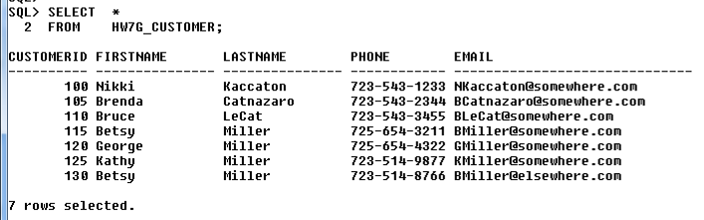

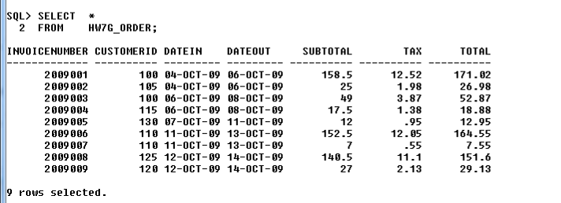

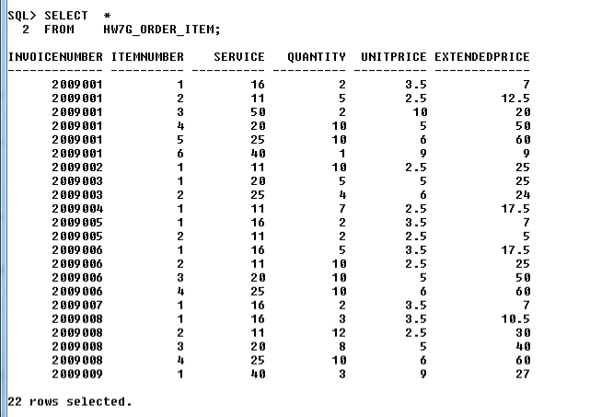

One other thing you'll want to check is to make sure that you included ON DELETE CASCADE with the foreign key in the HW7G_ORDER_ITEM table that refers back to HW7G_ORDER.

B. Assume that the relationship between HW7G_ORDER and HW7G_ORDER_ITEM is M-M. Design triggers to enforce this relationship. Use Figure 10A-58 and the discussion of that figure as an example, but assume that Marcia does allow ORDERs and their related ORDER_ITEM rows to be deleted. Use the deletion strategy shown in Figures 7–29 and 7–30 for this case. Create a table to describe the triggers you will need -- the start of the table is given below.

Recall that the content of each cell in the table is a description of what needs to be done and how it will be done (by a Trigger or by the DBMS because ... or using ...). Notice that the primary key of the HW7G_ORDER table is not a surrogate key, but it has the same characteristics, so you'll want to disallow changes to it (and you'll need to enforce that). You'll also want to disallow moving a row from the HW7G_ORDER_ITEM relation to reference a different HW7G_ORDER row (and you'll need to enforce that). For aid in the grading process, be sure to reference the Cell number that I've included below in a comment in any code you write -- put a comment at the start like:
/* This trigger handles the situation of Cell 9 */
In one case, a trigger will need to do one kind of action in some cases and multiple kinds of other actions in another case. In the real world, we'd have different people doing these different actions and would have multiple views and multiple triggers. For this homework, you may combine the actions into one trigger (with one view). Of course, you still need to test both actions.

Both HW7G_ORDER and HW7G_ORDER_ITEM are Required (M-M) | HW7G_ORDER  [Parent] | HW7G_ORDER_ITEM  [Child]
INSERT | HW7G_ORDER_ITEM is required;  A HW7G_ORDER_ITEM row will be created also by trigger | HW7G_ORDER is required parent;  A check that new HW7G_ORDER_ITEM has a valid InvoiceNumber (enforced by the DBMS)
Modify Primary Key or Foreign Key | Prohibit;  Modification disallowed because of surrogate key, enforced by trigger | Prohibit;  Modification disallowed because of surrogate key, enforced by trigger
DELETE | Allow, cascade deletion;  Deletion is cascaded, enforced by DBMS | Cannot delete the last child, otherwise allow;  Deletion prohibited if last child, enforced by trigger

C. Write and test the triggers you designed in part B.

Caution! This is a VERY BIG assignment -- I have many pages for the answers.
Some of the Triggers are easy (and some are based on homework you've already done -- see the individual homework, for example). Others involve more coding.
If you did Part B correctly, there will be four actions that will need triggers -- two of them are to deny some action.

Use Views and INSTEAD OF triggers so you completely control the process and you have access to both the :old... and :new... variables. A view can just be a different name for a table, of course. When you use views, you need to state that the user will be doing INSERTs, UPDATEs and DELETEs on the Views, of course, rather than on the underlying tables.

Show the code for the Views and the code for the triggers and screen shots of the tests, at least.

Again, to aid in the grading, put a comment at the start of each trigger that references the cell number, e.g.,:
/* This trigger handles the situation of Cell 9 */
ALL CODE IS PRINTED SEPARATELY AND STAPLED AT THE END
