Print Name(s): __Dolan, Thomas ; Lu, Stanley_____________
(last, first)
Group Project Homework
We certify that we have done this work totally within our group. We have not talked with any current or former students outside our group about the problems. We have not looked at former students’ work on these or similar problems (sometimes called “files”).

Signature(s): _________________________________________________

Note: This assignment can become very large, due to the screen shots. Use trimming and compression to keep it at a manageable size.

Suppose that you have designed a database for Marcia's Dry Cleaning that has the following tables:
CUSTOMER (CustomerID, FirstName, LastName, Phone, Email)
ORDER (InvoiceNumber, CustomerID, DateIn, DateOut, Subtotal, Tax, TotalAmount)
ORDER_ITEM (InvoiceNumber, ItemNumber, Service, Quantity, UnitPrice, ExtendedPrice)
SERVICE (Service, Description, UnitPrice)

Add the prefix "HW7G_" to each table name.

Do parts A through M as given below. Those that involve SQL should be written
in SQL*Plus and run, unless indicated otherwise.
Include screen shots of the results of your runs.
Note: This database has unnecessary duplicated data, which the owner wants to keep.

Here is a crow's foot diagram of the relationships that helps answer some parts:

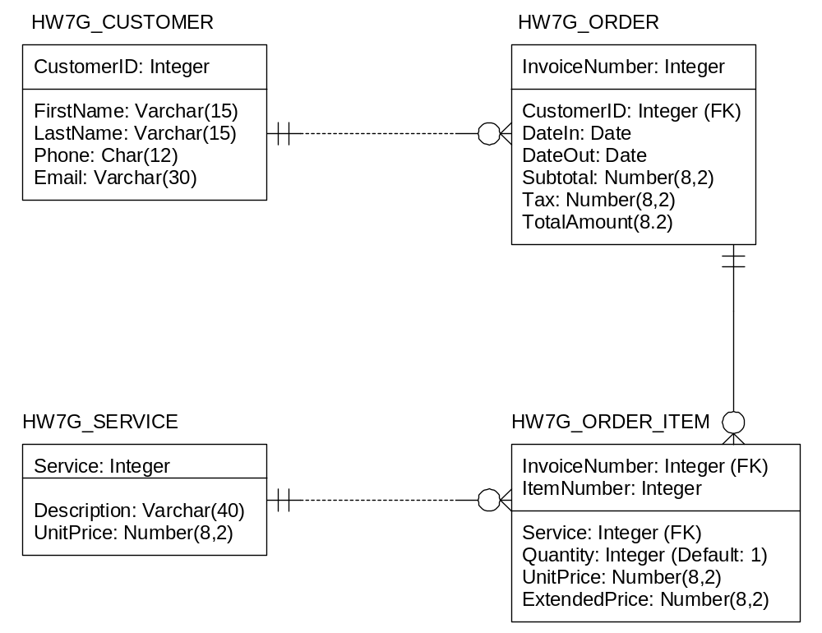

A. Specify NULL/NOT NULL constraints for each table column. Also specify alternate keys, if any. Use the following table form.
(Note: This is a big table, since every column of every table appears as a row.)
Table | Column | NULL/NOT NULL | Alternate Key?
HW7G_CUSTOMER | CustomerID | NOT NULL | No
HW7G_CUSTOMER | FirstName | NOT NULL | No
HW7G_CUSTOMER | LastName | NOT NULL | No
HW7G_CUSTOMER | PhoneNumber | NOT NULL | Yes, AK1.1
HW7G_CUSTOMER | Email | NOT NULL | Yes, AK1.2
HW7G_SERVICE | Service | NOT NULL | No
HW7G_SERVICE | Description | NOT NULL | No
HW7G_SERVICE | UnitPrice | NOT NULL | No
HW7G_ORDER | InvoiceNumber | NOT NULL | No
HW7G_ORDER | CustomerID | NOT NULL | No
HW7G_ORDER | DateIn | NOT NULL | No
HW7G_ORDER | DateOut | NULL | No
HW7G_ORDER | Subtotal | NULL | No
HW7G_ORDER | Tax | NULL | No
HW7G_ORDER | TotalAmount | NULL | No
HW7G_ORDER_ITEM | InvoiceNumber | NOT NULL | No
HW7G_ORDER_ITEM | ItemNumber | NOT NULL | No
HW7G_ORDER_ITEM | Service | NOT NULL | No
HW7G_ORDER_ITEM | Quantity | NOT NULL | No
HW7G_ORDER_ITEM | UnitPrice | NOT NULL | No
HW7G_ORDER_ITEM | ExtendedPrice | NULL | No

B. State relationships as implied by foreign keys and specify the maximum and minimum cardinality of each relationship. Justify your choices. Use the following table format:
(Note: Your justification should come after the table.)

Relationship |  |  | Cardinality
Parent | Child | Type | Max | Min
HW7G_CUSTOMER | HW7G_ORDER | Strong | 1:N | M-O
HW7G_ORDER | HW7G_ORDER_ITEM | ID | 1:N | M-O
HW7G_SERVICE | HW7G_ORDER_ITEM | Weak | 1:N | M-O

The relationship between the CUSTOMER and ORDER tables is strong because the relationship is 1:N with the foreign key from the parent being in the body of the child. The relationship between the ORDER and ORDER_ITEM tables is ID-dependent because the foreign key of the parent is in the primary key of the child. The relationship between the SERVICE and ORDER_ITEM tables is weak because ORDER_ITEM has already be established as a weak entity due to it being ID-dependent.

C. Explain how you will enforce the minimum cardinalities in your answer to part B. Use referential integrity actions for required parents, if any. Use Figure 6-28(b) as a boilerplate for required children, if any. Note that you do not have to write any code for this part, just explain what must be done.
CUSTOMER is required | Action on CUSTOMER | Action on ORDER
INSERT | None | Get a parent
UPDATE | Trigger defined for cascade | Will be cascaded onto
DELETE | Cascade | None

ORDER is required | Action on ORDER | Action on ORDER_ITEM
INSERT | None | Get a parent
UPDATE | Trigger defined for cascade | Will be cascaded onto
DELETE | Cascade | None

SERVICE is required | Action on SERVICE | Action on ORDER_ITEM
INSERT | None | Get a parent
UPDATE | Trigger defined for cascade | Will be cascaded onto
DELETE | Cascade | None

D. Write CREATE TABLE statements for each of the tables, using your answers to parts A to C as necessary. Use FOREIGN KEY constraints to create appropriate referential integrity constraints. Set UPDATE and DELETE behavior in accordance with your referential integrity action design, remembering that Oracle does not allow U:C, so an Application or Trigger will be needed in that case -- i.e., we won't have the referential integrity action in the CREATE TABLE statement. Write a constraint that SERVICE.UnitPrice be between 1.50 and 10.00. Also write a Sequence named HW7G_CustID that starts at 95 and increments by 5 for later use in creating CustomerID values (starting with 95 means that the first actual value assigned by the NextVal method will be 100). Note that tables must be created in a specific order. (We expect to see five screen shots here -- one for each table creation and one for the sequence creation.)
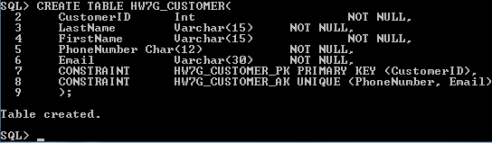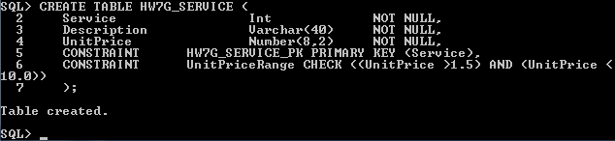
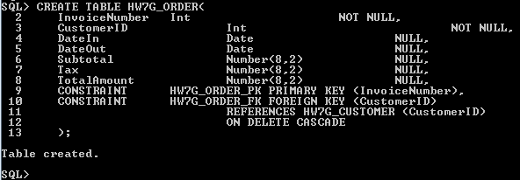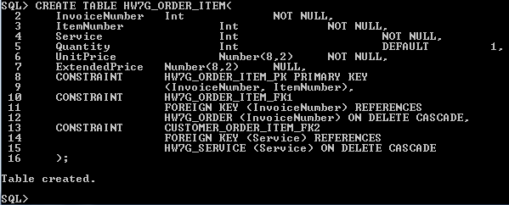
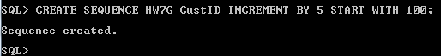
Note: We purposely modified the sequence from the direction stated. Oracle seems to be starting at 95 with the NextVal method unless we have an additional initialization statement. We were also under the impression from class that using NextVal on unused sequences starts you at the default value.

E. Explain how you would enforce the data constraint that HW7G_ORDER_ITEM.UnitPrice be equal to HW7G_SERVICE.UnitPrice, where HW7G_ORDER_ITEM.Service = HW7G_SERVICE.Service. Again, no code at this time, just an explanation.

You can write an INSERT trigger for HW7G_ORDER_ITEM. The trigger can check the constraint HW7G_ORDER_ITEM.Service = HW7G_SERVICE.Service then check for the existence of every instance of HW7G_ORDER_ITEM.UnitPrice inside of HW7G_SERVICE.UnitPrice. If it does not meet those conditions, block the insertion.

F. Insert all of the following data into the tables, using the CustID Sequence where appropriate:

The data used here is essentially the same data used in Chapter Two. Note that a Sales Tax Rate is needed for calculating the ORDER.Total. This data set (as given) uses 7.90% (.079). Note that dates are not in Oracle style, so you'll have to change them when you enter them.

TABLE OF CUSTOMER DATA:

CustomerID | FirstName | LastName | Phone | Email
100 | Nikki | Kaccaton | 723-543-1233 | NKaccaton@somewhere.com
etc., | Brenda | Catnazaro | 723-543-2344 | BCatnazaro@somewhere.com
as specified | Bruce | LeCat | 723-543-3455 | BLeCat@somewhere.com
by the | Betsy | Miller | 725-654-3211 | BMiller@somewhere.com
sequence | George | Miller | 725-654-4322 | GMiller@somewhere.com
 | Kathy | Miller | 723-514-9877 | KMiller@somewhere.com
 | Betsy | Miller | 723-514-8766 | BMiller@elsewhere.com

TABLE OF SERVICES:

Service | Description | UnitPrice
10 | Mens Shirt | 1.50
11 | Dress Shirt | 2.50
15 | Womens Shirt | 1.50
16 | Blouse | 3.50
17 | Dress Blouse | 4.50
20 | Mens Slacks | 5.00
25 | Womens Slacks | 6.00
30 | Skirt | 5.00
31 | Dress Skirt | 6.00
40 | Mens Suit | 9.00
45 | Womens Suit | 8.50
50 | Tuxedo | 10.00
60 | Formal Gown | 10.00

TABLE OF ORDER DATA: [Note: A Sales Tax Rate is needed for calculating the ORDER.Total. This data uses 7.90% (.079).]

InvoiceNumber | CustomerID | DateIn | DateOut | Subtotal | Tax | Total
2009001 | 100 | 10/4/2012 | 10/6/2012 | 158.50 | 12.52 | 171.02
2009002 | 105 | 10/4/2012 | 10/6/2012 | 25.00 | 1.98 | 26.98
2009003 | 100 | 10/6/2012 | 10/8/2012 | 49.00 | 3.87 | 52.87
2009004 | 115 | 10/6/2012 | 10/8/2012 | 17.50 | 1.38 | 18.88
2009005 | 125 | 10/7/2012 | 10/11/2012 | 12.00 | 0.95 | 12.95
2009006 | 110 | 10/11/2012 | 10/13/2012 | 152.50 | 12.05 | 164.55
2009007 | 110 | 10/11/2012 | 10/13/2012 | 7.00 | 0.55 | 7.55
2009008 | 130 | 10/12/2012 | 10/14/2012 | 140.50 | 11.10 | 151.60
2009009 | 120 | 10/12/2012 | 10/14/2012 | 27.00 | 2.13 | 29.13

TABLE OF ORDER ITEMS:

InvoiceNumber | ItemNumber | Service | Quantity | UnitPrice | ExtendedPrice
2009001 | 1 | 16 | 2 | 3.50 | 7.00
2009001 | 2 | 11 | 5 | 2.50 | 12.50
2009001 | 3 | 50 | 2 | 10.00 | 20.00
2009001 | 4 | 20 | 10 | 5.00 | 50.00
2009001 | 5 | 25 | 10 | 6.00 | 60.00
2009001 | 6 | 40 | 1 | 9.00 | 9.00
2009002 | 1 | 11 | 10 | 2.50 | 25.00
2009003 | 1 | 20 | 5 | 5.00 | 25.00
2009003 | 2 | 25 | 4 | 6.00 | 24.00
2009004 | 1 | 11 | 7 | 2.50 | 17.50
2009005 | 1 | 16 | 2 | 3.50 | 7.00
2009005 | 2 | 11 | 2 | 2.50 | 5.00
2009006 | 1 | 16 | 5 | 3.50 | 17.50
2009006 | 2 | 11 | 10 | 2.50 | 25.00
2009006 | 3 | 20 | 10 | 5.00 | 50.00
2009006 | 4 | 25 | 10 | 6.00 | 60.00
2009007 | 1 | 16 | 2 | 3.50 | 7.00
2009008 | 1 | 16 | 3 | 3.50 | 10.50
2009008 | 2 | 11 | 12 | 2.50 | 30.00
2009008 | 3 | 20 | 8 | 5.00 | 40.00
2009008 | 4 | 25 | 10 | 6.00 | 60.00
2009009 | 1 | 40 | 3 | 9.00 | 27.00

Show all the INSERT statements. You do not have to show screen shots of the runs that insert the values, since the screen shots you will do next will show insertion results.

After running the INSERT statements, create and run SQL statements to display each of the tables and include screen shots of the results. You may want to set linesize first in order to make this look better. (Suggestion: Linesize to 110 and Pagesize to 50. We expect to see four screen shots here.)

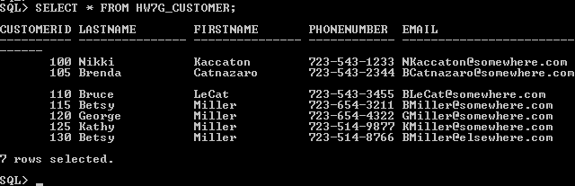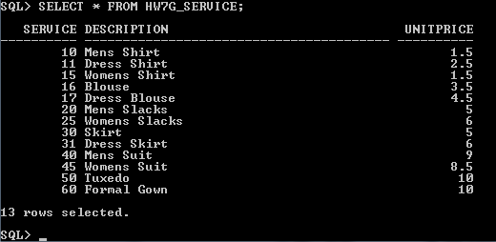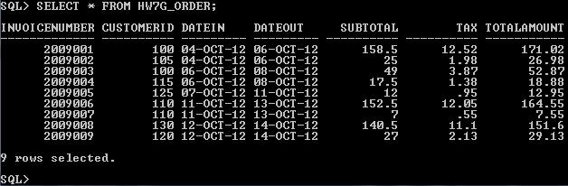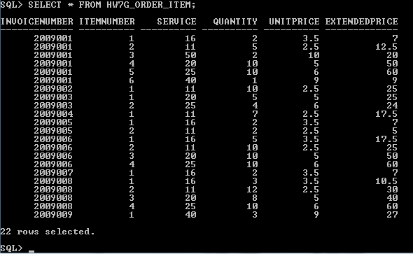

G. Write an UPDATE statement to change values of HW7G_SERVICE.Description from Mens Shirt to Mens' Shirts. Show a screen shot of running your statement.

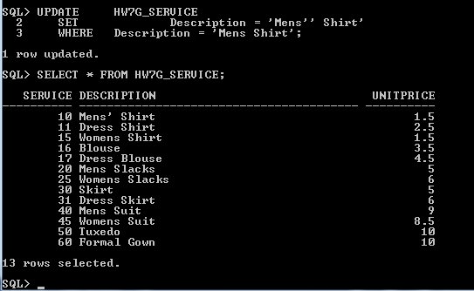

H. Write a single DELETE statement to delete a SALES_ORDER and all of the items on that SALES_ORDER. Note that we have set ON DELETE CASCADE between SALES_ORDER and ORDER_ITEM. Therefore, if we DELETE a record in SALES_ORDER, all associated records in ORDER_ITEM will also be deleted. This means we just use a simple DELETE statement on SALES_ORDER.

Pick Invoice number 2009010 as the one to delete. Insert it first, as shown below, and test by displaying periodically, also as shown below. Include screen shots of the results, as indicated:

INSERT INTO HW7G_ORDER
(InvoiceNumber, CustomerID, DateIn)
VALUES(2009010, 120, '15-Oct-09');
INSERT INTO HW7G_ORDER_ITEM
(InvoiceNumber, ItemNumber, Service, Quantity, UnitPrice)
VALUES (2009010, 1, 16, 3, 3.50);
INSERT INTO HW7G_ORDER_ITEM
(InvoiceNumber, ItemNumber, Service, Quantity, UnitPrice)
VALUES (2009010, 2, 11, 12, 2.50);

SELECT *
FROM HW7G_ORDER_ITEM;

<Include a screen shot here, showing the above sequence and results>
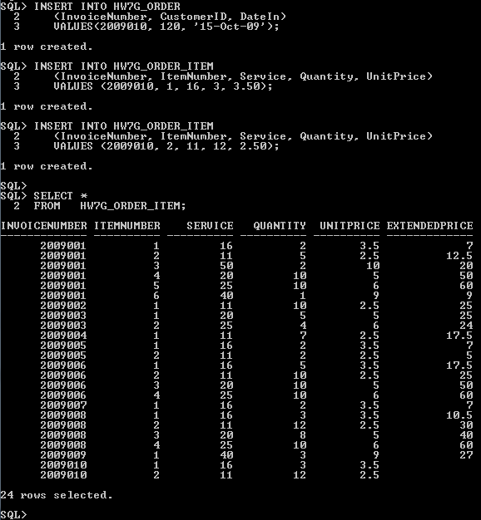

Now run your DELETE statement as specified in part H and then run the following:

SELECT *
FROM HW7G_ORDER_ITEM;

<Include another screen shot here, showing the results of your DELETE and the SELECT after it.>

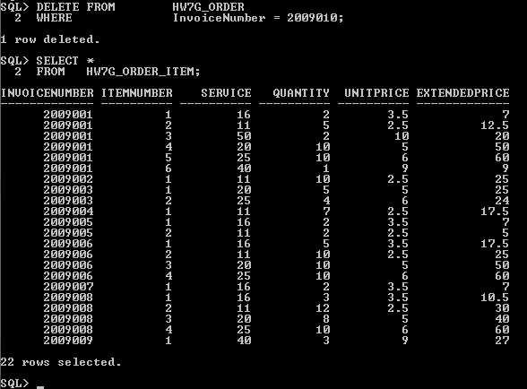

I. Create a view named HW7G_OrderSummaryView that contains InvoiceNumber, DateIn, and DateOut from HW7G_ORDER as well as ItemNumber, Service, and ExtendedPrice from HW7G_ORDER_ITEM. Show a screen shot of your creation step and, to test the view, also show a screen shot of running the following command -- you can include both on the same screen shot:

SELECT *
FROM HW7G_OrderSummaryView;

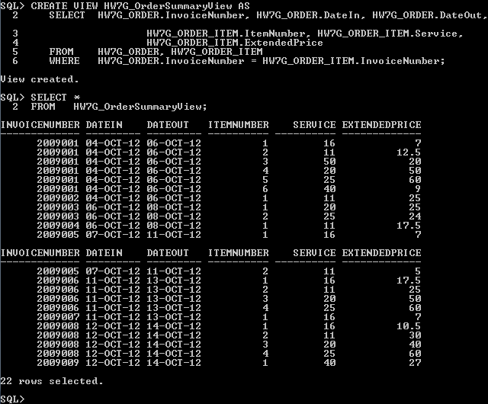
J. Create a view named HW7G_CustomerOrderSummaryView that contains HW7G_ORDER.InvoiceNumber, then FirstName, LastName, and Phone from HW7G_CUSTOMER, then DateIn, DateOut, and SubTotal from HW7G_ORDER, and, finally, ItemNumber, Service, and Extended Price from HW7G_ORDER_ITEM. Show a screen shot of your creation step and, to test the view, also show a screen shot of running the following command -- again, a single screen shot is OK:

SELECT *
FROM HW7G_CustomerOrderSummaryView
WHERE ROWNUM < 6
/* Oracle way to get first 5 records */
;

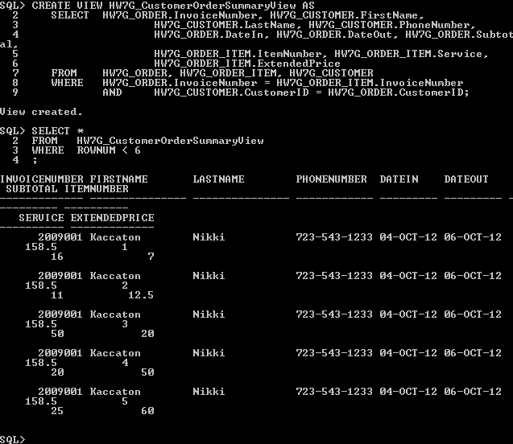
K. Create a view named HW7G_CustomerOrderHistoryView that includes all the columns of HW7G_CustomerOrderSummaryView except Phone, DateIn, ItemNumber and Service; and that sums and averages ExtendedPrice for each customer. Use the keyword "AS" to rename the ExtendedPrice column in this view to EP, and use the names TotEP and AvgEP for the sum and average.

Hint: To mix column selections with functions operating on the columns, you need to create groups (a GROUP BY clause) -- your group might include all the columns.

Show a screen shot of your creation step and, to test the view, also show a screen shot that displays the table generated by the view -- again, a single screen shot is OK:
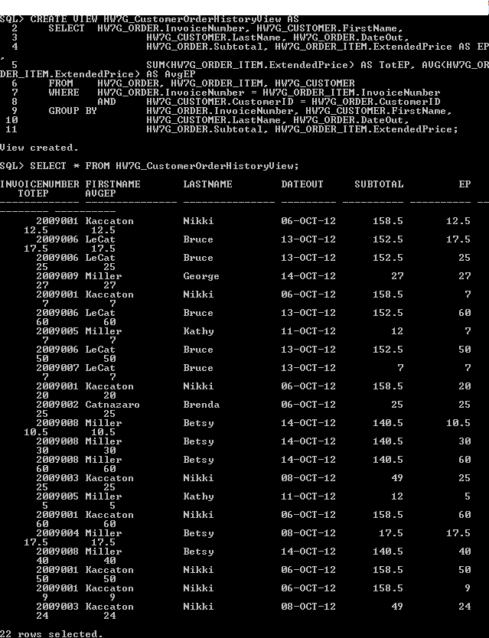

L. Create a view named HW7G_CustomerOrderCheckView that uses HW7G_CustomerOrderHistoryView, except that the column order is switched to put LastName, FirstName, and InvoiceNumber at the front, followed by Subtotal and the sum of ExtendedPrice, and that the view will show any customers for whom the sum of HW7G_ORDER_ITEM.ExtendedPrice is not equal to HW7G_ORDER.Subtotal. Show a screen shot of your creation step and, to test the view, also show a screen shot of running the following command -- again, a single screen shot is OK:

SELECT *
FROM HW7G_CustomerOrderCheckView
ORDER BY LastName, FirstName, InvoiceNumber;

[Note: For the customers who had only one item in their order, the sum of ORDER_ITEM.ExtendedPrice will equal ORDER.Subtotal. Everyone else should show up here.] 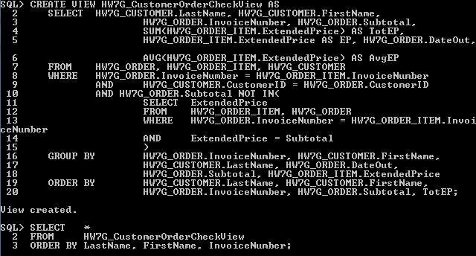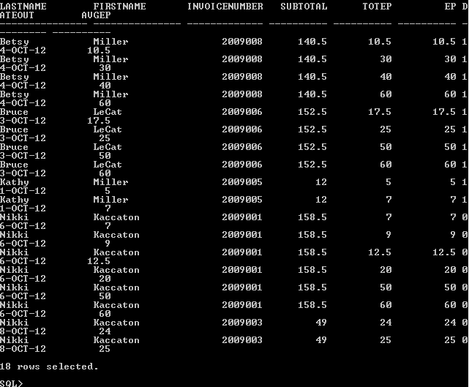

M. Explain, in general terms, how you will use triggers to enforce minimum cardinality actions as required by your design. You need not write the triggers now, just specify which triggers you need and describe, in general terms, their logic.

We will use the triggers to enforce minimum designs by making them for update actions. How these triggers will work is that they will check to see if there are any values different than what is already had. If there are none, then the trigger will not occur. However, if there are some, the trigger will activate and allow for updating to occur.

