Print Name: __Dolan, Thomas________________
(last, first)
Note: We are finished with Access at this point. Any work to be done with a database should now use Oracle -- true for HW 2 and following.

Note 2: This assignment can become very large, due to the screen shots. You should use the picture editor to focus on just the portion of the screen you want and then compress all the screen shots -- see information in Course Material.

Individual Homework
I certify that I have done this work individually. I have not talked with any current or former students about the problems. I have not looked at former students’ work on these or similar problems (sometimes called “files”).

Signature: ___________________________

1. What is an ad-hoc query?
Questions that can be answered using database data. Ex. How many users in Minneapolis use Firefox as their default browser?

2. Explain how enterprise-class DBMS products use SQL.
They require that you know how to use SQL. Data manipulation in enterprise products is shown using SQL nearly exclusively. Stripping away the GUI for elementary software gives you much more control and power to get what you want

3. Explain, in general terms, the relationships among the RETAIL_ORDER, ORDER_ITEM, and SKU_DATA tables of Fig. 2-4 -- what relates to what and how?
RETAIL_ORDER table relates to ORDER_ITEM table by the OrderNumber column.
ORDER_ITEM table relates to SKU_DATA table by the SKU column.

*****
For the remaining questions, use the following INVENTORY and WAREHOUSE relations, with the characteristics specified in the tables below them.

INVENTORY (SKU, WarehouseCity, SKU_Description, QuantityOnHand, QuantityOnOrder)
WAREHOUSE (WarehouseCity, Manager, SquareFeet)

INVENTORY Characteristics:
Column Name | Type | Key | Required | Remarks
SKU | Integer | Primary Key, Foreign Key | Yes | Surrogate Key
WarehouseCity | VarChar(15) | Primary Key, Foreign Key | Yes
SKU_Description | VarChar(30) | No | Yes
QuantityOnHand | Integer | No | No
QuantityOnOrder | Integer | No | No

WAREHOUSE Characteristics:
Column Name | Type | Key | Required | Remarks
WarehouseCity | VarChar(15) | Primary Key | Yes
Manager | VarChar(15) | No | No
SquareFeet | Integer | No | No

You will be provided with files to load the sample sets of data into the INVENTORY and WAREHOUSE tables. Run those files to create and load the INVENTORY and WAREHOUSE tables. Use only the INVENTORY table for questions 4 through 10; use both tables for questions 11 and 12. The prefix HW2I_ is affixed to these files, so they are named HW2I_INVENTORY, etc. Note that you'll need other tables as well and that the order of creation is important.
*****

4. Write and run a SQL statement to display SKU and SKU_Description. Show your SQL statement and also show a screen shot of your results.
SELECT SKU,SKU_Description
FROM HW2I_INVENTORY;
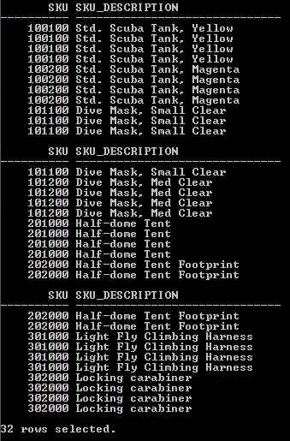

5. Write and run a SQL statement to display WarehouseCity with no duplications. Show your SQL statement and a screen shot of your results.
SELECT DISTINCT WarehouseCity
FROM HW2I_INVENTORY;
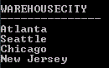

6. Write and run a SQL statement to display all of the columns without using *. Show your SQL statement and a screen shot of your results.
SELECT SKU,WarehouseCity,SKU_Description,QuantityOnHand,QuantityOnOrder
FROM HW2I_INVENTORY;

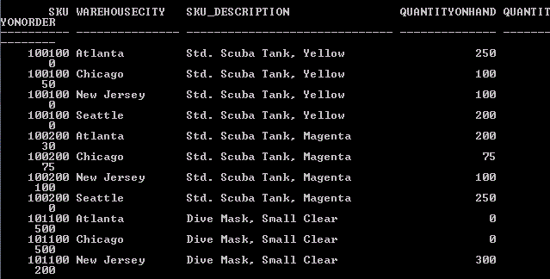
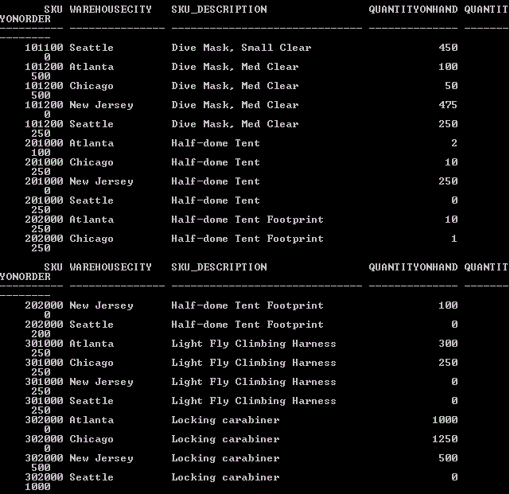

7. Write and run a SQL statement to display the SKU and SKU_Description of all items stored in the Seattle, Chicago, or New Jersey warehouses. Do not use IN. Show your SQL statement and a screen shot of your results.
SELECT SKU,SKU_Description
FROM HW2I_INVENTORY
WHERE WarehouseCity=’Seattle’
OR WarehouseCity=’Chicago’
OR WarehouseCity=’New Jersey’;
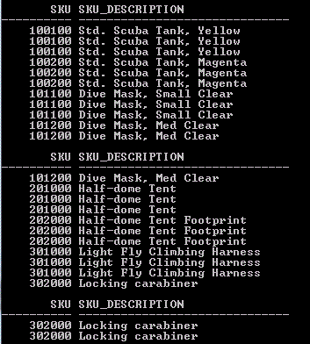

8. Write and run a SQL statement to display the SKU and SKU_Description of all items stored in the Seattle, Chicago, or New Jersey warehouses. Use IN. Show your SQL statement and a screen shot of your results.
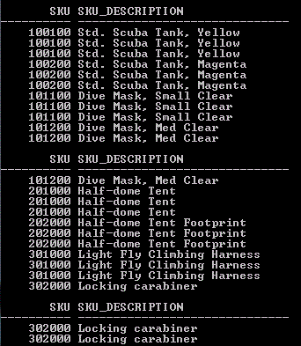
9. Write and run a SQL expression to display the WarehouseCity and the sum of QuantityOnHand, grouped by WarehouseCity. Name the sum TotalItemsOnHand and display the results in descending order of TotalItemsOnHand. Show your SQL statement and a screen shot of your results.

SELECT WarehouseCity,SUM(QuantityOnHand) AS TotalItemsOnHand
FROM HW2I_INVENTORY
GROUP BY WarehouseCity
ORDER BY TotalItemsOnHand DESC;
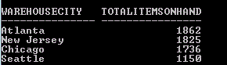
10. Write and run a SQL expression to display the WarehouseCity and the sum of QuantityOnHand grouped by WarehouseCity. Omit all items that have a QuantityOnHand greater than 2. Show only groups having fewer than 2 item counts (i.e., a number of records (rows or individual items) fewer than 2). Name the sum TotalItemsOnHand and display the results in descending order of TotalItemsOnHand.
[Hints:
Think of using COUNT inside a HAVING clause.
Order of clauses:
SELECT, FROM, WHERE, GROUP BY, HAVING, ORDER BY]
Show your SQL statement and a screen shot of your results.

SELECT WarehouseCity,SUM(QuantityOnHand) AS TotalItemsOnHand
FROM HW2I_INVENTORY
WHERE QuantityOnHand<3
GROUP BY WarehouseCity
HAVING COUNT(*)<2
ORDER BY TotalItemsOnHand DESC;
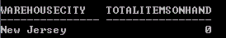

11. Write and run a SQL statement to show the SKU and SKU_Description of all items stored in a warehouse managed by 'Smith'. Use a subquery. Show your SQL statement and a screen shot of your results.

SELECT SKU,SKU_Description
FROM HW2I_INVENTORY
WHERE WarehouseCity IN (
SELECT WarehouseCity
FROM HW2I_WAREHOUSE
WHERE Manager=’Smith’);
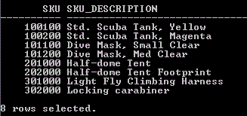

12. Write and run a SQL statement to show the SKU and SKU_Description of all items stored in a warehouse managed by 'Smith'. Use a join. Show your SQL statement and a screen shot of your results.
SELECT HW2I_INVENTORY.SKU,HW2I_INVENTORY.SKU_Description
FROM HW2I_INVENTORY,HW2I_WAREHOUSE
WHERE HW2I_INVENTORY.WarehouseCity=
HW2I_WAREHOUSE.WarehouseCity
AND HW2I_WAREHOUSE.Manager=’Smith’;
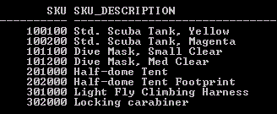

13. Explain how subqueries and joins differ.
Subqueries are in essence, a query within another query. They (the child query) must be placed in the WHERE clause and relate to the parent query in some way, usually a foreign key. They allow you to only look and worry about rows in the parent table that meet a matching condition in the child query. Joins combine 2 or more tables together by concatenating the rows of one table with another. When joining, it's necessary to remove garbage data by relating the 2 tables in your WHERE clause, so as to not get an excessively large table. Afterwards, you can then search for your data through the combined columns, making sure to specify where each data column orignates from

