Print Name: ____Dolan, Thomas_________________
(last, first)
Individual Homework [100 pts]
I certify that I have done this work individually. I have not talked with any current or former students about the problems. I have not looked at former students’ work on these or similar problems (sometimes called “files”).

Signature: ___________________________

Note: This assignment can become very large, due to the screen shots. Use trimming and compression to keep it at a manageable size.

Consider the following relations:
HW7I_EMPLOYEE( EmpNumber, LastName, FirstName, Eaddr )
HW7I_PROJECT( ProjectName, Description, StartDate, EndDate )
HW7I_ASSIGNMENT( EmpNumber, ProjectName, TotalHoursWorked )

Assume that the relationships from HW7I_EMPLOYEE to HW7I_ASSIGNMENT and from HW7I_PROJECT to HW7I_ASSIGNMENT are 1:N, M-O.
Referential Integrity Actions: Cascade deletions from HW7I-PROJECT to HW7I-ASSIGNMENT.
Some of the characteristics are given in the following tables:

HW7I_EMPLOYEE
Column Name | Type | Required | Notes
EmpNumber | Integer | Yes | PK
LastName | Varchar(20) | Yes | AK1.1
FirstName | Varchar(15) | Yes | AK1.2
Eaddr | Varchar(25) | No

HW7I_PROJECT
Column Name | Type | Required | Notes
ProjectName | Varchar(20) | Yes | PK
Description | Varchar(40) | No
StartDate | Date | No
EndDate | Date | No

HW7I_ASSIGNMENT
Column Name | Type | Required | Notes
EmpNumber | Integer | Yes | PK1.1, FK
ProjectName | Varchar(20) | Yes | PK1.2, FK
TotalHoursWorked | Number(5,2) | No | Default 4.0

1. Write a SQL*Plus CREATE TABLE statement for the HW7I_EMPLOYEE relation. Run your statement and include a screen shot of your run.

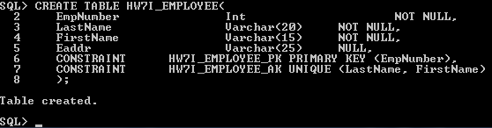

2. Run the following SQL statement and provide a screen shot of the result:
DESCRIBE HW7I_EMPLOYEE;
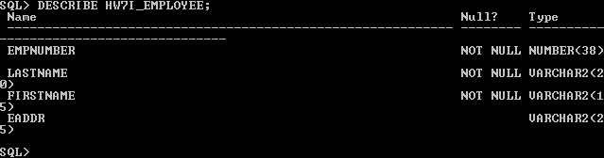

3. Write a SQL*Plus CREATE TABLE statement for the HW7I_PROJECT relation. Run your statement and include a screen shot of your run.

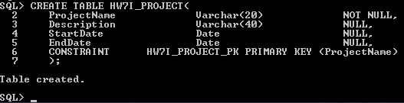

4. Run the following SQL statement and provide a screen shot of the result:
DESCRIBE HW7I_PROJECT;
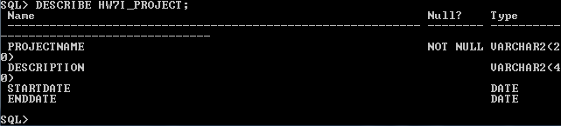

5. Write a SQL*Plus CREATE TABLE statement for the HW7I_ASSIGNMENT relation. Run your statement and include a screen shot of your run. Do NOT include the default value for TotalHoursWorked in your creation SQL (instead, see #6).
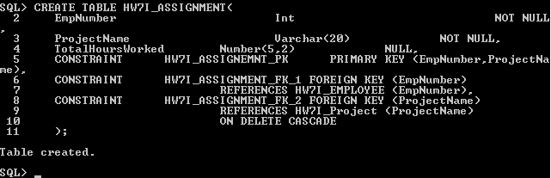
6. After creation of HW7I_ASSIGNMENT, use the ALTER TABLE statement to set the default value for TotalHoursWorked. Include a screen shot of your execution of this statement.
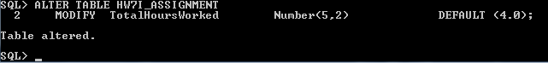

7. Run the following SQL statement and provide a screen shot of the result:
DESCRIBE HW7I_ASSIGNMENT;
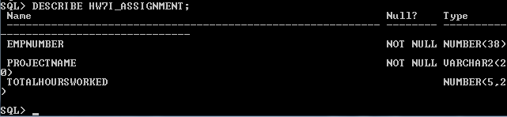

8. Create a relation named HW7I_PROJECT2 that is a revised version of HW7I_PROJECT. In this revised relation, include the constraint that StartDate be prior to EndDate. Also, constrain ProjectNames to the values Red, Blue, or Yellow. Run your create statement for this revised table and include a screen shot of your run.
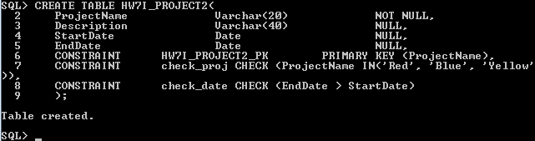

9. Run the following SQL statement and provide a screen shot of the result:
DESCRIBE HW7I_PROJECT2;
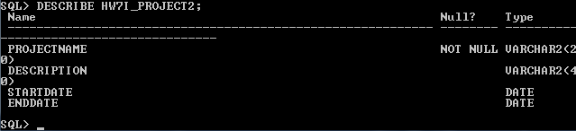

10. Create a relation named HW7I_ASSIGNMENT2 that makes the relationship between HW7I_EMPLOYEE and HW7I_ASSIGNMENT2 a 1:1 relationship. Put the default value for TotalHoursWorked into the create statement. Run your create statement for this revised table and include a screen shot of your run.
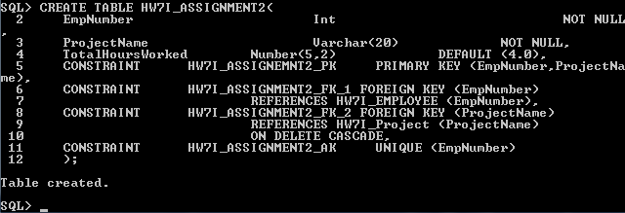

11. Create a copy of the HW7I_EMPLOYEE table and name it HW7I_EMPLOYEE2. Use SQL CREATE TABLE statements from your creation of the HW7I_EMPLOYEE table, modified to use the name HW7I_EMPLOYEE2 and be sure to change the names of the constraints to reflect EMPLOYEE2 as well, since we'll refer to them later. Run your create statement for this revised table and include a screen shot of your run.
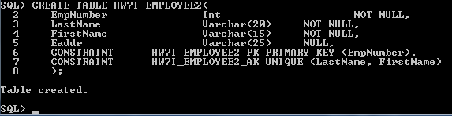

12. Write a SQL*Plus ALTER statement to add the column Phone to HW7I_EMPLOYEE2. Assume that Phone is not required and that we can treat Phone as 12 characters. Run your ALTER statement and include a screen shot of your run.
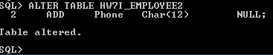

13. Write a SQL*Plus ALTER statement to remove the column Eaddr from HW7I_EMPLOYEE2. Run your statement and include a screen shot of your run.
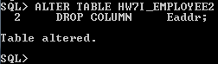

14. Write a SQL*Plus ALTER statement to make Phone an alternate key in HW7I_EMPLOYEE2. Run your statement and include a screen shot of your run.
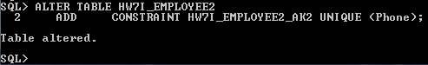

15. Write a SQL*Plus ALTER statement to drop the constraint that Names be unique in HW7I_EMPLOYEE2. Run your statement and include a screen shot of your run.
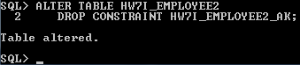

*** From here on, we will use the HW7I_EMPLOYEE and HW7I_ASSIGNMENT relations, with their original formats. ***

16. Write a SQL*Plus INSERT statement to add the row (12345, 'Jones', 'James', 'Jones@MyCorp.com') to HW7I_EMPLOYEE. Run your statement and include a screen shot of your run.
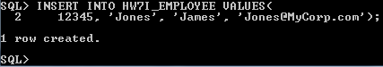

17. Run the following SQL statement and provide a screen shot of the result:
SELECT *
FROM HW7I_EMPLOYEE;
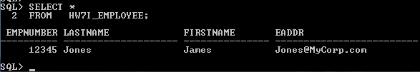

18. Write a SQL*Plus UPDATE statement to change the LastName of the employee named 'Jones' to 'Smith'. Run your statement and include a screen shot of your run.
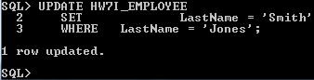

19. Run the following SQL statement and provide a screen shot of the result:
SELECT *
FROM HW7I_EMPLOYEE;
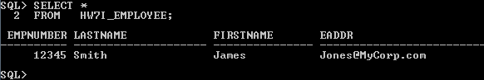

20. Write one SQL*Plus DELETE statement that would delete all data for project 'BLUE' and all of its rows in HW7I_ASSIGNMENT. Show your statement, but you do not need to run this statement. [Hint: Think about the parent of HW7I_ASSIGNMENT and the referential integrity actions on the relationship.]

DELETE FROM HW7I_PROJECT
WHERE ProjectName = 'BLUE';

21. Write and show a SQL*Plus DELETE statement that would delete the row for the employee named 'Smith' from HW7I_EMPLOYEE. You do not need to run this statement. What happens if this employee has rows in HW7I_ASSIGNMENT?

DELETE FROM HW7I_EMPLOYEE
WHERE LastName = 'Smith';

If there are rows related to this employee, upon deletion you would violate the foreign key restraint, throwing an error.

22. Write and show a SQL*Plus statement to join HW7I_EMPLOYEE, HW7I_ASSIGNMENT, and HW7I_PROJECT, using the JOIN ON syntax. You do not need to run this statement.

SELECT *
FROM HW7I_PROJECT JOIN HW7I_ASSIGNMENT
ON HW7I_PROJECT.ProjectName = HW7I_ASSIGNMENT.ProjectName
JOIN HW7I_EMPLOYEE
ON HW7I_ASSINGMENT.EmpNumber = HW7I_EMPLOYEE.EmpNumber;

23. What is a SQL view? What purposes do views serve?

An SQL view is a virtual table that is constructed from other tables or views. They serve to present data to a user without allowing them the modify the data.

24. What is the limitation on SELECT statements used in SQL views in the SQL-92 standard and how does Oracle differ?

In SQL-92 standard, views cannot be created from statements containing an ORDER BY clause. However, Oracle differs and does allow these.

25. Use SQL*Plus to create the View Ridge Gallery database. Some SQL to help with this is available on Blackboard.

In order to avoid problems with large cut and paste operations, you may need to do the insert operations on the VRG_WORK table in two pieces -- perhaps down to the two works titled "Farmer's Market #2" in a first set and the rest in a second set. Similarly, you may want to do the insert operations into the VRG_TRANS table in three operations, perhaps down to the first time WorkID 510 shows up in the first operation, then from the next Work down to the first time WorkID 520 shows up in the second operation, and then the remaining Works in a third cut-and-paste operation.

Once you have created the database, set Linesize to 120 and page size to 50 and then give screen shots as described below:
a) A display of the first 5 rows of the VRG_CUSTOMER table.
b) A display of the VRG_ARTIST table.
c) A display of the VRG_CUSTOMER_ARTIST_INT table.
d) A display of all entries in the VRG_WORK table that have a copy description of "Unique."
e) A display of the VRG_TRANS table.

26. Write and run a SQL*Plus statement to create a view named CustomerStateView that shows the values of VRG_CUSTOMER.State. Include a screen shot of the results of your creation run of the view.

27. Run the following SQL statement and provide a screen shot of the result:
SELECT *
FROM CustomerStateView;

28. Write and run a SQL*Plus statement to create a view named CustomerInfo_CA_View that shows LastName, FirstName, City, and State of VRG_CUSTOMER for customers in California. Include a screen shot showing the results of running your statement to create the view.

29. Write and run a SQL*Plus statement to create a view named ArtistWorkDescView that shows VRG_ARTIST.LastName, VRG_ARTIST.FirstName, VRG_ARTIST.Nationality, VRG_WORK.Title, and VRG_WORK.Description. Include a screen shot showing the results of running your creation statement.

30. Describe how views are used to provide an alias for tables. Why is this useful?

Views can be named differently from the table(s) used to create them, in most DBMS applications using the AS keyword. This is useful because it hides possibly sensitive column and table names from users who are not authorized to modify.

31. Explain how views can be used to improve data security.

By using aliases liberally, it can be very difficult to discover source table and column names. By having limited access to the source tables, the data integrity can be better monitored.

32. What is a trigger?

A special type of stored procedure that is invoked by the DBMS when a specified condition occurs.

33. What is the relationship between a trigger and a table or view?

Triggers are attached to a table or view. They fire when a specific event in the table or view occurs.

34. What is a stored procedure? How do stored procedures differ from triggers?

A stored procedure is a collection of SQL statements stored as a file that can be invoked by a single command. Triggers are called by the DBMS when INSERT, UPDATE, or DELETE commands are used, while stored procedures are called by users of database administrators. Triggers are assigned to specific tables or views while stored procedures are assigned to the database as a whole. Triggers may issue INSERT, UPDATE, or DELETE commands causing calls to other triggers, meaning a table or view can also have more than one trigger attached to it. Stored procedures can issue INSERT, UPDATE, DELETE, or MERGE commands and are generally used for repetitive tasks or as part of the application.

