**Computer Vision Project 3**

20171637 박성우

**Check the attached SIFT program analyze computation times of the functions in computeKeypointsAndDescriptors().**

**For the slowest function, explain how you can speed it up.**

By measuring time for each functions in ComputekeypointsAndDescriptors(), I came up with the results below.

Img1 img2

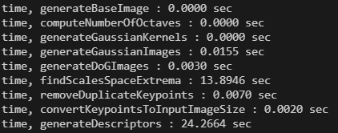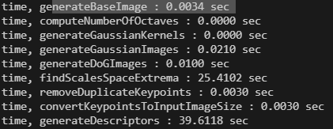

To speed up this SIFT program, it is obvious that findScalesSpaceExtrema and generateDescriptors functions must be more fast.

findScalesSpaceExtrema is a function to acquire scale-invariant keypoints. To speed up this function we can reduce the number of octaves to reduce calculation of DOG and reduce number of scale levels to reduce the search time of local extrema.

generateDescriptors function builds histogram for orientation normalization. To speed up this function we can reduce the size of window to deal with less pixels and reduce histogram size, or we can reduce parameter ‘scale_multiplier’ to reduce the histogram size.