**Computer Vision Project 2**

20171637 박성우

**Questions**

**- How can we improve the edge detection performance? Explain it　by　using the parameters given in the provided program,**

-Appropriate size of gaussian filter improves the edge detection. 5x5 size is better than 3x3 size but there were no significant difference between 5x5 and 7x7. And sharpening the gaussian filter helps(changing the numbers in the gaussian filter).

- Regarding the gradient we can use different sobel filter. Since lena picture has a lot of curves it is better use 45 degree sobel filter. it’s performance outstandingly increases!

-Regarding the double thresholding given code uses 2 threshold values which are lo and hi. By changing the value of lo, and hi we can improve the performance of edge detection. In conclusion if I change hi value to 0.3, and low value to 0.12 performance has improved. Reducing hi value catches more edges like lena’s armpit and links several more lines, and increasing li value erase some noises in lena’s hair. 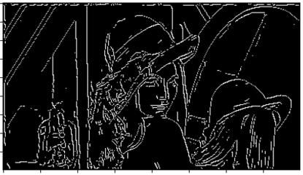

**- How can we improve the keypoint matching performance? Explain it by　using the parameters given in the provided program,**

In the given code, factors that affect performance of Harrison detector are sigma, nms_kernel_size, k, thresh. Sigma affects window size, nms_kernel_size affect non_maximal_suppression size, thresh and k affects the candidates of the corner. Variable max_no_corners might cutoff some detected corners depending on images and number of detected corner. All parameters should be appropriate not too low or too high.

Empirically sigma value of 1~2, k value of 0.04~0.06, thresh value of 0.6~1.4 showed good performance. Extreme values like sigma 5 or thresh 7 cut offed a lot of corners.