**2023-1 Multicore Computing, Project #1**

Problem 2

2023-04-18

CAU SW 20184286

LEE DONGHWA

**Environment**

CPU type_ Intel Core i5-8265U 1.60GHz, Hyper Threading ON

# of core_ 4

Memory size_ 8GB

OS type_ Window 11 Pro

**Result**

Tables_ (unit : ms, task size : 10)

|  |  |  |  |  |  |  |  |  |  |  |
| --- | --- | --- | --- | --- | --- | --- | --- | --- | --- | --- |
|  | 1 | 2 | 4 | 6 | 8 | 10 | 12 | 14 | 16 | 32 |
| Exec time | 447 | 244 | 206 | 172 | 262 | 222 | 193 | 201 | 256 | 317 |

|  |  |  |  |  |  |  |  |  |  |  |
| --- | --- | --- | --- | --- | --- | --- | --- | --- | --- | --- |
|  | 1 | 2 | 4 | 6 | 8 | 10 | 12 | 14 | 16 | 32 |
| **Performance** | 0.002237 | 0.004098 | 0.004854 | 0.005814 | 0.003817 | 0.004505 | 0.005181 | 0.004975 | 0.003906 | 0.003155 |

Graphs_

Explanation / Analysis_

When the number of threads increased initially, there was an improvement in performance, and the highest performance was achieved when parallel processing was done with six threads. However, when a large number of threads, such as 16 or 32, were used for parallel processing calculations, a phenomenon of decreased performance was observed instead. This may be because more resources are used to divide the tasks per thread for parallel processing than the efficiency gain from parallel processing calculations.

**Program Execution**

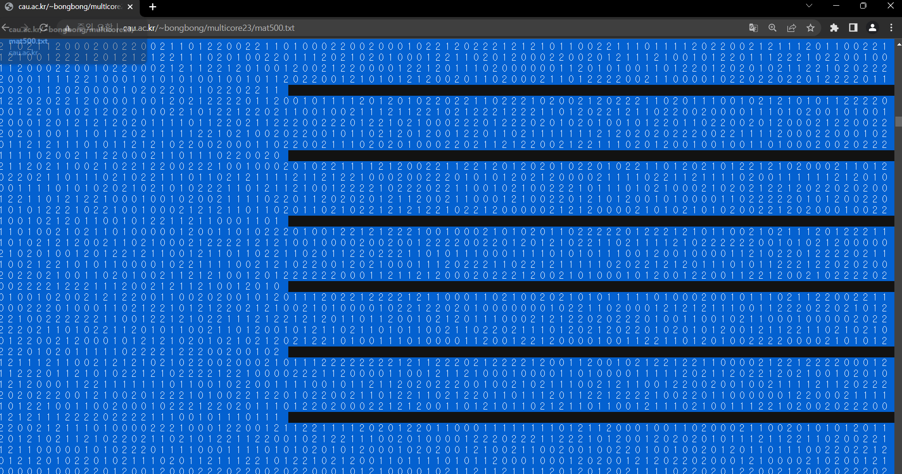

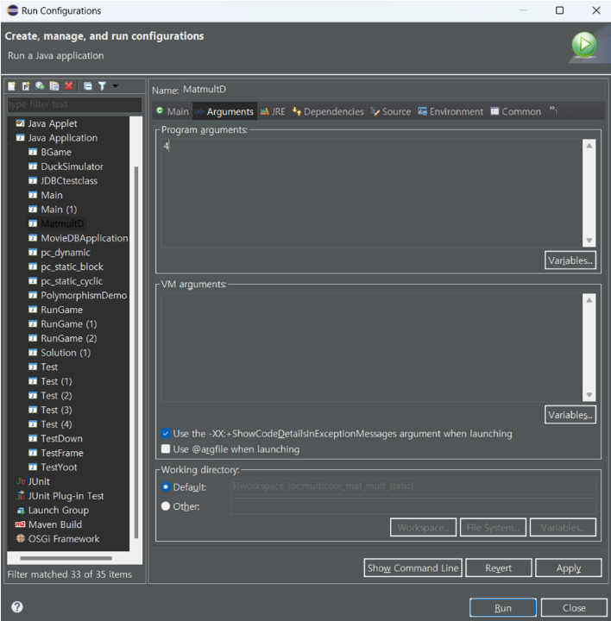

First, you prepare mat500.txt file. In eclipse, set the argument value and file input by using the menu [Run]->[Run Configurations]. And then, [Argument] menu, [Common -> Input File] menu help to access the txt file and you can change the number of threads.

And press ‘Run’ button then you can execute my code. If you want to change the number of threads, please change argument.

Execution Output_

The first screenshot is when the code that outputs the matix results is commented out, and the second capture is when the code is not commented out.

**Source Code**

MatmultD.java

