Mathematical Review:
Exponents:

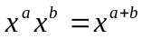

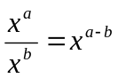

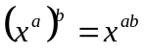

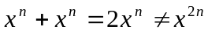

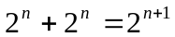

Logarithms (note, unless otherwise stated, log is log₂)

Definition:
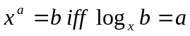

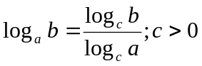

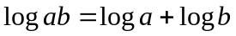

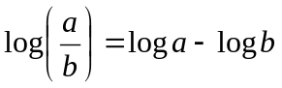

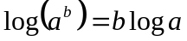

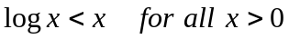

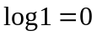

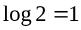

Series:

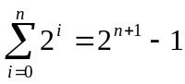

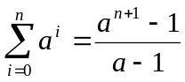
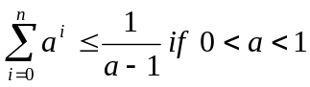

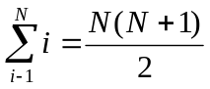

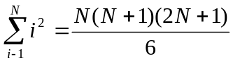

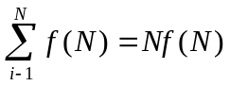

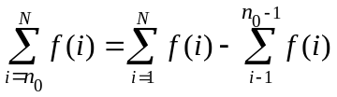

Definition:
a is congruent to b modulo n (written as: 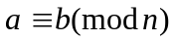) iff n divides a-b. Intuitively it means that a and b has the same remainder.

