ASSIGNMENT 2

for
Robert Boyczuk
BTP600 Professor
Seneca@York Campus
70 The Pond Road
Toronto, Ontario

by Group Members
Timothy Duavis - 019261049, Vincent Lam , Ryan Wang - 021040043
BTP600 Students

ASSIGNMENT 2 1
1.0 Game of Life Development Report 3
1.1 Project Description 3
1.2 Game of Life Rules 3
1.3 Game of Life Enhancement Specification 3
2.0 Development Strategy 3
2.1 Separation of Tiers 3
2.2 To Start from Scratch or To Not Start from Scratch, that is the Question? 4
3.0 Design Analysis 4
3.1 Design Problems 4
3.1.1 Composition and Recursion 4
3.1.2 Separation of Entities 5
Noun Filtering Table 5
3.1.3 Incorporating Existing Engines 8
3.1.4 Developing GUI Components 8
3.2 Game of Life Version 1.0 9
3.2.1 Results from Design Analysis 9
3.2.2 Actual Results 11
4.0 List of Bugs and Known Issues 12
References 12
Appendix A 13

Game of Life Development Report

Project Description
The following project implements the game called Game of Life as specified by John Conway.
This project is the second assignment for the class BTP600 – Design Patterns. The main goal of the project is to apply design pattern concepts discussed and lectured in class to specified requirements.
The programming language used to implement the Game of Life application is client Java with Java Swing Framework as the GUI front end.

Game of Life Rules
Take from Wikipedia John Conway’s Game of Life rules are specified below:

The universe of the Game of Life is an infinite two-dimensional orthogonal grid of square cells, each of which is in one of two possible states, live or dead. Every cell interacts with its eight neighbours, which are the cells that are directly horizontally, vertically, or diagonally adjacent. At each step in time, the following transitions occur:

1. Any live cell with fewer than two live neighbours dies, as if by loneliness.
2. Any live cell with more than three live neighbours dies, as if by overcrowding.
3. Any live cell with two or three live neighbours lives, unchanged, to the next generation.
4. Any dead cell with exactly three live neighbours comes to life.

The initial pattern constitutes the 'seed' of the system. The first generation is created by applying the above rules simultaneously to every cell in the seed-- births and deaths happen simultaneously, and the discrete moment at which this happens is sometimes called a tick. (In other words, each generation is based entirely on the one before.) The rules continue to be applied repeatedly to create further generations.

Game of Life Enhancement Specification
The following shows the chosen enhancements applied:
- Add varying speeds.
- Add display "zoom". Note that there is a practical limit to the zoom feature (1 pixel per cell) beyond which you cannot go. See the sample Java Applet to see how size works there.
- Add multiple forms of life represented by different colors. The different colors can only give birth to their own kind, but can kill other kinds in overcrowding situations.

Development Strategy

Separation of Tiers
Our initial development strategy is to develop the game, Game of Life into two distinct tiers: the first tier is the Game of Life engine where it has all the necessary entities modeled and then to best apply the appropriate design patterns and solutions. The next tier is to separate the GUI framework in order to fit it in with the Game of Life engine.

To Start from Scratch or To Not Start from Scratch, that is the Question?
Time was the biggest constraint in the overall development strategy. Each developer had limited time to give the best solution for the project at hand however making the project work was imperative.

We had two options in solving this dilemma. First option was to find an existing Game of Life application’s source code and strip both mention tiers and redesign the code into what we thought was the most effective design. Second option was to code everything from the ground up.

Design Analysis

Design Problems
The below list the design problems and dilemmas we ran into when designing and developing the Game of Life game application. The two main items in the list comply with our separation of tiers strategy therefore we would isolate the problems and work to complete or find a given solution.

- Designing Class structure for the Game of Life Engine
- Composition and recursion
- Separation of key entities: cell; generation; grid
- Strip an existing generation engine of a game of life to modify and fit the best possible design pattern within the assignment specification
- Designing User Interface Implementation
- Develop custom GUI components
- Incorporate existing GUI Frameworks

Composition and Recursion
In the initial analysis of the requirements we understood that Cell and the game of life Game Board are the two entities that would vary.

Thinking in terms data structure we wanted to use recursion to implement the generation of cells as the relationship between the Cell and the game board seem to be recursive. From experience the OO Design Pattern that commonly implemented recursion is Composition which correlated into the nature of the Cell and Game Board relationship as these entitles needed to be structured in the design class domain.

Eventually upon drafting pseudo code of the class diagram and recursion algorithm we thought this approach would be in vain and looked to find an easier solution both in implementing and for later extendibility purposes.

Separation of Entities
The separation of responsibilities was performed so that a model could be drafted to show the key entities of the Game of Life and be used as a conceptual guide during the class design diagram. Noun filtering was used in order to extract key nouns that formed the core of the game. The following displays the non filtering results that were used to develop the above model:

Noun Filtering Table
Nouns
- Cell
- Generation, Evolution
- Seed of System
- Steps in Time
- States
Verbs
Transition
Generation creation
Direction: horizontal, vertical, diagonally, adjacent
State – live or dead (birth / death)

What became apparent were three nouns: Cell, Generation, and Grid. In the design group but the following had reached a fairly general consensus: Grid had a 1-to-many relationship with Cell therefore making Grid be represented as some sort of aggregation data type structure aggregating many cells.
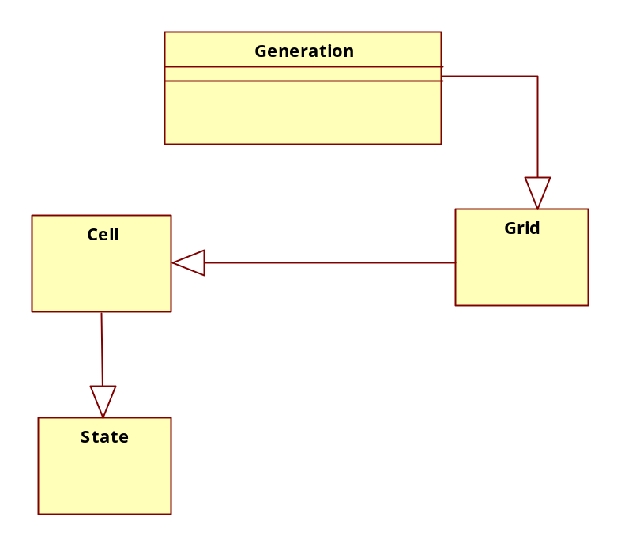
As specified in the requirements the Generation entity acted more as “bridge” or “glue” that combined the Cell and Grid together forming the dynamics of the Game of Life because during a generation based on the certain rules the Grid would change the amount of Cells contained. Therefore the Generation entity would be the information expert responsible for enforcing the policies of Cell and Grid interaction.

Essentially the Generation entity is the core engine of the game and therefore separating and encapsulating this entity would be important in terms of design principles because we would force this entity from changing affecting the future extensibility, maintenance and overall debugging of the life cycle of the application. The alternative was to place the generation code function within the Grid however this is proves not to be recommended since the Grid class could change or include other helper functions or design class structure associated to it; by forcing the Generation algorithm to be placed in a separate class we limit any future variances from affecting this core functionality.

The state pattern was proposed to be used to show the different forms of life however skeptical considerations for implementing this design pattern were raised as a cell’s various life form could be easily flagged as an INT macro flag.
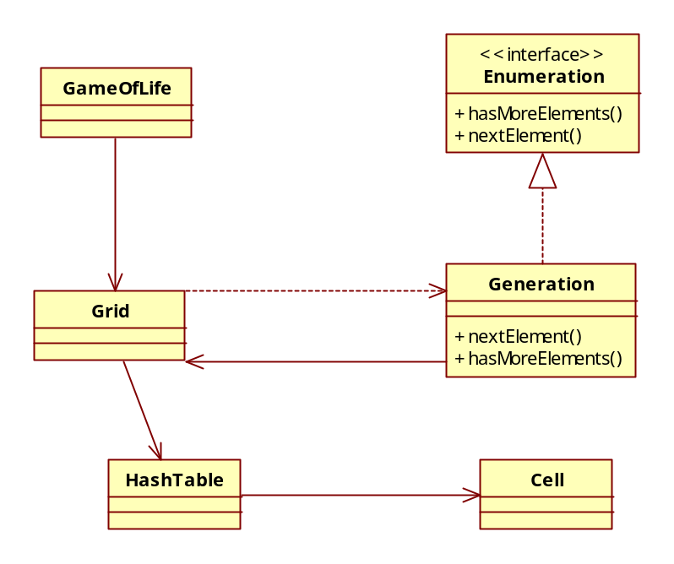
The above diagram shows the skeleton classes for the Game of Life engine. The GameOfLife class is the client class that composites the Grid class. The underlying purpose of the GameOfLife class will be explained in depth in section Developing GUI Components however in the class acts as a façade for the entire core classes.
Although the Grid class was mentioned in the above analysis as an aggregation, we decided to modify the iterator design pattern that is recommended to use to solve an aggregation type traversal issue. The reason being is that internally we decided to use a parallel collection data type provided in Java to represent an original collection of cells and a new collection cells that would be used to represent the current cells after the generation has taken place. The Generation class would implement an interator type interface in Java but would work not traditionally traverse through each set of hash table collection but instead would traverse each generation in the Game of Life.

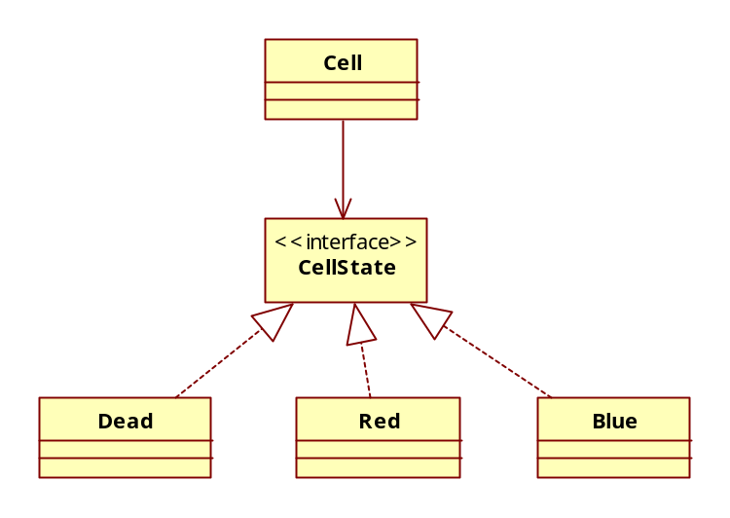
The above shows the proposed state pattern that would be applied. The context class is the Cell that is composed in the Grid’s parallel hash tables as various forms of state which is subjected to the next traversal logic in the Generation.

Incorporating Existing Engines
As part of our strategic option we did perform research of existing source code of the Game of Life. The first resource we found showed a very similar approach with what we initially modeled and designed. Both the reference and our work encapsulated the Generation entity so that we could isolate the core functionality from the dependent variations. Furthermore the referenced source code used two hash table collections to map the actual grid of the game with the corresponding cells contained in the hash table collection.

I could see that both designs incorporate the design principle of “Classes should be open for extension but close for modification” however our design explicitly defines the Generation to be an enumeration – java’s iterator class for hashed data type structures so that the Grid would only manage the aggregations – the composed hash tables.

Developing GUI Components
When developing the GUI components our group came up with two options:
- Panel that contains coordinates with grid lines drawn out and to manage the mapping of cells.
- Table with each column and row representing a grid.

We also needed a method in which the GUI components would receive information from the internal core classes. Therefore burrowing concepts from Model View Controller and Model View Separation architecture we would use the mentioned GameOfLife class as a Façade / controller class that would expose the necessary classes and properties of the core class, namely the Grid class and its subclasses contained within.

We had many concerns with the technical implementation as it relates to the specification of the assignment requirement narrowing down into the actual rendering of the grid and the mapping of the cells.

Therefore we consulted our references and performed additional research into GUI component implementation details.
Again the approach of model-view separation / controller design is not uncommon within applications this was clearly evident in the following resources and research we referred to.

Game of Life Version 1.0

Results from Design Analysis
Based on the requirements and design analysis much of the core engine was implemented. Using existing open source code proved only to take longer as code written had little patterns to use and far exceeded the assignment scope; therefore code for Game of Life as specified by BTP600 Assignment 2 was developed from scratch. The key entities have been implemented and encapsulated into design patterns. The following is class diagram that show the final implemented structure:

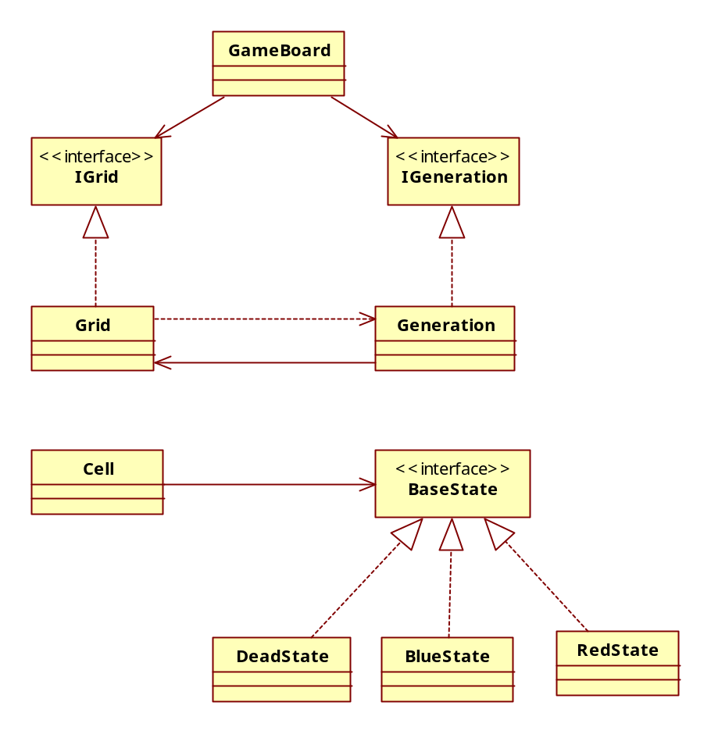
There were two re-designs that had to commit from the initial design: first is the hash table of cells contained in grid and the plan to make the GameOfLife a façade like class that would provide an entire interface to the game engine towards the GUI components.

The hash table collections were replaced with a single two-dimensional array of cell object which affected the corresponding iterator design by creating a custom iterator class and concrete iterator. The justification of this action was the unnecessary complexity in trying to map a cell based on a rectangular grid. This redesign benefit does not affect the future extendibility since Grid is encapsulated and a collection like hash table could be used to contain cell if creating an array of Cell is inappropriate.

The reason for abandoning the façade like design was the high coupling dependency of java’s GUI and system helper components such as the timer class that provided support for the speed enhancement.

The Java swing GUI framework proved to be complex in achieving low coupling as the built in observer patterns affected interaction and dynamics of Grid and Generation by creating high dependence on one anther. An example is found in the below code snippet:

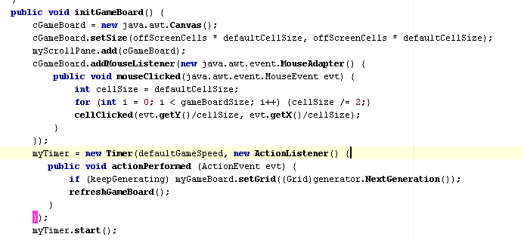

The above shows a snippet of the GameBoard class which holds the Timer class (method of implementing speed) containing a concrete observer component class called ActionListner whose subject is the GUI Components found in GameBoard. Now originally speed would have been included in Generation since essentially speed could be looked as a property of a generation or life cycle process. Implementing this could not be achieved as the Generation class would increase its responsibility: traversing the Grid aggregation and updating the subject class. Ultimately this redesign proves to better than the original as these properties are naturally separate. Space and time is a property of universe so is generation and speed is a property of the game board.

Actual Results
Both Generation and Grid now implement their respected interface allowing future upgrades on various concrete implementations. The iterator pattern applied to Generation and Grid provides the right amount of coupling between the aggregation of Cells and the coherence between the life generations processing of the cells. This is not only allows extendibility for future upgrades on how concrete grids and generation grids are defined but gives the application the desired maintainability during future modifications and extension.

Cell now contains a state pattern representing the two life form states as specified by Conway’s specification in conjunction to the added the colored state assignment specification. The original design drafted was implemented successfully. During the design stage much skepticism played in deciding to implement this pattern to state since a simple flag could be used however during actual results the binding function to change states proved to provide a much cleaner execution in terms of readability.

List of Bugs and Known Issues
Name of Bug / Issue | Comments
Creating an infinite grid | Rendering current GUI components used to build the grid UI.

References

The following shows the list of references used to help build the application and provide research references.

http://uvsc.freshsources.com/439R-Chapter2.ppt

http://en.wikipedia.org/wiki/Conway's_Game_of_Life

www.win.tue.nl/~wsinswan/javaID/voorbeelden/voorbeelden.html

legacy.drools.codehaus.org/Conway's+Game+Of+Life+Example

www.rennard.org/alife/english/logicellgb.html

www.cs.virginia.edu/cs201j/problem-sets/ps1/

http://today.java.net/pub/a/today/2005/05/03/midletUI.html?page=last

http://www.math.com/students/wonders/life/life.html

http://java.sun.com/j2se/1.5.0/docs/api/java/awt/Canvas.html

http://home.cogeco.ca/~ve3ll/jatutorf.htm

http://developer.mozilla.org/en/docs/Canvas_tutorial:Drawing_shapes

http://www.cs.virginia.edu/cs201j/problem-sets/ps1/

http://comsci.us/java/examples/awt/Canvas.html

http://www.bitstorm.org/gameoflife/

http://www.apl.jhu.edu/~hall/java/Swing-Tutorial/Swing-Tutorial-JPanel.html

Head First Design Patterns, Elisabeth Freeman (Author), Eric Freeman (Author), Bert Bates (Author), Kathy Sierra (Author)

Design Patter, Eric Gamma, Richard Helm, Ralph Johnson, John Vlissides

Appendix A

