Monday, January 22, 2007
BTP600

- Assignment Presentation Updates
- Notes
- Action Plan

1. PRESENTATION
- Formal citation (footnotes)
- Coding license, licensing attributions
- Comments → discussion link
  - Attribution in wiki is ~ ( X 4)

2, NOTES

Study group for studying patterns see link:
- with questions (investigate to apply principles to bbs study group)

Run-time binding
Recommended book → “Head First Design Pattern”

GoF
- Kent Beck → influenced by → Christopher Alexander
- Word Cunningham
- Grady Booch

Considerations when applying Patterns
- Maintenance
- Debug
- Extend

Chapter 1 – 2 – rational of design patterns
Chapter 3 – 5 Pattern Catalog
- Creational
- Behavior
- Structural

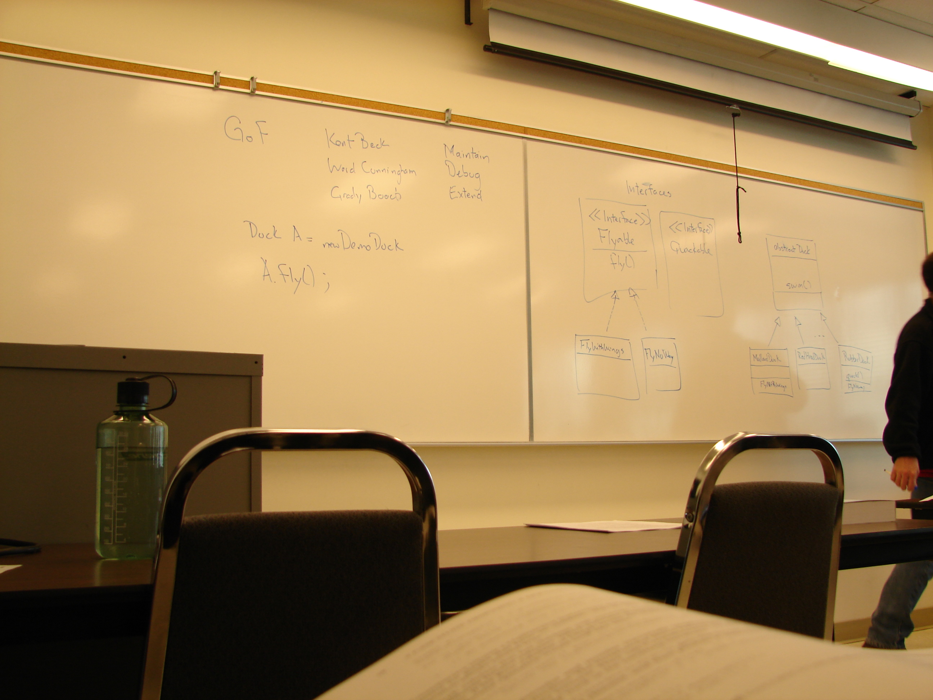Example from recommended book

Inheritance is not suggested

Principles
1. Prefer composition over inheritance (because issues in chain of hierarchy)
2. Program to interface not implementation
3. Identify aspects of your program and encapsulate them
4. Design for change
5. Delegation – ex. through composition

Dynamic Binding (late binding)

Duck A = new DemoDuck
A.fly()
A.setFlyBehaviour ( FlyWithWings fw )

Frameworks - .NET, visual studio, Java Applets (“you fill in the specifics → domain specifics)

How a specific pattern document is specified
- Identifier
- Problems
- Solutions
- Consequences

Pg 10. Table

“conceptual” class vs. object “implementation”

Considerations
Class
- inheritance
- subclass
Object
- dynamic binding
- polymorphisms

3.0 ACTION PLAN

- part 2, omt
- start Assignment 1

