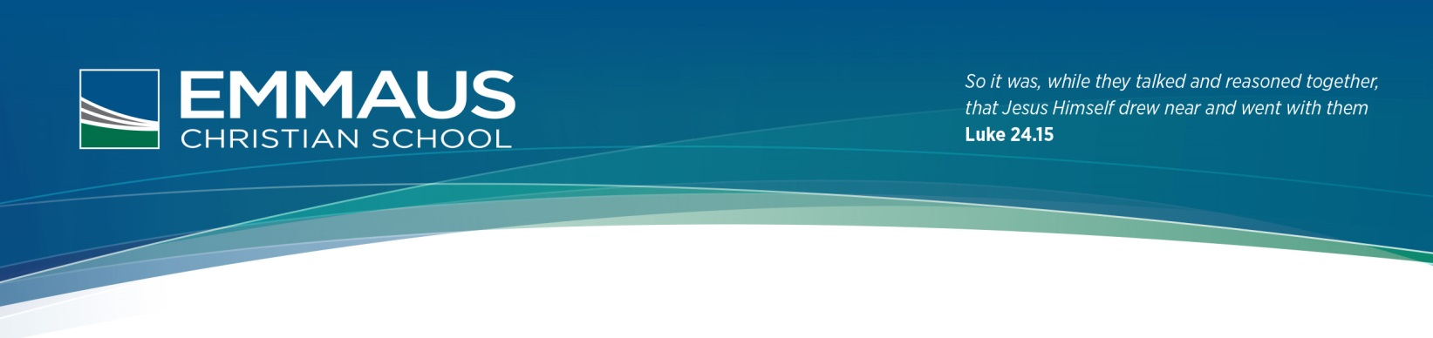

**Student Network and Technology Agreement 2016**

**(BYOD) 2016**

**Technology at Emmaus is provided for students’ educational purposes. The goal of our School is to create and maintain a cybersafety culture that is in keeping with the values of the School, and legislative and professional obligations.**

*The term ‘network and technology’ used in this document, includes, but is not limited to, Emmaus wifi network, internet access, computers (such as desktops, laptops, tablets, iPods), storage devices (such as USB memory devices, CDs, DVDs, iPods, MP3 players), cameras (such as video, digital, webcams), all types of mobile phones, gaming consoles, video and audio players (such as portable CD and DVD players), and any other similar technologies as they come into use. Any images or material on personal devices brought to school must be appropriate to the school environment.***Students are responsible for appropriate behaviour when using the School computer networks and technology, or any other network and technology when using the School’s name or any name or image of a member of the Emmaus community.**

**The following are prohibited:**Use of profanity, inappropriate language and any form of vilification or bullying.  
Use of another students account or device without their consent or knowledge.  
Reproduction of any material that is protected by copyright.

Access to any material that has been deemed inappropriate by the School.

Use of the names or images of student or staff members or of the School’s name on any private website without written permission of a member of staff.

Use of photographs or images of any member of the community without their permission.

***Illegal Downloads and Copying*:**Students are not permitted to download or install any software, commercial shareware or freeware onto network or local drives, USB drives, iPads or disks without the permission of the ICT teacher. It is a breach of the User Agreement to use the Emmaus wifi Network to download personal content such as music or movies, irrespective of whether or not his has been purchased.

Students should not copy other people’s work (Plagiarism) or attempt to access other student’s files.

**System Integrity:**Students should not engage in any activity that may affect the School network and technology. This would include reconfiguring desktop computers, laptops or iPad’s settings; disconnecting or removing cables or other parts of the network or technology in any room.

**Wider Internet Responsibility:**Students who sign this agreement are bound not to enter any information about the School or any members of the Emmaus community (students, staff, and parents) on ANY Internet Website without written consent. Failure to comply with this will constitute a breach of the School’s Network and Technology Policy. Students are obliged to report any cases of cyberbullying of which they become aware to the relevant Coordinator.

**Consequences:**Students breaching these guidelines will have their network and technology privileges restricted for an appropriate time and will be dealt with under the relevant sections of the School’s Policies. Parents will be notified in writing and a note of the breach will be kept on file. If illegal material or activities are involved, it may be necessary for the School to inform the police.

**Non-lodgement of this form:**Students who have not lodged this form will be denied access to the Schools network and technology. Such access is a privilege, not a right.

**✂**

**Emmaus Christian School Student Network and Technology Agreement 2016**

Student’s name (print)______________________________ Year ________ Homeroom Teacher: _____________

_________________________________________ _________________________________________ *Student’s Signature Parent’s Signature (Mother/Father/Other)*

*Date: Date:* **PLEASE SIGN AND RETURN TO YOUR HOMEROOM TEACHER**