User Stories

First Functionality (SearchOnAllLibraries)
As a User of the JabRef system, I want to be able to have multiple libraries, and search across all of them in a single search, so that I don’t have to search in each library.
The actors involved in the story are the user that wants to search on the libraries, and the database returning the element(s) according to the search.

Second Functionality (SearchByEntry)
As a User of the JabRef system, I want to be able to search by a certain type of entries, and I want to be able to add a certain time interval to my search, so that I can find certain types of entries, within a certain time period, in a single search.
The actors involved in the story are the user, and the database that will return the entries that we have according to our search.

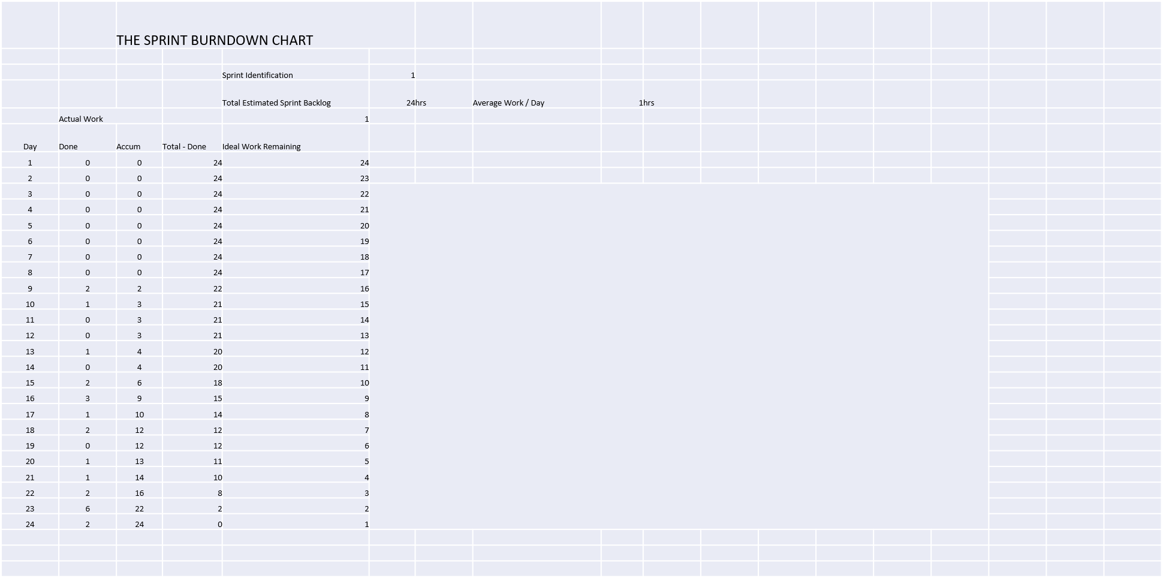

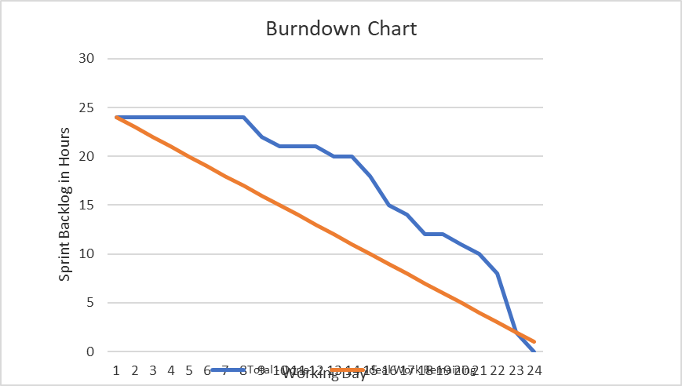

Link do vídeo da demonstração das funcionalidades
https://youtu.be/Ek64e-SwwFo

