Code Smells

Code smell 1:
Long Parameter List
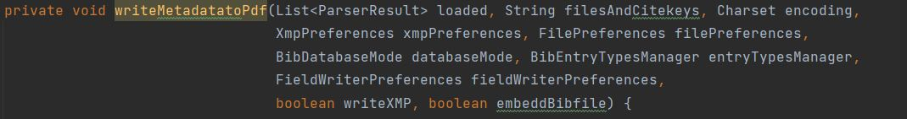
Located on line 275 of class Argument Processor, from path src/main/java/org/jabref/cli
Maximum of 7 parameters is advised for methods, this method has 9 parameters.
Refactoring: An auxiliary class containing the encoding(CharSet), filepreferences(FilePreferences), writeXMP(boolean) and embeddBibfile(boolean) and then having one object of that auxiliary class as a parameter would reduce the method’s parameters to 6 and the same information could still be accessed. Doing this would solve the same code smell (long parameter list) for methods writeMetadatatoPDFsOfEntry(line 309), writeMetadatatoPdfByFileNames(line 343), writeMetadatatoPdfByCitekey(line 330), which also have those 4 parameters in common.

Code smell 2:
Long Method
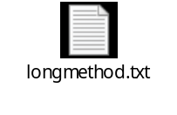
Located on line 181 of class Argument Processor, from path src/main/java/org/jabref/cli
Method with too many lines of code which makes it confusing and complex.
Refactoring: Some of the ifs could be on auxiliary methods (since there are many of conditions on this method), line 236 has a nested if which can be merged into a single if condition.

Code smell 3:
Message chain
Located on line 414 of class Argument Processor, from path src/main/java/org/jabref/cli
Code with structure similar to a typical message chain code smell, a.getB().getC().doSomething();
Refactoring: create instances before to minimize calls inside method.
By: Artur Lourenço 63764

