Design Patterns

Design Pattern 1:
Command
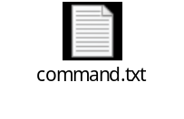
Located on path src/main/java/org/jabref/cli
It would be useful for when this class is called by class ArgumentProcessor (invoker) for us to store diferente commands so we can ‘redo’ them, since the same command may be rquested several times, or be held for later use. This also allows for a queue of commands to be executed in batch.

Design Pattern 2:
Factory Method

Located on path src/main/java/org/jabref/gui/maintain
We can identify this design pattern since we have a factory class that controls the class instanciation, replacing constructors, and abstracting the process of object generation so that the object instantiated can be determined at run-time.

Design Pattern 3:
Composite

Located on path src/main/java/org/jabref/gui/sidepane
The class SidePaneComponent and SidePane demonstrate the typical Component design pattern

By: Artur Lourenço 63764

