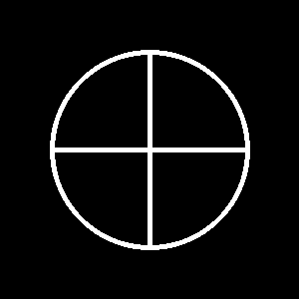
EMEGIR-ŠA WORLD ENCYCLOPEDIA

This document contains the full linguistic structure, phonology, morphology, syntax, and cultural role of the High Tongue of the Fracture...

