Final year project spec

Student name:

Student

H dip in com science

Waterford institute of tech.

Contents

1. Introduction. 3

1.1 Purpose. 3

1.2 Project Goals. 4

2. History and Research. 5

Hardware Overview. 9

3.1 Raspberry Pi. 9

3.2 DHT22 Temperature / Humidity Sensor. 10

3.3 Water Pump. 10

3.4 Luminosity Sensor. 10

3.5 Soil Moisture Sensor. 10

3. Software Overview. 11

4.1 Story Boards. 11

4.1.1 Start Screen. 11

4.1.2 Login Screen. 11

4.1.3 Register User Screen. 11

4.1.4 Splash Screen. 11

4.1.5 Main Screen. 11

4.1.6 Measurement Screen. 11

4.2 Flow Diagrams. 11

4.2.1 Start Screen. 11

4.2.2 Login Screen. 11

4.2.3 Register User Screen. 11

4.2.4 Splash Screen. 11

4.2.5 Main Screen. 11

4.2.6 Measurement Screen. 11

Figures

Figure 1 - Window Box Garden. 3

Figure 2 - Standard Project Block Diagram 4

Figure 3 - Super Intelligent Smart Garden 5

Figure 4 - Super Intelligent Smart Garden 6

Figure 5 - Outdoor IOT garden With Sensors 6

Figure 6 - Outdoor IOT Garden 7

Figure 7 - Homemade IOT Garden with water pressure sensors. 7

Figure 8 - Solar Powered IOT Garden. 8

# Introduction.

## Purpose.

The purpose of this document is to design a specification for a I.O.T Project, for a final year student studying Computer Science.

The whole initial idea was an I.O.T garden, where measurements like oxygen, carbon dioxide, soil moisture, sunlight and many more quantities can be stored in some type of database and then displayed to the user, I will hopefully also allow a user implement some type of watering / plant feeding timetable where the plants are fed at a certain time of day, or even allow the user a way of pressing a button to feed them.

I got the initial idea as my family sponsor cups in the Keep Kilkenny Beautiful gardening competition, but I have never won, I thought even starting a robotic garden would be an innovation.

Currently right now the project would not be outdoors, it would be all indoors but I could mimic the conditions.

Figure 1 - Window Box Garden.

## Project Goals.

The goal of this project is to have an automated garden where I can maintain the well being of a garden using the power of the internet of things and measure things like oxygen, carbon dioxide, and water plants using an android application.

The idea would be to interface the sensors to a raspberry pi, print them to a database (firebase) and then display the results in an app.

For example if I wasn’t happy with the level of moisture in the soil, I could press a button, the water pump would turn on and the flowers would get sprinkled with water.

I would also like a report where I could see the soil moisture, over a period of time, or even the oxygen and carbon dioxide produced in the area.

|  |  |
| --- | --- |
|  | |
| Figure 2 - Standard Project Block Diagram |  |

# History and Research.

There are many other projects available online, but a many of them a lot more advanced, the following image is where the user of the application can control the plants light source, my own project wont be that advanced although it should be able to measure and display moisture, oxygen, carbon dioxide, PH level, and have some type of water metering.

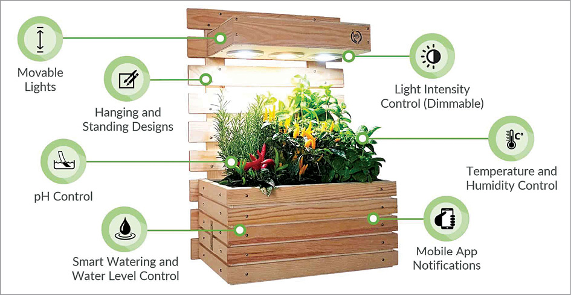

Figure 3 - Super Intelligent Smart Garden

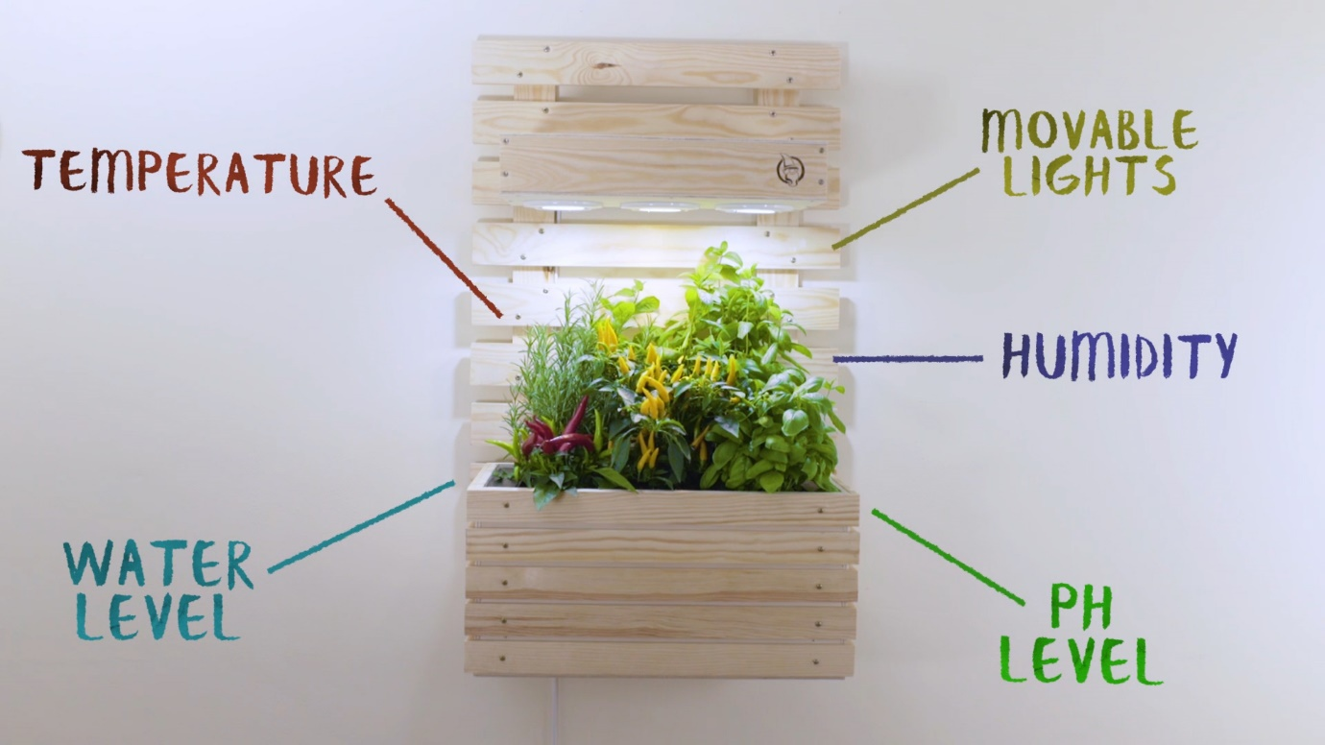

Figure 4 - Super Intelligent Smart Garden

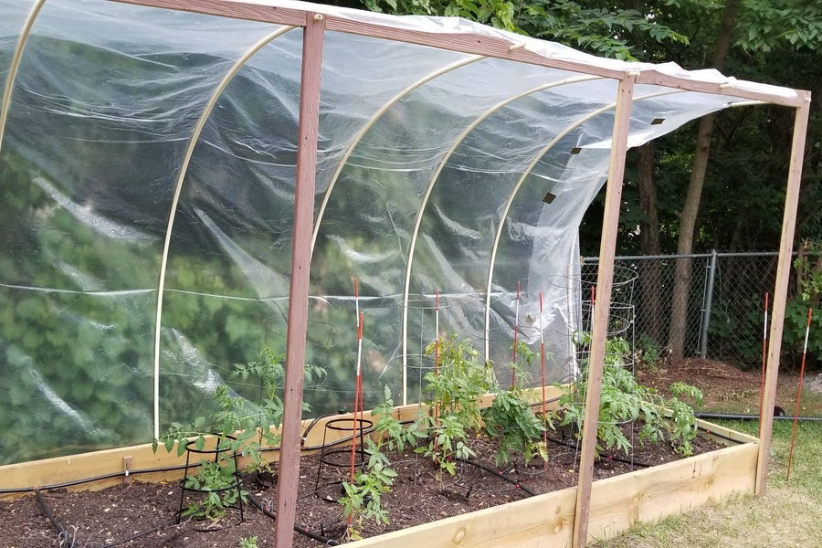

Figure 5 - Outdoor IOT garden With Sensors

Figure 6 - Outdoor IOT Garden

Figure 7 - Homemade IOT Garden with water pressure sensors.

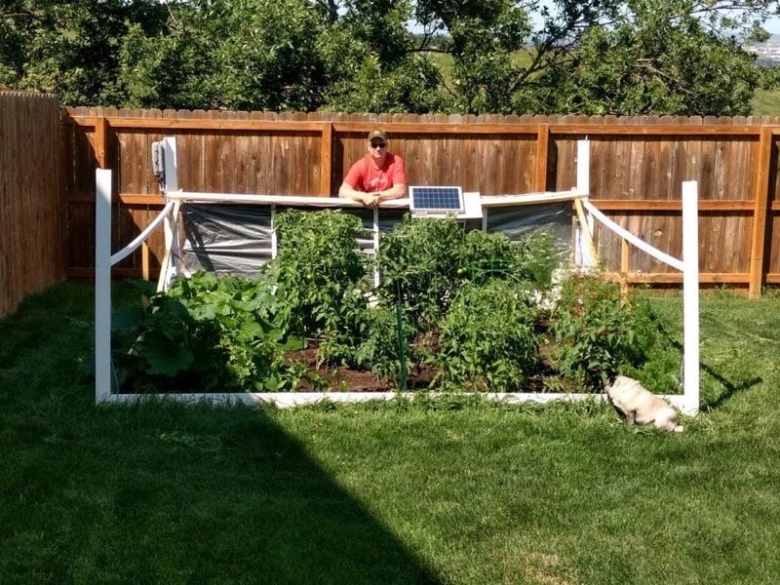

Figure 8 - Solar Powered IOT Garden.

# **3. Hardware Overview.**

## **3.1 Raspberry Pi.**

Raspberry Pi is a series of small single-board computers (SBCs) developed in the United Kingdom by the Raspberry Pi Foundation in association with Broadcom.

The Raspberry Pi project originally leaned towards the promotion of teaching basic computer science in schools and in developing countries.

The original model became more popular than anticipated, selling outside its target market for uses such as robotics.

It is widely used in many areas, such as for weather monitoring, because of its low cost, modularity, and open design.

It is typically used by computer and electronic hobbyists, due to its adoption of HDMI and USB devices.

After the release of the second board type, the Raspberry Pi Foundation set up a new entity, named Raspberry Pi Trading, and installed Eben Upton as CEO, with the responsibility of developing technology.

The Foundation was rededicated as an educational charity for promoting the teaching of basic computer science in schools and developing countries.

Sold units of the Raspberry Pi

The Raspberry Pi is the best-selling British computer.

As of May 2021, more than forty million boards have been sold.

Most Pis are made in a Sony factory in Pencoed, Wales, while others are made in China and Japan.

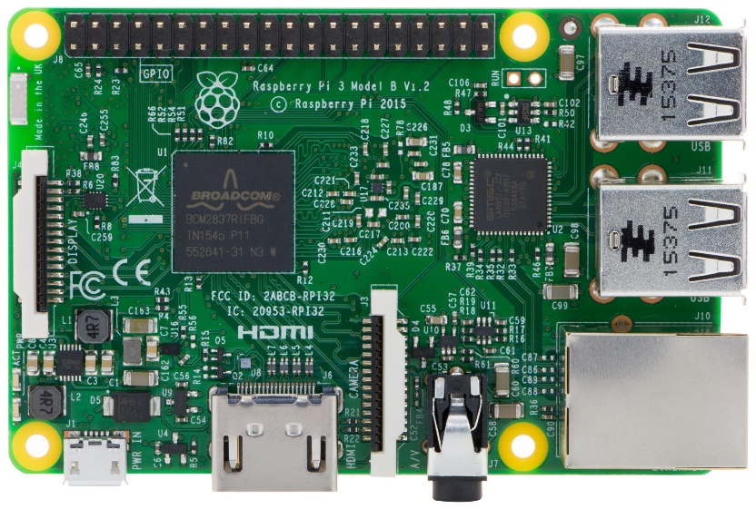

Figure 9 - Raspberry Pi Model.

## 3.2 DHT22 Temperature / Humidity Sensor.

The DHT22 is a basic, low-cost digital temperature and humidity sensor. It uses a capacitive humidity sensor and a thermistor to measure the surrounding air and spits out a digital signal on the data pin (no analog input pins needed). It's fairly simple to use but requires careful timing to grab data. The only real downside of this sensor is you can only get new data from it once every 2 seconds, so when using our library, sensor readings can be up to 2 seconds old.

Simply connect the first pin on the left to 3-5V power, the second pin to your data input pin, and the rightmost pin to ground. Although it uses a single wire to send data it is not Dallas One Wire compatible! If you want multiple sensors, each one must have its own data pin.

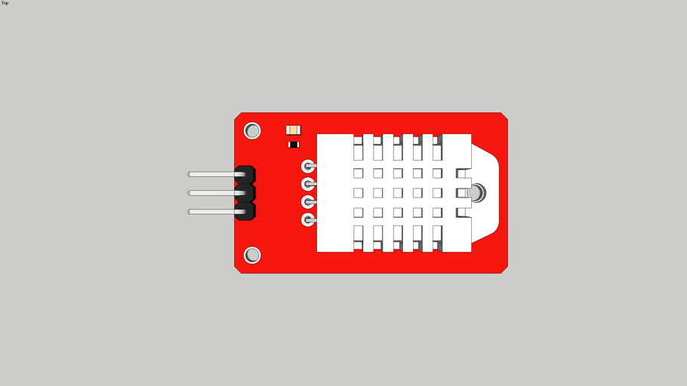

Figure 10 - Temperature And Humidity Sensor.

## 3.3 Water Pump.

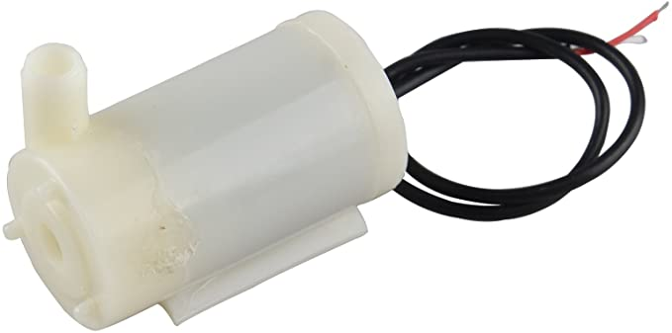

Figure 11 - Water Pump.

## **3.4 Luminosity Sensor.**

Figure 12 - Light Senor.

The TSL2561 luminosity sensor is an advanced digital light sensor, ideal for use in a wide range of light situations. Compared to low cost CdS cells, this sensor is more precise, allowing for exact Lux calculations and can be configured for different gain/timing ranges to detect light ranges from up to 0.1 - 40,000+ Lux on the fly. The best part of this sensor is that it contains both infrared and full spectrum diodes! That means you can seperately measure infrared, full-spectrum or human-visible light. Most sensors can only detect one or the other, which does not accurately represent what human eyes see (since we cannot perceive the IR light that is detected by most photo diodes).

## 3.5 Soil Moisture Sensor.

Soil moisture can be measured using a variety of different techniques: gravimetric, nuclear, electromagnetic, tensiometric, hygrometric, among others [read about the specifics types of soil moisture sensors here]. The technique explored here uses a gravimetric technique to calibrate a capacitive-type electromagnetic soil moisture sensor. Capacitive soil moisture sensors exploit the dielectric contrast between water and soil, where dry soils have a relative permittivity between 2-6 and water has a value of roughly 80 [find more specific values here]. Accurate measurement of soil water content is essential for applications in agronomy and botany - where the under- and over-watering of soil can result in ineffective or wasted resources. With water occupying up to 60% of certain soils by volume, depending on the specific porosity of the soil, calibration must be carried out in every environment to ensure accurate prediction of water content [more on this here]. Luckily, the accuracy of measurement devices has been increasing while the cost of the sensors have been decreasing. In this experiment, an Arduino board will be used to read the analog signal from the capacitive sensor, which will output voltage values which can be calibrated to volumetric soil moisture content via gravimetric methods (using volume and weight of dry and wet soil).

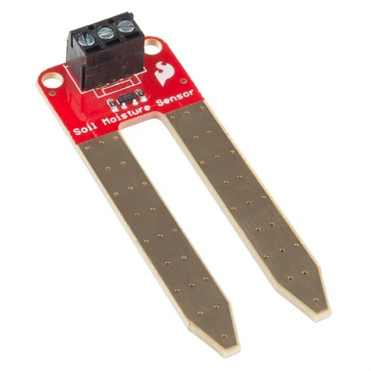

Figure 13 - Moisture Sensor.

# **Software Overview.**

## **4.1 Story Boards.**

### **4.1.1 Start Screen.**

This is a standard start screen, the user is given the option to sign up or login screen depending on which button they press.

**LOGIN BUTTON**

**SIGNUP BUTTON**

### **Login Screen.**

This is a standard login screen the user must enter their username and password and they must be correct in order for the user to proceed.

**REGISTER BUTTON**

**LOGIN BUTTON**

**PASSWORD TEXT FIELD**

**USERNAME TEXT FIELD**

Once the user hits the login either of 2 errors can occur if there is a mistake, the user is then given the option to register.

**USER DOES NOT EXIST**

**INCORRECT PASSWORD**

### **Signup User Screen.**

### **Splash Screen.**

### **Main Screen.**

### **4.1.6 Measurement Screen.**

### **Graph Screen.**

## **4.2 Flow Diagrams.**

### **4.2.1 Start Screen.**

### **4.2.2 Login Screen.**

### **4.2.3 Register User Screen.**

### **4.2.4 Splash Screen.**

### **4.2.5 Main Screen.**

### **4.2.6 Measurement Screen.**

1. Project Timeline.
2. Project Handover.
3. Conclusion.