TJ Guthrie
CpE670: Switching Circuit Theory
Fall 2013
Designing Circuits Using Genetic Algorithms

Question 01: What is the structure of the genes within a chromosome?
Answer: The genes in the chromosome are contained in the cell object. The cell object contains two strings and one integer for a total of three genes per cell. The integer gene represents the gate type or function where the gate can have a maximum of two inputs. The two string genes represent the two possible inputs to the gates. The output of a function is always taken from the first row, last column of the chromosome. If there is more than one output the next output is taken at the next row, last column. The structure of a cell is shown below:

Cell Structure

Question 02: How many genes are in each chromosome?
Answer: The amount of genes in each chromosome is determined by the size of the circuit or chromosome. The size of a chromosome depends on the parameters numRows and numCols which represent the number of rows and columns in the array of cells respectively. Below is an equation to calculate the number of genes within each chromosome:

Number of Genes Equation

Question 03: How are the genes encoded (binary or integers)?
Answer: The gene input01 is encoded in a string, the gene input02 is encoded in a string, and the gene gate function is encoded as an integer.

Question 04: What is the size of individual genes?
Answer: The size of input01 and input02 can range from one to two characters depending on what column the gene is located in the chromosome. If the gene is in the first column the size is one character(16-bits), if the gene is in the second column the size of the gene is two characters (32-bits). The size of the gene gate function is always one integer (32-bits).

Question 05: What is the range of values for each gene?
Answer: The range of values for the genes input01 and input02 in the first column are dependent on the number of inputs. If there are 3 inputs the possible values are A, B, and C. If there are 4 inputs the possible inputs are A, B, C, and D. If there are 5 in puts the range of possible values are A, B, C, D, and E. The value A is always the most significant bit. The value C, D, or E is the least significant bit depending on the number of inputs.

If input01 or input02 are in any other column but the first the possible values for the gene can be “any valid row” + “current column – 1”. The input to the gate can only come from any row in the previous column of the gate. For example if the cell was in the location (0,3) in a 4x4 chromosome the valid ranges are 02, 12, 22, and 32 for either input gene.

The gate function genes possible values are 0-7. The representation of the values are shown below:

Representation of Gate Values

Question 06: How is your fitness function defined to (a) implement the correct function, (b) minimize gate delays, (c) minimize the number of gates?
Answer: The fitness function is shown below:

Fitness Function

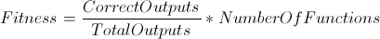

CorrectOutputs = Number of correct outputs for a singe function
TotalOutputs = Total number of outputs for a single function
NumberOfFunctions = Total number of functions

The genetic algorithm will stop when a correct circuit is generated. The fitness of a chromosome can determine if the circuit is 100% fully functional. It has nothing to do with minimizing gate delays or minimizing the number of gates. To minimize gate delays the dimensions of the chromosome should be changed. The gate delays depends on the number of columns in the circuit. The lower the number of columns the lower the gate delay excluding the WIRE function. Each cell represents a gate so to minimize the number of gates we can minimize the number of cells by changing the dimensions of the circuit.

Question 07: Define the library of gates and the type of connections used in implementing your design.
Answer: The library of gates are shown in Question 05 in the table “Representation of Gate Values”. The types of connections are also described in Question 05. When the gate function is a wire only input01 is connected. When the gate function is an inverter only input01 is connected.

Question 08: Define your GA parameters – initial population size, selection method of individuals in the population to perform crossover, crossover method, crossover rate, mutation method, and mutation rate.

Answer: All GA parameters are defined in designCircuit.java and can be changed. The initial population size was set to 150 and is consistent after each generation of the population. The population size can be changed by changing the variable populationSize.

The selection method used to select individuals for crossover was tournament selection. In tournament selection a random subset from the population is chosen and the most fit individual is selected from that subset. The parameter tournamentSize will change the size of the subset.
The cross over method used was single point crossover with limitations on where the point can be selected. In single point cross over a point is selected randomly. Every gene from the left of the point , excluding the point comes from parent01, every gene from the right of the point including the point comes from parent02. The point selected can be any row, column location where the column and row are not the first or the last in the chromosome. This limitation prevents the child being a duplicate of either parent. Two parents are selected using tournament selection and two children are produced, the most fit child is added to the population while the least fit child is discarded. By the end of the generation the maximum children produced is populationSize/2. The amount of children produced is depended on the cross over rate which can be changed by changing the crossoverRate variable.

Once the child is produced it can be selected for mutation. The chance of mutation is dependent on the mutation rate and can be changed by changing the variable mutationRate. Mutation can only occur after a child has been produced. When mutation occurs a random cell is chosen from a single chromosome. A random gene is chosen from the random cell selected. That gene is mutated and is guaranteed to change at the end of mutation. Only valid genes are produced from mutation. For example if the gate function gene was selected and contains a value of 3, only values 0 through 7 are valid excluding 3. As another example consider the case where the gene selected is input01 or input02 and the value is 13. 1 is the row and 3 is the column. The column can not be changed and the row can be changed to any value from 0 to number of rows – 1 excluding row 1.

Question 09: After the GA converges and produces a solution, clearly show by means of a diagram how that solution is decoded. Specifically show the types of gates used and how that gates are interconnected. Show this for each example.
Answer: Six test cases were selected.

1)
Problem:
Inputs: Number of Inputs = 3,
Number of Outputs = 1
Minterms Function01 = 1,3,5,7

Solution:
Time (Total CPU Time): user + sys = 0m0.204s + 0m0.019s = 0m0.223s
Generation: 1
Fitness: 1.0

Representation:
BB2 10000
CC2 00103

Circuit:

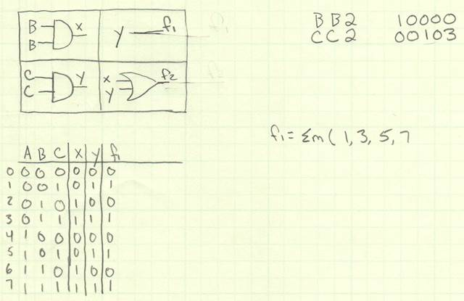

2)
Problem:
Inputs: Number of Inputs = 3,
Number of Outputs = 2
Minterms Function01 = 0,2,4,6
Minterms Function02 = 1,3,5,7

Solution:
Time (Total CPU Time): user + sys = 0m0.290s + 0m0.018s = 0m0.308s
Generation: 2
Fitness: 2.0

Representation:
AB1 10000
CB1 10101

Circuit:

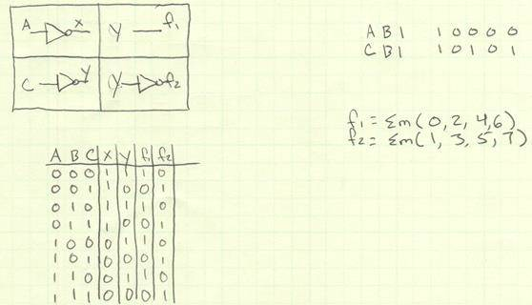

3)
Inputs: Number of Inputs = 3
Number of Outputs = 1
Minterms Function01 = 0,7

Solution:
Time (Total CPU Time): user + sys = 0m0.566s + 0m0.029s = 0m0.595s
Generation: 30
Fitness: 1.0

Representation:
BC4 20202 11016
CA0 00000 11016
AC4 20105 01215

Circuit:

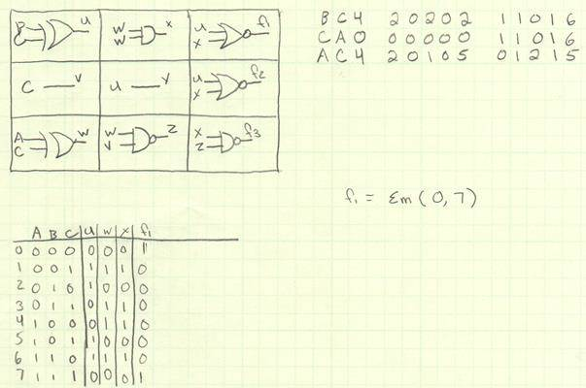

4)
Problem:
Inputs: Number of Inputs = 4,
Number of Outputs = 1
Minterms Function01 = 3,8,12,15

Solution:
Generation: 3709
Time (Total CPU Time): user + sys = 0m14.177s + 0m0.612s = 0m14.789s
Fitness: 1.0

Representation:
CD7 10207 01116
CB5 00201 21210
AC7 20202 11012

Circuit:

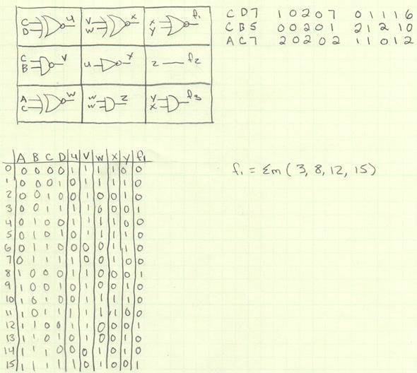

5)
Problem:
Inputs: Number of Inputs = 4,
Number of Outputs = 3
Minterms Function01 = 0,1,4,5,8,9,12,13
Minterms Function02 = 3,6
Minterms Function03 = 4,7

Solution:
Generation: 12357
Time (Total CPU Time): user + sys = 5m44.250s + 0m3.820s = 5m48.070s
Fitness: 3.0

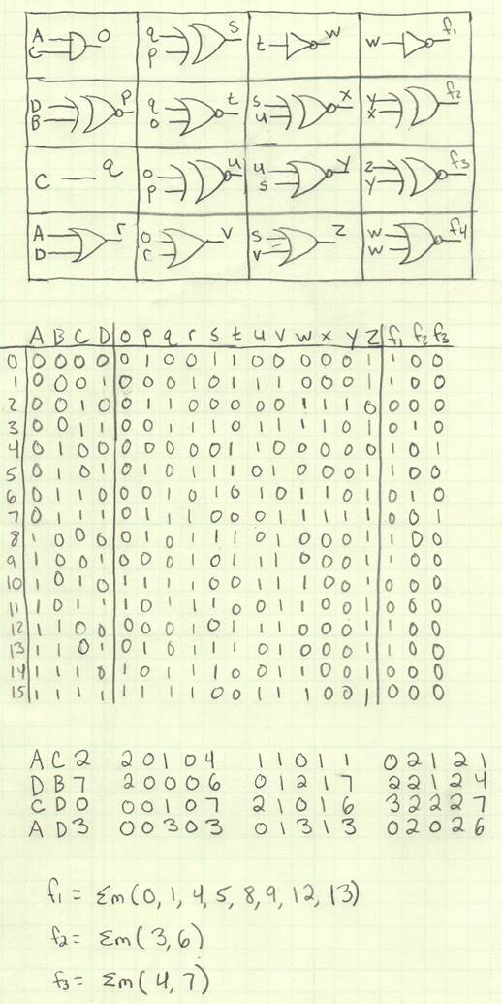
Representation: Circuit:
AC2 20104 11011 02121
DB7 20006 01217 22124
CD0 00107 21016 32227
AD3 00303 01313 02026

6)
Problem:
Inputs: Number of Inputs = 5,
Number of Outputs = 1
Minterms Function01 = 0,1,6,7,26,27,28,29

Solution:
Generation: 205
Time (Total CPU Time): user + sys = 0m5.676s + 0m0.568s = 0m6.244s
Fitness: 1.0

Representation: Circuit:
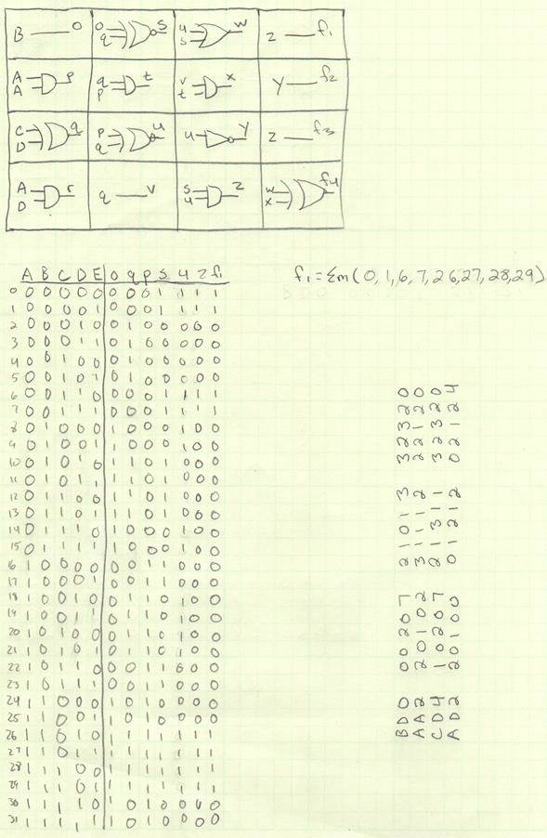
BD0 00207 21013 32320
AA2 20102 31112 22120
CD4 10207 21311 32320
AD2 20100 01212 02124

Question 10: Verify the GA produced the correct logic function based on the truth table initially defined.
Answer: See Circuit section of question 09

Question 11: Document the average time taken to produce a solution.
Answer: From the times in Question09

Question 12: Document the average number of iterations taken to reach a solution.
Answer:

Question 13: Show examples of 3 variable, 4 variable, and 5 variable functions implemented. Include single and multiple output functions.
Answer: See Question09.

Question 14: Use the same design examples shown in the paper to compare your solution with the solutions shown in the paper including the number of gates with the traditional logic function design.
Answer:

Problem: f(x,y,z) = !xyz + x!yz + xy!z

Genetic Algorithm Solution:

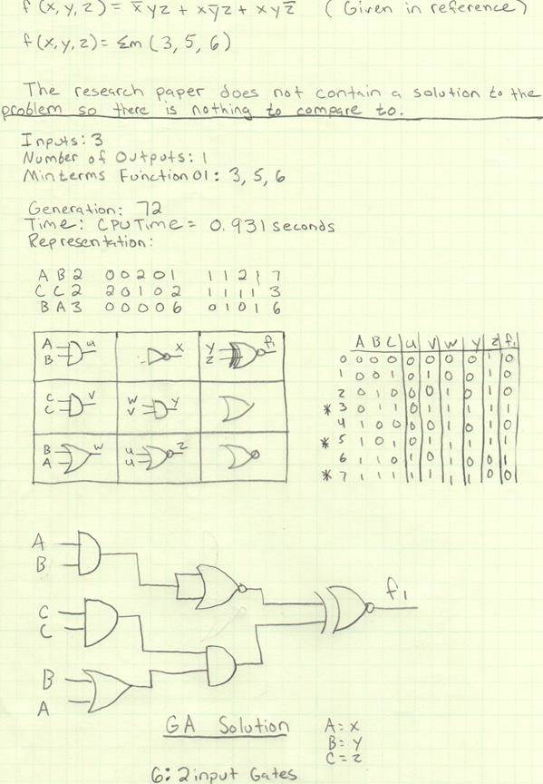

Human Designer Solution:

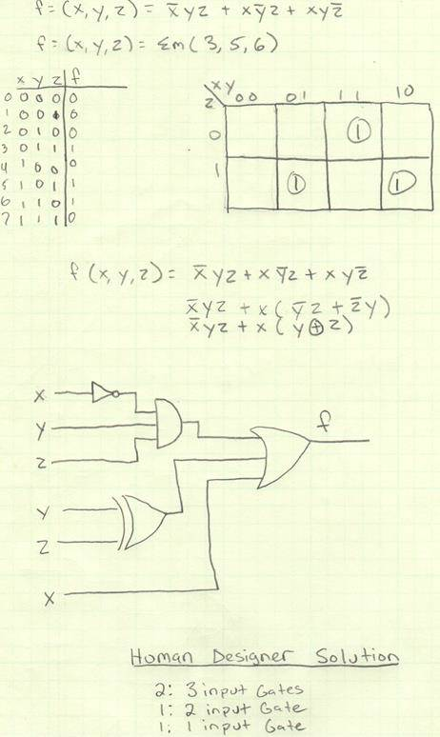

References

Combinational Circuit Design Using Evolutionary Algorithms
Ahmed T. Soliman and Hazem M. Abbas

http://ieeexplore.ieee.org.www.libproxy.wvu.edu/stamp/stamp.jsp?tp=&arnumber=1226389

