The Impact of Employment Protection Legislation on Unemployment in OECD Countries: A Meta-Analysis

Georgios P. Giotis and Michael Chletsos

Abstract
The role of labor market institutions and policies on the pattern of public policy has always been one of the most important issues in economic history. In this paper we investigate the effect of one of the tools of social policy, the employment protection, using meta-analysis methods. Our meta-sample combines the results of 74 empirical studies from OECD countries which generated 866 estimates. The analysis shows that once publication bias is corrected only a very small positive effect of employment protection on unemployment rate remains.

JEL Classification: J52, J21, J88, C01.
Keywords: Employment protection, Employment, Labor market policies, Meta-analysis.

- Introduction
The effect of labor market institutions and policies on the pattern of public sector reforms in almost all countries has always been a very important issue. For example, recently, in Greece the new government (SYRIZA) is already making waves towards the direction that Greece's minimum wage will be hiked by 10%, to about €750 per month from about €680. In addition, the National Confederation of Greek Commerce (ESEE) appeared supportive toward the newly elected Greek government’s proposal to gradually restore the country’s minimum wage to 751 Euros and estimated that such a development will significantly boost consumption, benefit turnovers and increase employment in the troubled Greek market.
In labor economics literature, many economists such as Nickel (1997) and Blanchard and Wolfers (2000) suggest that the differences in the labor market institutions and the labor market regulations which are designed to form the appropriate labor market policy, can explain the differences in unemployment rates among countries. More specifically, the protection of employment status, the regulation on the unemployment benefits, the power of the unions, the level of the minimum wages and other institutions in the labor market, can affect the level of employment and account for the variability of unemployment rates.
The purpose of this paper is to investigate the impact on unemployment rates of one of these tools of public and social policy, the employment protection, which has gained growing attention since the early 90’s (Lazear, 1990). However, whether employment protection has any effect on unemployment is an issue of disagreement in either the theoretical or empirical studies of the related literature. Basic economic theory suggests that, stricter employment protection reduces the propensity to hire by employers, since they fear that such decisions will not be easy to reverse in the future, for example during economic downturns. On the other hand, employment protection also leads firms during downswings to keep more workers employed, than they would have otherwise done. Therefore, employment protection reduces both job creation and job destruction, so that the net effects on unemployment are not a priori known.
In our research we did not find any meta-analysis study to investigate the impact of employment protection on unemployment despite the relative literature being large. In literature, there is great variability in the dependent variables used in the empirical studies since studies use employment-to-population ratios, labor force participation rates, job allocation, hours worked, employment rates, relative employment and many other employment measurements. In our analysis we chose to select only those studies which reported the effect of an employment protection legislation index to unemployment rates which kept the meta-sample homogeneous.
Our meta-sample consists of 74 empirical studies which reported at least one estimate and generated 866 estimates to perform our analysis. It has to be noted that for this preliminary version of the paper we used the coefficients but they will be replaced by the partial correlations once the coding of the studies finishes. Our preliminary findings indicate that employment protect has a positive effect on the unemployment rates but it very small that is of no practical significance.
The layout of this paper is as follows: firstly, we present the previous literature on the effect of employment protection on unemployment Secondly, we refer to the employment protection legislation and the way this index is constructed. We then describe the identifying and coding of the meta-analysis data. Thereafter, we report the preliminary results of our analysis (funnel graphs and FAT-PET tests) and then we present the moderators which will be used in the multivariate meta-regression analysis based on the studies of our sample. We close this paper with concluding remarks of the paper.

- The employment protection legislation (EPL legislation)
We would say that the employment protection legislation (EPL) is a multidimensional index which is quite difficult to quantify as it includes several types related to employment protection measures, such as firing (e.g. worker’s right to appeal against his lay-off, requirements for dismissals and redundancy procedures), hiring, collectively bargained conditions during employment, rules in favor of disadvantage groups, temporary employment protection terms or training rules. Furthermore, the protection of employment can be provided by several institutions of social and labor policy apart from the governments such as the trade unions, the unions of the employers, the collective bargaining arrangements (if they exist). Therefore this legislation has many dimensions but it is undoubtedly essential to be formed in an efficient way in order to create better working conditions characterized by cooperation and respect from all sides of the employment status which will be beneficial for both parties (employers and employees).
In literature many forms of set regulations can be found with the most but basically recent research employ the indexes elaborated by the OECD. More specifically, the methodology for the formation of these indicators of strictness of employment protection is based on 21 basic items classified into three main areas: a) protection of regular workers (against individual dismissal), b) regulation of temporary employment and c) specific requirements for collective dismissals. The scale that counts the strictness is measured from 0 to 6 with higher value representing more strict regulation. The most stringent restrictions for the dismissal of “permanent” workers in 2013, according to the OECD indicator, are found in Germany, Belgium and the Netherlands and follow France and Italy. On the other hand the least strict regulations are found in New Zealand, the USA, Canada and the UK.
Most theoretical analyses of EPL have focused on many aspects. Firstly, on its effect on the duality of the labor market, according to which the EPL divides the labor market to the insiders who have their job more protected and the outsiders who are mostly employed with a fixed-term or temporary contract. Secondly, employment protection can affect the firm’s productivity since stricter employment protection mean more difficulty in firing and therefore increased probability to shirk, but it may also increase productivity by strengthening the workers' incentives to invest in this firm to move higher to the hirocky in the firm that is employed. Moreover, the firm can invest in the skills of its employees and make them more productive and, in addition, it avoids firing costs.
Another factors regarding the labor market which is found to be affected by the employment protection legislation in the literature is the level of wages. Lazear (1990) found that (in a perfect labor market) severance payments can have no real effects in the existence of a properly designed labor contract which can undone this higher cost. Leonardi and Pica (2006) suggest that an Italian employment protection reform caused the reduction of entry wages, suggesting that firms tend to transfer the increase in the cost of firing onto the workers themselves, providing support to Lazear’s initial claim.
However, most of the empirical literature on employment protection legislation has been conducted on the effect on employment and unemployment expressed by both theoretical and empirical studies. From a theoretical point of view a stricter EPL provides a motive to firms not to employ a formal employee and workers would be positively affected by stricter EPL in the condition that it enhances their job security, provided that they are willing to accept lower wages. In this case, the effect of a stricter employment protection is not a priori known on the formal employment. They results of the studies reveal that the sign of the effect of employment protection on unemployment rate is not certain and it is expressed by conflicting empirical findings. In the next section we present a brief review of the literature on the effect of EPL on unemployment which will be enriched in an updated version of the paper.

- Literature review on the employment effect of EPL
The employment protection is a multidimensional set of regulations. It is an indicator of the general strictness of regulation on dismissals and the use of temporary contracts and shows the strength of the legal system regulating hiring and firing. High values are associated with countries having a high degree of employment protection, while low values indicate relative ease in dismissing employees. The name of this index itself implies protection of the employment. But does it actually protect employment? Is this result solidified by the findings of the empirical studies?
In general, employment protection legislation has been debated during the last two decades with contradictory empirical results. The literature on this issue is quite large in the borders of a country but also in cross-country studies. Relative recently, a survey by Skedinger (2010) includes over one hundred references on this topic and a more recent one by OECD (2013) includes 149 references, driven by the interest to explain the increasing unemployment rates which European countries face since the beginning of the 21th century.
The relative literature began in the late 1980s in an attempt to explain the increasing and in some cases high and persistent unemployment rates in the European countries. Lazear (1990) noted that the impact on labor costs may be offset through bargaining, which could weaken or eliminate the adverse effect on employment. Until then, and especially since the beginning of the millennium, a large literature can be found on the employment effect of protection legislation and this issue is quite controversial in the findings.
Since 2000 researchers have tried to investigate the impact of the components of EPL on employment using different structures of data. The majority of the studies use panel data while some studies use time-series and only a few are based on cross-section data. Apart from studies related to the effect of EPL on employment in a single country they are many studies which use cross-country evidence. For a review of studies see OECD (2004) and McLeon (2010).
In table 1 we present some of the studies which investigate the effect of EPL on unemployment rates with some basic characteristics and their findings.

Table 1. Some empirical studies on the effect of EPL on unemployment rate
Author and year | Title of the study | Sample | Results
Addison et al. (2000) | The Effect of Dismissals Protection on Employment: More on a Vexed Theme. | 20 countries;  1956-1984 | Employment protection is statistically insigniﬁcant.
Blanchard and  Wolfers (2000) | The Role of Shocks and Institutions in the  Rise of European Unemployment: The Aggregate Evidence | 20 OECD countries;  1960-1999; 8 ﬁve-year averages of data | The authors find that shock-EP interaction terms point to ampliﬁcation of the effects of adverse shocks
Botero et al. (2004) | The Regulation of Labor | 85 countries | Positive effect on unemployment rate
Di Tella and  MacCulloch (2005) | The Consequences of Labor Market Flexibility. Panel Evidence Based on Survey Data | 21 OECD countries:  1984-1990 | The association between  ﬂexibility and the unemployment rate is negative but not always significant
Elmeskov (1998) | Key Lessons from Labor Market Reforms: Evidence from OECD Countries’ Experience | 19 OECD countries;  1983-1995 | Employment protection raises structural unemployment
Feldmann (2008) | Business Regulation and Labor Market Performance Around the World | 74 countries;  2000-2003 | Labor market regulations increase unemployment
Kugler (1999) | The impact of ﬁring costs on turnover and unemployment: Evidence from the Colombian labor market reform | Colombian National  Household Survey | The exit hazard rates into and out of unemployment  increased after the reform by over 1% for formal workers (covered by the legislation) relative to informal (uncoverde)
Kugler (2004a) | The Effect of Job Security Regulations on Labor Market Flexibility: Evidence from the Colombian Labor Market Reform | Colombian household data on employment;  1988, 1992, 1996 | Reform contributed to about 10% of the reduction  in the unemployment rate between the pre and post reform periods.
Miles (2000) | Common law exceptions to employment at will and US labor markets | US panel from 1965 to 1994 | The exceptions to employment are seen to have no effect on aggregate employment nor unemployment.
Nickell (1997) | Unemployment and Labor Market Rigidities: Europe versus North America | 20 OECD countries;  1983-88 and 1989-94 | The effect of employment protection effect is negative on unemployment but statistically insigniﬁcant.
Pages and  Montenegro (2007) | Job Security and the Age-Composition  of Employment: Evidence from Chile | Chilean annual household surveys form 1960-1998 | Job security does not have a signiﬁcant impact on unemployment rates
Scarpetta (1996) | Assessing the Role  of Labour Market Policies and Institutional  Settings on Unemployment: A  Cross-Country Study | 17 OECD countries;  1983-1993 | Employment protection increases unemployment rate.

- Identifying studies and coding of the meta-data
The process of the searching, coding and identification of the studies which constitute the meta-sample is the first but very important step in the meta-analysis and we follow the guidelines as outlined in Stanley et al. (2013). The studies in our meta-sample were found using the search machine Google Scholar, the economic databases Econlit, Sciencedirect, RePEc and JSTOR. The main keywords used in the search were “employment protection” and “labor market institutions” as well as other several flections as keywords.
Regarding the identification of the studies, our objective was to find those studies which investigate the effect of an employment protection index on unemployment rates only. In the relative we found several employment measures but we chose to exclude those studies which used an employment measure other than the the unemployment rate. In this way the genuine effect will be more robust and the coefficient of the PET test more measurable with respect to the effect of the strictness of labor regulation on the unemployment rate.

Moreover, we excluded those studies which use a binary dependent variable, reporting employment probabilities from logit or probit estimations. In this way, many studies may have been excluded, but we kept the meta-sample more homogeneous. Another aspect worth mentioning is that we use coefficients in this preliminary analysis but as soon as the coding of the studies with their moderators finished will be replaced by the partial correlations which are considered more stable. Our meta-sample consists of 74 studies which generated 866 estimates. These estimates are presented in funnel graphs (figures 1 and 2) which are the simplest and most commonly used method to detect publication selection. A funnel graph is a scatter diagram of all empirical estimates and their estimates’ precisions (i.e. the inverse of the estimates’ standard errors, 1/SE). The graphs look somewhat symmetric which not as a surprise since 430 estimates are negative, 431 are positive and 3 are zero. However, that these graphs are considered to be quite vulnerable to misjudgments and subjective interpretation and criticism, so in order to test the hypothesis of presence of publication biasness, we have to use the FAT-PET test presented in the next section.

Figure 1. Funnel graph (n=866)
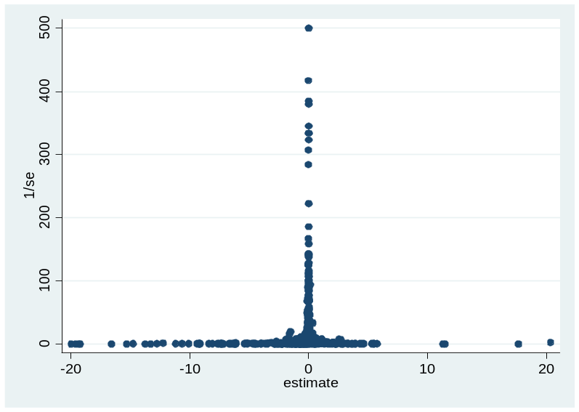
Figure 2. Funnel graph (n=843). 23 estimates were dropped out as outliers.
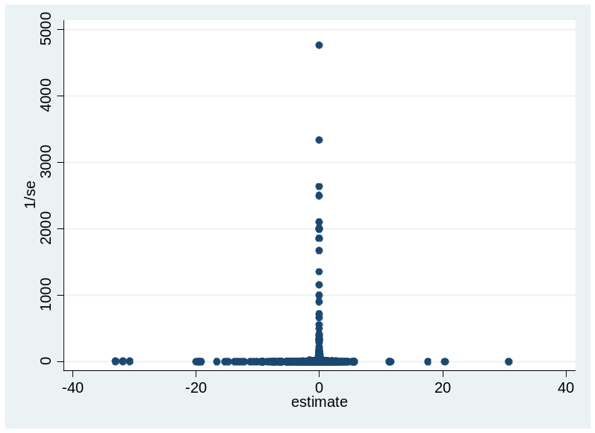

- FAT-PET tests
The tests presented in this section are nothing more than two tests of publication bias and authentic effect, respectively. The FAT test is a Funnel Asymmetry Test and estimates equation (1) below with the assumption that all the β₁ are zero, meaning that there is no heterogeneity. In other words, it is t-test of β₀. On the other hand, the PET test is a Precision Effect Test of β₁ and it tests the genuine or authentic effect, beyond publication bias.
t_{i} = β₀ + β₁(1/SE_{i}) + v_{i} (1)
where, t is the t-statistic of the elasticity of the i study, SE is the standard error of the elasticity and v is the error term.
In order to identify if there is publication bias in the meta-sample we follow Stanley et al. (2008) and Efendic et al. (2011) and we estimate equation (1). The results are presented in table 1 and do not indicate presence of publication bias apart from the WLS estimation.
As far as the precision of the estimated empirical effect (i.e. 1/SE) is concerned, we performed the PET test, which shows that there is evidence of positive effect of employment protection on unemployment rate. This finding holds for all the estimation methods and is statistically significant. However the magnitude is very small which implies that the positive effect of employment protection on unemployment is so small that is of no practical significance.
However, like in any regression model, the estimates of FAT-PET tests can become biased when important explanatory variables are omitted. Therefore the previous model in equation (1) should include moderator variables that explain variation in the estimates. For this reason the results of the FAT-PET tests should be treated with caution and without making strong and definite conclusions. In the following section we plan to incorporate in our analysis controllers that take into account the study heterogeneity.

Table 1. Funnel Asymmetry Test (FAT) and Precision Effect Test (PET). (n=866)
 | OLS | OLS-cluster | REML | FE | WLS
1/SE | 0.0018884**  (2.31) | 0.0018884**  (2.26) | 0.0018834**  (2.27) | 0.0018835*  (1.71) | 0.0009348***  (8.93)
Constant | -0.4004946  (-1.60) | -0.4004946  (-0.84) | -0.3919488  (-1.52) | 0.9493228  (0.97) | 1.224165***  (5.25)
R-squared | 0.0061 | 0.0061 | 0.48% (Adjusted) | 0.4531 | 0.0845

- Multiple MRA analysis
The coding of the studies is ongoing. The moderators planned to be used for the MRA analysis are the following:
Table 2. Moderator variables for meta-regression analysis.
Moderator variable | Definition
1/SE | the inverse of the standard error of the partial correlation
EPL measure
OECD | If study uses OECD index
EPR | If study uses employment protection for regular workers
EPT | If study uses employment protection for temporary workers
FIRING | If study uses firing index
HIRING | If study uses hiring index
Labor market controllers
LMI | If study uses another labor market institution (e.g. trade union, active labor market policies) as controller
HCOST | If study uses a hiring cost variable (e.g.minimum wage or tax wedge) as controller
WAGE | If study uses wage setting institutions (e.g. coordination, or bargaining) as controller
Country moderator
USA | = 1, if estimate comes from USA
EUROPE | = 1, if estimate comes from a European country
OECD | = 1, if estimate comes from a panel of OECD countries
Structure of data
Panel | = 1, if estimate relates to panel data with cross-section as the base
TSERIES | = 1, if estimate relates to time-series data with cross-section as the base
Group related
Teens | = 1, if estimate relates to teenagers
Youth | = 1, if estimate relates to youth
Males | = 1, if estimate relates to males
Females | = 1, if estimate relates to females
Specification controllers
ENDOG | = 1, if estimate come from a methods that deals with endogeneity
DLAGGED | =1, if estimate employs lagged dependent variable
AVEYEAR | the average year of the time period that is used to estimate each elasticity
TIME | = 1, if time-speciﬁc ﬁxed effects are used
FE | = 1, if country/state/industry ﬁxed effects are used
Quality
PUBLISH | =1, if the elasticity comes from a study that has been published in a journal

We will then taking into account the study heterogeneity, following Adam et. al. (2013) including the moderator variables and we will estimate the equation:
t_{i} = β₀ + β₁(1/SE_{i}) + 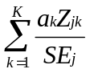 + v_{j} (2)
Where, t is the t-statistic of the elasticity of the i study, SE is the standard error of the elasticity of the i study, Z_{k} are the K moderator variables, and v_{j} is the error term.

- Conclusions
In labor economics literature, many economists such as Nickel (1997) and Blanchard and Wolfers (2000) suggest that the differences in the labor market institutions and the labor market policies which are designed to form the appropriate labor market policy, can explain the differences in unemployment rates among countries. More specifically, the regulation on the unemployment benefits, the power of the unions, the protection of employment status, the level of the minimum wages and other institutions in the labor market, can affect unemployment and account for any differences in their level.
The purpose of this study is to investigate the presence of publication bias and the genuine effect of employment protection on unemployment rate, which has gained large attention during the last two decades with opposing empirical studies. Using a meta-sample of 74 empirical studies on OECD countries which generated 866 estimates, we find that the genuine effect is positive but so small that is of no significant use. However, these results should be treated with caution as the multiple meta-regression analysis is still ongoing.

References

Adam, A., Kammas, P. and Lagou, A. (2013) The effect of globalization on capital taxation: What have we learned after 20 years of empirical studies? Journal of Macroeconomics. Vol 35, No. 3, p. 199-209.
Blanchard, O., and Wolfers, J., (2000). The role of shocks and institutions in the rise of European unemployment: The aggregate evidence. The Economic Journal, Vol. 110, No. 462, p. C1-C33.
Efendic, A., Pugh, G. and Adnett, N. (2011) Institutions and economic performance: a meta-regression analysis. European Journal of Political Economy, Vol. 27, p. 586-99.
Lazear, E., (1990). Job security provisions and employment. Quarterly Journal of Economics, Vol. 105, No. 3, p. 699-726.
Leonardi, M., and Giovanni, P., (2006). Effects of employment protection legislation on wages: a Rrgression discontinuity approach. IZA Working Papers.
MacLeod, B., (2010). Great Expectations: Law, Employment Contracts, and Labor Market Performance. NBER Working Paper No. 16048
Nickell, S., (1997). Unemployment and labor market rigidities: Europe versus North America. The Journal of Economic Perspectives, Vol. 11, No. 3. p. 55-74.
OECD (2013), Employment Outlook, OECD, Paris, France.
OECD (2004), Employment Outlook, OECD, Paris, France.
Skedinger, P. (2010), Employment Protection Legislation: Evolution, Effects, Winners and Losers, Cheltenham, UK, and Northampton, MA, US: Edward Elgar.
Stanley, T. D., Doucouliagos, C. and Jarrell, S. (2008). Meta-regression analysis as the socioeconomics of economics research. The Journal of Socio- Economics, Vol. 37, p. 276-92.

Corresponding author at: University of Ioannina, Department of Economics, P.O. Box 1186, 45110 Ioannina, Greece. Tel.: +30 2651005905, E-mail address: ggiotis@cc.uoi.gr.
University of Ioannina, Department of Economics, P.O. Box 1186, 45110 Ioannina, Greece. Tel.: +30 2651005924, Fax: +30 2651005092, E-mail address: mhletsos@cc.uoi.gr.
See Lindbeck and Snower (1988).
See Lindbeck and Snower (1986) and Booth and McCulloch (1996).
For more information and full methodology, see www.oecd.org/employment/protection.

