Processing Steps for Creating a Phenologic Time Series for NLCD Land Cover Classes:

*Tim Hoheneder, University of New Hampshire,* [*Tim.Hoheneder@unh.edu*](mailto:Tim.Hoheneder@unh.edu)

1. **Download USGS Landsat Data from USGS EarthExplorer:**
   1. Link: [USGS EarthExplorer](https://earthexplorer.usgs.gov/)
   2. NDVI: Band 4 (Vis Red) and Band 5 (NIR)
   3. GCC: Band 2 (Vis Blue), Band 3 (Vis Green), and Band 4 (Vis Red)
   4. Cloud Cover Should be Less Than 25% for Scene
2. **Separate Each Band .tiff File into Separate Pre-processing Folder:**
   1. Name Folder According to Band Number
   2. Do Not Alter the File Naming Conventions for Landsat Imagery
3. **Download Mask for Study Area Extent:** 
   1. Link: [NHD Watershed Extent Database](https://prd-tnm.s3.amazonaws.com/index.html?prefix=StagedProducts/Hydrography/NHD/HU8/Shape/)
4. **Download NLCD for Land Cover Designations:** 
   1. Link: [NLCD Dataset Download](https://www.mrlc.gov/data?f%5B0%5D=year%3A2019)
5. **Run Singular Process of Extracting NLCD Rasters to Study Area Extent:**
   1. Unnecessary to Run in Model Builder
   2. Extract to Mask
      1. Inputs: NLCD Dataset, Study Area Extent
   3. Raster Calculator
      1. Inputs: NLCD Dataset
      2. Deciduous Forest Expression: NLCD == 41
      3. Evergreen Forest Expression: NLCD==42
      4. Mixed Forest Expression: NLCD==43
      5. Grassland Expression: NLCD==71
   4. Save Files to Accessible Location in Single Folder
6. **Run QGIS Model Visualizer Script to Calculate NDVI/GCC:**
   1. Extract to Mask
      1. Inputs: Landsat Imagery Bands, Study Area Extent
   2. Raster Calculator
      1. Inputs: Masked Landsat Image Bands
      2. NDVI Equation: (LS_B5 – LS_B4) / (LS_B5 + LS_B4)
      3. GCC Equation: LS_B3 / (LS_B2 + LS_B3 + LS_B4)
   3. Raster Calculator
      1. Deciduous Forest NDVI Expression: NLCD41 * NDVI
      2. Evergreen Forest NDVI Expression: NLCD42 * NDVI
      3. Mixed Forest NDVI Expression: NLCD43 * NDVI
      4. Grassland NDVI Expression: NLCD71 * NDVI
      5. Same Expressions Substituting GCC
   4. Zonal Statistics
      1. Use MEAN statistic
      2. Inputs: NLCD-NDVI or NLCD_GCC rasters, Study Area Extent
   5. Attribute Table to Excel
      1. Input: Mean NDVI/GCC Tables by NLCD
7. **Develop Time Series Using Excel Tables:**
   1. Paste Mean NDVI/GCC Value per Landsat Imagery Date into Excel Chart
      1. Reference Naming Convention of Image for Date
      2. Can Access Cloud Cover by Referencing Metadata in Layer Properties
   2. Create Time Series Using Excel or Code-Based Software
8. **Create Regression Analysis Using Scatter Plots (Optional):** 
   1. Regression of NDVI v. GCC
   2. Regression of NDVI v. Cloud Cover
   3. Regression of GCC v. Cloud Cover

To-Do List Items:

* Establish Working Directory of Images and Raster Outputs
* Download NLCD Dataset
* Download Landsat Imagery
  + Record Dates of Landsat Imagery
  + Record Cloud Coverage Percentage of Landsat Imagery
  + September 1st, 2016- September 1st, 2022 (5 Water Years)
* Establish Working Extent of Project
  + HUC8 to HUC12 Scale
* Run QGIS Model Visualizer
  + Record NDVI Values per NLCD Landcover Class in Excel Table
* Generate Time Series of NDVI by Land Cover Class
* Generate Map Layout to Demonstrate NLCD Class Spatiality and NDVI Spatial Extent
* Optional: Regress NDVI Datasets Against Cloud Cover Percentage
  + Possibly NDVI v. GCC if There is Time

Reference Materials:

* Watershed Names and Unit Codes:
  + HUC8: Expansive Extent, Piscataqua River Watershed
  + HUC10: Regional Extent, Great Bay Watershed
  + HUC12: Local Extent, Oyster River Watershed
* Landsat 8 Bands:
  + Band 2: Blue
  + Band 3: Green
  + Band 4: Red
  + Band 5: NIR
* NDVI Equation: (NIR – Red) / (NIR + Red)
  + NDVI Values Should Range From -1 to 1
* Red to Green Colour Ramp is Universally-Deployed Colour Scheme for NDVI
  + Brown to Blue for Colour-Blind Considerate Colour Schemes
* 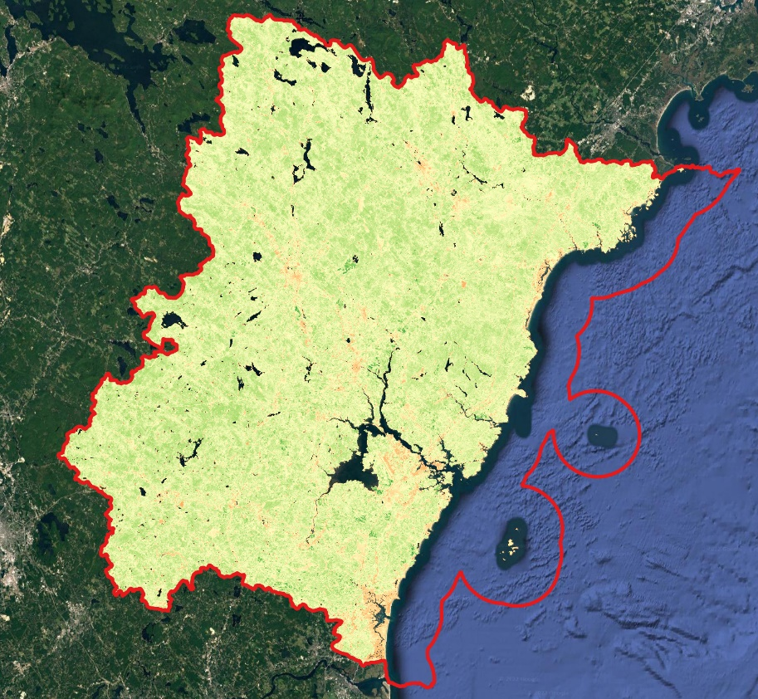Example of NDVI Imagery Product for HUC8 Piscataqua River Watershed Extent: