
Department of CSE

B.Tech. CSE Trimester -5

Roll Number- 2520030048
Name- Teja Hasini Reddy

Cloud Infrastructure and Services
25CS2206E

LAB RECORD
2026

Experiment -1a

AIM: To create an AWS free tier account to provision the resources.

Description:
Amazon Web Services (AWS) is a cloud platform that provides on-demand computing, storage, networking and database services on a pay-as-you-go basis. The AWS Free Tier lets new users explore and provision these services at little or no cost. This experiment covers creating a new AWS account, completing the email, payment, identity and mobile verification, and accessing the AWS Management Console.
Prerequisites:
• Valid email ID.
• Mobile phone number for OTP verification.
• Personal details (name and address).
• Internet connection.
• Payment method requested by AWS: Credit/Debit Card (Visa, Mastercard, RuPay or American Express) or UPI (where supported by the AWS India billing process).
• Aadhaar, PAN or another accepted identity document, if requested during AWS India customer verification.

Steps:
1. Open the AWS website. Open a web browser (Chrome/Edge recommended) and go to https://aws.amazon.com/free
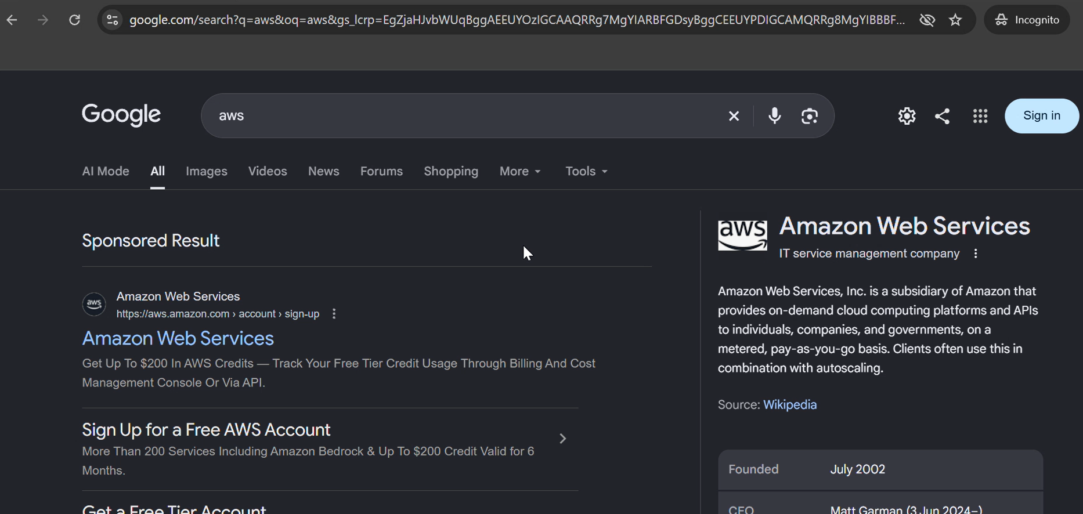
2. Click Sign in to console.
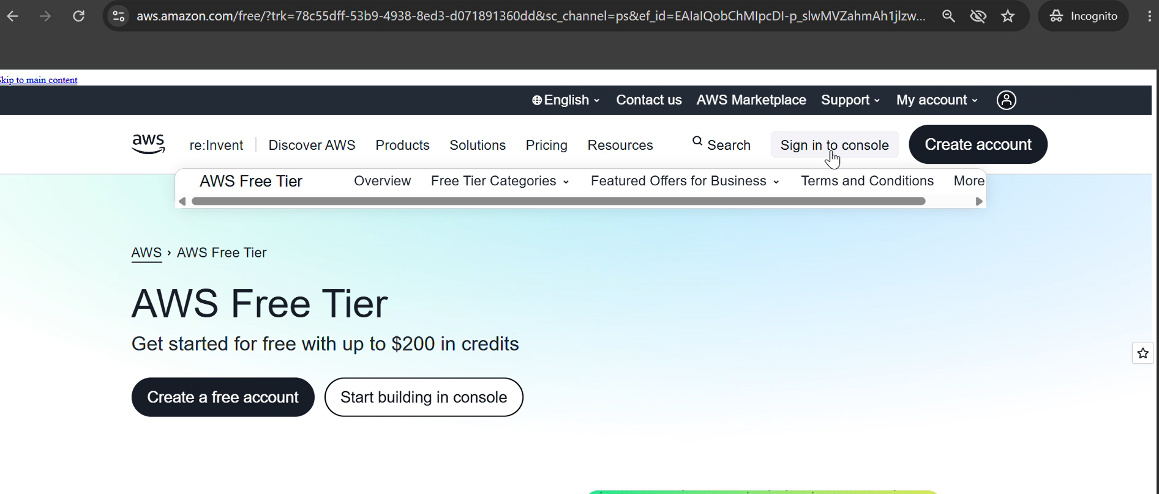
3. Click Create a new AWS account.
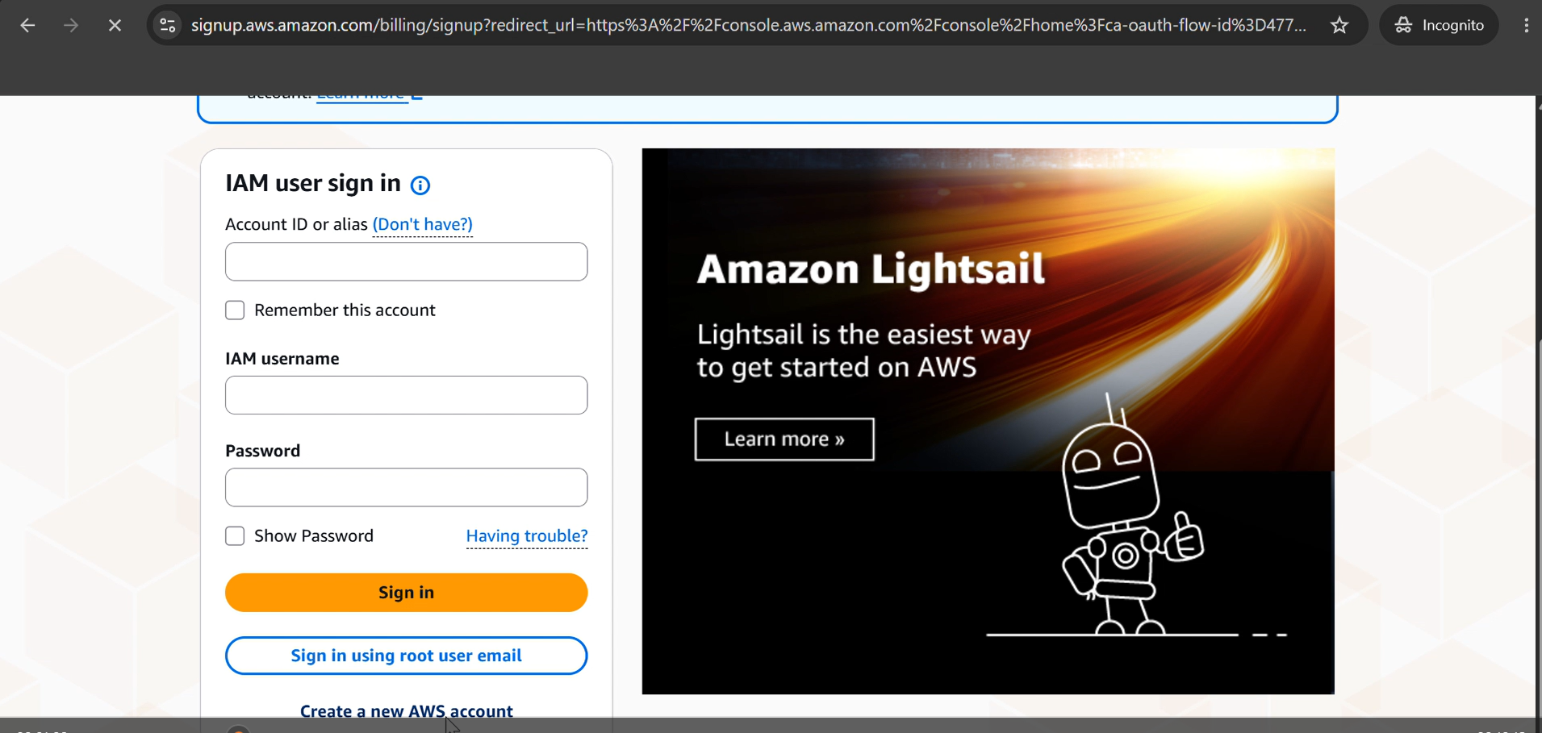
4. Enter the following details:
• Email address
• Password
• AWS Account Name (e.g., StudentAWSAccount)
5. Click Verify email address and enter the OTP sent to your email.
6. Choose the account plan Free (6 months) and click Choose Free plan.
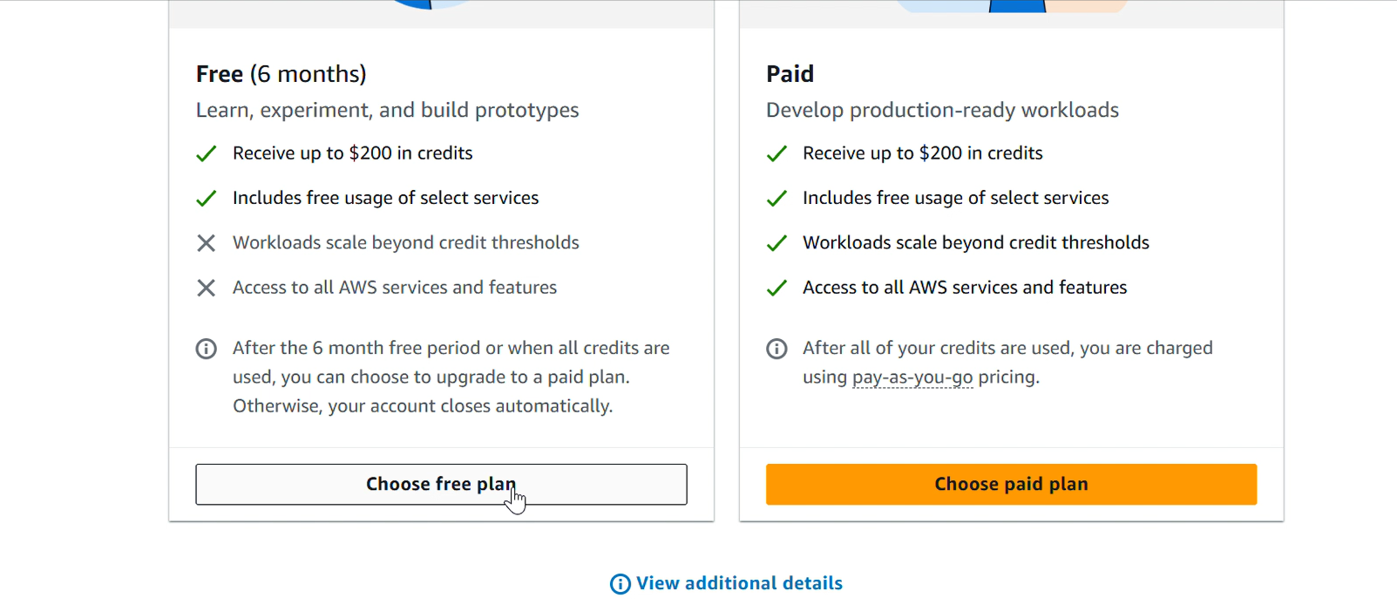
7. Provide all contact information: full name, phone number and address. Click Agree and continue.
8. Provide the billing information. Choose either the UPI or Debit/Credit Card option and enter the details. If UPI is used, an automatic payment limit of 15000 should be set, only for authorization; the autopay can be deleted later.
Note: For AWS India accounts using the advanced registration process, card verification may involve a temporary ₹2 charge, which AWS refunds after verification. UPI is also supported for AWS India bill payments and UPI AutoPay.
9. Confirm your identity. Choose the primary purpose of account registration as Academic and the ownership type as Individual. Select the document type as Aadhaar (verification through DigiLocker); a Voter ID or Driving Licence can also be provided. Click Continue.
10. Provide the mobile number and click Send SMS. Enter the verification code received and continue.
11. Wait for the AWS account to be set up (around 1 to 2 minutes).
12. The AWS Management Console dashboard becomes visible. You can also log in at https://console.aws.amazon.com and sign in as the root user using the registered email and credentials.

Output:
The AWS account was created and verified successfully, and the AWS Management Console was accessed.
• The AWS Management Console dashboard is visible.
• The AWS account name is displayed in the account menu at the top-right corner.
• The account status and Free Plan information are accessible.
• The AWS services available under the account plan can be accessed.

