
Department of CSE

B.Tech. CSE Trimester -5

Roll Number- 2520030048
Name- Teja Hasini Reddy

Cloud Infrastructure and Services
25CS2206E

PRACTICAL 1
LAB RECORD
2026

Experiment -1a

AIM: To create an AWS free tier account to provision the resources.

Description:
Amazon Web Services (AWS) is a cloud platform that provides on-demand computing, storage, networking and database services on a pay-as-you-go basis. The AWS Free Tier lets new users explore and provision these services at little or no cost. This experiment covers creating a new AWS account, completing the email, payment, identity and mobile verification, and accessing the AWS Management Console.
Prerequisites:
• Valid email ID.
• Mobile phone number for OTP verification.
• Personal details (name and address).
• Internet connection.
• Payment method requested by AWS: Credit/Debit Card (Visa, Mastercard, RuPay or American Express) or UPI (where supported by the AWS India billing process).
• Aadhaar, PAN or another accepted identity document, if requested during AWS India customer verification.

Steps:
1. Open the AWS website. Open a web browser (Chrome/Edge recommended) and go to https://aws.amazon.com/free
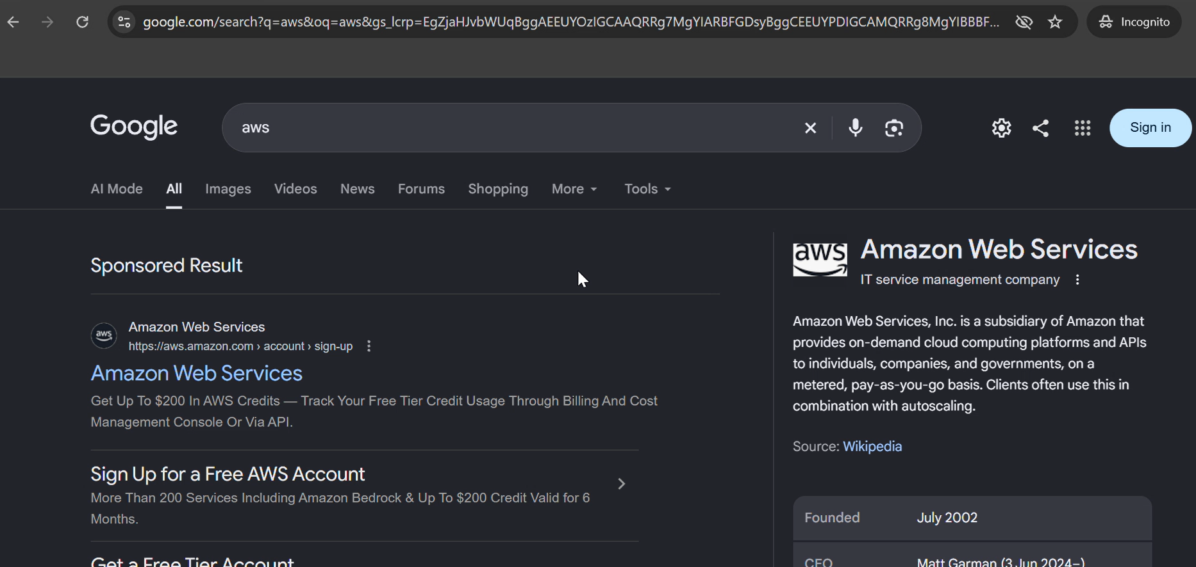
2. Click Sign in to console.
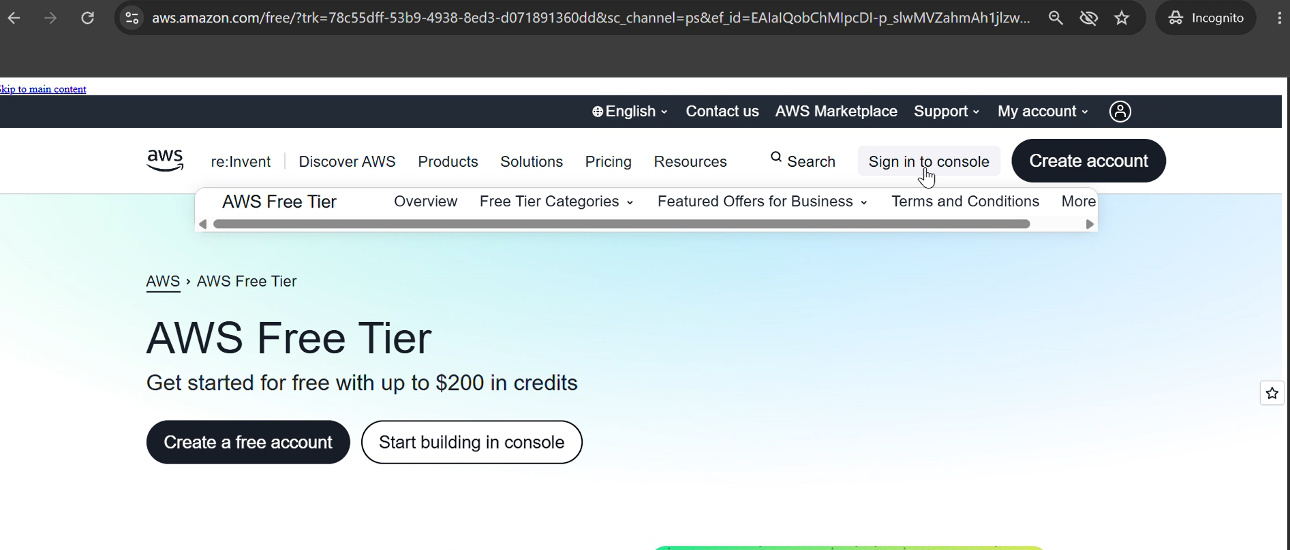
3. Click Create a new AWS account.
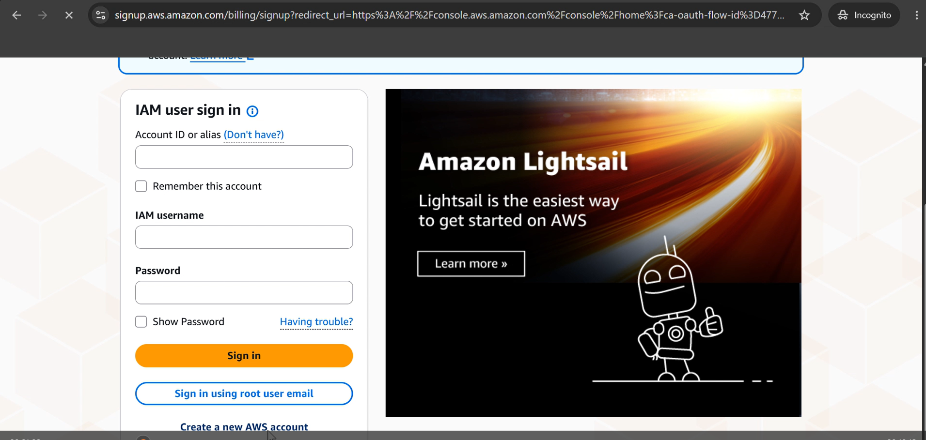
4. Enter the following details:
• Email address
• Password
• AWS Account Name (e.g., StudentAWSAccount)
5. Click Verify email address and enter the OTP sent to your email.
6. Choose the account plan Free (6 months) and click Choose Free plan.
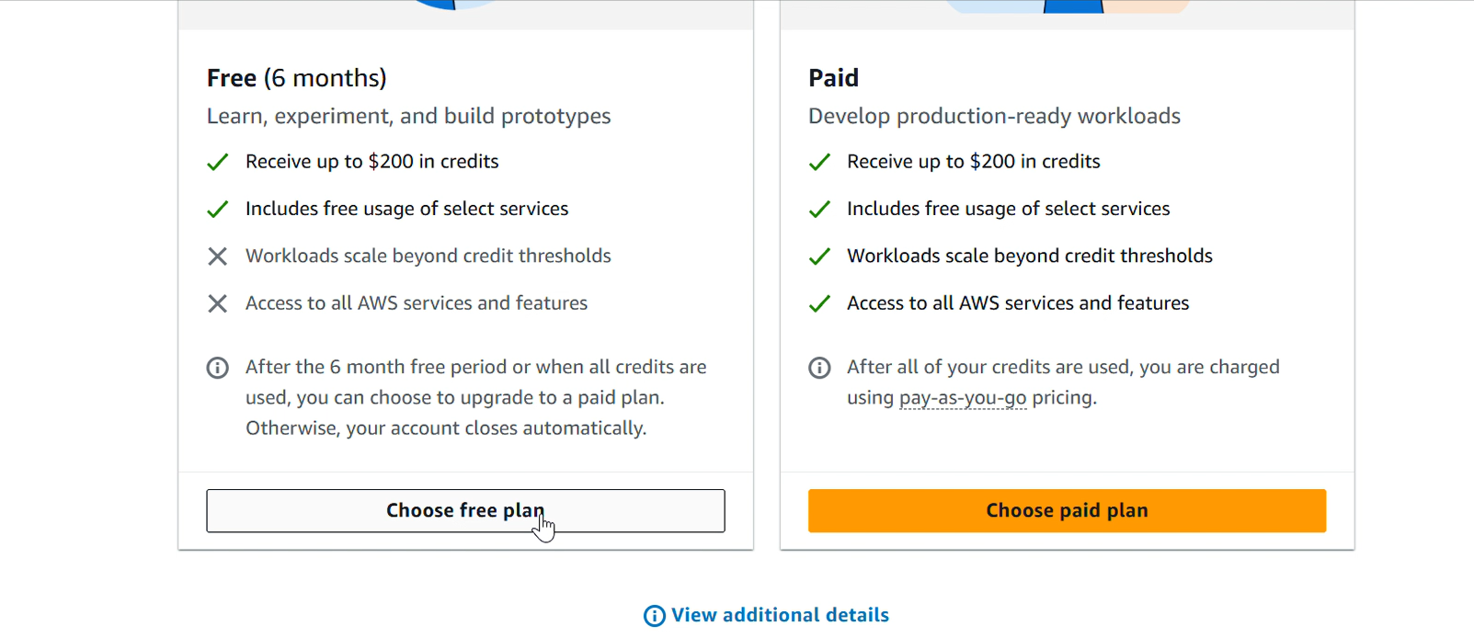
7. Provide all contact information: full name, phone number and address. Click Agree and continue.
8. Provide the billing information. Choose either the UPI or Debit/Credit Card option and enter the details. If UPI is used, an automatic payment limit of 15000 should be set, only for authorization; the autopay can be deleted later.
Note: For AWS India accounts using the advanced registration process, card verification may involve a temporary ₹2 charge, which AWS refunds after verification. UPI is also supported for AWS India bill payments and UPI AutoPay.
9. Confirm your identity. Choose the primary purpose of account registration as Academic and the ownership type as Individual. Select the document type as Aadhaar (verification through DigiLocker); a Voter ID or Driving Licence can also be provided. Click Continue.
10. Provide the mobile number and click Send SMS. Enter the verification code received and continue.
11. Wait for the AWS account to be set up (around 1 to 2 minutes).
12. The AWS Management Console dashboard becomes visible. You can also log in at https://console.aws.amazon.com and sign in as the root user using the registered email and credentials.

Output:
The AWS account was created and verified successfully, and the AWS Management Console was accessed.
• The AWS Management Console dashboard is visible.
• The AWS account name is displayed in the account menu at the top-right corner.
• The account status and Free Plan information are accessible.
• The AWS services available under the account plan can be accessed.

Experiment -1b
AIM: To enable Multi-Factor Authentication (MFA) for an AWS IAM user to provide an additional layer of security during AWS Management Console sign-in.
Description:
AWS Identity and Access Management (IAM) is used to create users and control their access to AWS resources. In this experiment, an IAM user named StudentUser01 was created in the AWS account. The permission review displayed the AWS managed policies AdministratorAccess and IAMUserChangePassword.
A virtual MFA device was then configured using an authenticator application. The application generates a time-based six-digit code. During sign-in, the IAM user must provide the username, password, and current MFA code. This adds a second verification step to protect console access.
Steps:
1. Sign in to the AWS Management Console and open the IAM service.
2. Select Users, click Create user, and enter the username StudentUser01.
3. Enable AWS Management Console access and configure the console password.
4. Set the permissions as shown in the experiment review screen. The displayed policies were AdministratorAccess and IAMUserChangePassword.
5. Review the user details and permissions, then click Create user.
6. Use the AWS account ID, IAM username, and console sign-in URL to sign in as StudentUser01. Update the console password if AWS requires it.
7. Open IAM → Users → StudentUser01 → Security credentials.
8. In the Multi-factor authentication (MFA) section, click Assign MFA device. Enter the device name StudentMFA01 and select Authenticator app.
9. Open an authenticator application, scan the QR code displayed by AWS, and enter two consecutive six-digit codes to complete device registration.
10. Confirm that the virtual MFA device is listed as assigned to StudentUser01.
11. Sign out and sign in again using the IAM user credentials. When prompted, enter the current six-digit code from the authenticator application.
12. Verify that AWS Console Home opens under StudentUser01 after MFA verification.
Output:
The IAM user StudentUser01 was created successfully. The permission review displayed AdministratorAccess and IAMUserChangePassword. A virtual MFA device was assigned, and the final sign-in test reached AWS Console Home under StudentUser01. The first sign-in attempt failed; updating the IAM console password resolved the issue.
Recorded AWS details:
AWS Account ID: 839848201044
AWS Region: us-east-1
IAM username: StudentUser01
IAM user sign-in URL: https://839848201044.signin.aws.amazon.com/console
MFA device name: StudentMFA01
MFA type: Virtual authenticator application

OUTPUT – SCREENSHOT EVIDENCE
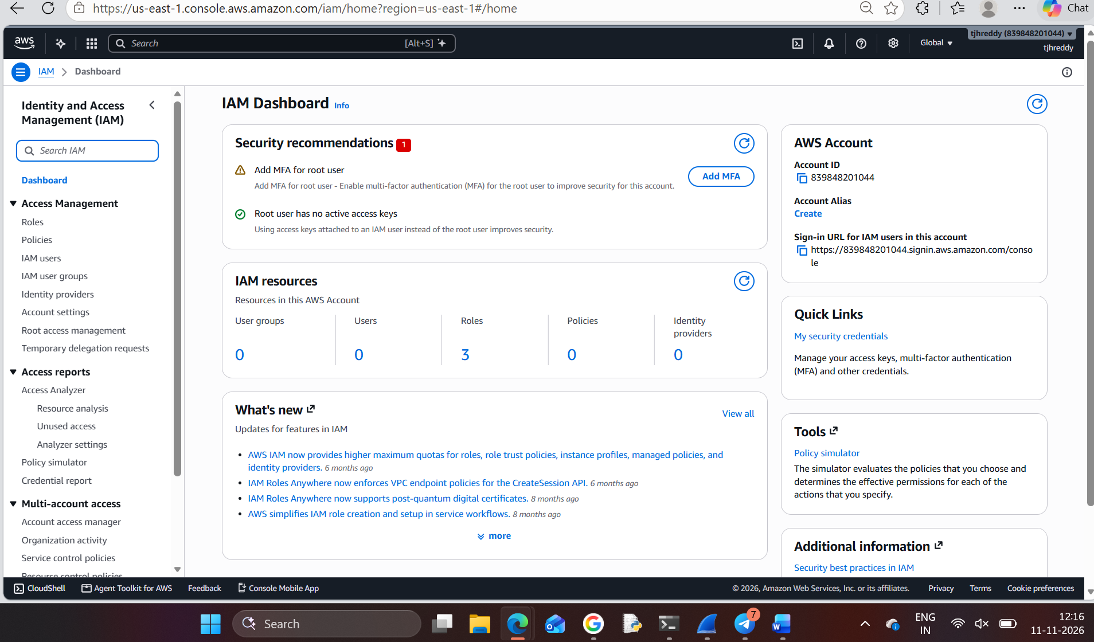
Figure 1. AWS IAM dashboard opened from the AWS Management Console.

OUTPUT – SCREENSHOT EVIDENCE
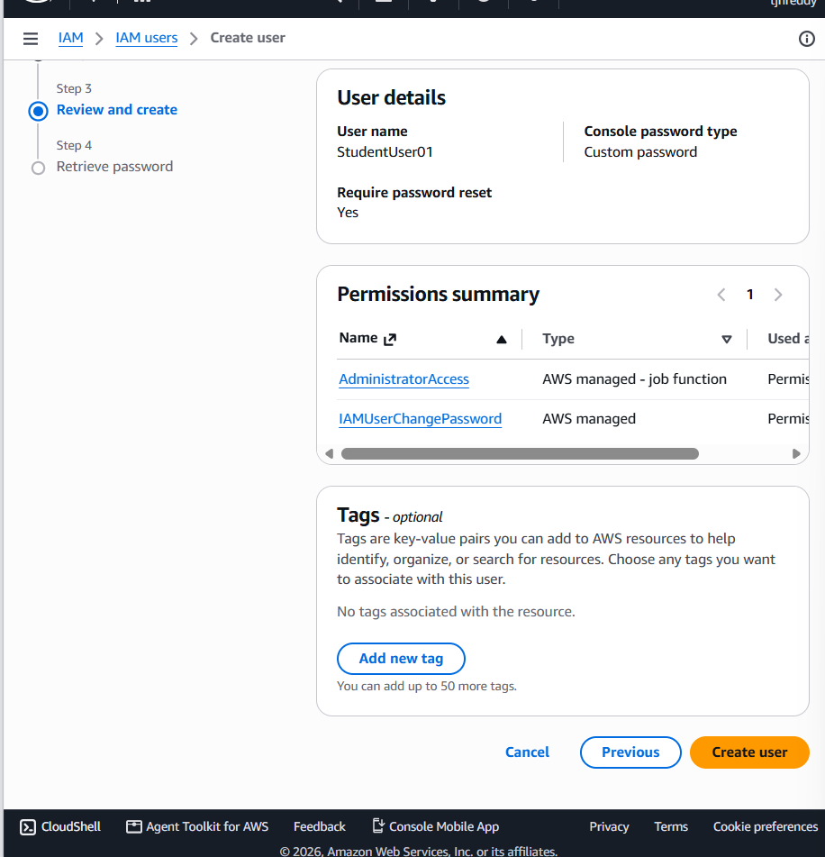
Figure 2. Review and create screen showing the IAM user and attached permissions.

OUTPUT – SCREENSHOT EVIDENCE
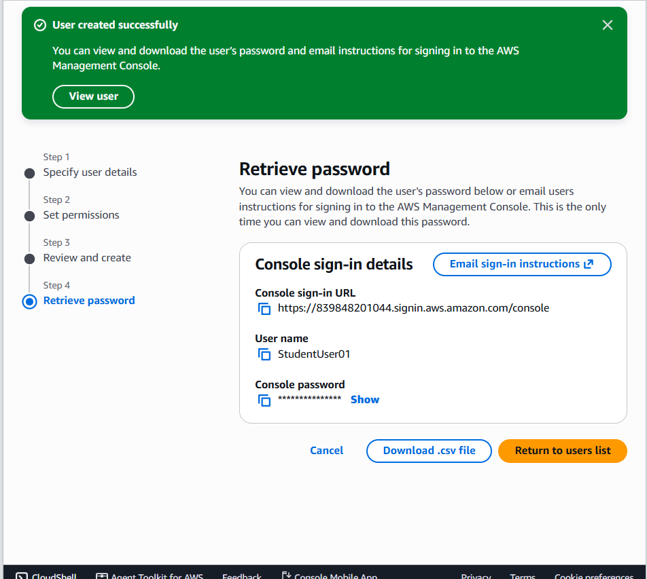
Figure 3. AWS confirmation that StudentUser01 was created successfully; the console password is masked by AWS.

OUTPUT – SCREENSHOT EVIDENCE
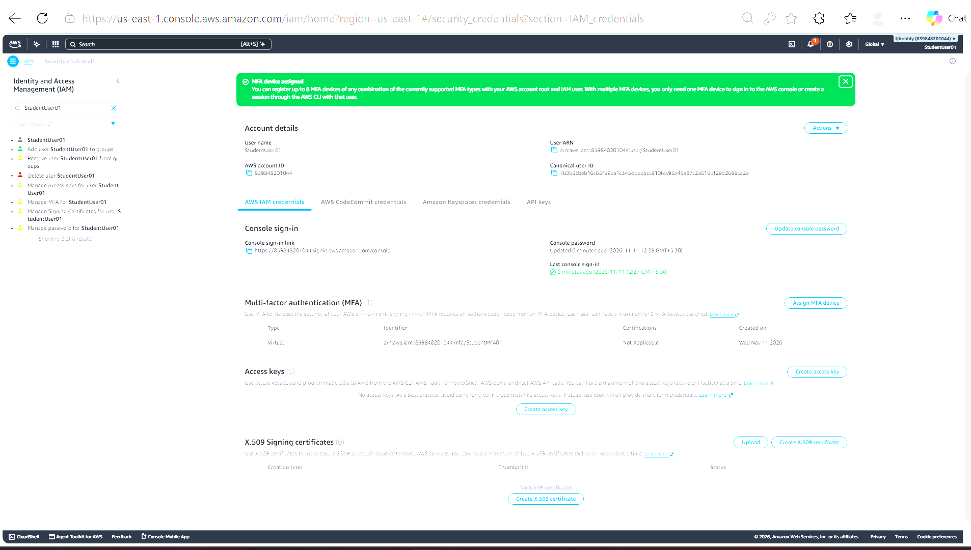
Figure 4. Security credentials page showing that the virtual MFA device was assigned to StudentUser01.

OUTPUT – SCREENSHOT EVIDENCE
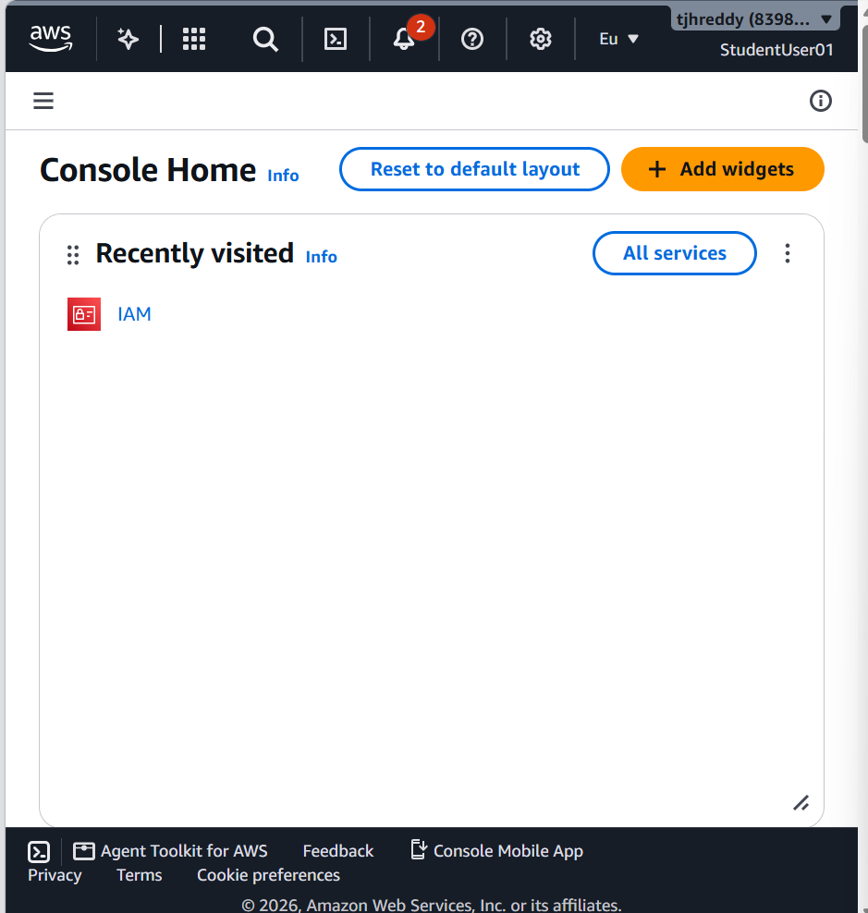
Figure 5. AWS Console Home displayed after signing in as StudentUser01.

