CNNP – SKILL 1
ENCAPSULATION BUILDER
Analyze protocol-header overhead and determine network efficiency
━━━━━━━━━━━━━━━━━━━━━━━━━━━━━━━━━━━━━━━━
LAB RECORD
.

DETAIL | INFORMATION
Student Name | Teja Hasini Reddy
Roll Number | 2520030048
Course / Lab | CNNP – Skill 1
Section / Cluster | Section 5
Date of Experiment | 11 November 2026

Wireshark packet capture • Ethernet / IPv4 / TCP inspection • HTTP stream analysis

1. Experiment Overview

Aim
To capture network packets and understand how Ethernet, IP, and TCP/UDP headers are added during data transmission. The captured packet is inspected in Wireshark to identify header sizes, calculate total overhead, and determine payload efficiency.

Objectives
- Capture real network traffic using Wireshark on the active Wi-Fi interface.
- Identify TCP, UDP, and other protocol traffic using Wireshark display filters.
- Inspect the Frame, Ethernet II, IPv4, and TCP sections of a selected packet.
- Record source and destination MAC/IP addresses, header lengths, packet length, and TCP payload length.
- Follow a TCP stream to view the HTTP request and corresponding server response.
- Calculate the observed packet's header overhead and application-payload efficiency.
- Save the packet capture in PCAPNG format for later inspection.

Background Theory
Encapsulation is the process in which each network layer adds its own control information, usually in the form of a header, before passing data to the next lower layer. At the receiver, these headers are interpreted and removed during decapsulation.
Layer / Protocol | Role in this capture
Application – HTTP | Carries the GET request and the server's HTTP response.
Transport – TCP | Provides source/destination ports, sequence and acknowledgement information, flags, and reliable byte-stream delivery.
Network – IPv4 | Provides source/destination IP addresses, packet length, TTL, and protocol identification.
Data Link – Ethernet II | Provides source/destination MAC addresses and the EtherType field.

Software / Tools Used
Tool | Purpose
Wireshark 4.6.9 | Capture, filter, and inspect network packets and TCP streams.
Windows Wi-Fi interface | Network interface selected for packet capture.
PCAPNG file | Stores the captured packets for later analysis.
Wireshark display filters | Narrow the packet list to a protocol or TCP stream.

2. Procedure – Capture and Filtering

Step 1: Open Wireshark and select the network interface
Wireshark was opened and the available network interfaces were displayed. The Wi-Fi interface was selected because the computer was connected through Wi-Fi. Packet capture was started on that interface.
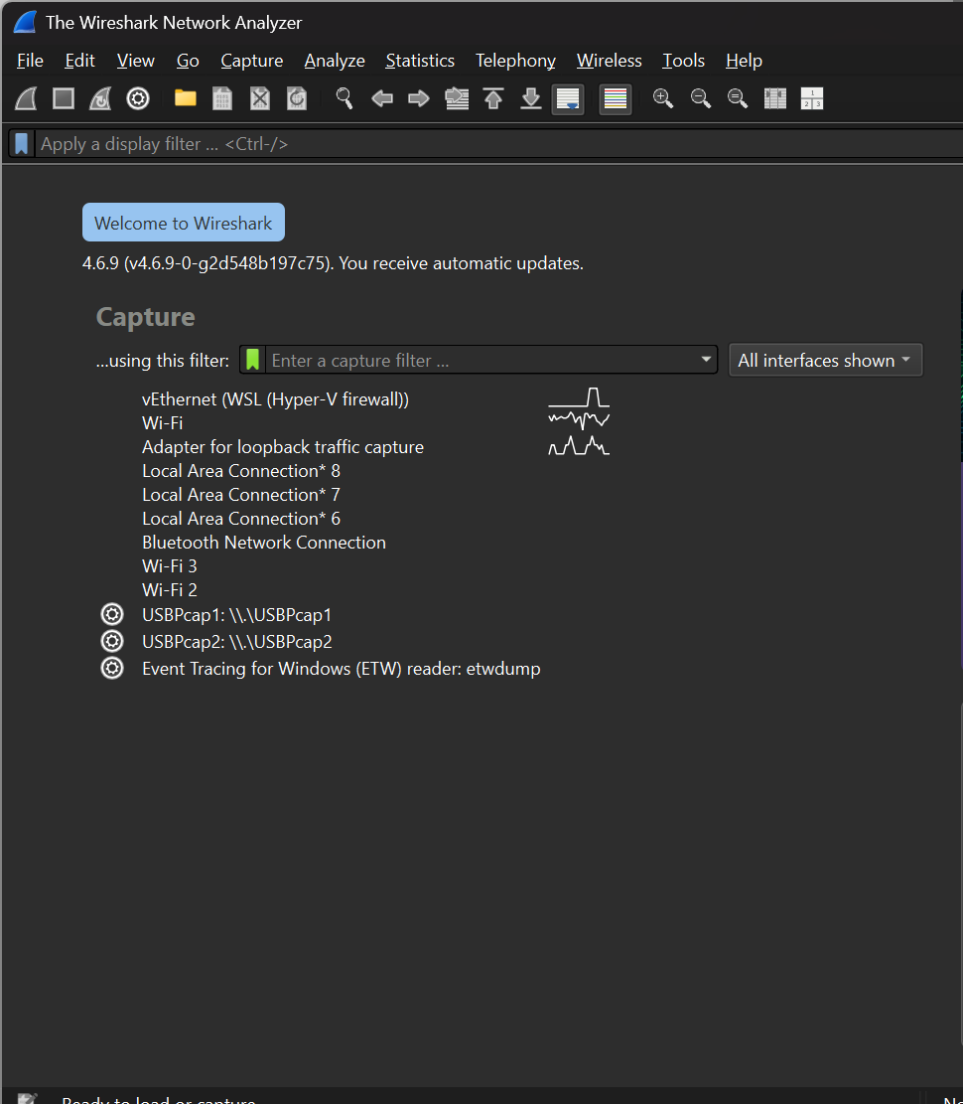
Figure 1. Wireshark start screen showing the available capture interfaces.
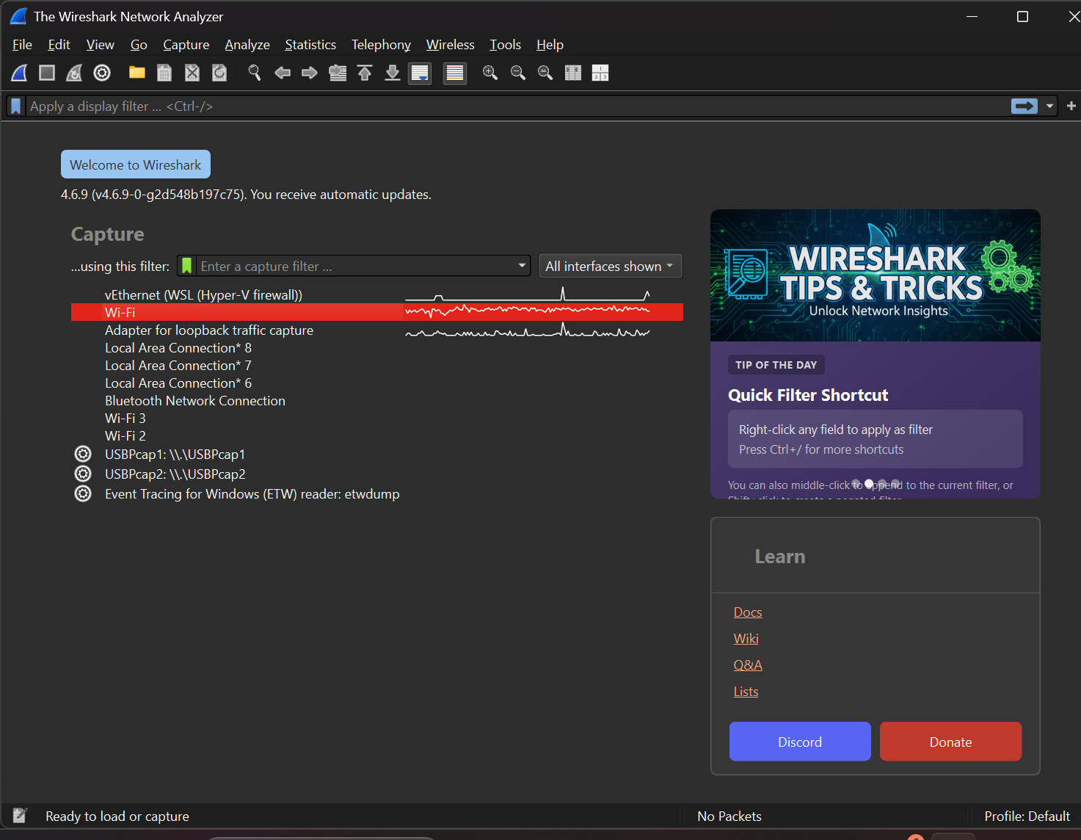
Figure 2. Wi-Fi interface selected in Wireshark.

Step 2: Capture network traffic
Network activity was captured on the Wi-Fi interface. The packet list contained several protocols, including TCP, HTTP, mDNS, SSDP, and ARP. The presence of mDNS and SSDP entries indicates that UDP-based traffic was also present in the overall capture, although a UDP packet's detailed header fields were not included in the submitted screenshots.
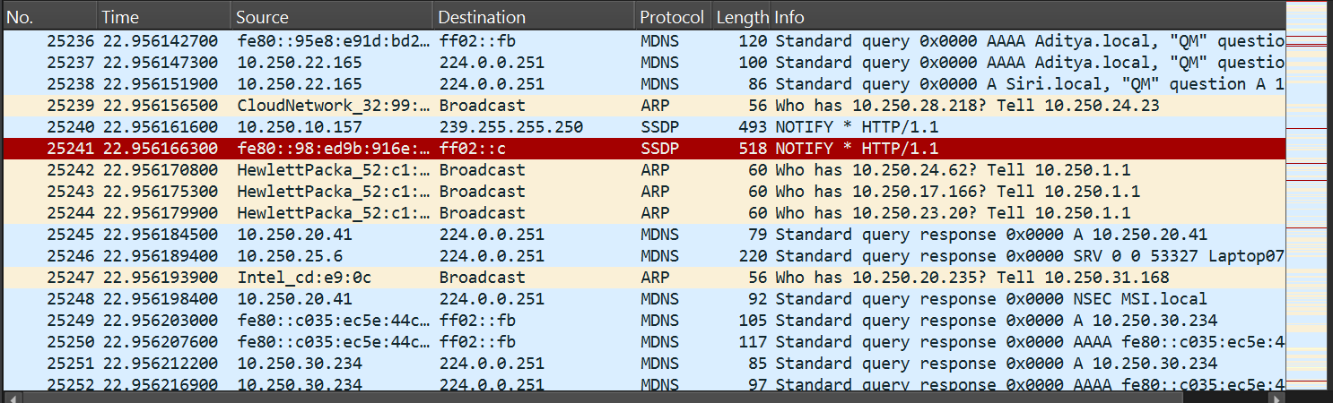
Figure 3. Captured Wi-Fi traffic showing multiple protocols, including mDNS, SSDP, ARP, TCP, and HTTP.

Step 3: Apply a TCP stream display filter
The saved capture was opened and the display filter tcp.stream eq 5 was applied. This isolated TCP stream number 5. Packet 162 was selected for detailed inspection.
tcp.stream eq 5

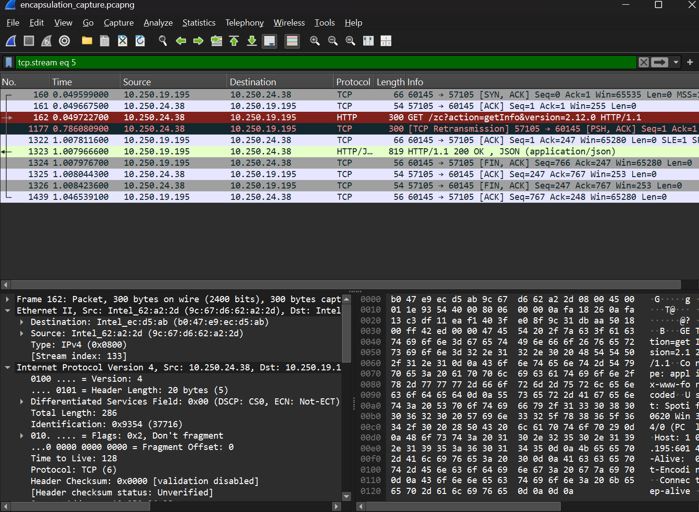
Figure 4. Saved capture encapsulation_capture.pcapng with TCP stream 5 selected and packet 162 highlighted.

3. Packet Header Inspection

Step 4: Inspect the Ethernet II header
The Ethernet II section identifies the link-layer source and destination hardware addresses. The selected frame uses IPv4 as the encapsulated network-layer protocol (EtherType 0x0800).
Ethernet field | Observed value
Source MAC address | 9c:67:d6:62:a2:2d
Destination MAC address | b0:47:e9:ec:d5:ab
EtherType | IPv4 (0x0800)
Ethernet header length | 14 bytes (standard Ethernet II header; also 300 − 286)

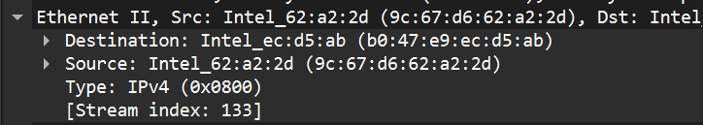
Figure 5. Ethernet II details for the selected packet.

Step 5: Inspect the IPv4 header
IPv4 field | Observed value
Version | 4
Header length | 20 bytes
Total length | 286 bytes
Source IP address | 10.250.24.38
Destination IP address | 10.250.19.195
Time to Live (TTL) | 128
Protocol | TCP (6)
Flags | Don't fragment

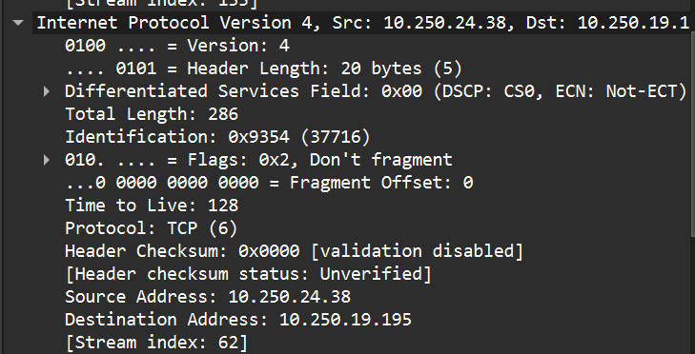
Figure 6. IPv4 header details showing source/destination addresses, 20-byte header, total length 286 bytes, and TTL 128.

Step 6: Inspect the TCP header
TCP field | Observed value
Source port | 57105
Destination port | 60145
Header length | 20 bytes
TCP payload / segment data length | 246 bytes
Flags | PSH, ACK
Sequence number (relative) | 1
Acknowledgement number (relative) | 1
TCP stream index | 5

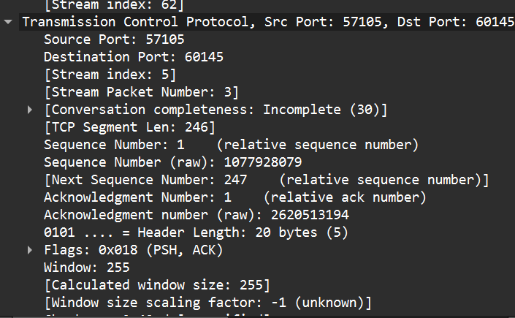
Figure 7. TCP details showing ports, 20-byte header, PSH/ACK flags, and stream information.
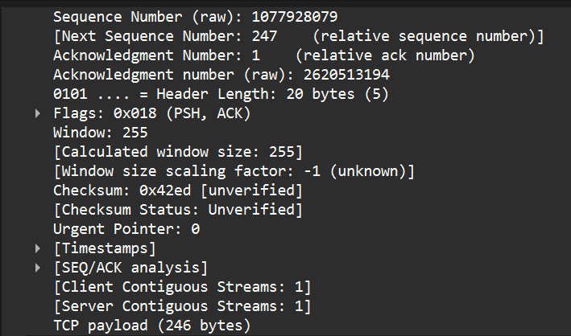
Figure 8. TCP payload field showing 246 bytes of application data.

4. Application-Layer and TCP Stream Analysis

Step 7: Inspect the HTTP request
The selected TCP payload was decoded by Wireshark as an HTTP request. The request was generated by a Spotify desktop client and sent to the destination shown in the IPv4 header.
GET /zc?action=getInfo&version=2.12.0 HTTP/1.1
Content-Type: application/x-www-form-urlencoded
User-Agent: Spotify/130800620 Win32_x86_64/0 (PC laptop)
Host: 10.250.19.195:60145
Keep-Alive: 0
Accept-Encoding: gzip
Connection: keep-alive

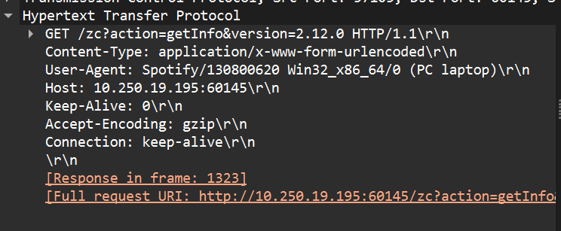
Figure 9. HTTP request details displayed under the Hypertext Transfer Protocol section.

Step 8: Follow the TCP stream
The Follow TCP Stream feature displayed both directions of the conversation: the client's HTTP GET request and the server's HTTP response. The server returned HTTP/1.1 200 OK with a JSON response.
HTTP/1.1 200 OK
Content-Type: application/json
Content-Length: 674
Connection: close

The visible JSON response included statusString = OK, spotifyError = 0, responseSource = Spotify, version = 2.12.0, and deviceType = COMPUTER.
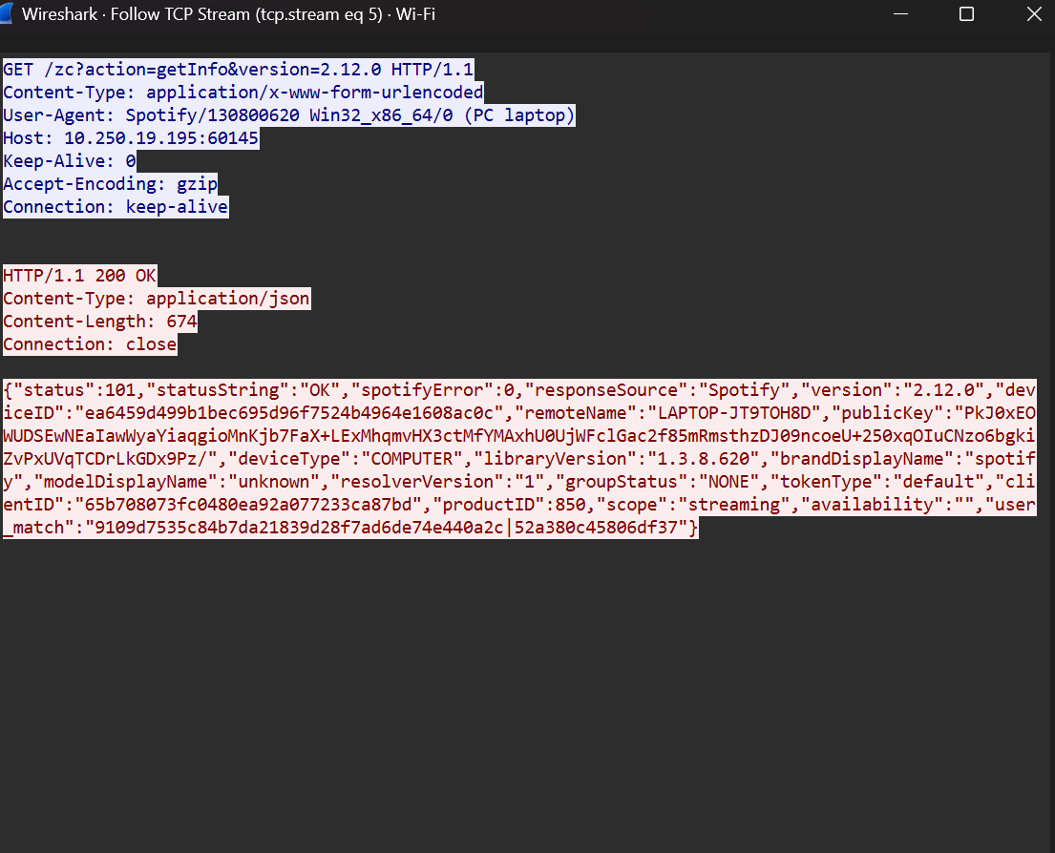
Figure 10. Follow TCP Stream showing the HTTP GET request and HTTP 200 OK JSON response.

5. Observation Table
The following values are taken from the selected TCP packet (Frame 162). The UDP column is intentionally left as not recorded because the supplied screenshots show UDP-based traffic in the packet list but do not show the expanded details of a selected UDP packet.
Parameter | TCP packet – Frame 162 | UDP packet
Frame length | 300 bytes | Not recorded
Ethernet header length | 14 bytes | Not recorded
IP header length | 20 bytes | Not recorded
Transport header length | 20 bytes | Not recorded
IP total length | 286 bytes | Not recorded
Transport payload length | 246 bytes | Not recorded
Protocol / example | TCP carrying HTTP | UDP traffic visible (mDNS / SSDP); details not inspected

6. Header Overhead and Payload Efficiency Calculations

Observed packet values
Component | Size
Ethernet II header | 14 bytes
IPv4 header | 20 bytes
TCP header | 20 bytes
Application payload | 246 bytes
Total captured Ethernet frame | 300 bytes

Calculation 1: Verify the IP total length
IPv4 total length = IP header + TCP header + TCP payload
= 20 + 20 + 246
= 286 bytes

Calculation 2: Verify the Ethernet frame length
Frame length = Ethernet header + IPv4 total length
= 14 + 286
= 300 bytes

Calculation 3: Total header overhead
Total header overhead = Ethernet + IPv4 + TCP headers
= 14 + 20 + 20
= 54 bytes

Calculation 4: Header overhead percentage
Header overhead (%) = (Header bytes / Total frame bytes) × 100
= (54 / 300) × 100
= 18%

Calculation 5: Payload efficiency
Payload efficiency (%) = (Application payload / Total frame bytes) × 100
= (246 / 300) × 100
= 82%

Interpretation: In the observed 300-byte Ethernet frame, 246 bytes (82%) carry TCP application data and 54 bytes (18%) are protocol headers. The supplied packet details do not show a separate Ethernet FCS field, so an additional 4-byte FCS has not been added to the observed frame calculation.

7. Capture File and Display-Filter Record
The capture was saved in PCAPNG format with the filename shown in the final Wireshark screenshot.
Item | Recorded result
Saved capture filename | encapsulation_capture.pcapng
Wireshark version | 4.6.9
Capture interface | Wi-Fi
Display filter visible in final screenshot | tcp.stream eq 5
Selected packet | Frame 162 – HTTP over TCP

Display filters specified by the lab handout
Display filter | Purpose | Evidence in submitted screenshots
tcp | Display TCP packets | TCP packets are visible; separate filter entry not shown
udp | Display UDP packets | mDNS / SSDP traffic is visible; UDP details not expanded
icmp | Display ICMP packets | ICMP-filtered result not shown
tcp.len > 0 | Display TCP packets carrying data | Not separately shown
tcp.stream eq 5 | Display packets belonging to TCP stream 5 | Shown in final saved-capture screenshot

8. Answers to the Lab Questions
1. What is encapsulation?
Encapsulation is the process in which each network layer adds its own header to data before passing it to the next lower layer.
2. What is the purpose of the Ethernet header?
It carries the source and destination MAC addresses and the EtherType, helping deliver the frame across the local network link.
3. What information is stored in the IP header?
It contains source and destination IP addresses, packet length, TTL, protocol identification, fragmentation information, and other control fields.
4. What is the difference between TCP and UDP headers?
TCP has a larger header with sequence numbers, acknowledgements, flags, and window information; UDP has a compact 8-byte header with source port, destination port, length, and checksum.
5. Why does each protocol add a header?
Each layer adds control information required for addressing, routing, delivery, error checking, ordering, or application identification.
6. What is packet overhead?
Packet overhead is the extra bytes used by protocol headers and trailers rather than the application data itself.
7. How does header overhead affect network efficiency?
More header bytes reduce the percentage of each transmitted frame available for application data, increasing bandwidth used for protocol control.

9. Results and Discussion
- Wireshark successfully captured traffic on the Windows Wi-Fi interface.
- The capture contained multiple protocols, including TCP, HTTP, mDNS, SSDP, and ARP.
- Frame 162 was identified as a 300-byte HTTP/TCP packet from 10.250.24.38 to 10.250.19.195.
- The IPv4 header length was 20 bytes, the IPv4 total length was 286 bytes, and the TTL was 128.
- The TCP header length was 20 bytes and the TCP application payload was 246 bytes.
- The HTTP request and server response were successfully inspected using Follow TCP Stream. The server response status was HTTP/1.1 200 OK.
- The observed header overhead was 54 bytes (18% of the captured frame), while payload efficiency was 82%.
- UDP-based traffic was visible in the packet list, but the supplied screenshots do not contain a selected UDP packet's detailed header values.

10. Conclusion
The Encapsulation Builder experiment demonstrated how Ethernet II, IPv4, and TCP headers are added to application data during network transmission. Using Wireshark, a real HTTP-over-TCP packet was inspected at the frame, Ethernet, IP, TCP, and HTTP levels. The selected 300-byte frame contained 54 bytes of protocol headers and 246 bytes of application payload, resulting in 18% header overhead and 82% payload efficiency. Following the TCP stream also demonstrated the HTTP request-response exchange and the server's HTTP 200 OK response.

11. Evidence Notes / Items Not Shown in the Submitted Screenshots
This record reports only values visible in the supplied screenshots. The lab handout additionally asks for a detailed inspection of one UDP packet and for the saved capture to be filtered with icmp. The screenshots show UDP-based mDNS/SSDP traffic in the packet list, but do not show the expanded UDP header or its length field; an ICMP-filtered packet list is also not included. These observations are marked as not recorded rather than assigning guessed values.
If the instructor requires every handout checkbox to be evidenced, add one screenshot of an expanded UDP packet (Frame → Ethernet II → IPv4 → User Datagram Protocol) and one screenshot after applying the icmp display filter. The current TCP encapsulation calculations and Follow TCP Stream analysis are complete.

Reference
CNNP – Skill 1 lab handout, “Encapsulation Builder: Analyze the overhead introduced by protocol headers and determine how encapsulation affects network efficiency”

