CNNP – SKILL 2
THREE-POINT CAPTURE
Packet Capture Analysis Across Three Network Observation Points
━━━━━━━━━━━━━━━━━━━━━━━━━━━━━━━━━━━━━━━━━━━━

Student Name | Teja Hasini Reddy
Roll Number | 2520030048
Course / Lab | CNNP – Skill 2
Section / Cluster | Section 5
Date of Experiment | 11 November 2026
LAB RECORD

1. Experiment Overview

Aim
To create a three-node network path (Host1 → Router → Host2), capture packets at three observation points, and compare packet flow, TTL, payload, delay, retransmission indicators, and round-trip time.

Objectives
- Create isolated Linux network namespaces for Host1, Router, and Host2.
- Connect the namespaces using virtual Ethernet (veth) pairs and configure IPv4 addresses and routes.
- Introduce a 20 ms delay and 1% packet-loss setting using Linux traffic control (netem).
- Capture traffic simultaneously at Host1, the router, and Host2 using TShark.
- Send a TCP text message and extract its payload from the router capture.
- Compare TTL values and measure delay and RTT.
- Merge the three capture files and inspect the traffic in Wireshark.

Software / Tools Used
Tool | Purpose
Ubuntu / Linux terminal | Run network namespace and traffic-control commands.
iproute2 (ip) | Create namespaces, veth links, IP addresses, and routes.
tc netem | Apply configured delay and packet loss.
TShark | Capture packets and extract fields from PCAP files.
Wireshark | Inspect packets, add a TTL column, merge captures, and view Expert Information.
netcat (nc) | Send a TCP text message between Host1 and Host2.
MTR | Measure hop-by-hop packet loss and round-trip time.

Network Topology
Host1 | Link 1 | Router | Link 2 | Host2
10.0.1.1/30  veth-h1  Capture: cap1 | veth-h1 ↔ veth-r1 | 10.0.1.2/30  10.0.2.1/30  Capture: cap2 | veth-r2 ↔ veth-h2  (netem on veth-r2) | 10.0.2.2/30  veth-h2  Capture: cap3

Capture locations used in the supplied lab procedure: cap1 at Host1 (veth-h1), cap2 at the router (veth-r1), and cap3 at Host2 (veth-h2). The delay/loss qdisc was configured on the router interface veth-r2.

2. Procedure – Network Setup and Impairment

Step 1: Install the required tools
sudo apt update
sudo apt install -y tshark iperf3 mtr-tiny iproute2 wireshark netcat-openbsd

Step 2: Create network namespaces and virtual links
sudo ip netns add host1
sudo ip netns add router
sudo ip netns add host2
sudo ip link add veth-h1 type veth peer name veth-r1
sudo ip link add veth-r2 type veth peer name veth-h2
sudo ip link set veth-h1 netns host1
sudo ip link set veth-r1 netns router
sudo ip link set veth-r2 netns router
sudo ip link set veth-h2 netns host2

Step 3: Configure IP addresses
sudo ip netns exec host1 ip addr add 10.0.1.1/30 dev veth-h1
sudo ip netns exec host1 ip link set veth-h1 up
sudo ip netns exec host1 ip link set lo up
sudo ip netns exec router ip addr add 10.0.1.2/30 dev veth-r1
sudo ip netns exec router ip addr add 10.0.2.1/30 dev veth-r2
sudo ip netns exec router ip link set veth-r1 up
sudo ip netns exec router ip link set veth-r2 up
sudo ip netns exec router ip link set lo up
sudo ip netns exec host2 ip addr add 10.0.2.2/30 dev veth-h2
sudo ip netns exec host2 ip link set veth-h2 up
sudo ip netns exec host2 ip link set lo up

Step 4: Enable routing and test connectivity
sudo ip netns exec router sysctl -w net.ipv4.ip_forward=1
sudo ip netns exec host1 ip route add 10.0.2.0/30 via 10.0.1.2
sudo ip netns exec host2 ip route add 10.0.1.0/30 via 10.0.2.1
sudo ip netns exec host1 ping -c 3 10.0.2.2

Observed initial connectivity: 3 packets transmitted, 3 received, and 0% packet loss. The reported RTT was min/avg/max/mdev = 0.041/0.073/0.136/0.044 ms.

Step 5: Apply delay and packet loss
sudo ip netns exec router tc qdisc add dev veth-r2 root netem delay 20ms loss 1%
sudo ip netns exec router tc qdisc show dev veth-r2

The qdisc output showed a netem discipline with delay 20 ms and loss 1%. A subsequent 10-packet ping returned 10/10 replies with 0% observed loss and average RTT of 20.284 ms. A 1% configured loss is probabilistic; a short test can still observe zero dropped packets.
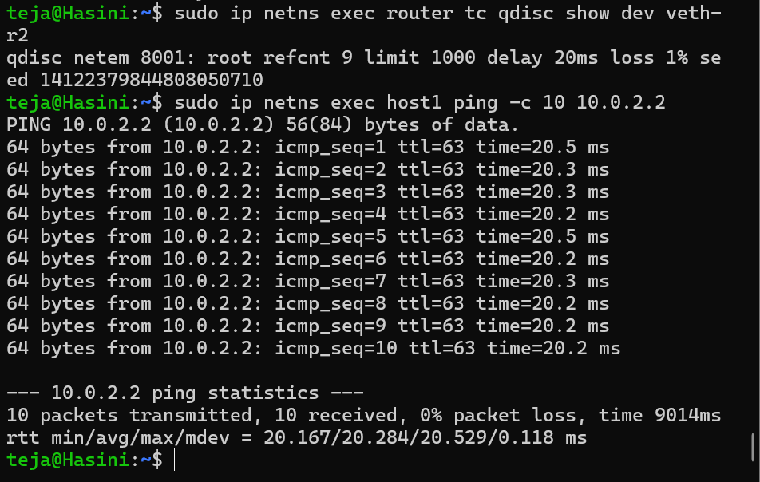
Figure 1. Terminal verification of netem delay 20 ms / loss 1% and the 10-packet ping result.

3. Procedure – Three-Point Packet Capture

Step 6: Start the three captures simultaneously
Four terminals were used as directed in the lab handout. The capture commands were run in separate terminals and left running while the TCP message was sent.
# Terminal 1 – Host1
sudo ip netns exec host1 tshark -i veth-h1 -w /tmp/cap1.pcap
# Terminal 2 – Router
sudo ip netns exec router tshark -i veth-r1 -w /tmp/cap2.pcap
# Terminal 3 – Host2
sudo ip netns exec host2 tshark -i veth-h2 -w /tmp/cap3.pcap

Step 7: Send a TCP message from Host1 to Host2
# Start the receiver on Host2 (Terminal 4)
sudo ip netns exec host2 nc -l 1234
# Connect from Host1 (a separate terminal)
sudo ip netns exec host1 nc 10.0.2.2 1234

The following text was sent from Host1:
Hello from host1!
This is Alekhya
Computer Networks Lab
Three Point Capture Experiment
Message traveling through router

Step 8: Stop captures and fix file permissions
# Press Ctrl+C in the three capture terminals, then run:
sudo chmod 644 /tmp/cap1.pcap /tmp/cap2.pcap /tmp/cap3.pcap
ls -lh /tmp/cap1.pcap /tmp/cap2.pcap /tmp/cap3.pcap

Observed file sizes: cap1.pcap = 2.3 KB, cap2.pcap = 2.3 KB, and cap3.pcap = 2.3 KB. All three files were present and non-empty.
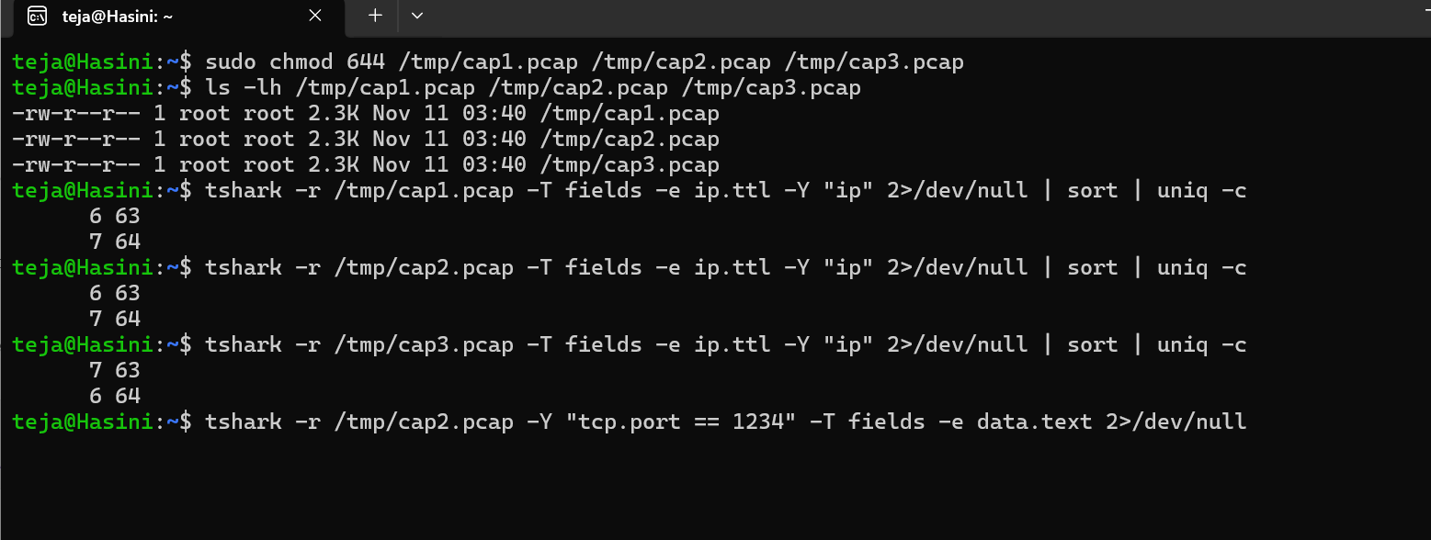
Figure 2. File-permission check, capture-file sizes, initial TTL counts, and the first data.text extraction attempt.

4. Results – TTL and TCP Payload

Step 9: Check TTL at all three capture points
tshark -r /tmp/cap1.pcap -T fields -e ip.ttl -Y "ip" 2>/dev/null | sort | uniq -c
tshark -r /tmp/cap2.pcap -T fields -e ip.ttl -Y "ip" 2>/dev/null | sort | uniq -c
tshark -r /tmp/cap3.pcap -T fields -e ip.ttl -Y "ip" 2>/dev/null | sort | uniq -c

Capture | Observed unfiltered TTL counts
cap1 – Host1 | 6 packets with TTL 63; 7 packets with TTL 64
cap2 – Router | 6 packets with TTL 63; 7 packets with TTL 64
cap3 – Host2 | 7 packets with TTL 63; 6 packets with TTL 64

The unfiltered files contain traffic in both directions, so both TTL 63 and TTL 64 appear. To isolate Host1-to-Host2 packets at Host2, the direction-specific filter was used:
tshark -r /tmp/cap3.pcap -Y "ip.src == 10.0.1.1 && ip.dst == 10.0.2.2" -T fields -e ip.ttl

Observed result: seven packets were displayed, each with TTL 63. In the router capture, a selected Host1-to-Host2 packet showed TTL 64. This demonstrates the one-hop TTL decrement between the router-side observation and Host2.

Step 10: Extract the actual TCP message from cap2
The initial data.text field query returned no text. The TCP payload was then extracted in hexadecimal and decoded:
tshark -r /tmp/cap2.pcap -Y "tcp.port == 1234 && tcp.len > 0" -T fields -e tcp.payload 2>/dev/null | tr -d ':' | xxd -r -p

The decoded payload matched the text sent from Host1:
Hello from host1!
This is Alekhya
Computer Networks Lab
Three Point Capture Experiment
Message traveling through router

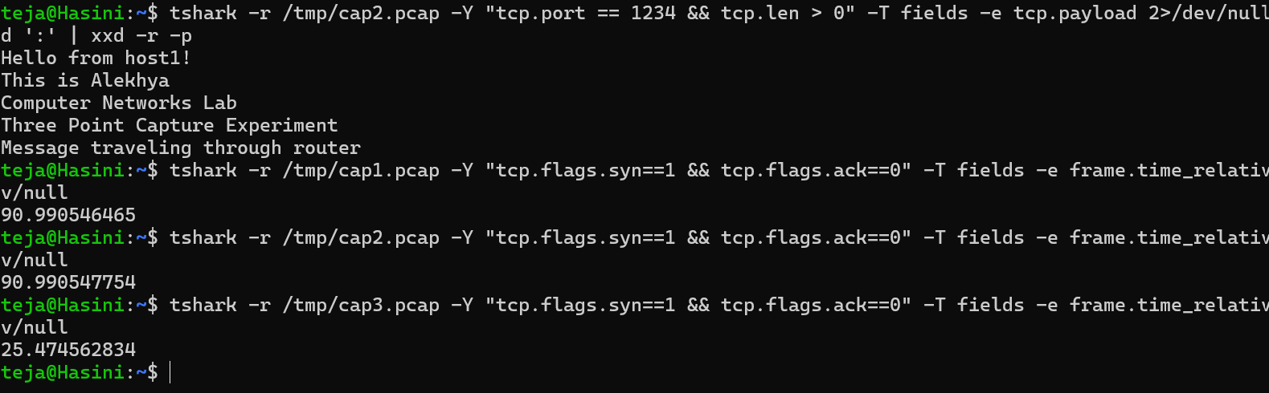
Figure 3. Direction-filtered TTL values at Host2 and successful TCP payload extraction from the router capture.

5. Results – Delay Measurement

Step 11: Compare capture timestamps
The first comparison used frame.time_relative. Those values were 90.990546465 s (cap1), 90.990547754 s (cap2), and 25.474562834 s (cap3). Since each capture file has its own relative-time origin, these values are not directly comparable across independent files.
To compare the same SYN packet across the three capture files, absolute frame.time_epoch timestamps were extracted:
tshark -r /tmp/cap1.pcap -Y "tcp.flags.syn==1 && tcp.flags.ack==0" -T fields -e frame.time_epoch
tshark -r /tmp/cap2.pcap -Y "tcp.flags.syn==1 && tcp.flags.ack==0" -T fields -e frame.time_epoch
tshark -r /tmp/cap3.pcap -Y "tcp.flags.syn==1 && tcp.flags.ack==0" -T fields -e frame.time_epoch

Capture point | Observed frame.time_epoch
cap1 – Host1 | 1794368287.133742449
cap2 – Router | 1794368287.133750263
cap3 – Host2 | 1794368287.154015468

Calculated time differences
Interval | Difference
Host1 → Router (cap1 to cap2) | 0.000007814 s ≈ 0.0078 ms
Router → Host2 (cap2 to cap3) | 0.020265205 s ≈ 20.265 ms
Host1 → Host2 (cap1 to cap3) | 0.020273019 s ≈ 20.273 ms

The measured Host1-to-Host2 timestamp difference was approximately 20.27 ms, consistent with the configured 20 ms netem delay (allowing for small processing and timestamp differences).
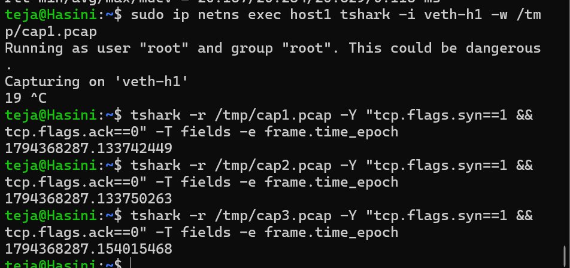
Figure 4. Absolute timestamps extracted from cap1, cap2, and cap3 for the same SYN packet.

6. Results – Retransmission and RTT Analysis

Step 12: Count TCP retransmission indications in each individual capture
tshark -r /tmp/cap1.pcap -Y "tcp.analysis.retransmission" 2>/dev/null | wc -l
tshark -r /tmp/cap2.pcap -Y "tcp.analysis.retransmission" 2>/dev/null | wc -l
tshark -r /tmp/cap3.pcap -Y "tcp.analysis.retransmission" 2>/dev/null | wc -l

Capture | Observed retransmission count
cap1 – Host1 | 0
cap2 – Router | 0
cap3 – Host2 | 0

No TCP retransmissions were identified by this filter in the three individual captures. This does not contradict the 1% loss configuration: packet loss is probabilistic, and a short capture may not contain a dropped packet that triggers TCP retransmission.
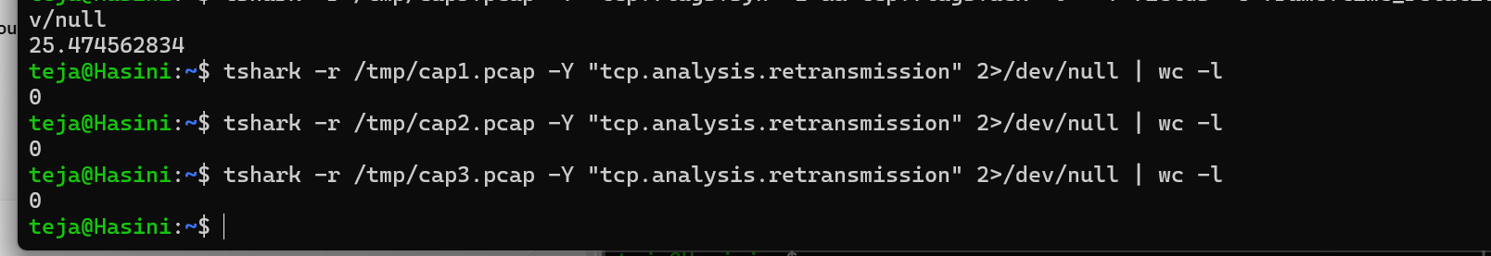
Figure 5. TShark retransmission counts: zero in cap1, cap2, and cap3.

Step 13: Measure RTT and path loss using MTR
sudo ip netns exec host1 mtr --report 10.0.2.2

Hop / Destination | Loss | Sent | Last (ms) | Avg (ms) | Best (ms) | Worst (ms) | StDev (ms)
10.0.1.2 | 0.0% | 10 | 0.1 | 0.1 | 0.0 | 0.2 | 0.1
10.0.2.2 | 0.0% | 10 | 20.2 | 20.3 | 20.2 | 20.4 | 0.1

The destination Host2 (10.0.2.2) showed an average RTT of 20.3 ms and 0.0% loss over 10 probes. This is consistent with the configured delay and the observed ping results.
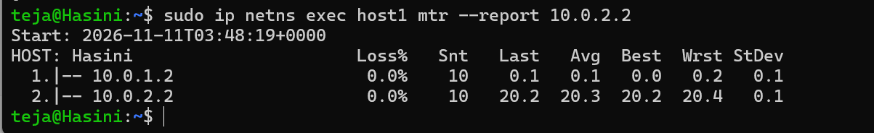
Figure 6. MTR report showing the route through 10.0.1.2 to 10.0.2.2 and an average destination RTT of 20.3 ms.

7. Wireshark Packet Inspection

Step 14: Open the router capture and apply a display filter
wireshark /tmp/cap2.pcap &

The display filter tcp.port == 1234 was applied to show the TCP session used for the message transfer. The packet list showed traffic from 10.0.1.1 to 10.0.2.2 and the reverse direction.
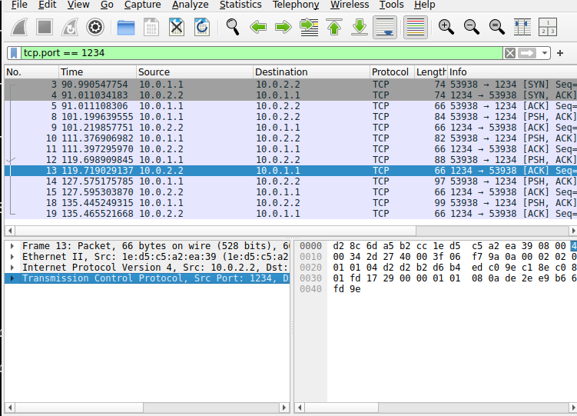
Figure 7. Wireshark view of the TCP session using the display filter tcp.port == 1234.

Step 15: Inspect the IPv4 TTL and TCP data
- A Host1-to-Host2 packet was selected in the packet list.
- The Internet Protocol Version 4 section showed Time to Live: 64 in the router-side capture.
- The TCP payload was visible in the Data section. The displayed hexadecimal payload corresponds to the message text.
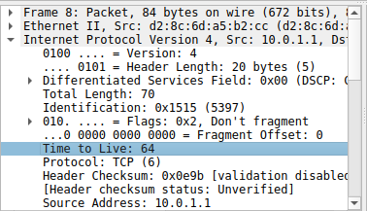 | 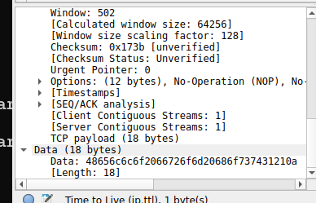
Figures 8–9. Wireshark packet details: IPv4 TTL = 64 and the TCP Data field containing the message payload in hexadecimal.

8. Merge and Final Wireshark Analysis

Step 16: Merge the three capture files
The captures were merged chronologically in Wireshark using File → Merge. cap1.pcap and cap3.pcap were merged into the open capture, which was saved as merged.pcapng.
The merged view showed 57 packets in total. With the display filter tcp.port == 1234, 39 packets (68.4%) were displayed.
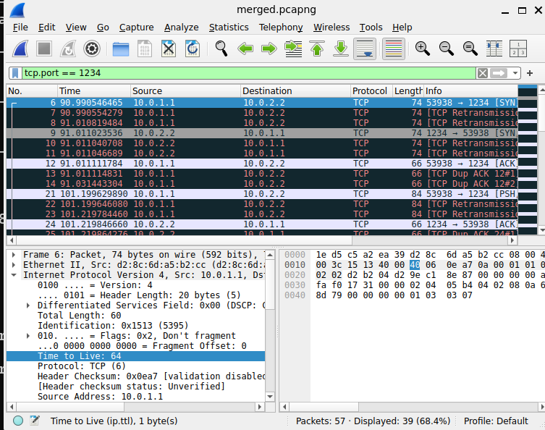
Figure 10. Merged capture merged.pcapng with the TCP display filter; Wireshark reports 57 packets total and 39 displayed.

Step 17: Add a TTL column
A custom packet-list column was added with the title TTL, type Custom, and field ip.ttl. The final packet list visibly displayed TTL values including 64 and 63.
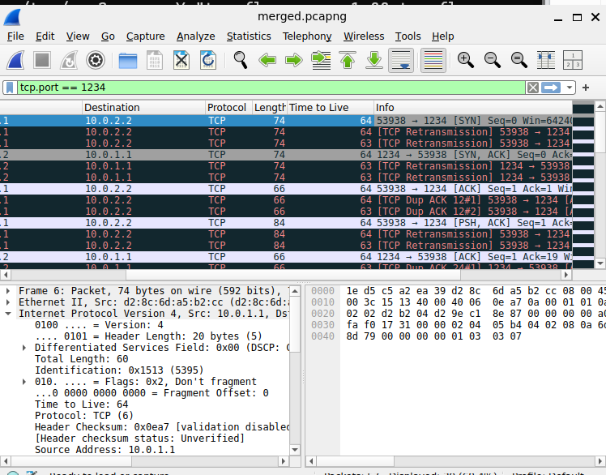
Figure 11. Final merged Wireshark packet list showing the custom Time to Live column.

9. Expert Information, Discussion and Conclusion

Step 18: Inspect Expert Information
The Wireshark Expert Information window displayed the following entries under the tcp.port == 1234 display filter:
- Duplicate ACK
- Ambiguous ACK following Karn's definition
- This frame is a (suspected) retransmission
- Connection establish acknowledge (SYN+ACK)
- Connection establish request (SYN)
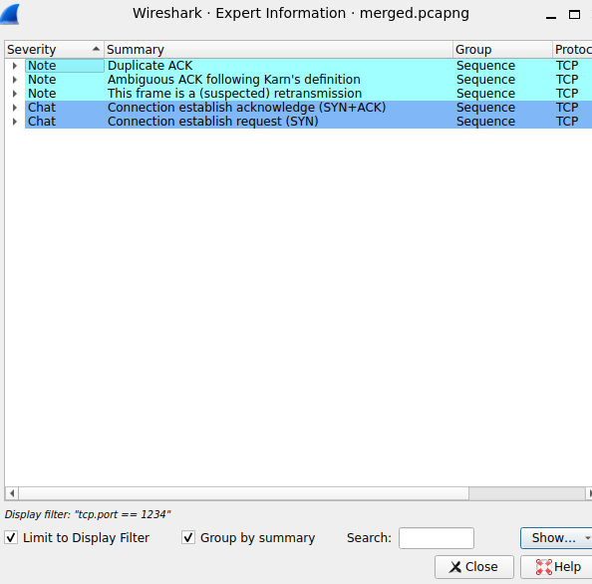
Figure 12. Wireshark Expert Information entries for the merged capture.

Discussion of observed results
- Connectivity was successful: the initial ping returned 3 transmitted, 3 received, and 0% packet loss.
- The router qdisc showed netem delay 20 ms and loss 1%. A later 10-packet ping showed 10 received and an average RTT of 20.284 ms.
- All three capture files were present and non-empty (approximately 2.3 KB each).
- The direction-filtered Host1-to-Host2 traffic at Host2 showed TTL 63, while the inspected router-side Host1-to-Host2 packet showed TTL 64. This is consistent with one router hop decrementing TTL by one.
- The router capture successfully revealed all five transmitted text lines after decoding the TCP payload.
- Absolute timestamps showed approximately 20.273 ms from cap1 to cap3, consistent with the configured 20 ms delay.
- The individual capture files each showed zero retransmissions. MTR also showed 0.0% loss over 10 probes.
- The merged capture's Expert Information included duplicate-ACK and suspected-retransmission notes. These are analyzer annotations in the merged view and should be interpreted alongside the individual capture counts; they do not, by themselves, prove a retransmission occurred on a particular link.

Conclusion
The Three-Point Capture experiment was completed using three Linux network namespaces connected through a router namespace. Packet captures were collected at Host1, the router, and Host2. The experiment demonstrated successful end-to-end TCP communication, extraction of the transmitted message, TTL decrement across the router, and an approximately 20 ms delay between the first and third observation points. Wireshark was used to inspect, merge, and analyse the capture files.

Limitations / observations
The configured 1% packet loss did not produce observed loss in the short ping/MTR samples, and no retransmissions were counted in the individual PCAP files. This is possible because netem loss is probabilistic. A longer test with more packets may be needed to observe an actual dropped packet and TCP recovery.

Cleanup (after preserving the capture files)
sudo ip netns del host1
sudo ip netns del router
sudo ip netns del host2
sudo ip netns list

The supplied handout specifies that the final ip netns list should be blank after cleanup. The screenshots provided for this record do not show this cleanup being executed; run it only after saving the PCAP files and any required screenshots.

Reference
CNNP – Skill 2 lab handout, “Three-Point Capture – Analyze packet captures from three points in a network path to understand packet flow and identify performance differences” (supplied 33-page PDF).

