KLH UNIVERSITY
BACHUPALLY CAMPUS
CNNP LAB RECORD
SKILL 3
QUEUEING CURVE, LITTLE'S LAW,
AND BUFFER ANALYSIS
Identify the queueing threshold (knee), examine buffer behavior,
and experimentally validate Little's Law.

Record Details | Information
Student Name | Teja Hasini Reddy
Roll Number | 2520030048
Course / Lab | CNNP – Skill 3
Cluster | 2
Academic Year | 2026–2027
Date of Experiment | 13 November 2026

LAB RECORD

1. Experiment Overview

Aim
To study network queueing behavior, identify the queueing threshold (knee), examine buffer behavior under different traffic loads, and experimentally estimate Little's Law using packet and delay measurements.

Objectives
- Create an isolated sender–router–receiver network using Linux network namespaces and virtual Ethernet links.
- Configure IPv4 addresses, routing, and IP forwarding between the namespaces.
- Use iperf3 to generate UDP traffic at different offered rates.
- Apply a 5 Mbps Token Bucket Filter (TBF) bottleneck on the router's outgoing interface.
- Compare receiver throughput, UDP jitter, and packet loss as the offered traffic increases.
- Change the TBF buffer limit to 16 KB, 64 KB, and 256 KB and compare the observed results.
- Measure baseline and loaded ping behavior and use the results to estimate queueing delay.
- Apply Little's Law, L = λW, as an approximate queue-occupancy estimate.

Software and Tools Used
Tool | Purpose
Ubuntu / Linux terminal | Run namespaces, routing, traffic-control and test commands.
iproute2 (ip) | Create namespaces, veth interfaces, addresses and routes.
tc (Traffic Control) | Configure and inspect the TBF queueing discipline.
iperf3 | Generate UDP traffic and measure throughput, jitter and packet loss.
ping | Measure reachability, round-trip time and packet loss.
Wireshark | Specified in the handout for packet capture and I/O graph analysis; no capture file was present in the supplied screenshots.

Theory
Queueing occurs when packets arrive at a router faster than the outgoing interface can transmit them. The router temporarily stores packets in a buffer. When the buffer fills, additional packets are dropped.
A bottleneck is the link or device that limits the end-to-end data rate. In this experiment, the router's outgoing interface is shaped to 5 Mbps using the Token Bucket Filter (TBF). When offered UDP traffic exceeds this rate, receiver throughput stops increasing in proportion to the offered load and packet loss rises.
The queueing threshold, or knee, is the region where delay begins to rise sharply as load approaches capacity. The available measurements clearly show a throughput plateau and rising packet loss near the 5 Mbps bottleneck. Per-load average queueing-delay readings were not captured, so the precise delay-based knee cannot be plotted from the supplied evidence.
Little's Law relates average number of packets in a system (L), arrival rate (λ), and average time spent in the system (W):
L = λ × W
For this record, the admitted packet rate is estimated from the iperf3 receiver count, while the additional ping RTT is used as an approximate delay indicator. This provides an estimate, not an independent time-average queue measurement.

2. Network Topology and Addressing
SENDER → ROUTER (5 Mbps TBF) → RECEIVER
Node / Namespace | Interface | IPv4 Address | Role
sender | veth-s | 192.168.10.2/24 | Traffic source
router | veth-r0 | 192.168.10.1/24 | Sender-side router interface
router | veth-r1 | 192.168.20.1/24 | Receiver-side / shaped interface
receiver | veth-rx | 192.168.20.2/24 | iperf3 server

Two veth pairs connect the namespaces: veth-s ↔ veth-r0 and veth-r1 ↔ veth-rx. The TBF queueing discipline is attached to router interface veth-r1, which is the outgoing interface toward the receiver.

3. Procedure and Commands Executed

Step 1: Create the network namespaces
sudo ip netns add sender
sudo ip netns add router
sudo ip netns add receiver
sudo ip netns list
Three isolated network namespaces named sender, router and receiver were created. The namespace list confirmed that all three were present.

Step 2: Create and assign virtual Ethernet pairs
sudo ip link add veth-s type veth peer name veth-r0
sudo ip link add veth-r1 type veth peer name veth-rx

sudo ip link set veth-s netns sender
sudo ip link set veth-r0 netns router
sudo ip link set veth-r1 netns router
sudo ip link set veth-rx netns receiver
Virtual Ethernet pairs provide point-to-point links between the namespaces. The router has one interface connected to the sender and another connected to the receiver.

Step 3: Assign IPv4 addresses
sudo ip -n sender addr add 192.168.10.2/24 dev veth-s
sudo ip -n router addr add 192.168.10.1/24 dev veth-r0
sudo ip -n router addr add 192.168.20.1/24 dev veth-r1
sudo ip -n receiver addr add 192.168.20.2/24 dev veth-rx

Step 4: Bring interfaces up and configure routes
sudo ip -n sender link set lo up
sudo ip -n router link set lo up
sudo ip -n receiver link set lo up

sudo ip -n sender link set veth-s up
sudo ip -n router link set veth-r0 up
sudo ip -n router link set veth-r1 up
sudo ip -n receiver link set veth-rx up

sudo ip -n sender route add 192.168.20.0/24 via 192.168.10.1
sudo ip -n receiver route add 192.168.10.0/24 via 192.168.20.1

Step 5: Enable IPv4 forwarding and test connectivity
sudo ip netns exec router sysctl -w net.ipv4.ip_forward=1
sudo ip netns exec sender ping -c 4 192.168.20.2
The router reported net.ipv4.ip_forward = 1. The four-packet ping test returned four replies with 0% packet loss. The measured average RTT in that short test was 0.121 ms.

Step 6: Configure the 5 Mbps TBF bottleneck
sudo ip netns exec router tc qdisc replace dev veth-r1 root tbf rate 5mbit burst 32kb limit 64kb
sudo ip netns exec router tc -s qdisc show dev veth-r1
Parameter | Configured value | Meaning
rate | 5mbit | Maximum shaped transmission rate
burst | 32kb | Permitted token-bucket burst size
limit | 64kb | Initial maximum queued data limit
qdisc | tbf | Token Bucket Filter queueing discipline

Step 7: Start the iperf3 receiver
sudo ip netns exec receiver iperf3 -s
sudo ip netns exec receiver ss -lntp | grep 5201
The receiver listened on TCP port 5201 for iperf3 control connections. A later attempt to start a second server returned 'Address already in use'; the ss command confirmed that an iperf3 process was already listening, so the existing server was used.

Step 8: Generate UDP traffic at different offered rates
sudo ip netns exec sender iperf3 -c 192.168.20.2 -u -b 1M -l 1200 -t 30 -i 1
sudo ip netns exec sender iperf3 -c 192.168.20.2 -u -b 2M -l 1200 -t 30 -i 1
sudo ip netns exec sender iperf3 -c 192.168.20.2 -u -b 4M -l 1200 -t 30 -i 1
sudo ip netns exec sender iperf3 -c 192.168.20.2 -u -b 5M -l 1200 -t 30 -i 1
sudo ip netns exec sender iperf3 -c 192.168.20.2 -u -b 7M -l 1200 -t 30 -i 1
sudo ip netns exec sender iperf3 -c 192.168.20.2 -u -b 10M -l 1200 -t 30 -i 1
The -u option selects UDP, -b specifies the offered bitrate, -l 1200 sets the UDP payload size to 1200 bytes, -t 30 runs the test for 30 seconds, and -i 1 prints one-second intervals.

Step 9: Inspect queue statistics
sudo ip netns exec router tc -s qdisc show dev veth-r1
The tc output reports transmitted bytes and packets, dropped packets, overlimits and backlog. A zero backlog in a snapshot means no packets were waiting at that instant; it does not mean the queue never filled during the test.

Step 10: Repeat the 10 Mbps test with different buffer limits
# Small buffer
sudo ip netns exec router tc qdisc replace dev veth-r1 root tbf rate 5mbit burst 32kb limit 16kb

# Medium buffer
sudo ip netns exec router tc qdisc replace dev veth-r1 root tbf rate 5mbit burst 32kb limit 64kb

# Large buffer
sudo ip netns exec router tc qdisc replace dev veth-r1 root tbf rate 5mbit burst 32kb limit 256kb

# Repeat the same offered-load test after each change
sudo ip netns exec sender iperf3 -c 192.168.20.2 -u -b 10M -l 1200 -t 30 -i 1
The offered UDP rate and duration were kept at 10 Mbps and 30 seconds while the TBF limit was changed. This makes the buffer-limit results comparable.

Step 11: Compare baseline and loaded ping
# Baseline ping
sudo ip netns exec sender ping -c 20 192.168.20.2

# Continuous ping while the network is under UDP load
sudo ip netns exec sender ping 192.168.20.2
# Stop the continuous ping with Ctrl+C after the test

4. Results and Observations

4.1 Queueing-curve traffic tests
Offered load | Receiver throughput | Packet loss | iperf3 jitter | Observation
1 Mbps | 0.999 Mbps | 0% | 0.037 ms | Traffic received successfully.
2 Mbps | 2.00 Mbps | 0% | 0.123 ms | Throughput follows offered load.
4 Mbps | 4.00 Mbps | 0% | 0.029 ms | Still below the 5 Mbps bottleneck.
5 Mbps | 4.84 Mbps | 2.9% | 0.461 ms | Loss begins near the bottleneck.
7 Mbps | 4.84 Mbps | 31% | 0.443 ms | Throughput plateaus; congestion increases.
10 Mbps | 4.84 Mbps | 51% | 0.173 ms | Offered rate is about twice the shaped rate.

The jitter column is the UDP jitter reported by iperf3. It is not the same as average queueing delay. The handout's delay-versus-offered-load graph requires separate delay readings at each offered rate; those readings were not present in the supplied terminal screenshots.
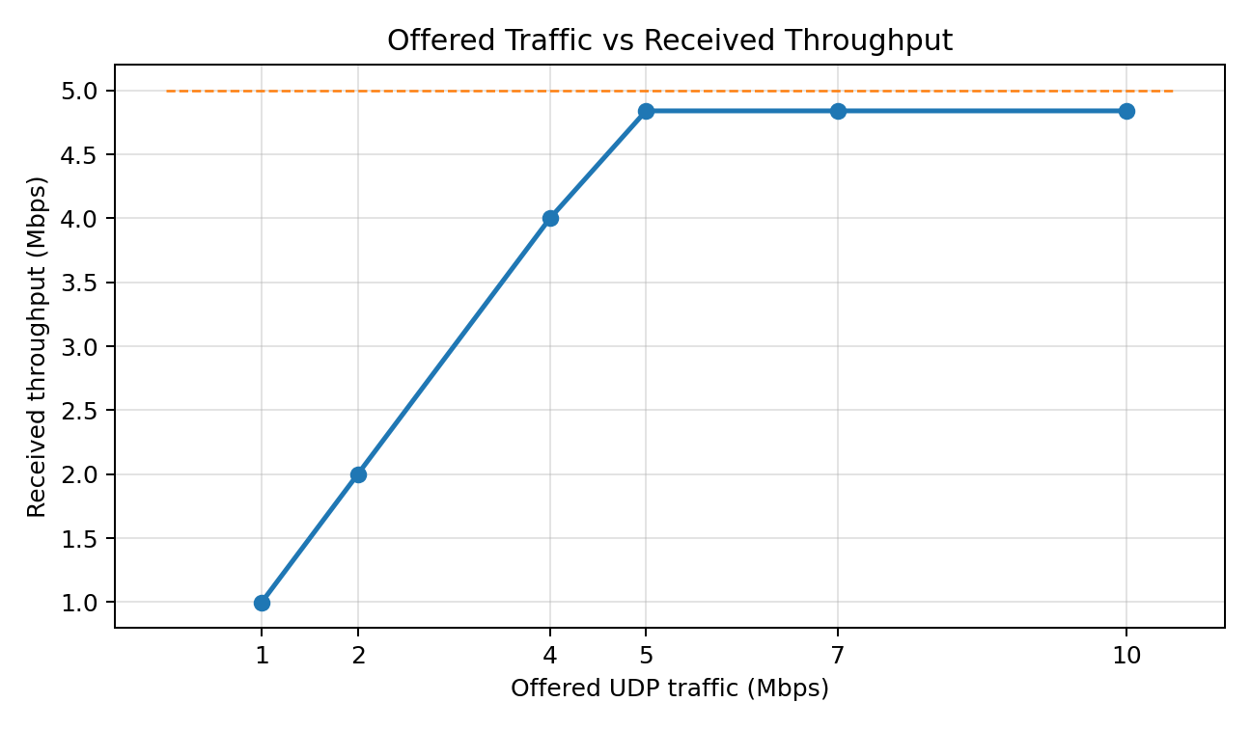
Figure 1. Measured offered UDP traffic versus received throughput. The receiver rate plateaus near 4.84 Mbps.

Interpretation of the queueing curve
- At 1, 2 and 4 Mbps, receiver throughput closely matches the offered traffic and packet loss is 0%.
- At 5 Mbps, the receiver throughput reaches approximately 4.84 Mbps and packet loss begins (2.9%).
- At 7 and 10 Mbps, receiver throughput remains approximately 4.84 Mbps while packet loss rises to 31% and 51%.
- The throughput and loss measurements indicate the onset of congestion around the configured 5 Mbps bottleneck. This is an approximate throughput-based knee indicator; the exact delay-based knee requires per-load queueing-delay measurements.

4.2 TBF buffer analysis
TBF buffer limit | Offered UDP rate | Receiver throughput | Packet loss | iperf3 jitter
16 KB | 10 Mbps | 4.84 Mbps | 52% | 0.185 ms
64 KB | 10 Mbps | 4.84 Mbps | 51% | 0.173 ms
256 KB | 10 Mbps | 4.84 Mbps | 51% | 0.313 ms

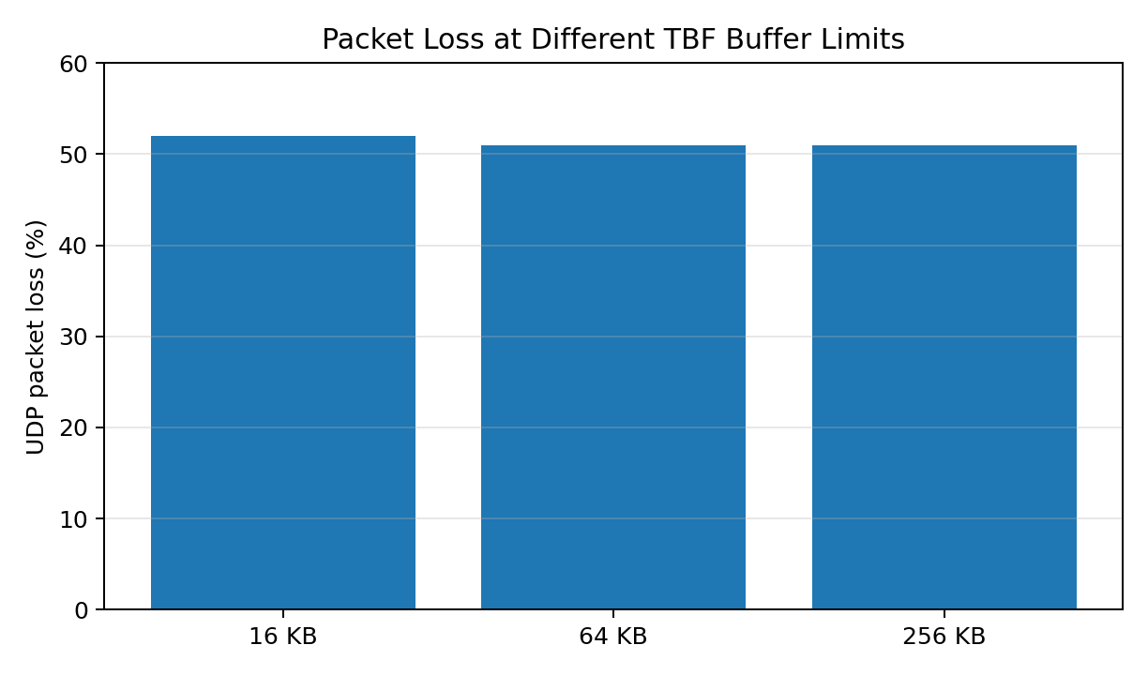
Figure 2. Packet loss reported by iperf3 for the three TBF buffer limits.
All three buffer settings produced approximately the same receiver throughput because the bottleneck rate remained fixed at 5 Mbps. Packet loss changed only slightly: 52% at 16 KB and approximately 51% at 64 KB and 256 KB. The 256 KB run reported higher jitter than the 16 KB and 64 KB runs. A larger buffer can hold more queued packets, but this can increase waiting time when the queue is persistently occupied.

4.3 Router TBF statistics
Observed qdisc snapshot | Sent bytes | Sent packets | Dropped packets | Overlimits | Backlog
5 Mbps, burst 32 KB; 64 KB limit snapshot | 83,724,500 | 67,512 | 23,228 | 156,893 | 0 B / 0 p
5 Mbps, burst 32 KB; 256 KB limit snapshot | 140,632,619 | 113,537 | 71,203 | 341,623 | 0 B / 0 p

These are the cumulative counters shown by tc at the times of the screenshots. They are not independent per-run drop totals and should not be used as a direct one-to-one comparison of the three buffer settings.

4.4 Ping delay and packet loss
Condition | Packets sent | Packets received | Packet loss | Average RTT | Maximum RTT
Baseline (20-packet ping) | 20 | 20 | 0% | 0.116 ms | 0.191 ms
During sustained UDP load | 161 | 138 | 14.2857% | 20.129 ms | 417.836 ms

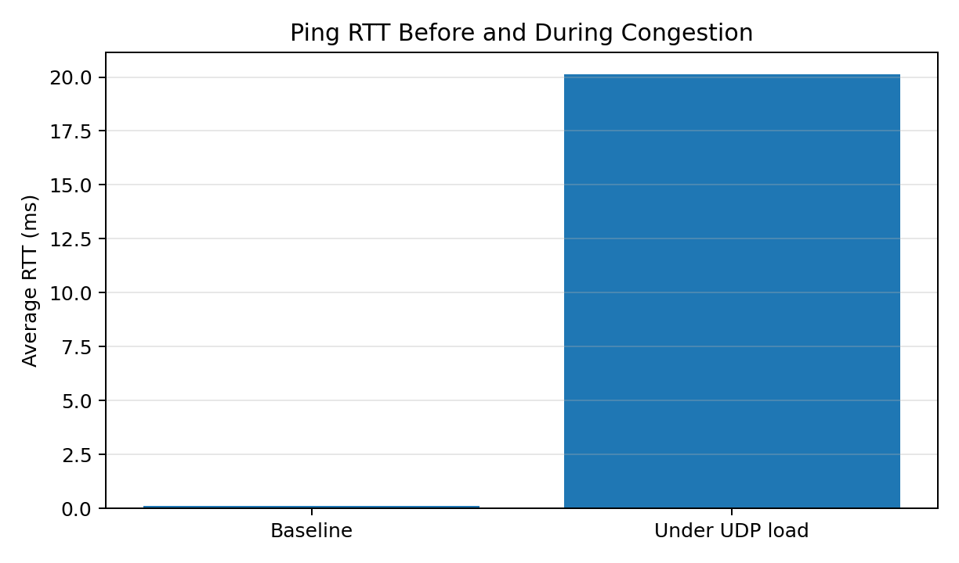
Figure 3. Average ping RTT before and during heavy UDP traffic.
The average RTT increased from 0.116 ms at baseline to 20.129 ms under load. The loaded ping also showed a maximum RTT of 417.836 ms and 14.2857% packet loss. This indicates substantial delay variation and packet loss while the bottleneck is congested.

5. Little's Law – Approximate Calculation
Little's Law is L = λ × W, where λ is the admitted packet arrival rate in packets per second, W is the average time in the system in seconds, and L is the average number of packets in the system.
Parameter | Value used | Basis
Received datagrams in 5 Mbps test | 15,175 packets | 15,626 total minus 451 lost
Receiver test duration | 30.11 s | iperf3 receiver summary
Estimated admitted packet rate (λ) | ≈ 504 packets/s | 15,175 ÷ 30.11
Baseline average RTT | 0.116 ms | 20-packet ping
Loaded average RTT | 20.129 ms | Ping during sustained UDP load
Estimated additional delay (W) | 20.013 ms = 0.020013 s | 20.129 − 0.116 ms

L = λ × W = 504 × 0.020013 ≈ 10.09 packets
The calculated value is an approximate Little's Law estimate. It treats the additional ping RTT as an approximate queueing-delay indicator, following the simplified method described in the handout. The handout also asks for an independent time-average queue occupancy measurement by periodically sampling tc backlog and comparing it with L. Such periodic backlog samples and a Wireshark packet capture were not included in the screenshots supplied for this record; therefore, the independent validation portion is indicative rather than complete.

6. Discussion
- The sender, router and receiver namespaces communicated successfully through the configured veth links and routes.
- The four-packet connectivity test returned 4 replies with 0% packet loss, confirming the routed path.
- TBF successfully shaped the router's outgoing traffic to a configured rate of 5 Mbps.
- For offered traffic below the bottleneck, the received rate closely followed the offered rate.
- When the offered rate reached or exceeded the bottleneck, receiver throughput remained close to 4.84 Mbps and packet loss increased.
- Changing the buffer limit from 16 KB to 256 KB did not materially increase receiver throughput; the rate remained limited by TBF.
- Loaded ping measurements showed a much higher average RTT and occasional large delay spikes compared with baseline.
- The observed tc counters confirmed packet drops and overlimits, while the post-test backlog snapshots showed zero queued packets at the instant of sampling.

7. Conclusion
The experiment successfully created a sender–router–receiver network using Linux namespaces, configured IPv4 routing and forwarding, verified connectivity, and applied a 5 Mbps TBF bottleneck. iperf3 tests demonstrated that receiver throughput followed the offered rate at low traffic loads but plateaued near 4.84 Mbps as the offered load reached and exceeded the bottleneck. Packet loss increased from 0% at 1–4 Mbps to 2.9% at 5 Mbps, 31% at 7 Mbps and 51% at 10 Mbps. Buffer-limit tests showed similar throughput and packet loss across 16 KB, 64 KB and 256 KB settings, while loaded ping results showed a substantial increase in RTT. Little's Law produced an approximate queue-occupancy estimate of 10.09 packets. Independent time-averaged queue sampling and Wireshark capture analysis remain necessary for a complete quantitative validation of every part of the handout.

8. Limitations and Data Notes
- The supplied screenshots do not contain a saved Wireshark .pcapng file or an I/O Graph screenshot.
- Average queueing delay was not separately measured for every offered traffic rate; iperf3 jitter is reported separately and is not substituted for queueing delay.
- The tc counters shown are cumulative snapshots, not isolated drop counts for each buffer-limit run.
- The average queue backlog was not sampled periodically during each test. A zero backlog after a test is only an instantaneous observation.
- The Little's Law result is therefore an estimate based on the available iperf3 and ping measurements.

9. Viva Questions and Answers
Q. What is queueing in a computer network?
A. Queueing is the temporary storage of packets when they arrive faster than an outgoing link can transmit them.
Q. What is a bottleneck?
A. A bottleneck is the network component or link that limits the overall throughput.
Q. What is the knee point?
A. The knee point is the load region where delay begins to rise sharply as the system approaches capacity.
Q. What is TBF?
A. Token Bucket Filter is a traffic-control mechanism that limits the transmission rate while allowing a configured burst.
Q. What is the purpose of a router buffer?
A. It temporarily stores packets waiting for transmission on an outgoing interface.
Q. What happens when a buffer becomes full?
A. New packets may be dropped, resulting in packet loss.
Q. What is throughput?
A. Throughput is the amount of data successfully delivered per unit time.
Q. What is packet loss?
A. Packet loss occurs when transmitted packets fail to reach the destination.
Q. State Little's Law.
A. Little's Law is L = λW, where L is average number in the system, λ is arrival rate and W is average time in the system.
Q. What is iperf3 used for?
A. iperf3 generates network traffic and measures throughput, jitter and packet loss.
Q. What is Wireshark used for?
A. Wireshark captures and analyses packets to inspect protocol fields and traffic behavior.
Q. What is bufferbloat?
A. Bufferbloat is excessive latency caused by persistently large queues in network devices.

Appendix A. Terminal Screenshots
The following screenshots are included as evidence of the commands and measurements recorded during execution.
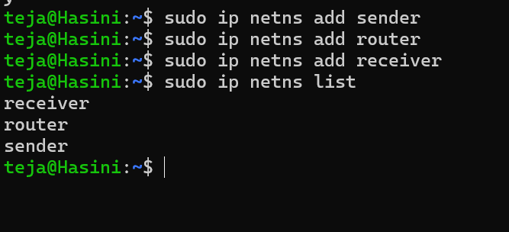
Figure A1. Creation and verification of sender, router and receiver namespaces.

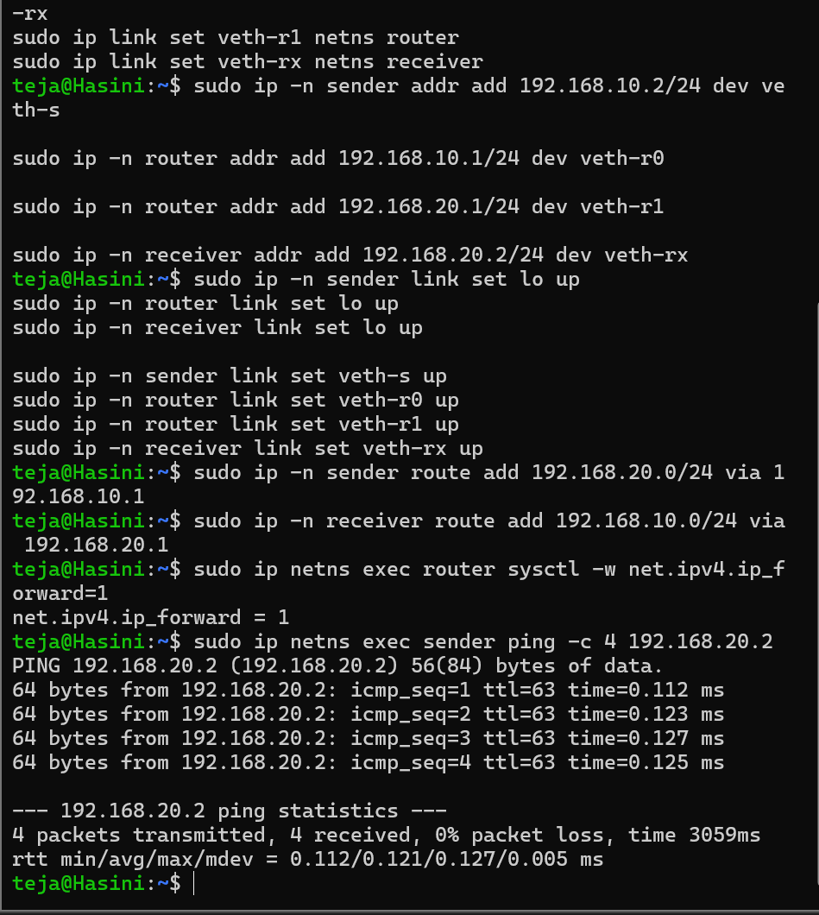
Figure A2. IP address configuration, routes, IP forwarding and successful ping test.

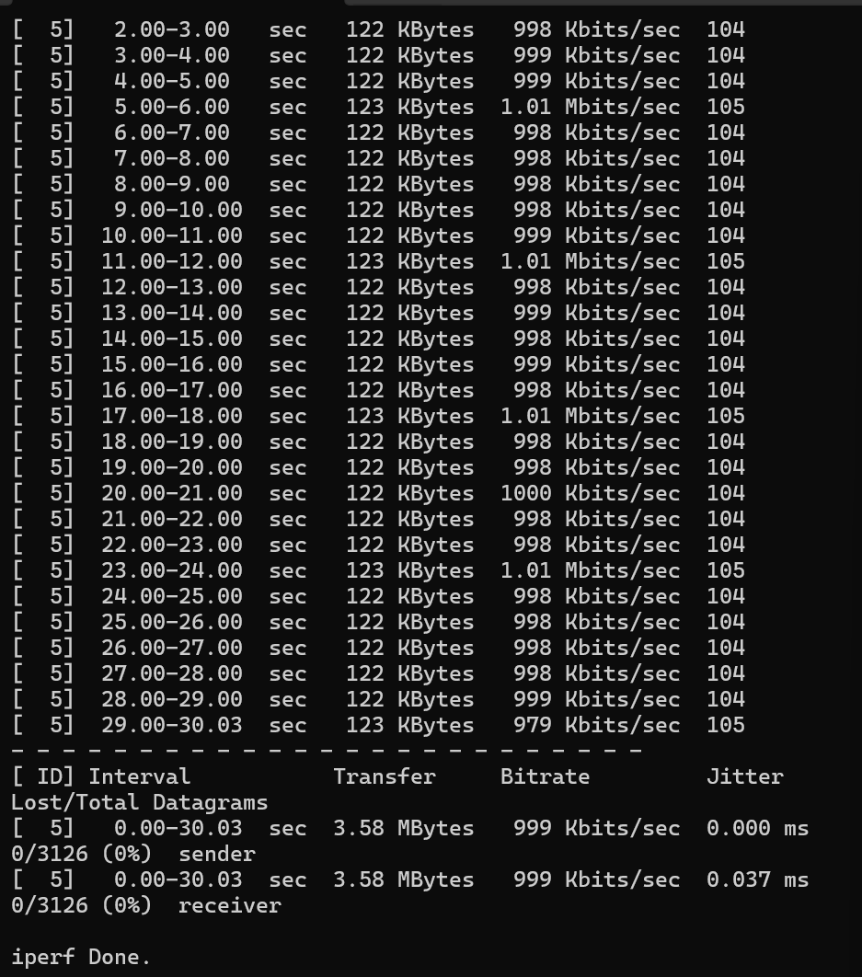
Figure A3. iperf3 UDP test at 1 Mbps: 999 Kbps received and 0% packet loss.

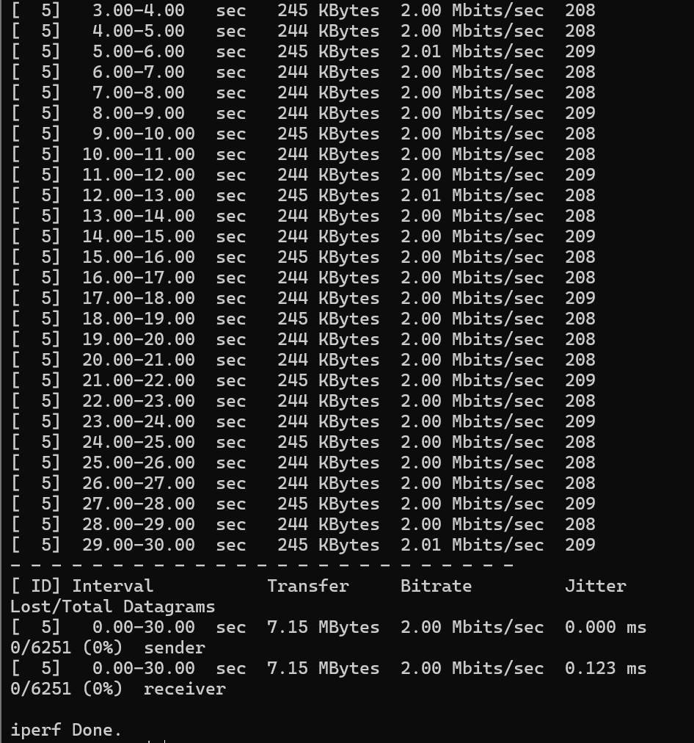
Figure A4. iperf3 UDP test at 2 Mbps: 2.00 Mbps received and 0% packet loss.

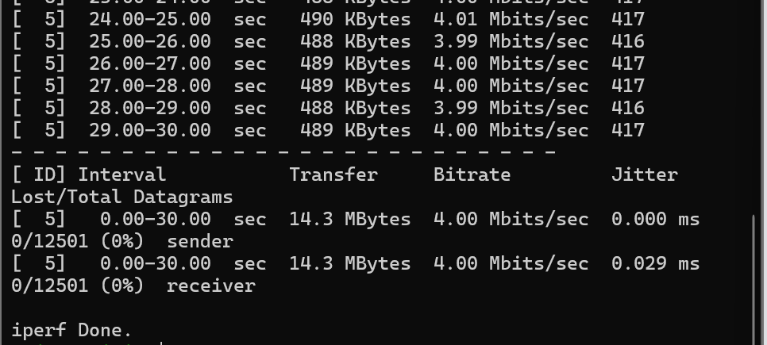
Figure A5. iperf3 UDP test at 4 Mbps: 4.00 Mbps received and 0% packet loss.

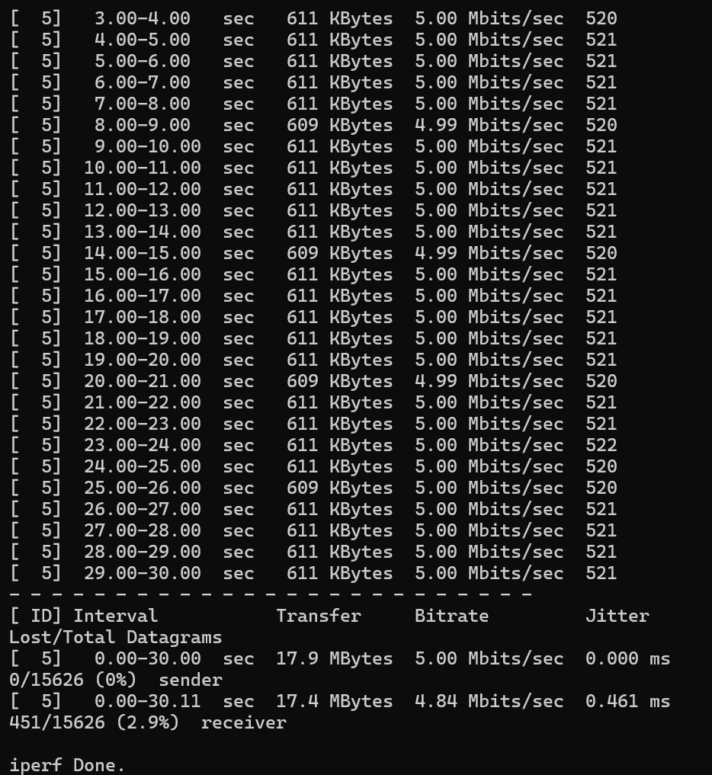
Figure A6. iperf3 UDP test at 5 Mbps: 4.84 Mbps received and 2.9% packet loss.

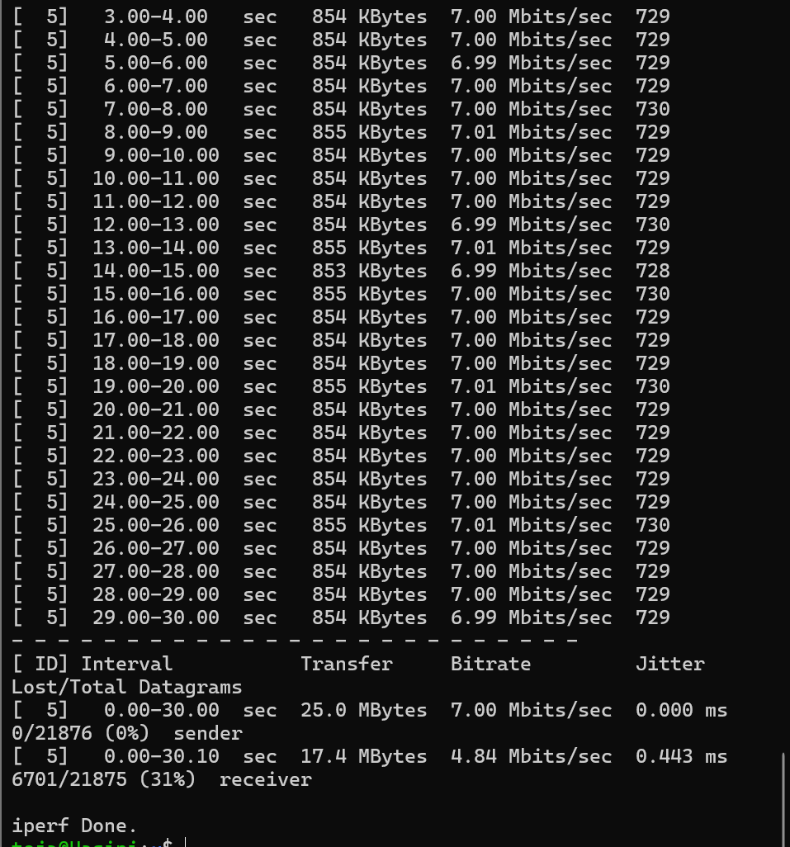
Figure A7. iperf3 UDP test at 7 Mbps: 4.84 Mbps received and 31% packet loss.

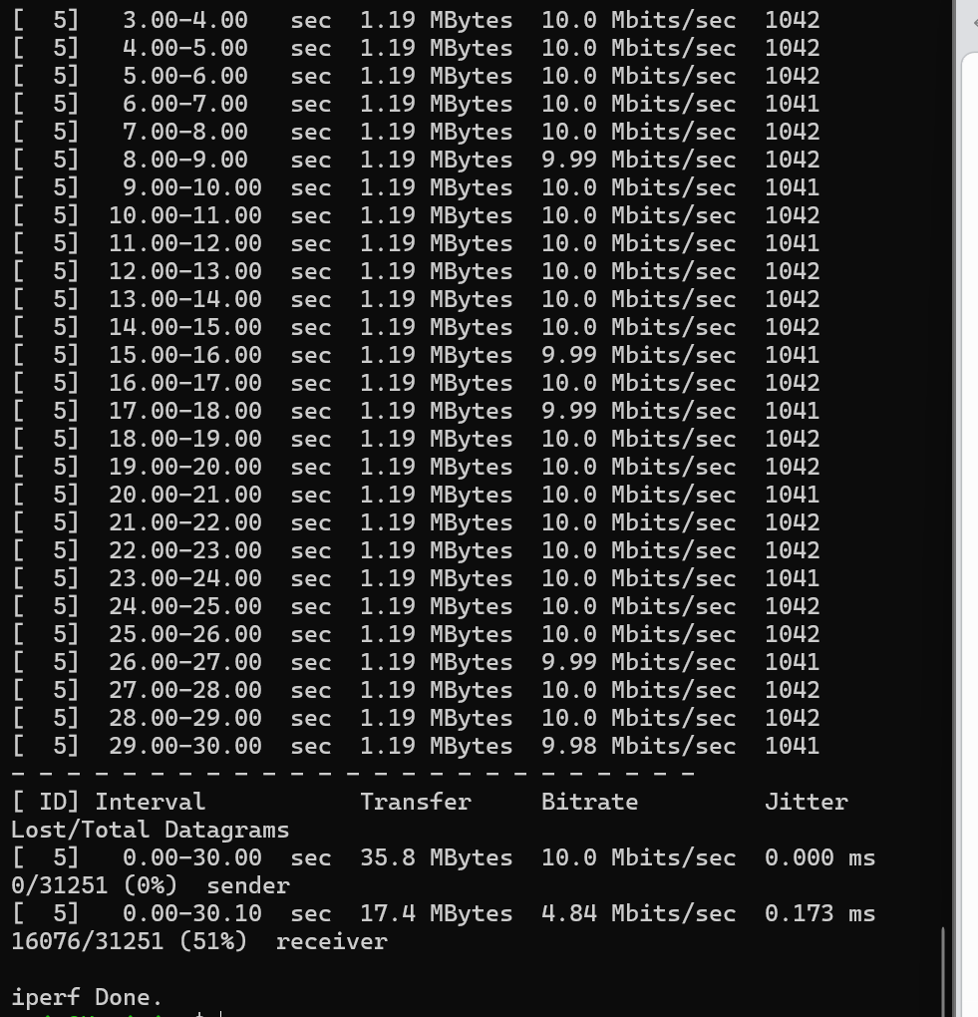
Figure A8. iperf3 UDP test at 10 Mbps: 4.84 Mbps received and 51% packet loss.

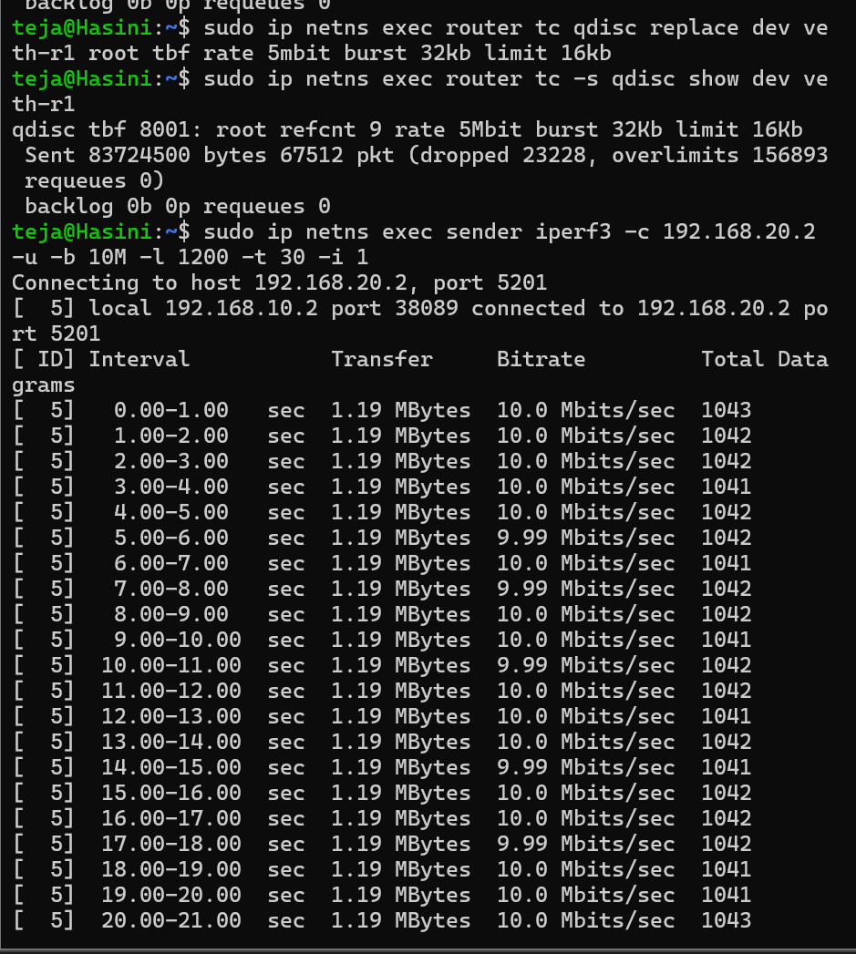
Figure A9. TBF queue changed to 16 KB and the 10 Mbps UDP test executed.

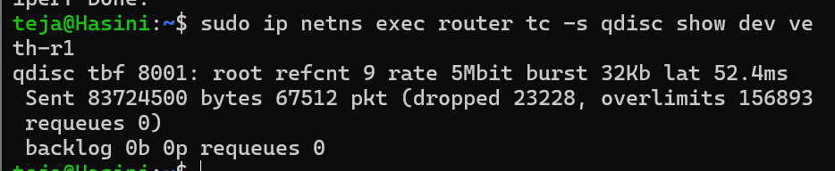
Figure A10. TBF statistics snapshot showing sent packets, drops, overlimits and backlog.

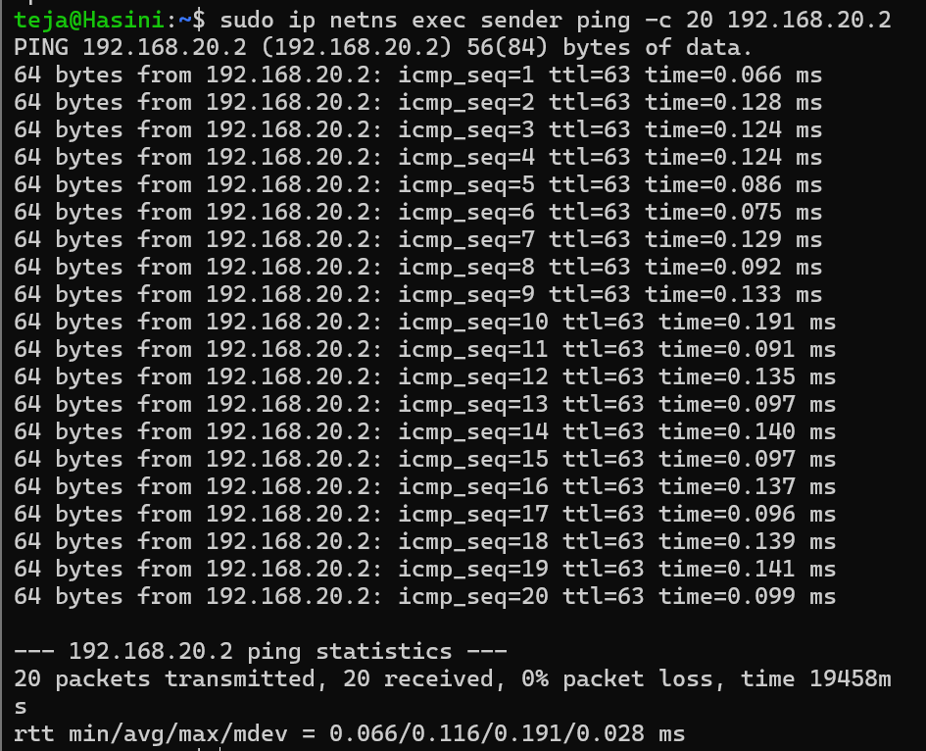
Figure A11. Baseline ping measurements.

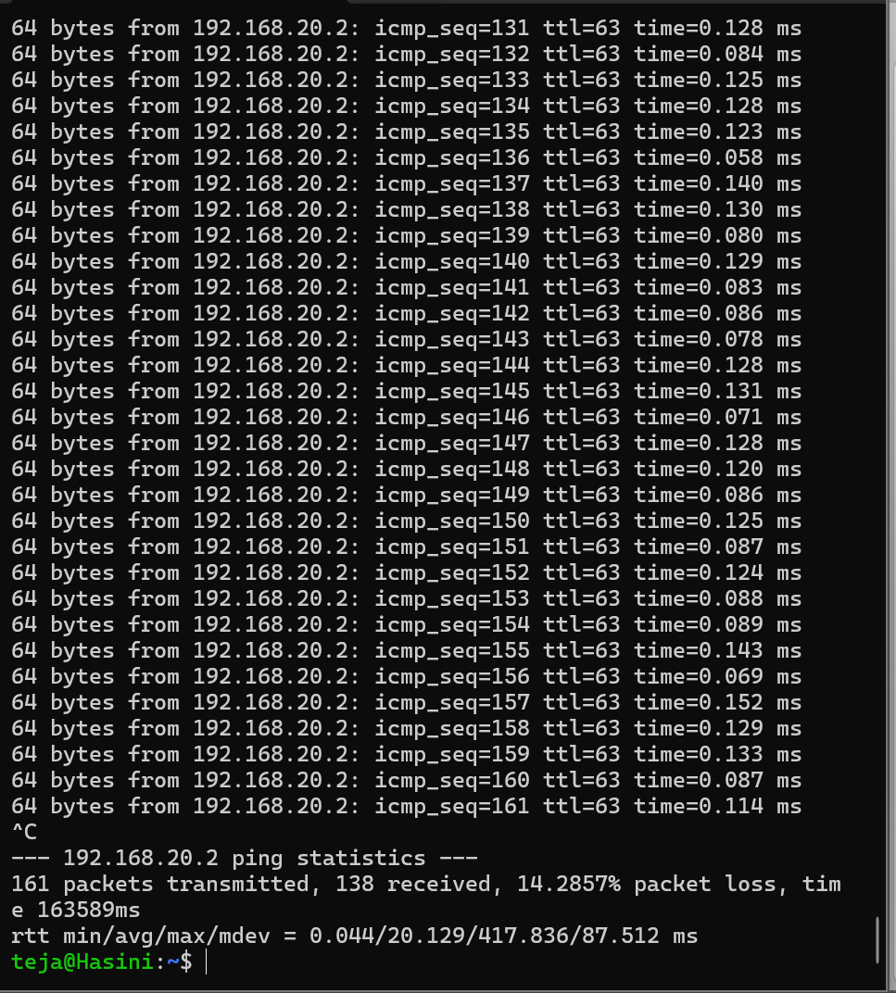
Figure A12. Ping statistics observed during sustained traffic load.

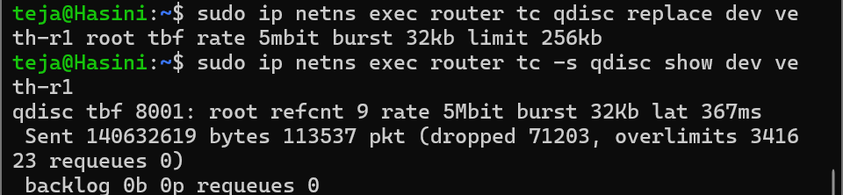
Figure A13. TBF queue changed to a 256 KB buffer limit and qdisc statistics checked.

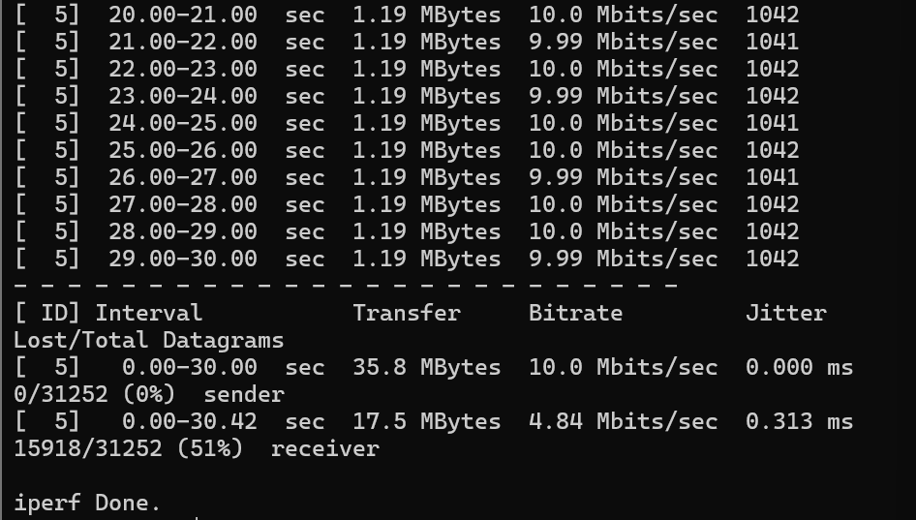
Figure A14. Final 10 Mbps UDP test summary for the 256 KB buffer setting.

Reference
SKILL–3: “Queueing Curve, Little's Law, and Buffer Analysis – Identify the queueing threshold (knee), examine buffer behavior, and experimentally validate Little's Law.” Supplied CNNP Skill-3 laboratory handout.
.

