NAME – TEJA HASINI REDDY
ROLL NUMBER – 2520030048

QUERY 1-
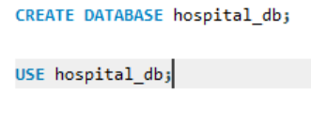
OUTPUT-
QUERY2-
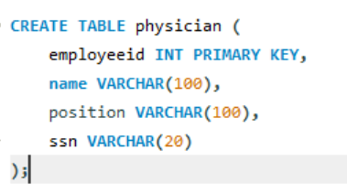
OUTPUT-
QUERY3-
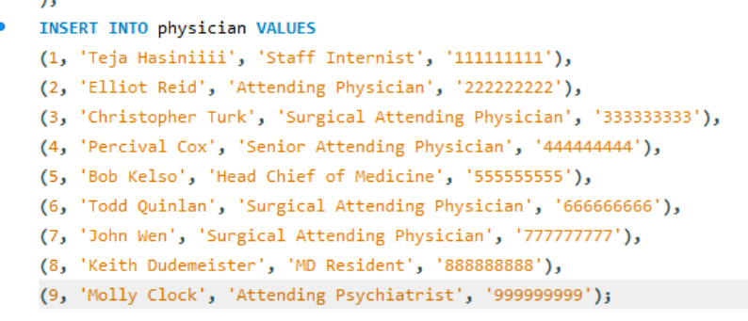
OUTPUT-
QUERY4-
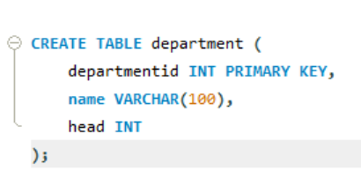
OUTPUT -
QUERY5-
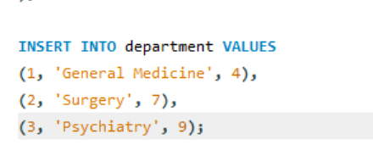
OUTPUT-
QUESTION1 – INNER JOIN
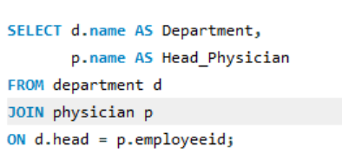
OUTPUT-

QUESTION2 – WHERE CLAUSE
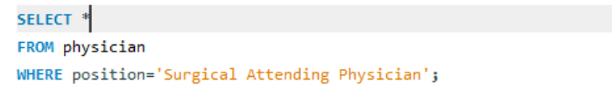
OUTPUT-
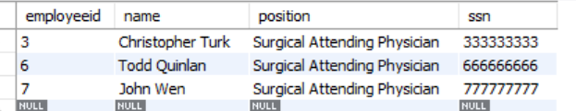
QUESTION3 – WHERE + LIKE
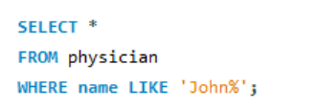
OUTPUT-
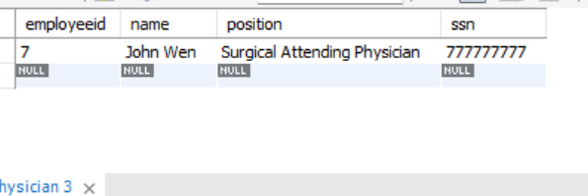
QUESTION4 –

OUTPUT-


QUESTION5-

OUTPUT –
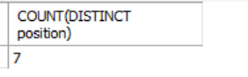
QUESTION6-
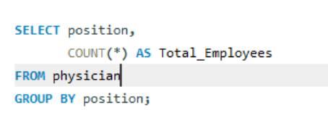
OUTPUT-


QUESTION7-
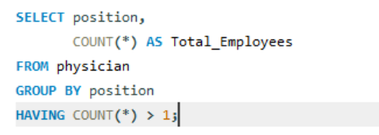
OUTPUT-


QUESTION8-
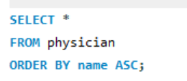
OUTPUT-
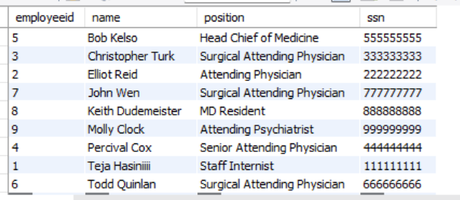

QUESTION9-
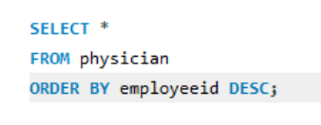
OUTPUT-
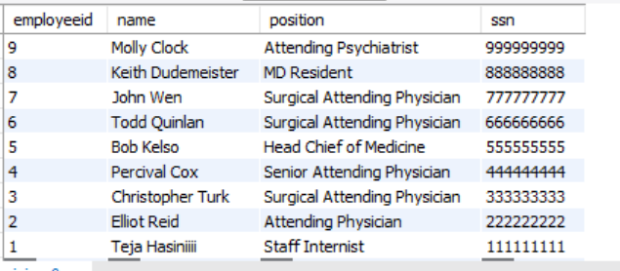
QUESTION10-
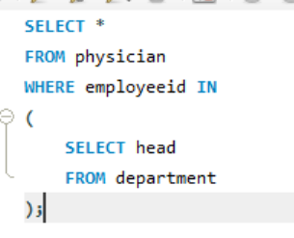
OUTPUT-
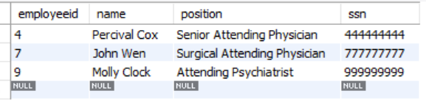
QUESTION11-
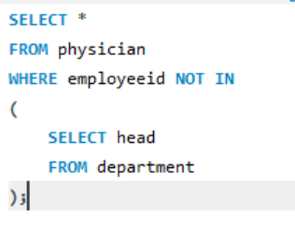
OUTPUT-
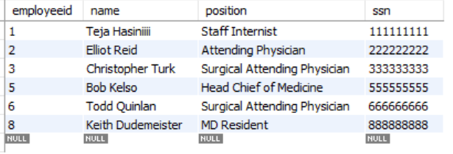
QUESTION12-
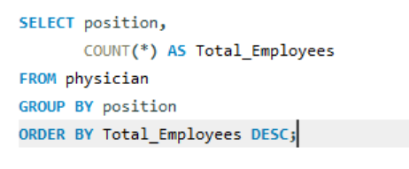
OUTPUT-

QUETSION13-
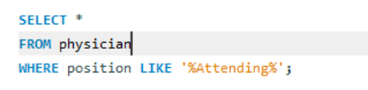
OUTPUT-
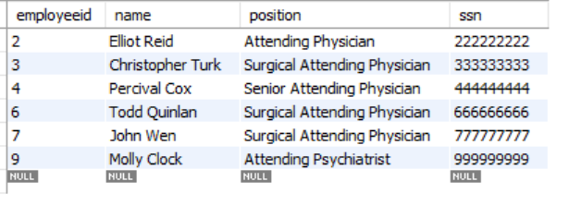
QUESTION14-
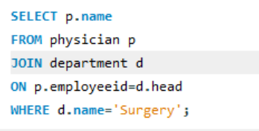
OUTPUT-

QUESTION15-
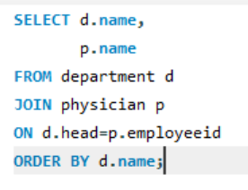
OUTPUT-
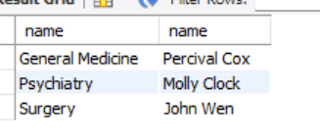
QUESTION 16-
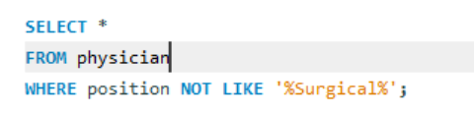
OUTPUT-
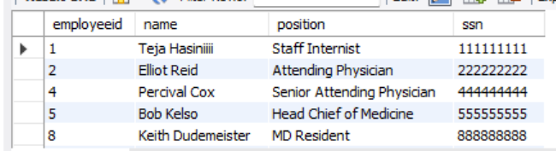
QUESTION17-
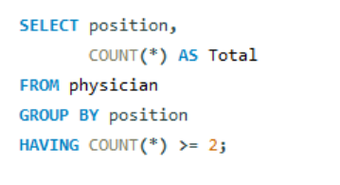
OUTPUT-
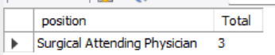
QUESTION18-
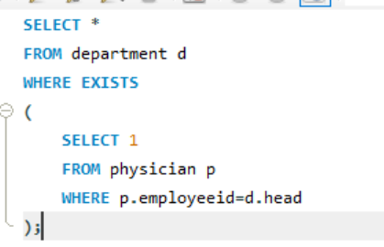
OUTPUT-

QUESTION19-

OUTPUT-

QUESTION20-
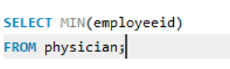
OUTPUT-
