DATABASE SYSTEM ENGINEERING AND DISTRIBUTED BACKEND DEVELOPMENT

SKILL SESSION 5 — LAB RECORD

Student Name | Teja Hasini Reddy
Roll Number | 2520030048
Section | 7
Course | Database System Engineering and Distributed Backend Development (25CS1302E)
Experiment Title | Bank Transaction Management Using MongoDB Atlas — Aggregation Pipelines
Platform | MongoDB Atlas — Aggregation Pipeline Builder
Database | bankdb
4. Aggregation Queries (Q12 – Q20)

Query 12: Sort Customers by Balance (Descending)
Collection: customers Stage 1 — $sort:
{ "balance": -1 }
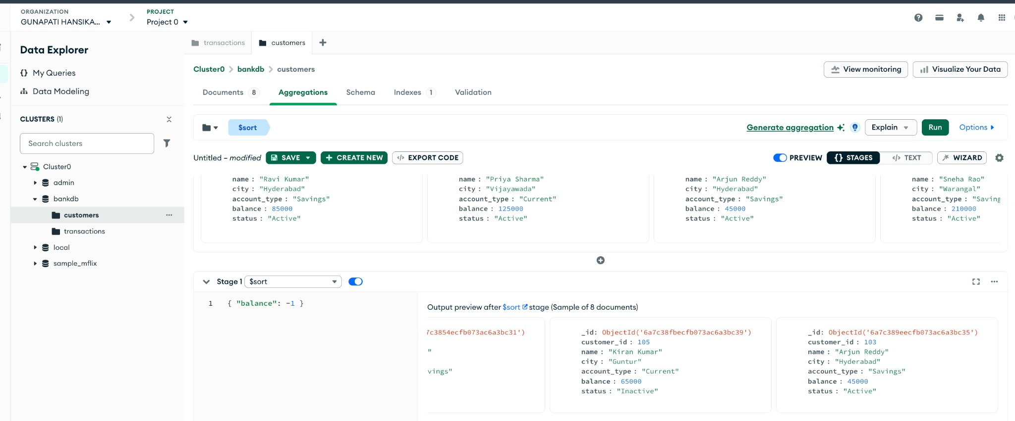

Query 13: Total Transaction Amount (All Transactions)
Collection: transactions Stage 1 — $group:
{ "_id": null, "total_amount": { "$sum": "$amount" } }
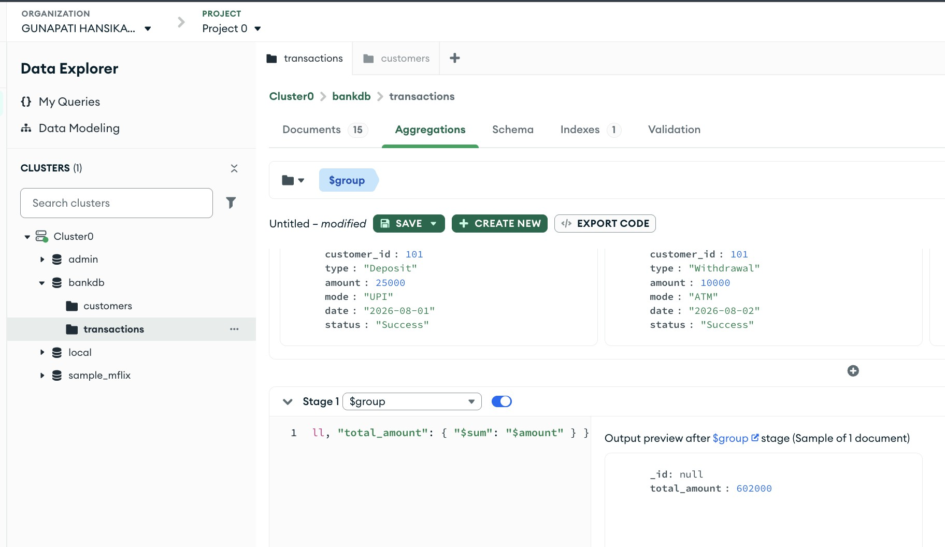

Query 14: Average Transaction Amount
Collection: transactions Stage 1 — $group:
{ "_id": null, "average_amount": { "$avg": "$amount" } }

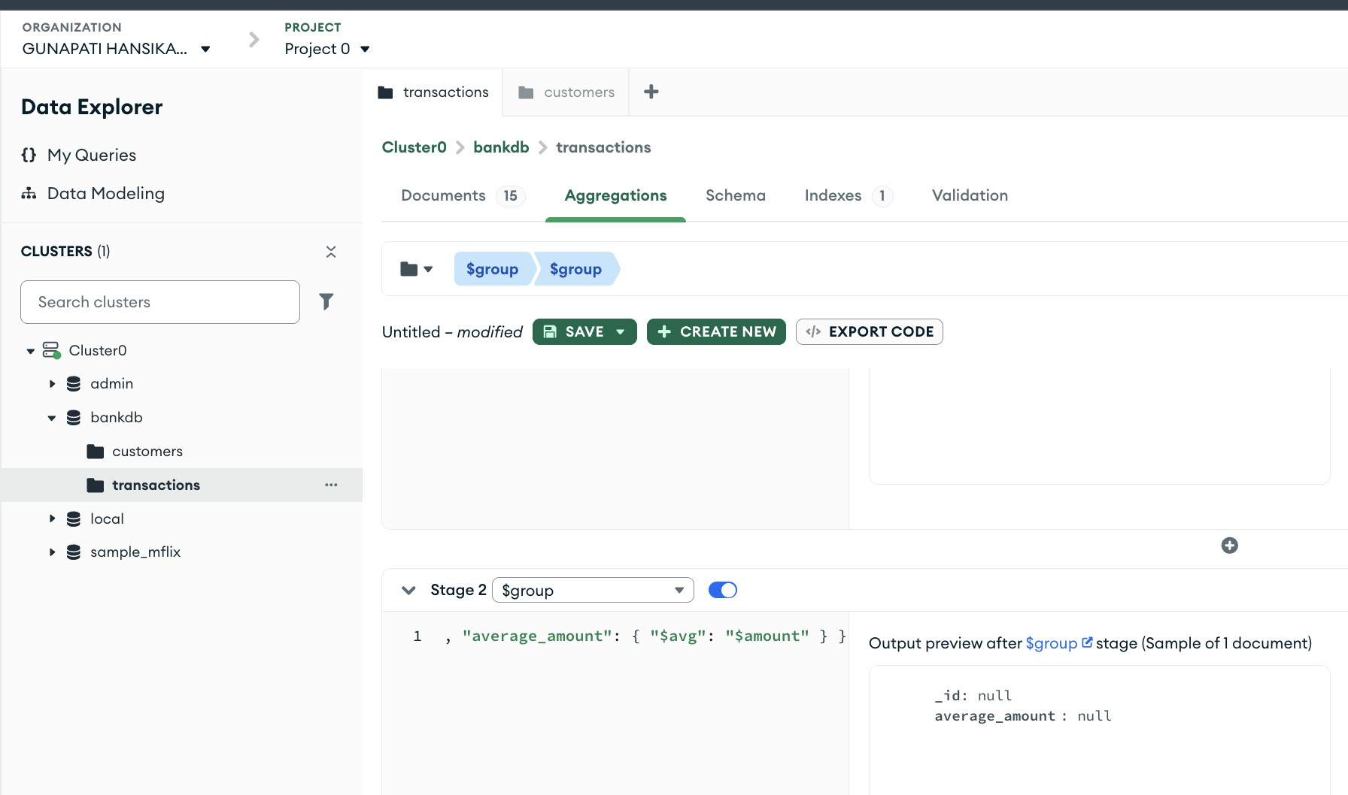

Query 15: Total Amount Grouped by Transaction Type
Collection: transactions Stage 1 — $group:
{ "_id": "$type", "total_amount": { "$sum": "$amount" } }
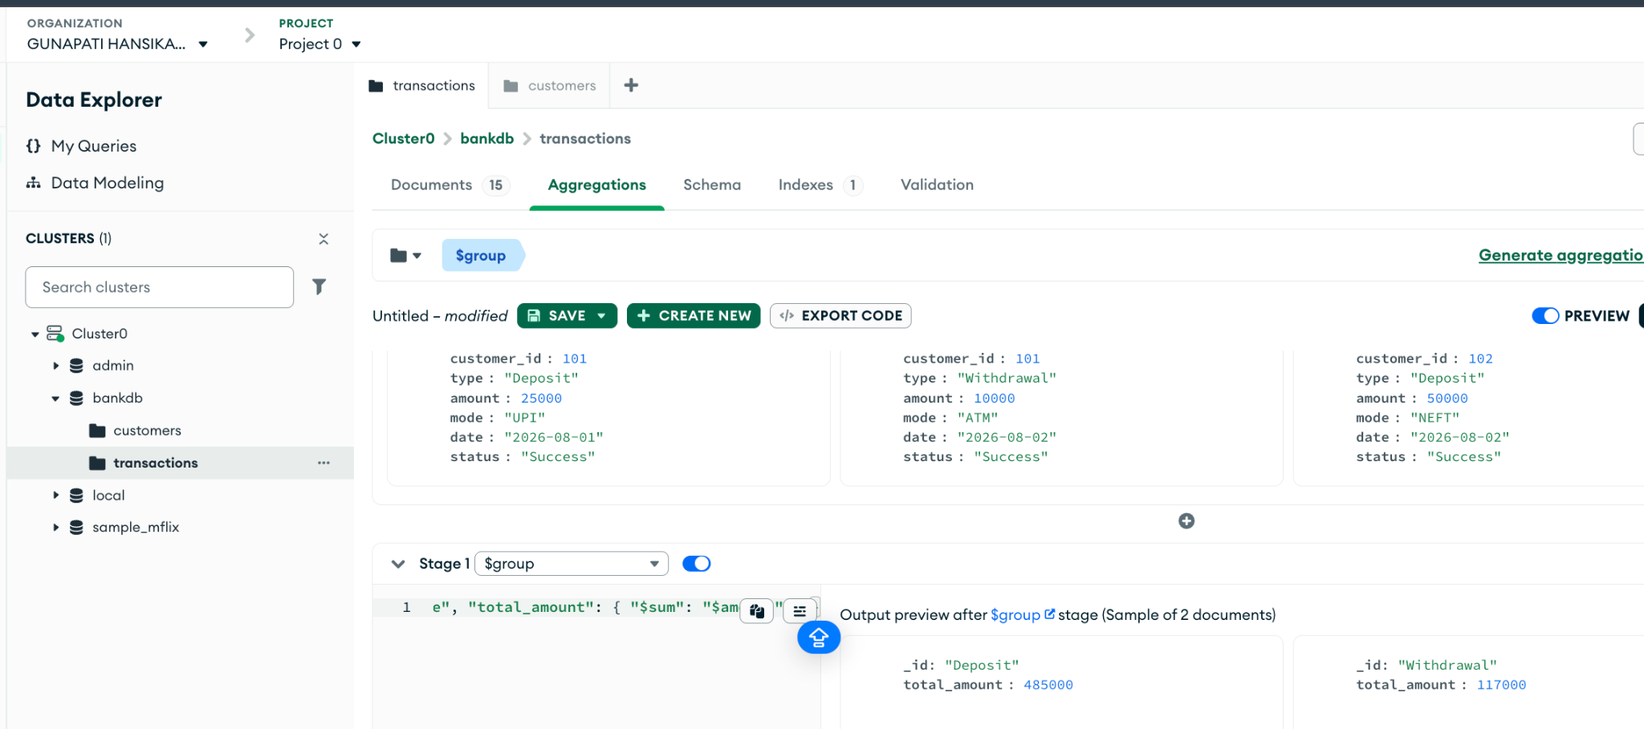

Query 16: Number of Transactions per Customer
Collection: transactions Stage 1 — $group:
{ "_id": "$customer_id", "transaction_count": { "$sum": 1 } }
Stage 2 — $sort:
{ "transaction_count": -1 }

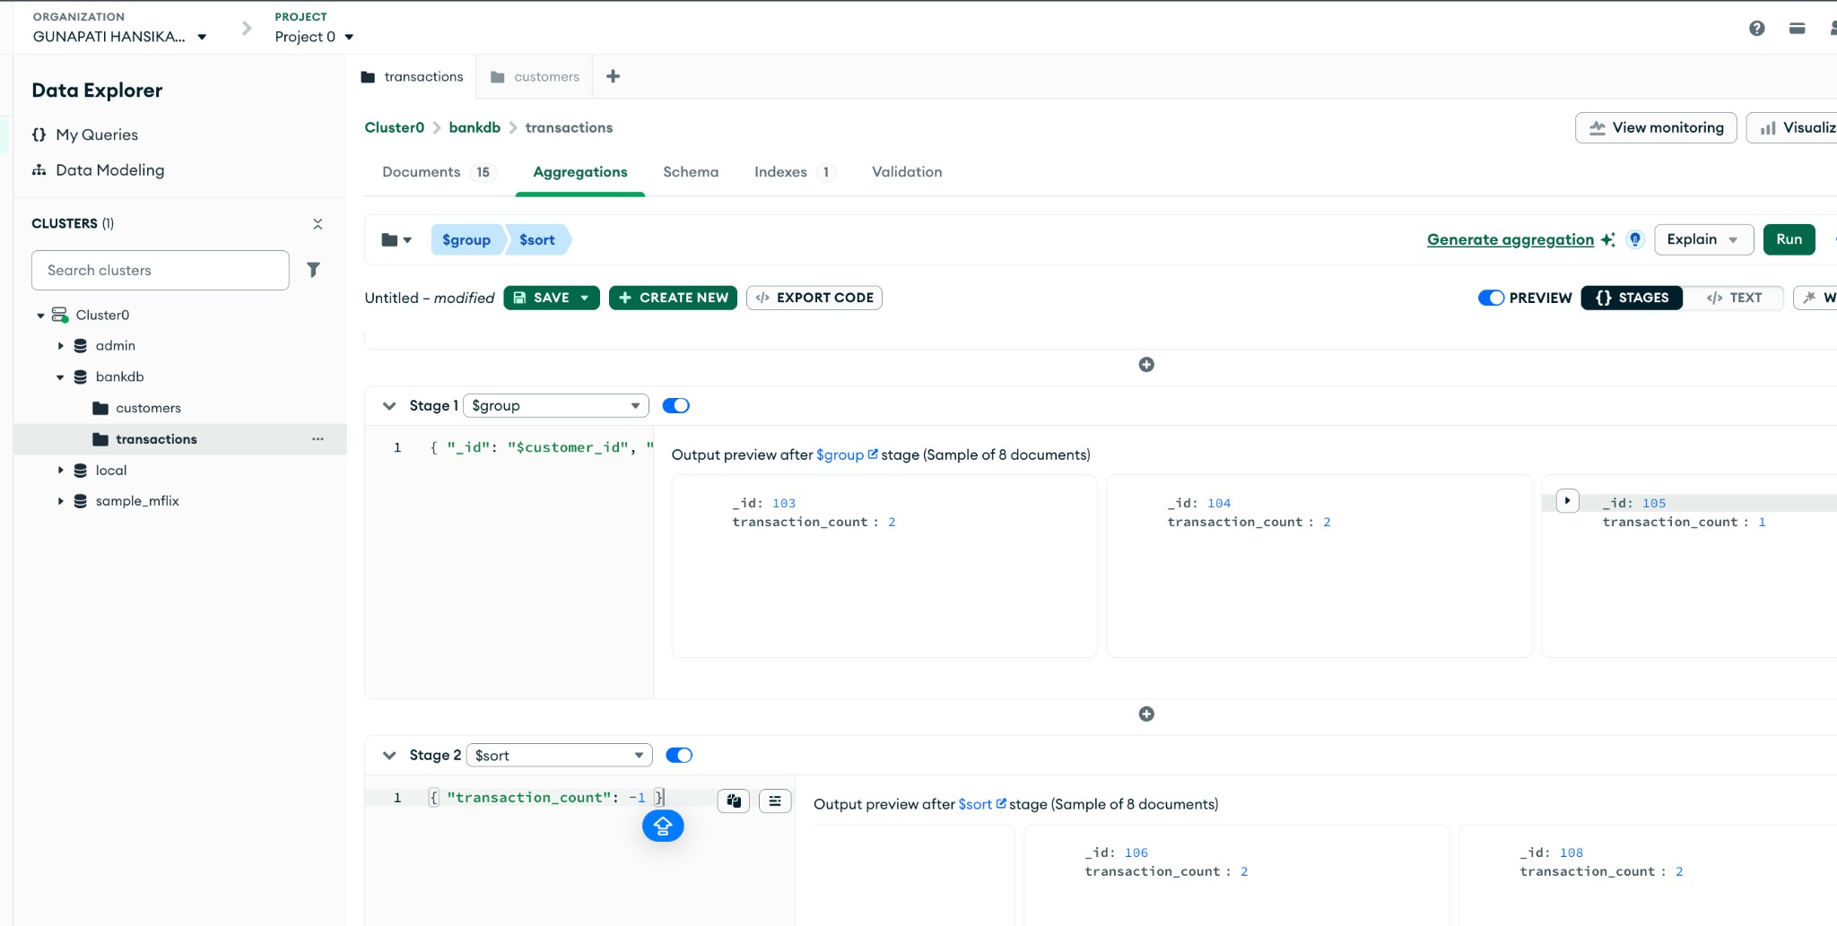

Query 17: Join Transactions with Customer Details ($lookup)
Collection: transactions Stage 1 — $lookup:

{
"from": "customers", "localField": "customer_id", "foreignField": "customer_id",

"as": "customer_details"
}
Stage 2 — $unwind:
"$customer_details"

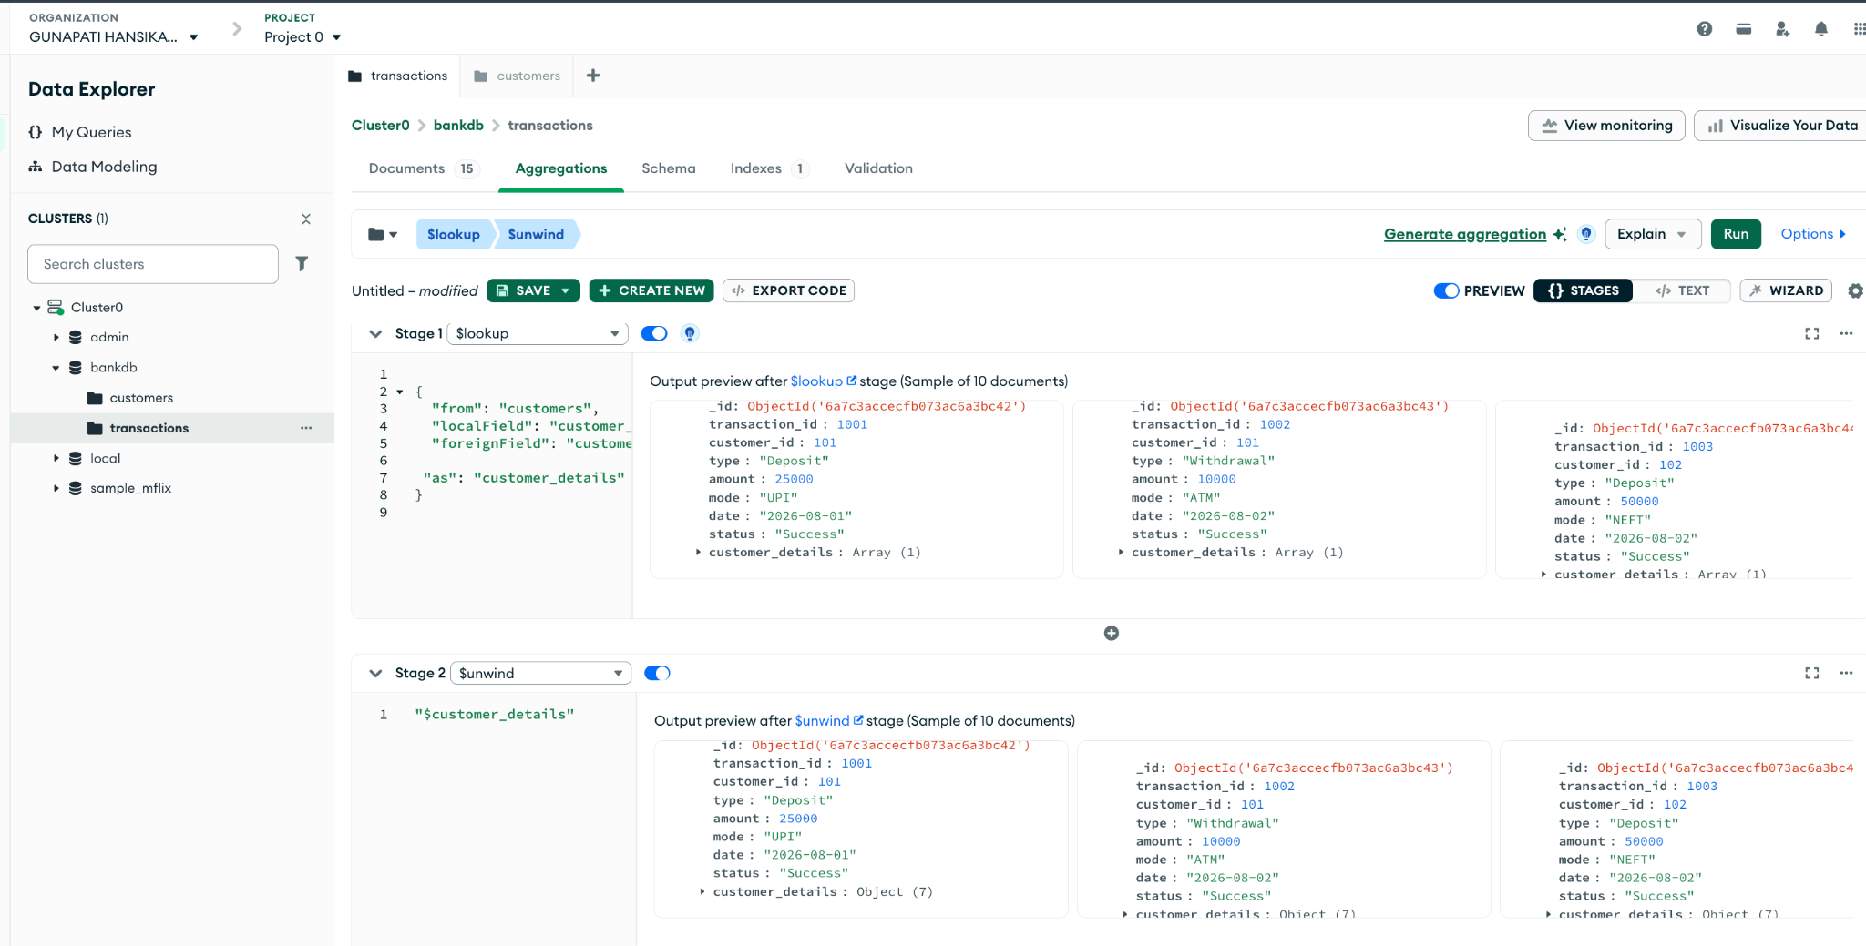

Query 18: Customer Name + Transaction Amount (Reshape with $project)
Collection: transactions Stage 1 — $lookup:
{
"from": "customers", "localField": "customer_id", "foreignField": "customer_id", "as": "customer"
}
Stage 2 — $unwind:
"$customer"
Stage 3 — $project:
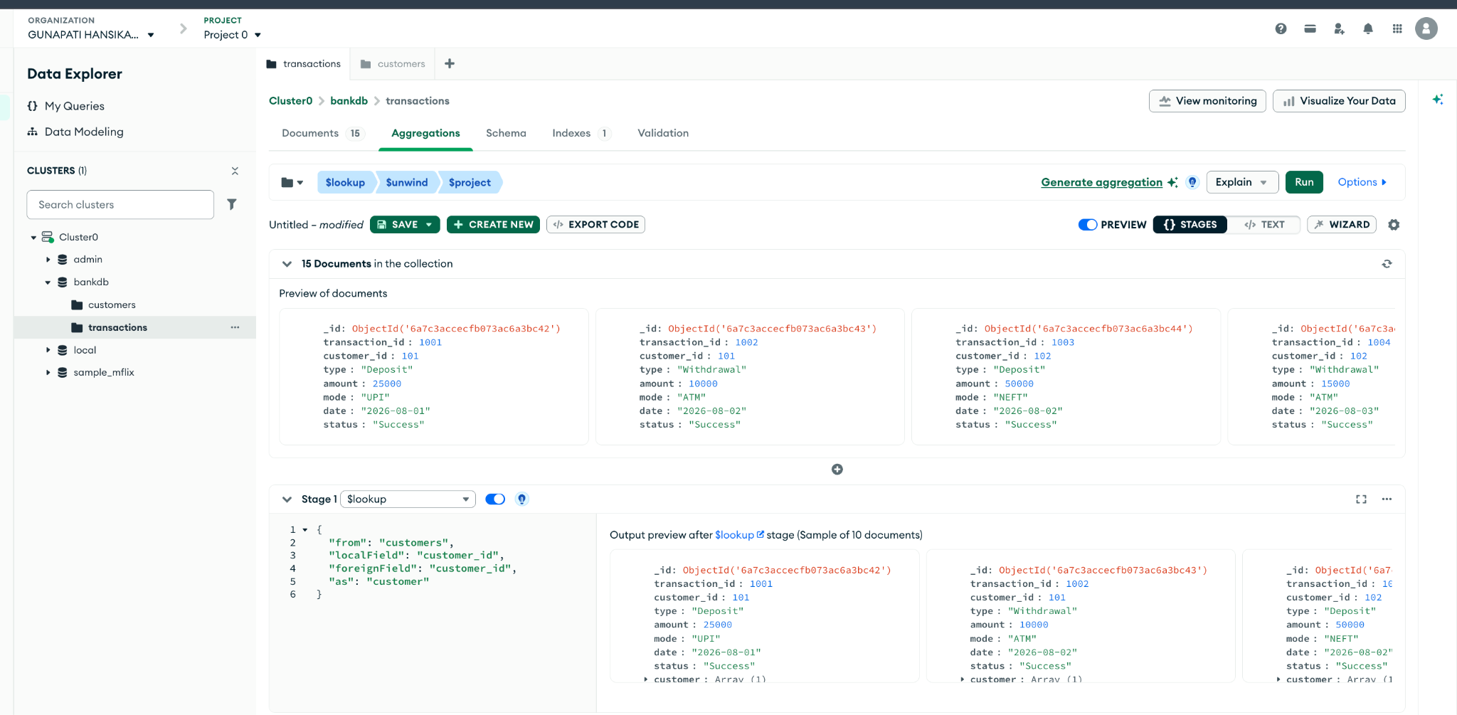
{
"_id": 0,
"transaction_id": 1, "customer_name": "$customer.name", "city": "$customer.city",
"type": 1,
"amount": 1,
"mode": 1
}

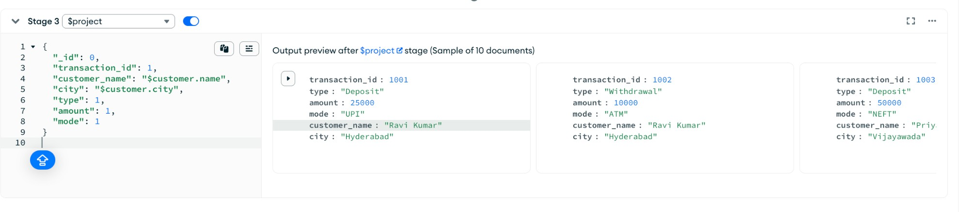

Query 19: Total Transaction Amount per Customer (with Name)
Collection: transactions Stage 1 — $group:
{ "_id": "$customer_id", "total_transaction": { "$sum": "$amount" } }
Stage 2 — $lookup:
{
"from": "customers",
"localField": "_id", "foreignField": "customer_id", "as": "customer"
}
Stage 3 — $unwind:
"$customer"
Stage 4 — $project:
{
"_id": 0, "customer_id": "$_id",
"customer_name": "$customer.name", "total_transaction": 1
}
Stage 5 — $sort:
{ "total_transaction": -1 }

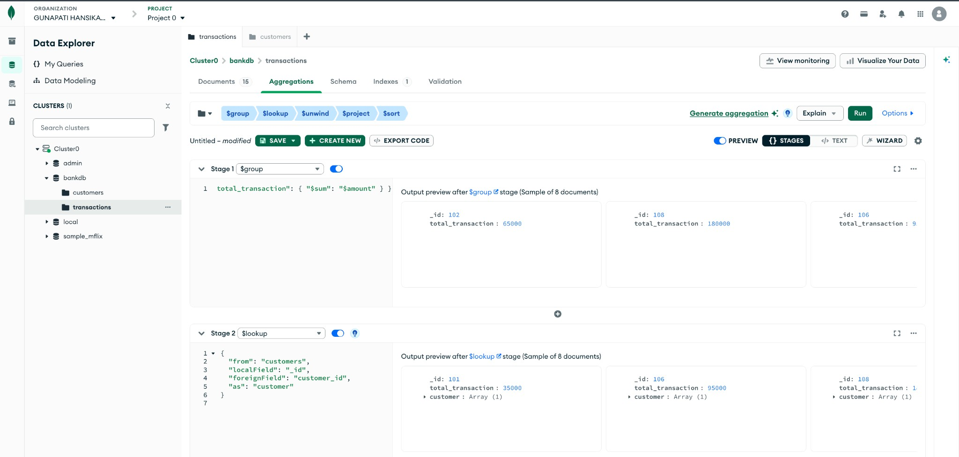
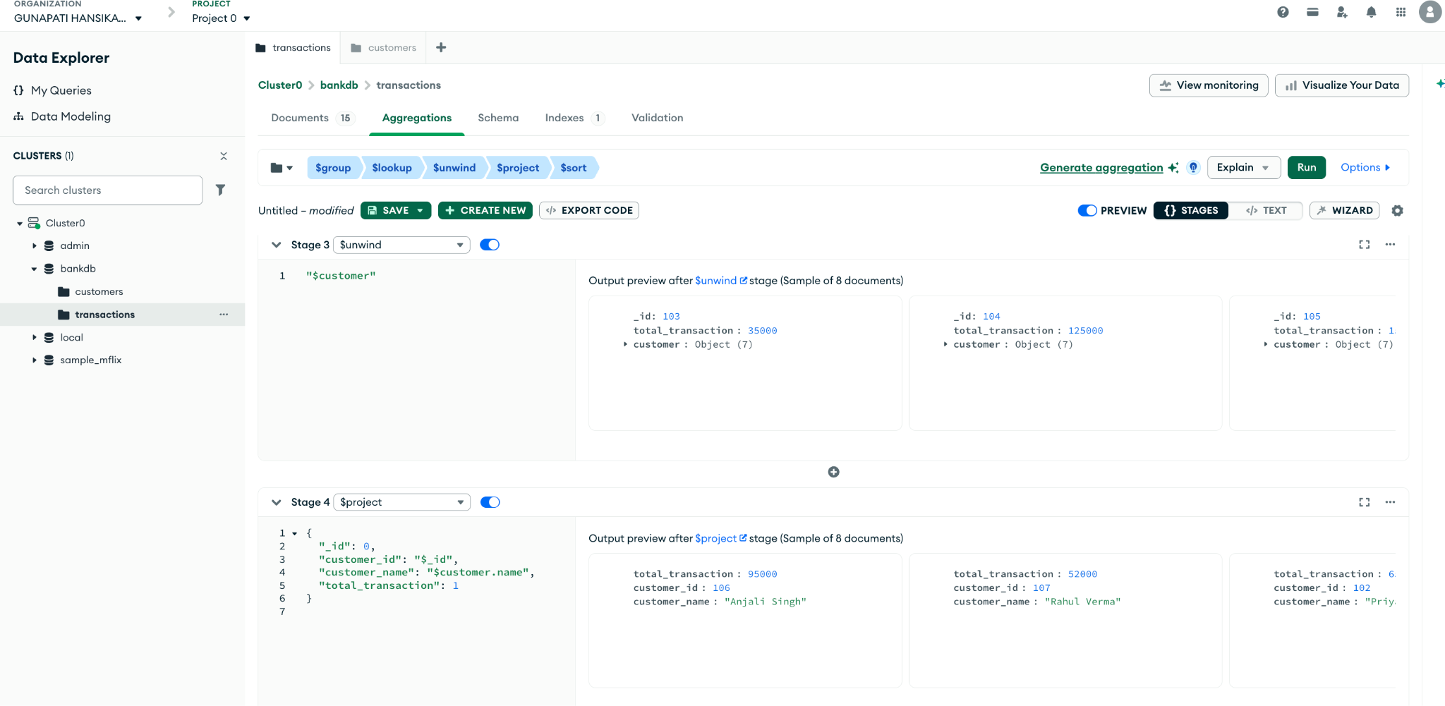

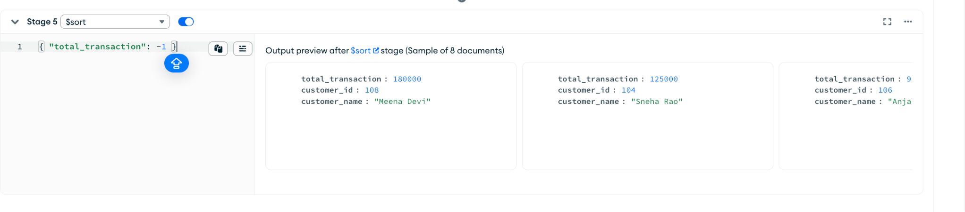

Query 20: Complex Bank Transaction Report
Collection: customers Stage 1 — $match:
{ "status": "Active", "balance": { "$gt": 80000 } }
Stage 2 — $lookup:
{
"from": "transactions", "localField": "customer_id", "foreignField": "customer_id", "as": "transactions"
}
Stage 3 — $unwind:
"$transactions"
Stage 4 — $group:
{
"_id": "$customer_id", "customer_name": { "$first": "$name" },
"city": { "$first": "$city" },
"balance": { "$first": "$balance" }, "total_transactions": { "$sum": "$transactions.amount" }, "transaction_count": { "$sum": 1 }
}
Stage 5 — $sort:
{ "total_transactions": -1 }

