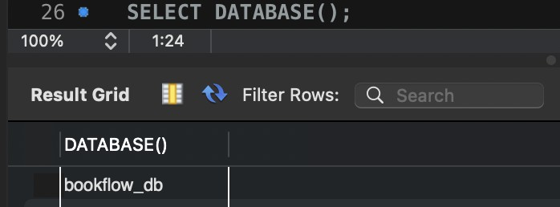
Database System Engineering and Distributed Backend Development

WEEK-4: BookFlow Intelligent Catalog & API Blueprint
Name: Teja Hasini Reddy
Roll No: 2520030048

Section: 7
Email: tejahasinireddy@klh.edu.in

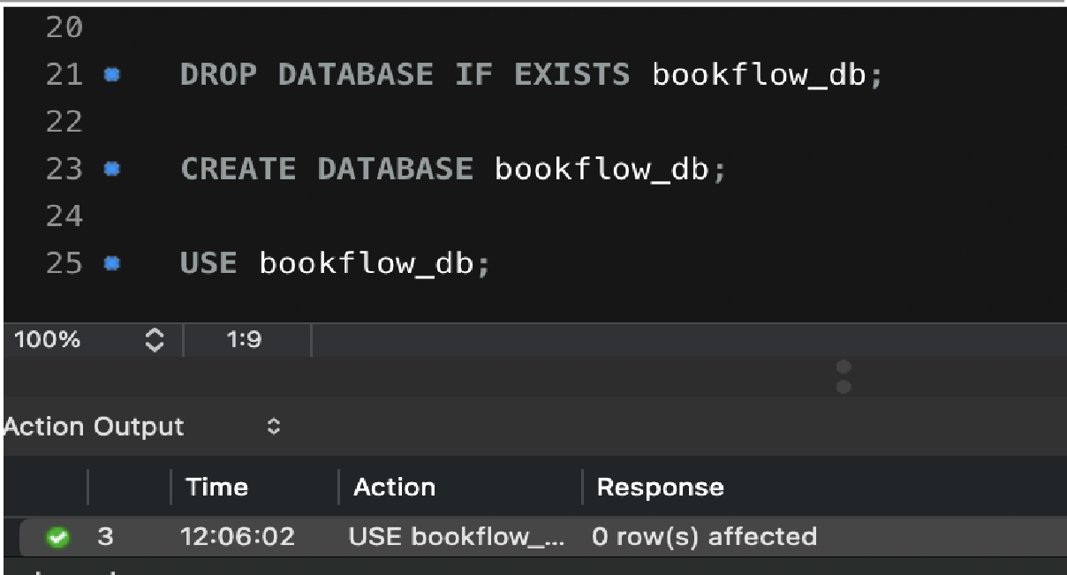
Step 1 — Create Database
DROP DATABASE IF EXISTS bookflow_db; CREATE DATABASE bookflow_db;
USE bookflow_db;

SELECT DATABASE();

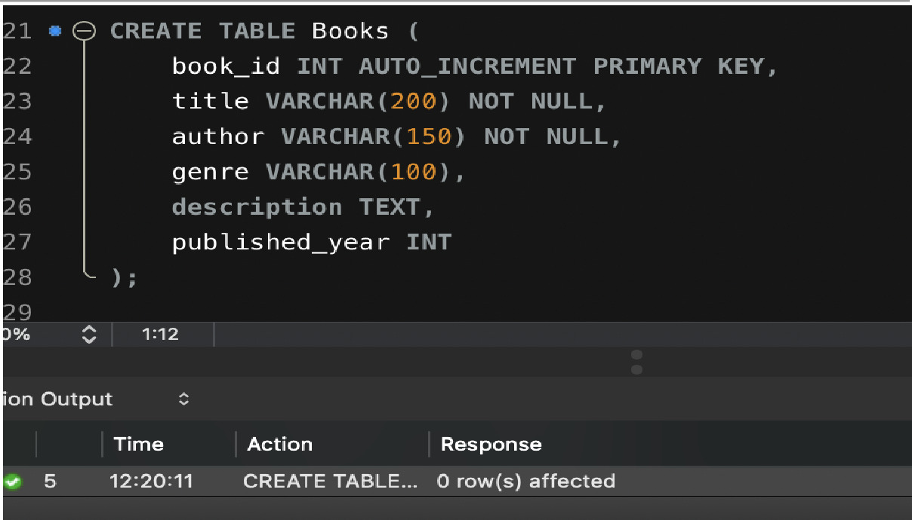
Step 2 — Create Books Table
CREATE TABLE Books (
book_id INT AUTO_INCREMENT PRIMARY KEY, title VARCHAR(200) NOT NULL,
author VARCHAR(150) NOT NULL, genre VARCHAR(100),
description TEXT, published_year INT
);

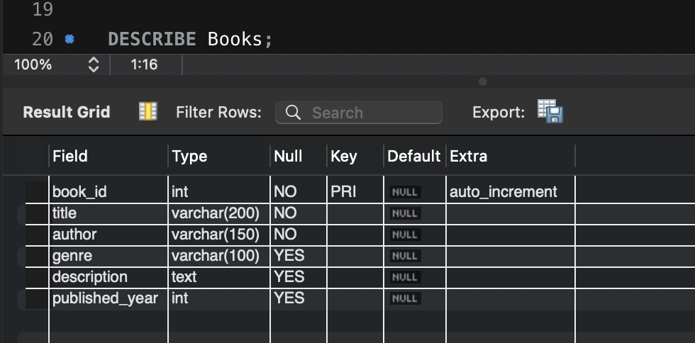
Check the structure:
DESCRIBE Books;

Step 3 — Insert 10 Books
INSERT INTO Books (title, author, genre, description, published_year) VALUES ('The Martian', 'Andy Weir', 'Science Fiction', 'An astronaut struggles to survive alone on Mars.', 2011),
('Dune', 'Frank Herbert', 'Science Fiction', 'A story involving planets, politics, survival and space.', 1965),
('The Hitchhikers Guide to the Galaxy', 'Douglas Adams', 'Science Fiction', 'A humorous adventure across space and alien worlds.', 1979),
('Pride and Prejudice', 'Jane Austen', 'Romance', 'A classic story about relationships and social expectations.', 1813),
('The Great Gatsby', 'F. Scott Fitzgerald', 'Classic', 'A story of ambition, wealth, love and the American dream.', 1925),
('Foundation', 'Isaac Asimov', 'Science Fiction', 'A futuristic story about mathematics, civilization and space.', 1951),
('The Hobbit', 'J.R.R. Tolkien', 'Fantasy', 'A fantasy adventure involving Bilbo Baggins and a dangerous journey.', 1937),
('Enders Game', 'Orson Scott Card', 'Science Fiction', 'A young student is trained for an interstellar conflict.', 1985),
('Harry Potter and the Sorcerers Stone', 'J.K. Rowling', 'Fantasy', 'A young wizard begins his magical education.', 1997),
('Twenty Thousand Leagues Under the Seas', 'Jules Verne', 'Adventure', 'A fantastic underwater adventure aboard a mysterious submarine.', 1870);

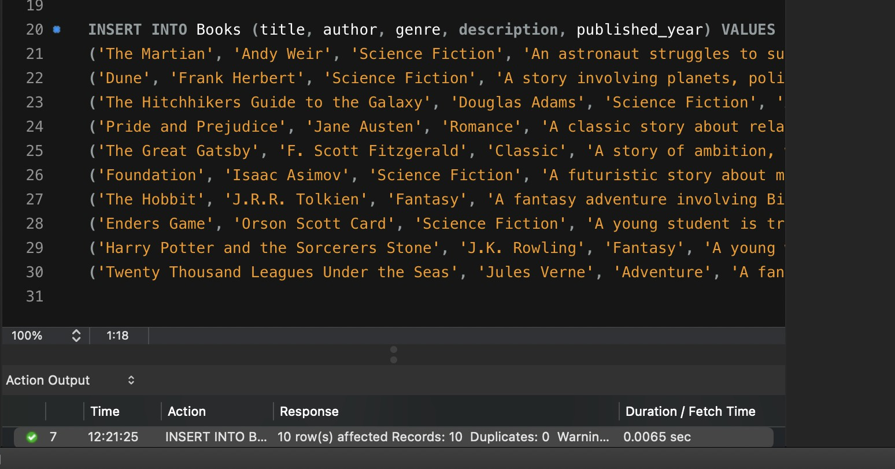
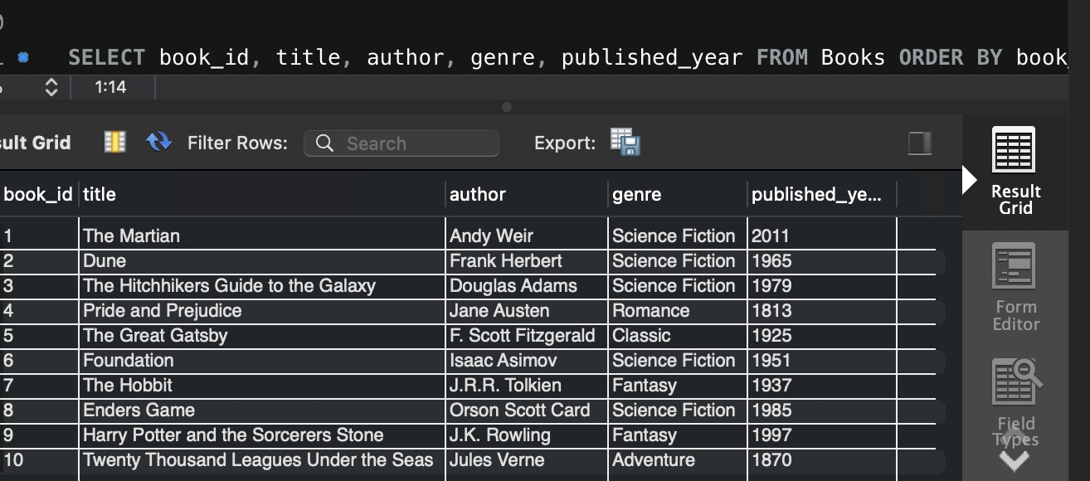
Step 4 — Display All Books
SELECT book_id, title, author, genre, published_year FROM Books ORDER BY book_id;

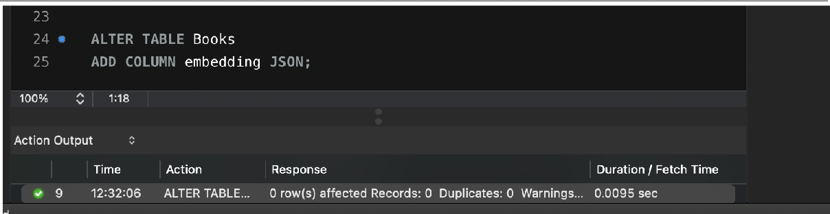
Step 5 — Add the Embedding Column (Semantic Search Setup)
ALTER TABLE Books
ADD COLUMN embedding JSON;

DESCRIBE Books;

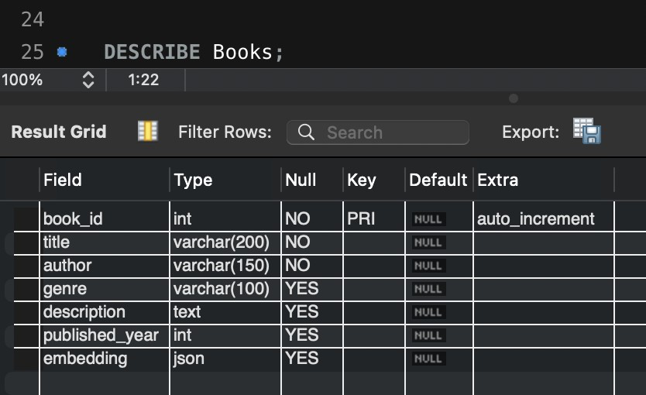
Step 6 — Insert Mock Vectors for Each Book

UPDATE | Books | SET | embedding | = | JSON_ARRAY(0.90, | 0.80, | 0.20) | WHERE | book_id | = | 1;
UPDATE | Books | SET | embedding | = | JSON_ARRAY(0.85, | 0.75, | 0.25) | WHERE | book_id | = | 2;
UPDATE | Books | SET | embedding | = | JSON_ARRAY(0.80, | 0.70, | 0.30) | WHERE | book_id | = | 3;
UPDATE | Books | SET | embedding | = | JSON_ARRAY(0.10, | 0.20, | 0.90) | WHERE | book_id | = | 4;
UPDATE | Books | SET | embedding | = | JSON_ARRAY(0.15, | 0.30, | 0.80) | WHERE | book_id | = | 5;
UPDATE | Books | SET | embedding | = | JSON_ARRAY(0.95, | 0.65, | 0.20) | WHERE | book_id | = | 6;
UPDATE | Books | SET | embedding | = | JSON_ARRAY(0.30, | 0.75, | 0.90) | WHERE | book_id | = | 7;
UPDATE | Books | SET | embedding | = | JSON_ARRAY(0.88, | 0.85, | 0.15) | WHERE | book_id | = | 8;
UPDATE | Books | SET | embedding | = | JSON_ARRAY(0.20, | 0.55, | 0.95) | WHERE | book_id | = | 9;
UPDATE | Books | SET | embedding | = | JSON_ARRAY(0.70, | 0.90, | 0.40) | WHERE | book_id | = | 10;

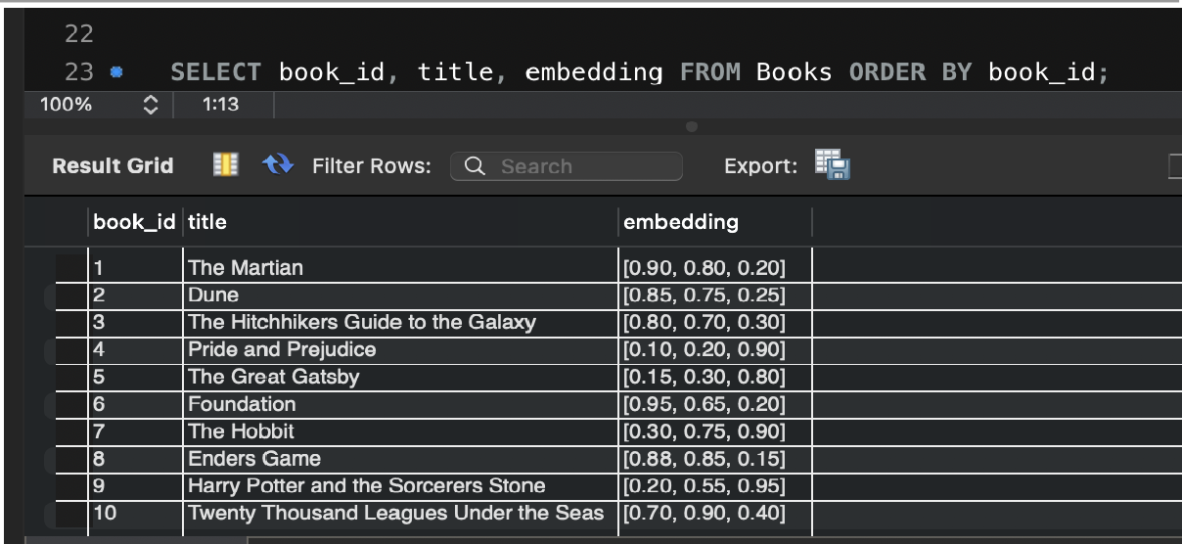
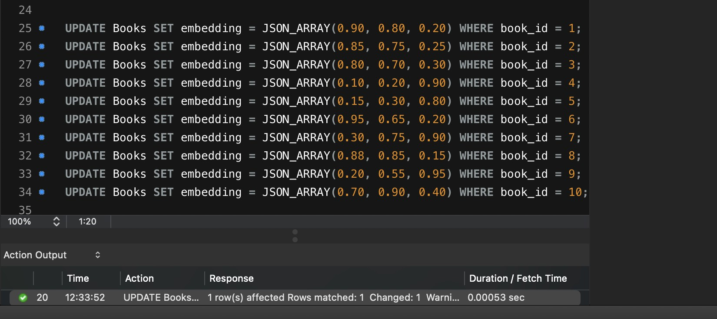
Step 7 — Verify All Vectors
SELECT book_id, title, embedding FROM Books ORDER BY book_id;

Step 8 — Similarity Search: L2 Distance ("closest" books)
Search vector used = [0.90, 0.80, 0.20] → represents "Stories about space". Smaller distance = more similar.
SELECT
book_id, title, author, genre, ROUND(
SQRT(
POW(CAST(JSON_EXTRACT(embedding,'$[0]') AS DECIMAL(10,6)) - 0.90, 2) + POW(CAST(JSON_EXTRACT(embedding,'$[1]') AS DECIMAL(10,6)) - 0.80, 2) + POW(CAST(JSON_EXTRACT(embedding,'$[2]') AS DECIMAL(10,6)) - 0.20, 2)
), 4
) AS l2_distance FROM Books
WHERE embedding IS NOT NULL ORDER BY l2_distance ASC LIMIT 3;
Conclusion: The 3 closest books are The Martian, Enders Game, and Dune.

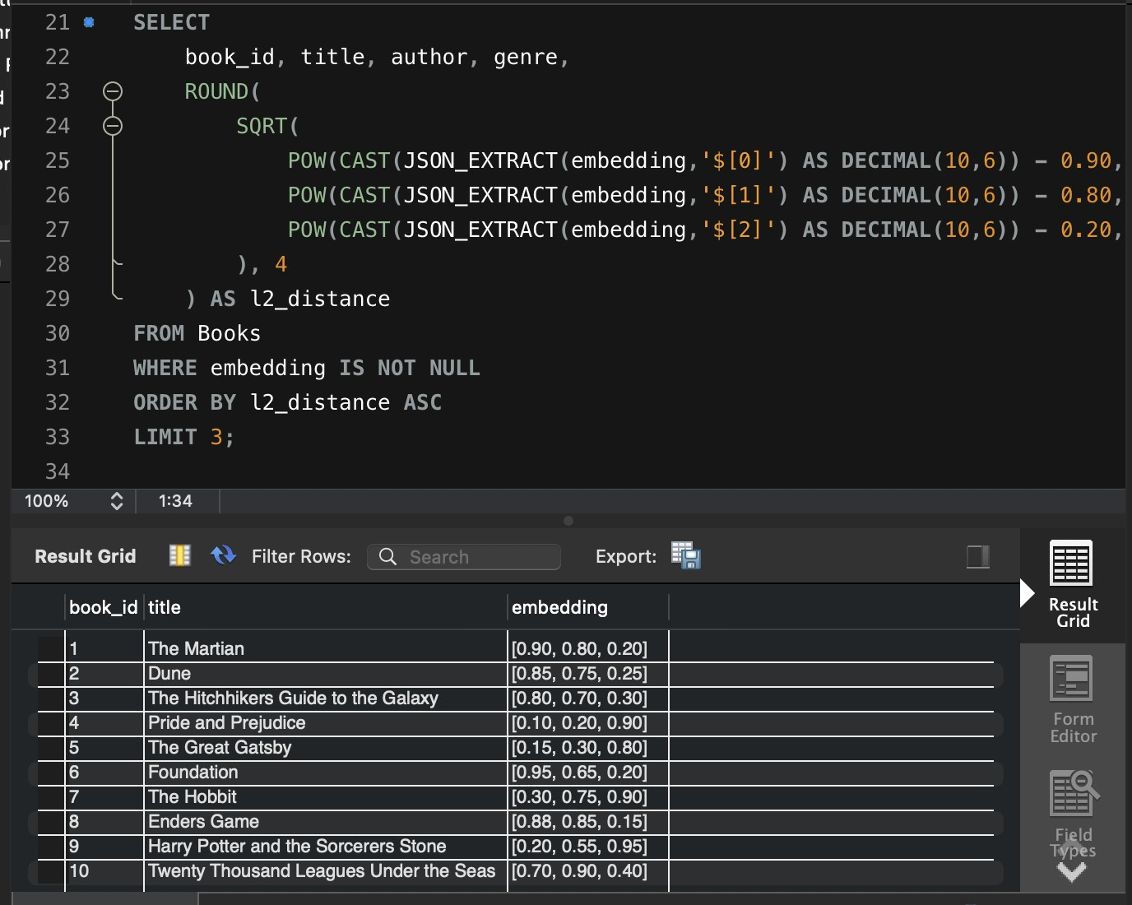
Step 9 — Similarity Search: Cosine Similarity
SELECT
book_id, title, author, genre, ROUND(
(
CAST(JSON_EXTRACT(embedding,'$[0]') AS DECIMAL(10,6)) * 0.90 + CAST(JSON_EXTRACT(embedding,'$[1]') AS DECIMAL(10,6)) * 0.80 + CAST(JSON_EXTRACT(embedding,'$[2]') AS DECIMAL(10,6)) * 0.20
) /
(
SQRT(
POW(CAST(JSON_EXTRACT(embedding,'$[0]') AS DECIMAL(10,6)),2) + POW(CAST(JSON_EXTRACT(embedding,'$[1]') AS DECIMAL(10,6)),2) + POW(CAST(JSON_EXTRACT(embedding,'$[2]') AS DECIMAL(10,6)),2)
)
* SQRT(POW(0.90,2) + POW(0.80,2) + POW(0.20,2))
), 4
) AS cosine_similarity FROM Books
WHERE embedding IS NOT NULL ORDER BY cosine_similarity DESC LIMIT 3;

