PRACTICAL - 5

Name: Teja Hasini Reddy
Rollno: 2520030048
Section: 8

Experiment No. 5
Title: Implementation of a Producer-Consumer Communication System and a Shell Pipeline Emulator using Anonymous Pipes, fork(), dup2(), and exec() System Calls.
Aim:
To develop C programs that (i) implement a producer-consumer system using anonymous pipes where a parent process produces data and a child process consumes it, measuring the communication efficiency, and (ii) emulate the shell command ls -l | grep ".c" using fork(), pipe(), dup2(), and exec() system calls.
Objective:
- To understand inter-process communication (IPC) using anonymous pipes.
- To implement a producer-consumer relationship between a parent and child process.
- To measure and evaluate the communication efficiency (throughput) of pipe-based IPC.
- To understand file descriptor duplication using dup2().
- To emulate shell command piping between two processes using pipe(), fork(), dup2(), and exec().
Theory:
An anonymous pipe is a unidirectional inter-process communication mechanism provided by the operating system that allows related processes (such as a parent and its child created via fork()) to exchange data. A pipe has two ends represented by file descriptors: fd[0] for reading and fd[1] for writing. Data written to the write end can be read sequentially from the read end, and the pipe acts as a bounded, in-kernel buffer.
In a producer-consumer system, the producer (parent process) writes data into the pipe, while the consumer (child process) reads and processes this data. Since the pipe has a limited buffer size, the OS automatically blocks the producer when the pipe is full and blocks the consumer when the pipe is empty, providing implicit synchronization.
The dup2() system call is used to duplicate a file descriptor onto another descriptor number, commonly used to redirect standard input/output to a pipe. This is exactly how the shell implements command pipelines such as ls -l | grep ".c": the standard output of the first command is redirected to the write end of a pipe, and the standard input of the second command is redirected to the read end of the same pipe, after which each command is executed using the exec() family of system calls.
Communication efficiency in this context is measured as throughput — the amount of data transferred through the pipe per unit time — calculated by timing the total duration of the write operations against the total volume of data transferred.
Algorithm (Part 1 – Producer-Consumer):
- Start the program and create a pipe using pipe().
- Create a child process using fork().
- In the child (consumer): close the unused write end, read data from the pipe in a loop until EOF, and record the total bytes received.
- In the parent (producer): close the unused read end, note the start time, write a fixed number of data chunks into the pipe, close the write end to signal EOF, and wait for the child.
- Note the end time in the parent and compute elapsed time and throughput.
- Display the number of bytes transferred and the communication efficiency.
- Stop.
Algorithm (Part 2 – ls -l | grep ".c" Emulation):
- Start the program and create a pipe using pipe().
- Create the first child process using fork().
- In the first child: redirect stdout to the pipe's write end using dup2(), close both pipe descriptors, and execute execlp("ls","ls","-l",NULL).
- Create the second child process using fork().
- In the second child: redirect stdin to the pipe's read end using dup2(), close both pipe descriptors, and execute execlp("grep","grep",".c",NULL).
- In the parent: close both ends of the pipe (so no descriptor keeps it open) and wait for both children using waitpid().
- Display a completion message.
- Stop.
System Calls Used:
System Call | Purpose
pipe() | Creates a unidirectional communication channel (read and write file descriptors)
fork() | Creates a child process
dup2() | Duplicates a file descriptor onto stdin/stdout for redirection
exec() family | Replaces a process image to run an external command (ls, grep)
read() / write() | Transfers data through the pipe
wait() / waitpid() | Synchronizes parent and child process completion
close() | Closes unused pipe file descriptors
Program 1: Producer-Consumer with Communication Efficiency Measurement
File: producer_consumer.c
#include <stdio.h>
#include <stdlib.h>
#include <unistd.h>
#include <string.h>
#include <sys/wait.h>
#include <sys/time.h>

#define CHUNK_SIZE 64
#define NUM_CHUNKS 1000

int main() {
int fd[2];
pid_t pid;
struct timeval start, end;

if (pipe(fd) < 0) {
perror("pipe failed");
exit(1);
}

pid = fork();

if (pid < 0) {
perror("fork failed");
exit(1);
}

if (pid == 0) {
/* ---- Child Process : Consumer ---- */
char buffer[CHUNK_SIZE];
int total_bytes = 0;
close(fd[1]); /* close write end, child only reads */

int n;
while ((n = read(fd[0], buffer, CHUNK_SIZE)) > 0) {
total_bytes += n;
}

printf("\nChild (Consumer) Process\n");
printf("Child PID : %d\n", getpid());
printf("Total bytes read: %d\n", total_bytes);

close(fd[0]);
exit(0);
} else {
/* ---- Parent Process : Producer ---- */
char data[CHUNK_SIZE];
memset(data, 'A', CHUNK_SIZE);
close(fd[0]); /* close read end, parent only writes */

gettimeofday(&start, NULL);
for (int i = 0; i < NUM_CHUNKS; i++) {
write(fd[1], data, CHUNK_SIZE);
}
close(fd[1]); /* signals EOF to child */

wait(NULL);
gettimeofday(&end, NULL);

double elapsed = (end.tv_sec - start.tv_sec) +
(end.tv_usec - start.tv_usec) / 1e6;
long total_sent = (long)CHUNK_SIZE * NUM_CHUNKS;
double throughput = total_sent / elapsed / 1024.0; /* KB/s */

printf("\nParent (Producer) Process\n");
printf("Parent PID : %d\n", getpid());
printf("Total bytes sent : %ld\n", total_sent);
printf("Time taken : %f seconds\n", elapsed);
printf("Communication efficiency (throughput): %.2f KB/s\n", throughput);
}
return 0;
}
Sample Output (Program 1):
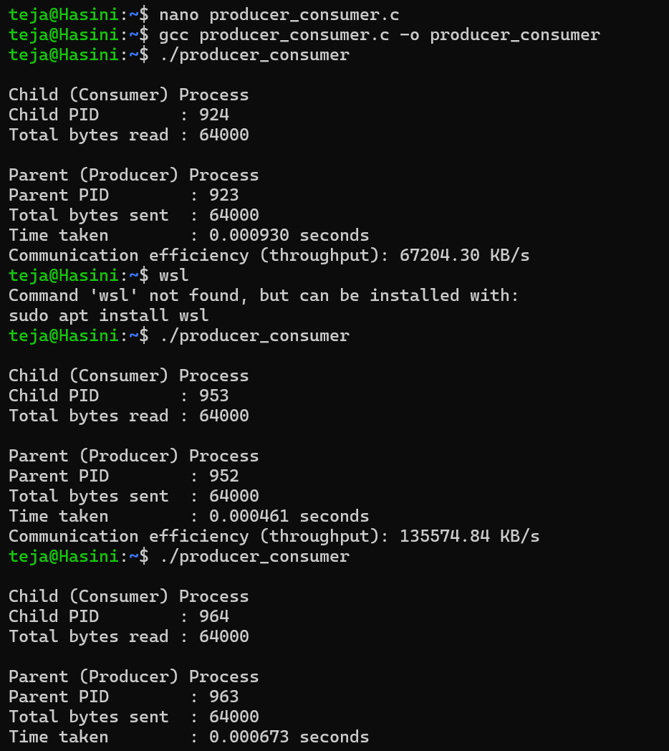

Program 2: Emulating ls -l | grep ".c" using pipe(), fork(), dup2(), exec()
File: pipeline.c
#include <stdio.h>
#include <stdlib.h>
#include <unistd.h>
#include <sys/wait.h>

int main() {
int fd[2];
pid_t pid1, pid2;

if (pipe(fd) < 0) {
perror("pipe failed");
exit(1);
}

/* ---- First child : executes ls -l ---- */
pid1 = fork();
if (pid1 < 0) {
perror("fork failed");
exit(1);
}
if (pid1 == 0) {
dup2(fd[1], STDOUT_FILENO); /* redirect stdout to pipe write end */
close(fd[0]);
close(fd[1]);
execlp("ls", "ls", "-l", NULL);
perror("exec ls failed");
exit(1);
}

/* ---- Second child : executes grep ".c" ---- */
pid2 = fork();
if (pid2 < 0) {
perror("fork failed");
exit(1);
}
if (pid2 == 0) {
dup2(fd[0], STDIN_FILENO); /* redirect stdin from pipe read end */
close(fd[0]);
close(fd[1]);
execlp("grep", "grep", ".c", NULL);
perror("exec grep failed");
exit(1);
}

/* ---- Parent : closes both ends and waits ---- */
close(fd[0]);
close(fd[1]);
waitpid(pid1, NULL, 0);
waitpid(pid2, NULL, 0);

printf("\nPipeline execution completed (ls -l | grep \".c\").\n");
return 0;
}
Sample Output (Program 2):

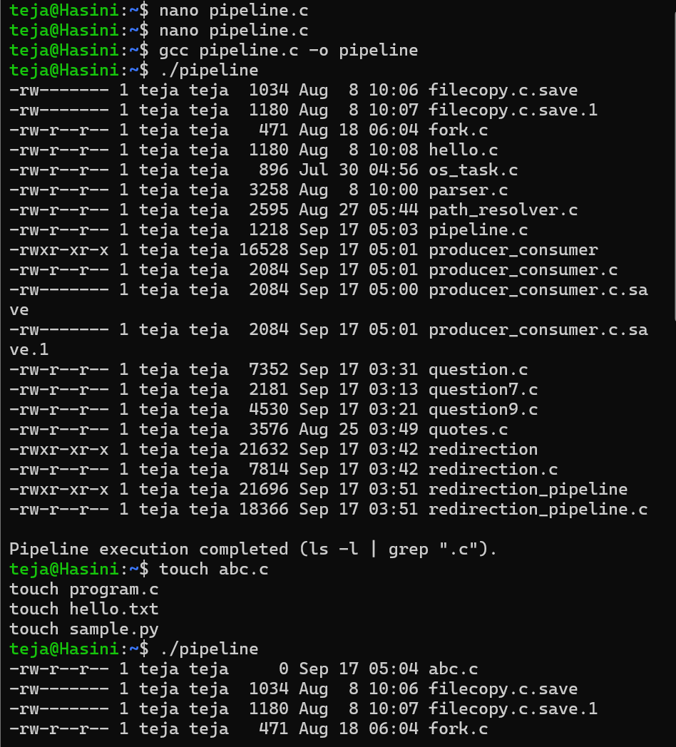
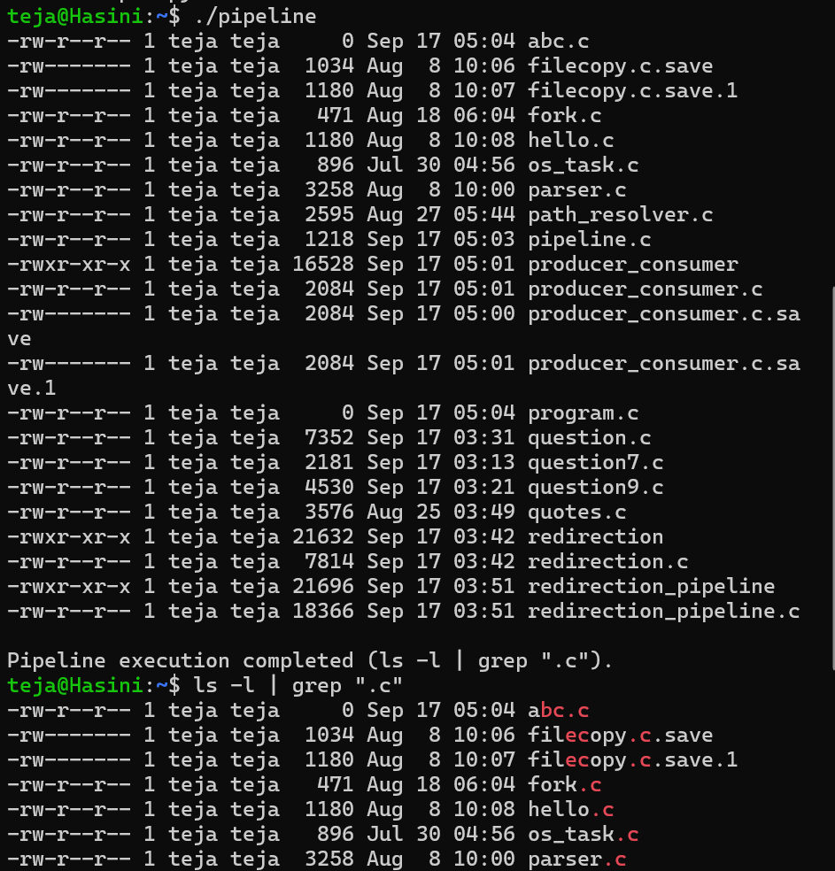
Observation:
- A pipe was successfully created and used to transfer data between a parent (producer) and child (consumer) process.
- The operating system's pipe buffer provided implicit synchronization between the producer and consumer without needing explicit locks.
- The communication efficiency (throughput) was computed by timing the write operations against the volume of data transferred through the pipe.
- Using dup2(), standard output of one process and standard input of another were successfully redirected to the two ends of a pipe, allowing exec()-launched programs (ls and grep) to communicate exactly as the shell pipeline ls -l | grep ".c" would.
- Closing unused pipe ends in every process (including the parent) was essential — otherwise the reading process never receives EOF and blocks indefinitely.
Result:
The programs were successfully executed. A producer-consumer communication system was implemented using anonymous pipes, and the communication efficiency (throughput) was measured. The shell command ls -l | grep ".c" was successfully emulated using fork(), pipe(), dup2(), and exec() system calls, correctly filtering and displaying only the ".c" files from the directory listing.

