PCAT Management System
Solution Design Document
Replacing Airtable with an In-House Product Catalog Solution

Version 1.1 | Draft
December 2024

Executive Summary
This document outlines a comprehensive solution to replace Airtable as the Product Catalog (PCAT) management system. The proposed solution addresses critical business challenges including manual validation processes, lack of version control, licensing costs, and vendor dependency.
Key Objectives:
- Eliminate dependency on third-party tools while reducing licensing costs
- Automate validation and diff checking to reduce manual effort by 70%+
- Implement proper version control for parallel release management
- Provide intuitive tree-based UI for business users
- Enable seamless integration with CCL2 build process

Current State Analysis

Existing Workflow
The current PCAT workflow involves multiple manual handoffs between business and technical teams:
Step | Activity | Owner
1 | Receive product rules in Excel format | Business Team
2 | Upload and maintain data in Airtable | Business Team (BBA/SC)
3 | Manually validate new entries and changes | Business Team
4 | Export data as CSV file | Business Team
5 | Convert CSV to XML using Automator/Loader | Development Team
6 | Integrate XML into CCL2 build | Development Team

Data Hierarchy
The product catalog follows a strict hierarchical structure that must be preserved in the new system:
Level | Description | Example
Application | Root level - the system | CCL2
Underwriting Region | Geographic division | East, West, Quebec
Risk Type | Category of insurance risk | Property, Liability
Form Level | Insurance form identifier | BPO, LA01
Coverage Level | Specific coverage type | COVGEN, Coverage IDs
Attributes | Coverage details | Limit, Deductible, Rules

Key Challenges
- No Automated Diff Process: Business team must manually compare entries when new data is loaded, leading to errors and inefficiency
- No Version Control: Multiple files maintained manually for parallel releases with manual synchronization
- Manual Data Entry: High effort required for data input (Santhosh's team working to minimize)
- Licensing Costs: Ongoing Airtable subscription fees
- Vendor Lock-in: Data stored in third-party tool with limited flexibility and export options
- No Automated Testing: No way to validate catalog changes against CCL2 before deployment

Proposed Solution

Solution Goals
- Intuitive tree-based UI for hierarchical data entry and navigation
- Automated diff checking between versions and releases
- Built-in validation engine for business rules
- Git-style versioning with branch and merge capabilities
- Multi-format export (XML, JSON, Excel, CSV)
- Approval workflow for change management
- Direct CCL2 integration with automated testing

High-Level Architecture
The solution consists of five core components working together to provide a complete product catalog management system. The following diagram illustrates the system architecture:
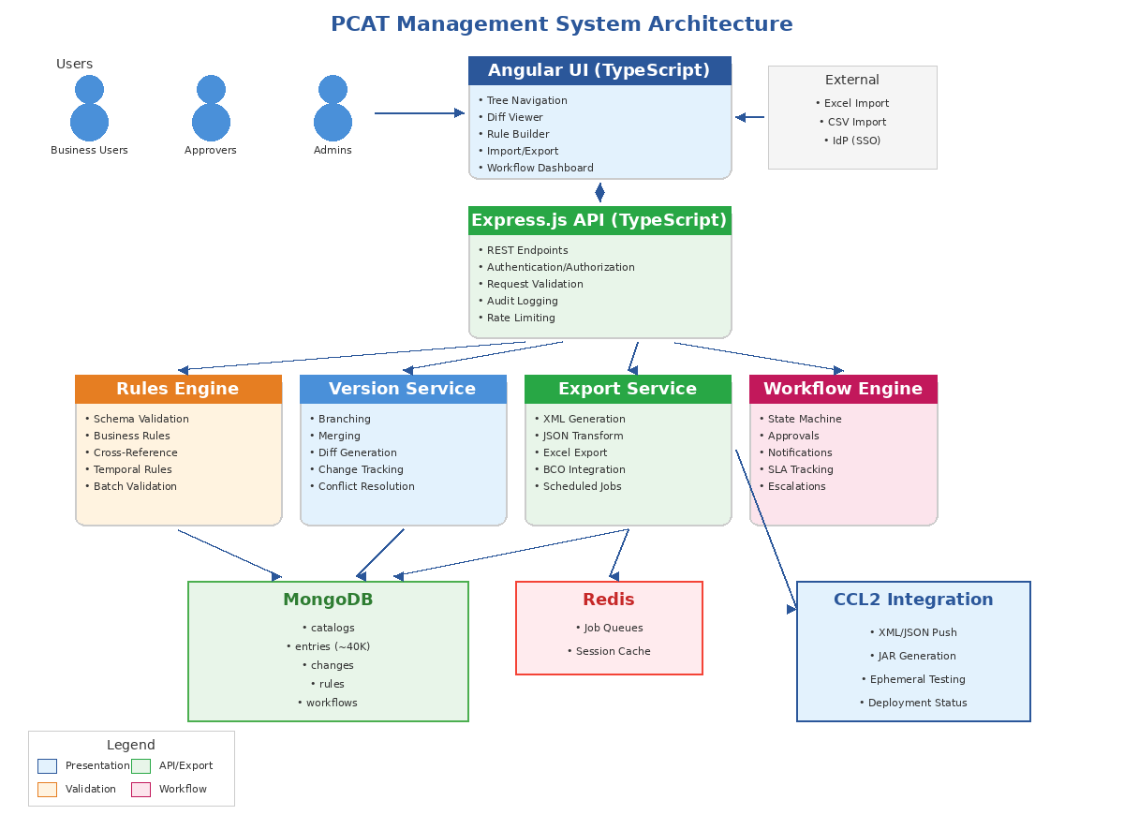
Figure 1: PCAT Management System Architecture
Component | Description
PCAT Web UI | Angular 17+ frontend with tree navigation, bulk import, diff viewer, and version management
PCAT API | Express.js (TypeScript) REST API handling authentication, business logic, and data operations
MongoDB Database | Primary data store for catalog entries, leveraging document model for hierarchical data
Rules Engine | Validation service enforcing schema rules, business constraints, and cross-references
Export Service | Handles format conversion (XML/JSON/Excel) and CCL2 integration

Detailed Component Design

1. PCAT Web UI (Angular)
A modern, responsive web application built with Angular 17+ and TypeScript, designed specifically for business users managing the product catalog.

Technology Stack
- Angular 17+ with standalone components
- TypeScript for type safety and better developer experience
- Angular Material or PrimeNG for UI components
- NgRx for state management (catalog data, user state)
- RxJS for reactive data handling

Tree Navigation View
- Expandable/collapsible hierarchy: Application → Region → Risk Type → Form → Coverage
- Search and filter capabilities at each level
- Drag-and-drop for reorganizing entries (using Angular CDK)
- Quick actions (add, edit, delete, duplicate) from context menu
- Breadcrumb navigation for current position

Data Entry Features
- Reactive form-based entry with real-time validation
- Inline editing for quick changes
- Bulk import from Excel/CSV with column mapping interface
- Copy/paste support for efficiency
- Auto-save with conflict detection

Diff and Comparison Tools
- Side-by-side version comparison
- Visual diff highlighting (additions in green, deletions in red, changes in yellow)
- Filter diff by change type, date range, or user
- Export diff reports for review

2. PCAT API (Express.js + TypeScript)
RESTful API built with Express.js and TypeScript, providing a robust backend for all PCAT operations.

API Structure
Endpoint Group | Methods | Purpose
/api/catalogs | GET, POST, PUT | Catalog version management (create, list, update)
/api/entries | CRUD + PATCH | Catalog entry operations with bulk support
/api/versions | GET, POST | Branching, merging, diff operations
/api/rules | CRUD | Business rule definition and management
/api/validate | POST | Run validation against rules engine
/api/workflows | GET, POST, PATCH | Approval workflow operations
/api/export | POST | Generate XML, JSON, Excel exports
/api/import | POST | Excel/CSV import with validation

Key Middleware
- Authentication middleware (JWT validation with enterprise IdP)
- Authorization middleware (role-based access control)
- Audit logging middleware (all changes tracked)
- Rate limiting and request validation

3. Version Control System
Git-inspired versioning designed for product catalog management, supporting 2-3 concurrent versions.

Branch Model
Branch Type | Purpose | Example
Main | Current production catalog | main
Release | Upcoming release preparation | release/january-2025
Feature | Work-in-progress changes | feature/new-liability-coverage

Version Operations
- Create new version/branch from any existing version
- Merge changes between branches with conflict resolution
- Cherry-pick specific changes across versions
- Rollback to any previous state
- Full audit trail of all changes with user attribution

4. Approval Workflow
Configurable approval process ensuring proper review before catalog changes go live.

Workflow States
State | Description | Next Actions
Draft | Changes in progress, editable by author | Submit
Pending Review | Submitted for approval, locked from edits | Approve / Reject
Approved | Ready for export and deployment | Export / Deploy
Rejected | Returned with comments for revision | Revise
Published | Deployed to CCL2 | Archive

Approval Features
- Configurable approval rules (single approver, multi-level, or consensus)
- Email notifications for pending approvals
- Comment threads on specific changes
- Approval delegation and escalation
- SLA tracking for review turnaround

5. Rules Engine (Detailed)
The Rules Engine is a critical component that automates validation, ensuring data quality and business rule compliance without manual review. It is designed to be configurable by business users while providing the flexibility to handle complex insurance product rules.

5.1 Architecture Overview
The Rules Engine operates as a separate service within the PCAT ecosystem, callable from both the API (synchronous validation) and as a background job (batch validation). It uses a declarative rule definition approach that separates rule logic from application code.
Component | Description
Rule Repository | MongoDB collection storing rule definitions, versioned alongside catalog data
Rule Parser | Converts JSON rule definitions into executable validation functions
Execution Engine | Runs parsed rules against catalog entries, collecting violations
Result Aggregator | Consolidates validation results with severity levels and fix suggestions

5.2 Rule Categories
Category 1: Schema Validation
Ensures structural integrity of catalog entries - required fields, data types, and format constraints.
Rule Type | Description | Example
Required Field | Field must be present and non-empty | coverageId is required
Data Type | Field must match expected type | limit must be numeric
Format Pattern | Field must match regex pattern | formId matches [A-Z]{2}[0-9]{2}
Enumeration | Field must be from allowed values | region in [East, West, Quebec]
Length Constraint | String length within bounds | description max 500 chars
Category 2: Business Rules
Domain-specific constraints that encode insurance business logic.
Rule Type | Description | Example
Comparison | Compare two field values | deductible <= limit
Range Validation | Value within min/max bounds | limit between 5000 and 10M
Conditional Required | Field required based on other field | if riskType=Property, buildingLimit required
Mutual Exclusion | Only one of multiple fields allowed | cannot have both flatDeductible and percentDeductible
Calculation Validation | Computed value must match | totalPremium = basePremium + fees
Category 3: Cross-Reference Rules
Validates relationships and dependencies between different catalog entries.
Rule Type | Description | Example
Parent Exists | Referenced parent must exist | formId must exist in Forms
Dependency Check | Required coverage must be present | Liability coverage requires GeneralLiability
Uniqueness | No duplicates within scope | coverageId unique per region+form
Hierarchy Integrity | Path must be valid through tree | Form BPO valid under Property risk
Orphan Detection | Entry must have valid parent chain | Coverage must link to existing Form
Category 4: Temporal Rules
Date and time-based validations ensuring temporal consistency.
Rule Type | Description | Example
Date Sequence | Dates in logical order | expiryDate > effectiveDate
No Overlap | Date ranges don't conflict | Same coverage, no overlapping periods
Future Date | Date must be in future | effectiveDate >= today for new entries
Gap Detection | No gaps in coverage periods | Continuous coverage for mandatory items

5.3 Rule Definition Format
Rules are defined in JSON format, stored in MongoDB, and can be created/edited through the UI or API. Below is the schema for rule definitions:
{
"ruleId": "BUS-001",
"name": "Deductible Must Not Exceed Limit",
"description": "The deductible amount cannot be greater than the coverage limit",
"category": "business",
"severity": "error",
"enabled": true,
"appliesTo": {
"entityType": "coverage",
"conditions": {
"riskType": ["Property", "Liability"]
}
},
"rule": {
"type": "comparison",
"operator": "<=",
"leftField": "attributes.deductible",
"rightField": "attributes.limit"
},
"message": "Deductible ({{attributes.deductible}}) exceeds Limit ({{attributes.limit}})",
"suggestion": "Reduce deductible to be at or below the limit value"
}

5.4 Severity Levels
Level | Behavior | Use Case
Error | Blocks save/approval | Critical issues: missing required data, invalid relationships
Warning | Allows save, flags for review | Potential issues: unusual values, deprecated options
Info | Informational only | Best practice suggestions, optimization hints

5.5 Rule Execution Modes
Mode | Trigger | Use Case
Real-time | On field change in UI | Instant feedback during data entry
On-Save | When entry is saved | Full validation before persisting
Batch | Manual or scheduled | Validate entire catalog or after import
Pre-Approval | Before workflow submission | Gate check before approval process
Pre-Export | Before generating output | Ensure export-ready data quality

5.6 Business User Rule Builder
The UI provides a no-code rule builder allowing business users to create and modify validation rules without developer assistance:
- Visual rule builder with dropdown selections for fields, operators, and values
- Pre-built rule templates for common validation patterns
- Test rule against sample data before activation
- Rule versioning - rules tied to catalog version
- Import/export rules as JSON for backup or migration
- Rule grouping and tagging for organization

5.7 Validation Report
After validation runs, a detailed report is generated showing:
- Summary: Total entries validated, pass/fail counts by severity
- Violations grouped by rule category and specific rule
- Direct links to affected entries for quick fixes
- Suggested corrections where applicable
- Export report as PDF or Excel for offline review
- Historical comparison: violations vs. previous validation run

6. Export and Integration Service
Handles all data export and downstream system integration.

Export Formats
Format | Use Case | Target
XML | Legacy CCL2 integration (current format) | CCL2 Build
JSON | Modern API integration, BCO transformation | CCL2 (future)
Excel | Business reporting and offline review | Business Team
CSV | Data exchange and backup | Various

CCL2 Integration
- Direct API integration to push approved catalogs to CCL2
- Automated JAR file generation for build process
- Ephemeral environment testing before production deployment
- Rollback capability if deployment issues detected
- Deployment status tracking and notifications

Data Model

MongoDB Schema Design
The MongoDB schema leverages the document model to naturally represent the hierarchical catalog structure while maintaining flexibility for business rule evolution.

Core Collections
Collection | Purpose | ~40K Records
catalogs | Top-level catalog metadata (version, status, dates) | ~10-20
entries | All catalog entries with full hierarchy path | ~40,000
changes | Change history for audit and diff | Growing
rules | Business rule definitions | ~100-500
workflows | Approval workflow instances | Growing
users | User profiles and permissions | ~50-100

Sample Entry Document Structure
Each entry document stores the complete path in the hierarchy along with its attributes, enabling efficient querying at any level:
{
"_id": "ObjectId",
"catalogId": "january-2025",
"path": {
"application": "CCL2",
"region": "East",
"riskType": "Property",
"formId": "BPO",
"coverageId": "COVGEN"
},
"attributes": {
"limit": { "min": 5000, "max": 1000000 },
"deductible": { "options": [500, 1000, 2500] },
"effectiveDate": "2025-01-01",
"expiryDate": "2025-12-31"
},
"metadata": {
"createdBy": "user123",
"createdAt": "ISODate",
"modifiedBy": "user456",
"modifiedAt": "ISODate",
"status": "approved"
}
}

Implementation Roadmap

Phased Approach
The implementation follows a phased approach, delivering value incrementally while managing risk.

Phase 1: Foundation (Weeks 1-6)
- Set up MongoDB cluster and Express.js API infrastructure
- Implement core data model and CRUD operations
- Build Angular application shell with tree navigation UI
- Create Excel/CSV import functionality
- Migrate existing Airtable data to MongoDB
Milestone: Business team can view and edit catalog data in new UI

Phase 2: Version Control (Weeks 7-10)
- Implement branching and version management
- Build diff comparison tool
- Add change history and audit logging
- Create merge and conflict resolution UI
Milestone: Teams can manage parallel releases with automated diff

Phase 3: Validation & Workflow (Weeks 11-14)
- Build validation engine framework
- Create rule definition UI for business users
- Implement approval workflow engine
- Add email notifications and SLA tracking
Milestone: Automated validation catches errors; formal approval process in place

Phase 4: Integration (Weeks 15-18)
- Build XML export service (compatible with current Automator)
- Implement JSON export with BCO transformation support
- Create CCL2 deployment integration
- Set up ephemeral testing environment integration
- Deprecate Airtable; full production cutover
Milestone: End-to-end automated pipeline from catalog to CCL2 deployment

Timeline Summary
Phase | Duration | Key Deliverable | Risk Level
Phase 1: Foundation | 6 weeks | Core UI + Data Migration | Medium
Phase 2: Version Control | 4 weeks | Branching + Diff Tool | Low
Phase 3: Validation | 4 weeks | Rules Engine + Workflow | Medium
Phase 4: Integration | 4 weeks | CCL2 Pipeline | High
Total | 18 weeks (~4.5 months) | Full Production | -

Technology Stack
Layer | Technology | Rationale
Frontend Framework | Angular 17+ (TypeScript) | Enterprise standard, strong typing, built-in features
UI Components | Angular Material / PrimeNG | Tree view, forms, tables, dialogs out of box
State Management | NgRx | Redux pattern for Angular, predictable state
Backend API | Express.js (TypeScript) | Lightweight, flexible, strong MongoDB integration
Database | MongoDB (Atlas or self-hosted) | Document model fits hierarchy, flexible schema
Authentication | Passport.js + Enterprise IdP | SSO integration, JWT tokens
Hosting | OpenShift (on-prem) or AWS EKS | Container orchestration, scalability
Background Jobs | Bull (Redis-backed queues) | Async processing for exports, validation
Testing | Jest + Cypress | Unit tests (Jest), E2E tests (Cypress)

Risks and Mitigations
Risk | Impact | Mitigation
Data migration errors | High | Parallel run period; automated comparison scripts; rollback plan
User adoption resistance | Medium | Early involvement in design; training sessions; champion users
CCL2 integration complexity | High | Maintain XML compatibility initially; phase JSON adoption
Performance with 40K records | Medium | Proper indexing; pagination; lazy loading in UI
Scope creep | Medium | Fixed phase scope; change control process; MVP focus
Resource availability | Medium | Dedicated team; clear ownership; stakeholder commitment

Success Metrics
Metric | Current State | Target
Manual validation time per release | ~X hours (to be baselined) | 70% reduction
Data errors caught pre-deployment | Manual review only | 95%+ automated detection
Version sync effort (parallel releases) | Manual file management | Automated merge/diff
Time from approval to CCL2 deploy | Manual handoff (hours/days) | < 30 minutes automated
Annual licensing cost | Airtable subscription | $0 (in-house)
User satisfaction score | Baseline TBD | > 4.0 / 5.0

Recommended Next Steps
- Review and approve this solution design with stakeholders
- Baseline current metrics (validation time, error rates, costs)
- Finalize hosting decision (OpenShift on-prem vs AWS)
- Identify and allocate development team resources
- Document detailed business rules for validation engine
- Schedule kickoff for Phase 1 development

Appendix

A. Glossary
Term | Definition
PCAT | Product Catalog - the system for managing insurance product definitions
CCL2 | Contact 2.0 - the downstream system that consumes product catalog data
BCO | Business Configuration Object - transformation work for XML to JSON
BBA/SC | Business team members responsible for catalog maintenance

B. Related Documents
- Current Airtable schema export
- CCL2 XML schema specification
- BCO transformation documentation
- Existing Automator/Loader source code

