

Beijing-Dublin International College _____________________________________________________

BDIC1048J – English for General Academic Purposes _____________________________________________________________

Dr Alex Runchman

PRACTICE EXAM
Analysis of a Data Source

May 2025

1 hour

The graphs on page 2 relates to Sustainable Development Goal 3: Good Health and Well-Being.

Summarize the information in the graphs. Your summary should provide an overview of the information and highlight any key details. You may wish to make comparisons.

To help you, some further notes on the issue are provided on page 2.

You should write around 300 words.

I have read and clearly understand the Examination Rules of both Beijing University of Technology and University College Dublin. I am aware of the Punishment for Violating the Rules of Beijing University of Technology and/or University College Dublin. I hereby promise to abide by the relevant rules and regulations by not giving or receiving any help during the exam. If caught violating the rules, I accept the punishment thereof.
Name: ________________________ Teacher Name: _________________

UCD Number: _______________________ BDIC Number: _________________

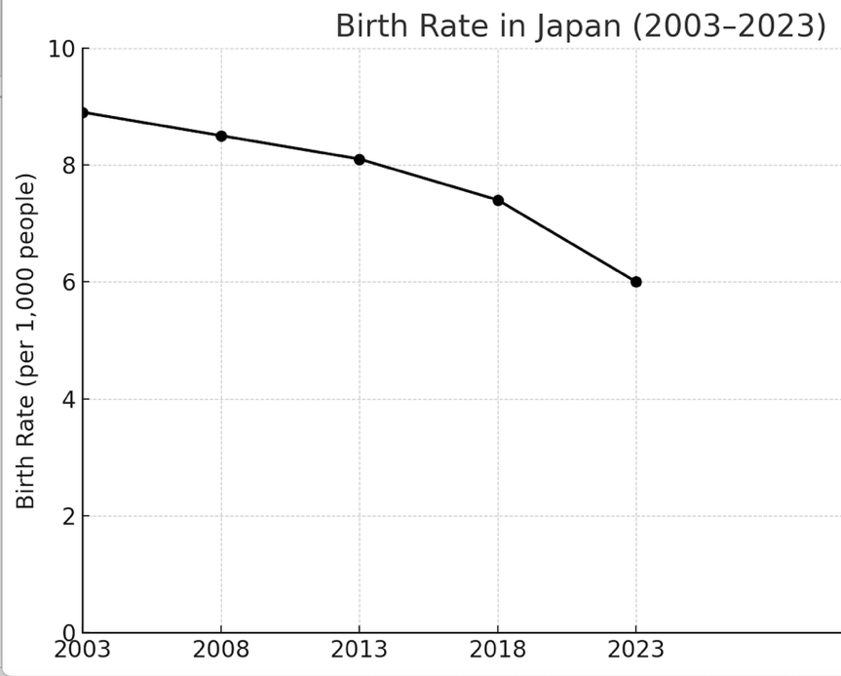

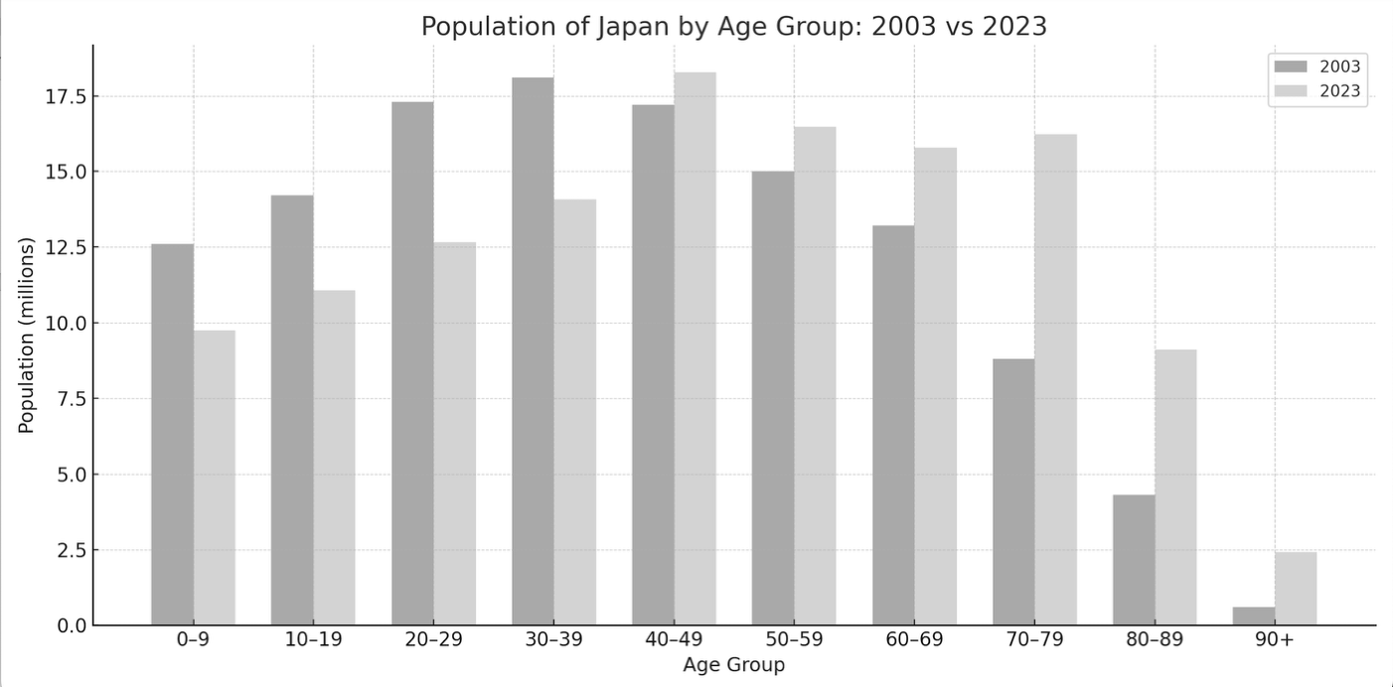

Sustainable Development Goal 3: Good Health and Well-Being is to ‘ensure healthy lives and promote well-being at all ages’. Several of the targets for this SDG emphasize the need to reduce early deaths from causes such as road traffic accidents and preventable diseases. Target 3.7 focuses on universal access to family planning methods and services.

Japan is a developed country is East Asia with a developed universal healthcare system.

Please write your summary and analysis below:

(25 marks)

