Overview: System Purpose and Modular Design

Data Structures Used: Justification for graph, hash table, heap, sorting.
Module 2: Hash-Based Patient Lookup – Short written justification of hash strategy, table size and hash function
1. Collision Handling Strategy: Chaining
The collision handling strategy I’ve chosen is chaining using linked lists, over open addressing methods like linear probing.
- Chaining is generally simpler to implement, particularly when it comes to the deletion of entries. In open addressing DELETE often requires complex logic to maintain the integrity of subsequent lookups. Whereas in chaining, you simply remove a node from the linked list.
- Chaining handles high load factors (many entries compared to the table size) more gracefully. In contrast, open addressing methods suffer from clustering, where occupied slots form large contiguous blocks, causing performance to degrade across the entire table.
2. Hash Function & Table Size strategy: Modulo + Prime Number
- The primary goal of the hash function I have chosen is to minimise collisions and apply uniform key distribution.
  - Hash function: The sum of ASCII values of the patient ID’s is used for has I believe this was sufficient for the application’s needs.
  - Table Size optimisation: The table size is always set to the next prime number greater than the requested capacity.
  - Prime modulo operator: Remainder (%) of when hash is divided by size of the table is used to
- Why Prime? Using a prime number as the table size is crucial when the modulo operator (the remainder of the hash divided by the table size) is used to map the hash value to a bucket index. A prime size helps ensure that the resulting indices are more uniformly distributed, which significantly reduces the number of initial collisions.
Module 3: Heap-Based Emergency Scheduling – Brief written note on update strategy
Update Strategy: Reinsertion is the strategy I have chosen for handling a change in a patient's urgency level. Each update is treated as a new request. A potential new entry with the new, re-calculated priority is inserted into the heap. My approach avoids any alternative approaches such as: a manual search & update O(n) operation. When the old, lower-priority request is eventually found, the system can perform a quick check against the hash table to see if the patient's status has changed or if they have already been treated, and discard the old request.
Implementation: 0-Based Array Per the provided example, this heap uses a 0-based array.
Parent of i: (i - 1) // 2
Left Child of i: 2 * i + 1
Right Child of i: 2 * i + 2
Brief written note on update strategy.
The strategy for handling a new update to a patinet’s urgency is to treat the update as a new request. A new entry is inserted into the heap.
- Edge Cases (The "Bouncer" Checks): Before the Triage Nurse even bothers calculating a priority, they do a quick "bouncer check" on the request.
  - "Are you on the list?" (Invalid ID): They check the hospital records (patient_table.search(999)). "I've never heard of Patient #999." -> REJECTED.
  - "Are you an active case?" (Inactive Status): "I found Patient #1010, but my file says they were discharged." -> REJECTED.
  - "Does your request make sense?" (Invalid Time): "This slip says Patient #101 needs '0 minutes' of treatment." -> REJECTED.
This "graceful handling" is crucial. Your system doesn't crash; it just prints a clear error and moves on to the next request.

Module 4: Sorting Patient Records - Brief write-up on stability and pivot strategy.
MergeSort: Top-down recursive approach is an intuitive way. Moreover, it uses a temporary array to merge results back into the original array “A”.
QuickSort: Quicksort uses median of 3 privot strategy.
- Pivot strategy (implementation):
  - GetMedianPivot function inspects the 1st, middle and final elements.
  - Manually sort the 3 elements in and return the median value as an index.
- My chosen pivot strategy is a good against the worst-case scenario: causing an already sorted list to be resorted.
Stability:
- MergeSort is very stable. Dring merge, if 2 elements have the same duration, element from left array is taken first, preserving the original order of equal elements.
- Uicksort is not stable. Partition involves long distance swaps which don’t preserve order of elements.

3) Module Integration: Flowchart/UML describing data flow and interactions.
Flowchart/UML describing data flow and interactions
Module 1: Graph Based Hospital Navigation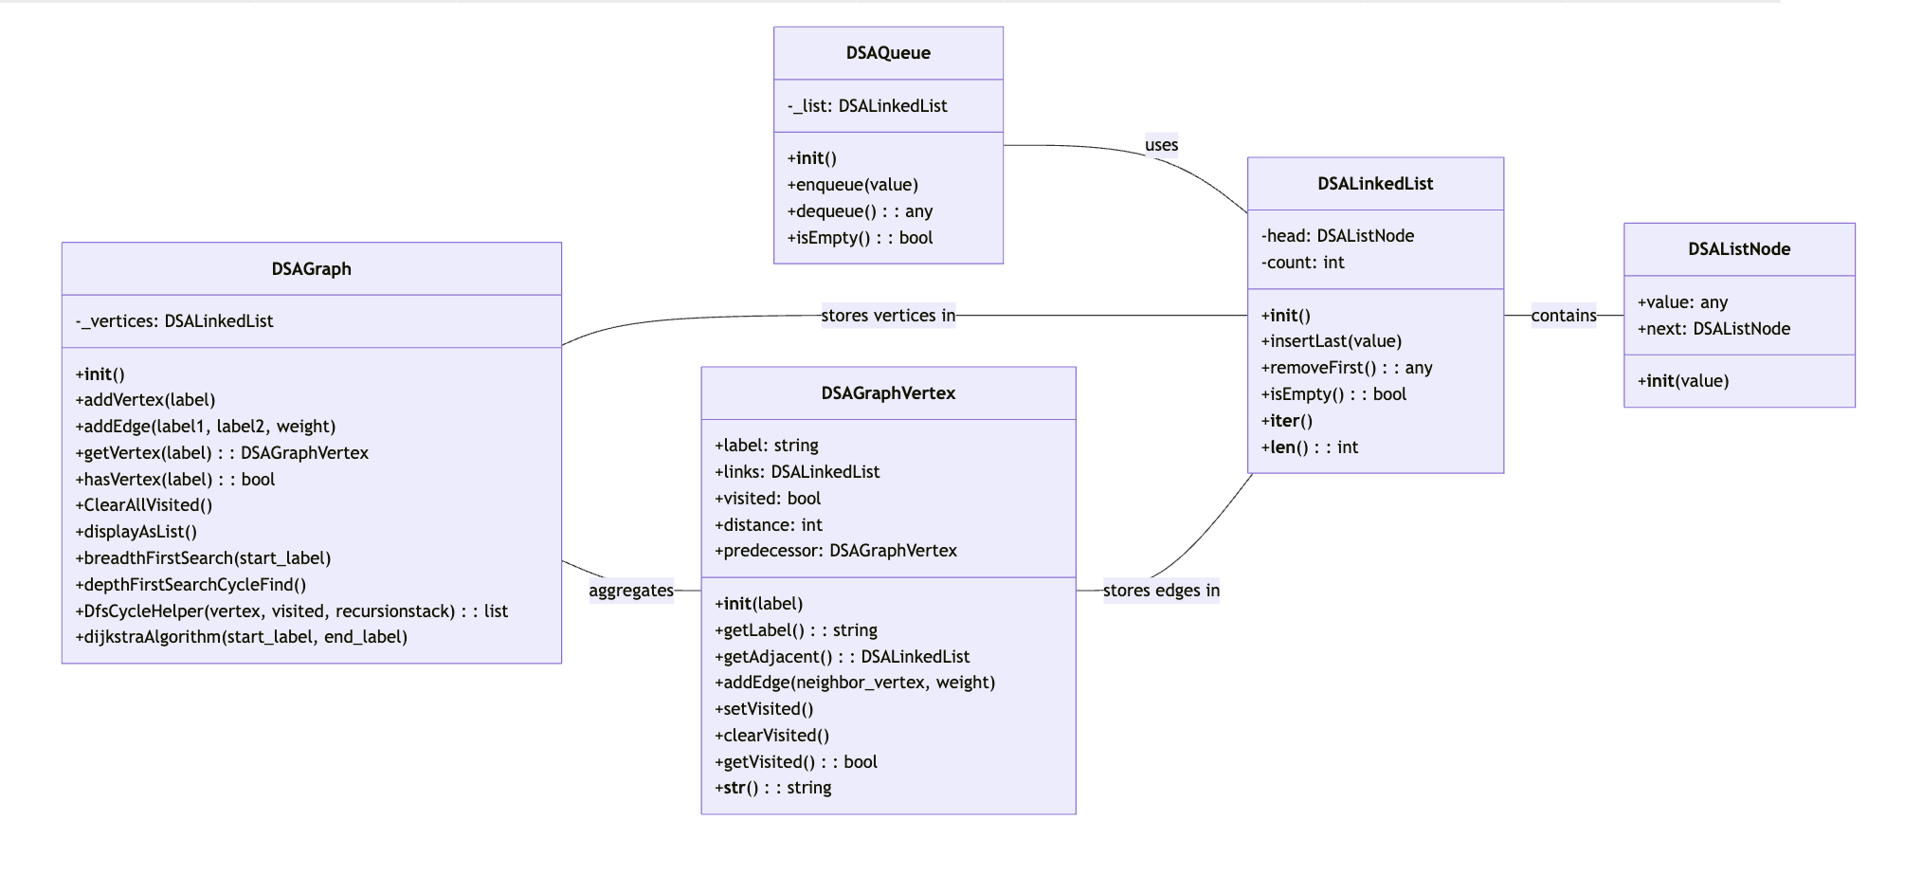
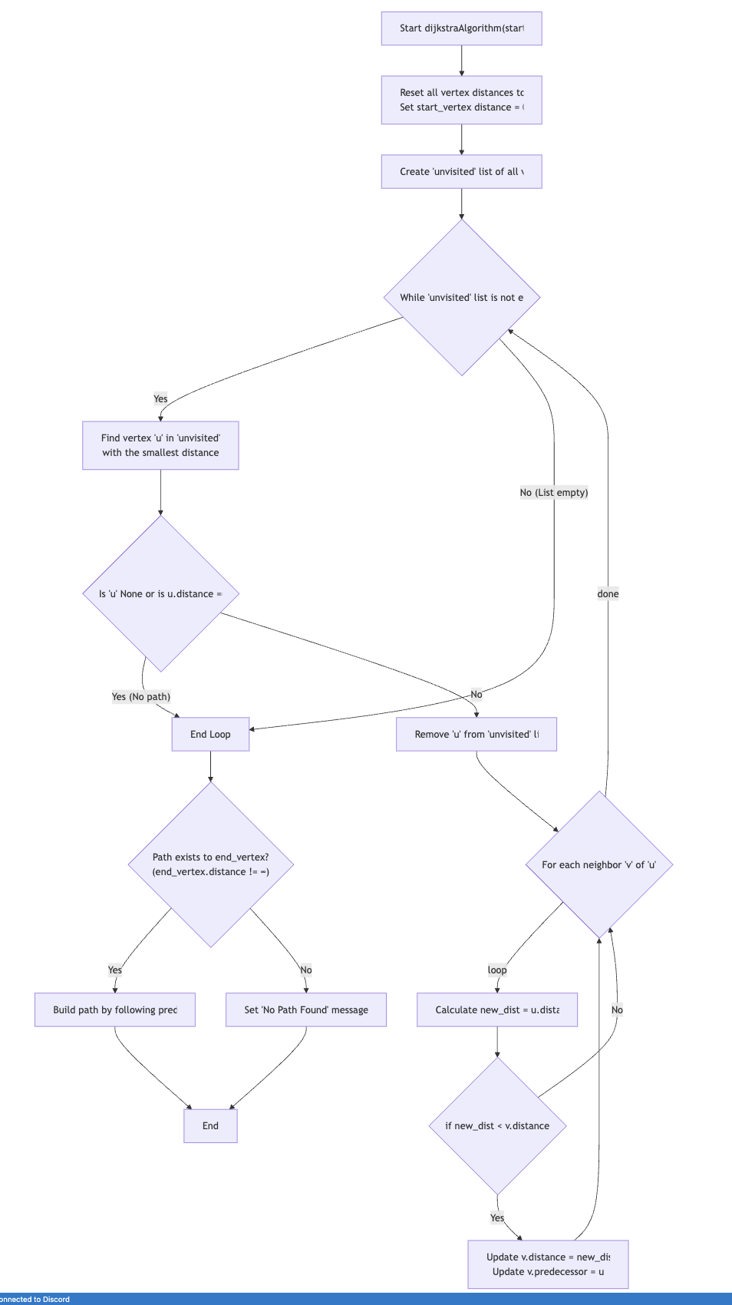
Module 2: Hash-based patient lookup
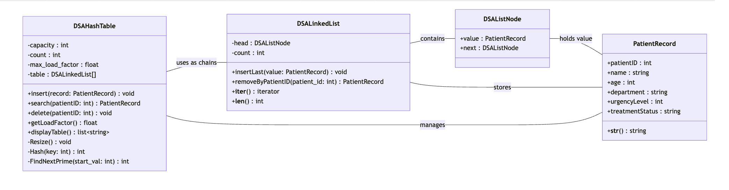
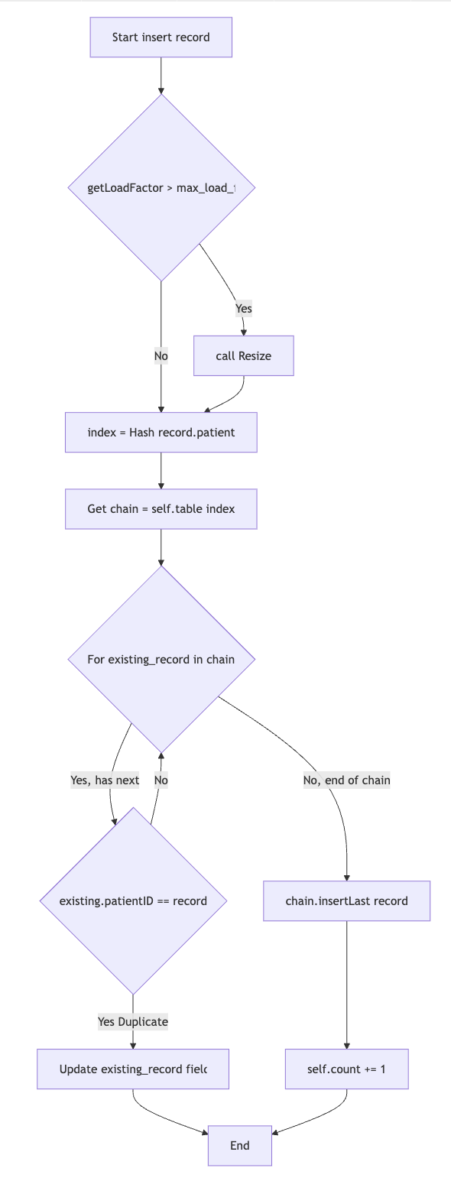
Module 3: Heap-based emergency scheduling.
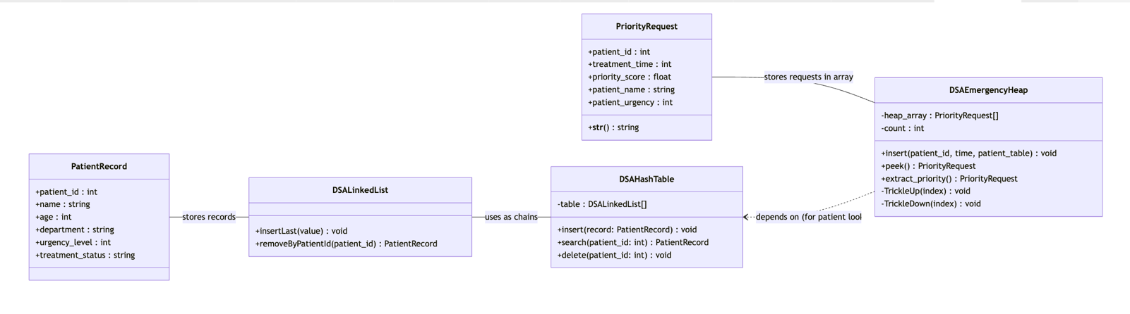
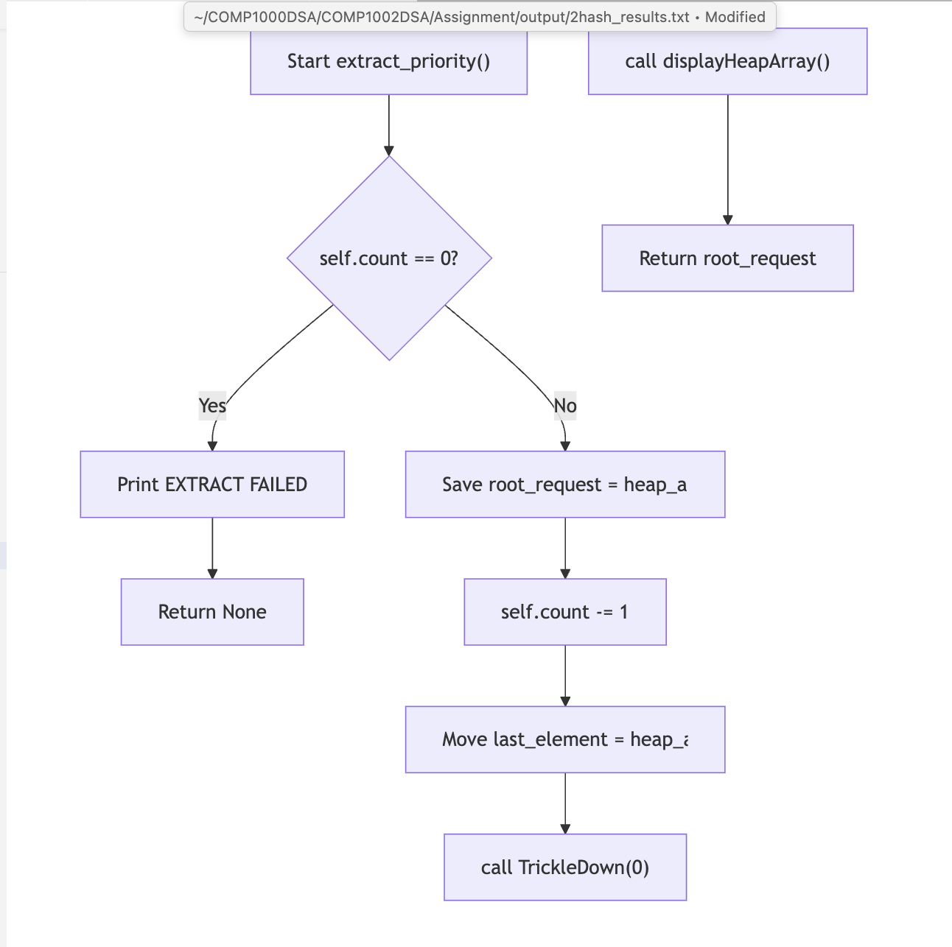
Module 4: Sorting Patients Records
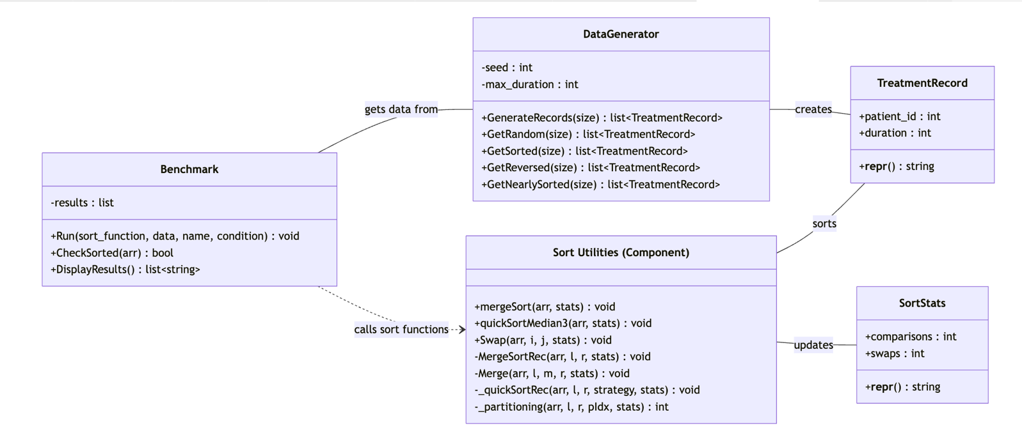

4) Algorithm Complexity: Time and space analysis for each module.
Module 1: Graph Based Hospital Navigation
- Performance of mdoule 1 is defined mainly by its 2 main variables V (no. Of departments/vertices) and E (edges/corridors.
- The BFS DFS algorithms have linear time complexity.
- Dijkstra's algorithm has a time complexity of O(n^2). This is a trade off because, as we are unable to use built-in functions, a manual scan of the list of departments is require.
Module 2: Hash-based patient lookup
- Module achieves a average-case time complexity O(1) for insert(0, search() and delete().
- This is achieved with the combination of prime number and good hash function for the distribution of keys.
- The good performance is depicted by the load factor being a healthy figure of 0.45, even after undergoing resizing.
- Primary trade-off: choosing chaning for collision handling.
Module 3: Heap-based emergency scheduling.
- Core operations insert() and extract_priority() achieve a time complexity of O(nlogn).
  - They both use trickle up/down and both need to traverse the height of the heap tree rather than the entire array.
- Peek() finds the highest priority patient with an instantaneous O(1).
- Trade off: a small cost of O(logn) on every insertion.
Module 4: Sorting Patients Records
- As n increases from 100 -> 1000, runtime increases from 0.08ms to 1.3ms. (nlogn growth).
- Merge sort is independent of order of input. Time on reversed data is the same as random input (1.106ms == 1.319ms).
- Conversely, quick sort operates using O(logn). With O(n^2) on worst caps input.

5) Sample Output: Screenshots/log excerpts per module.
Module 1: Graph Based Hospital Navigation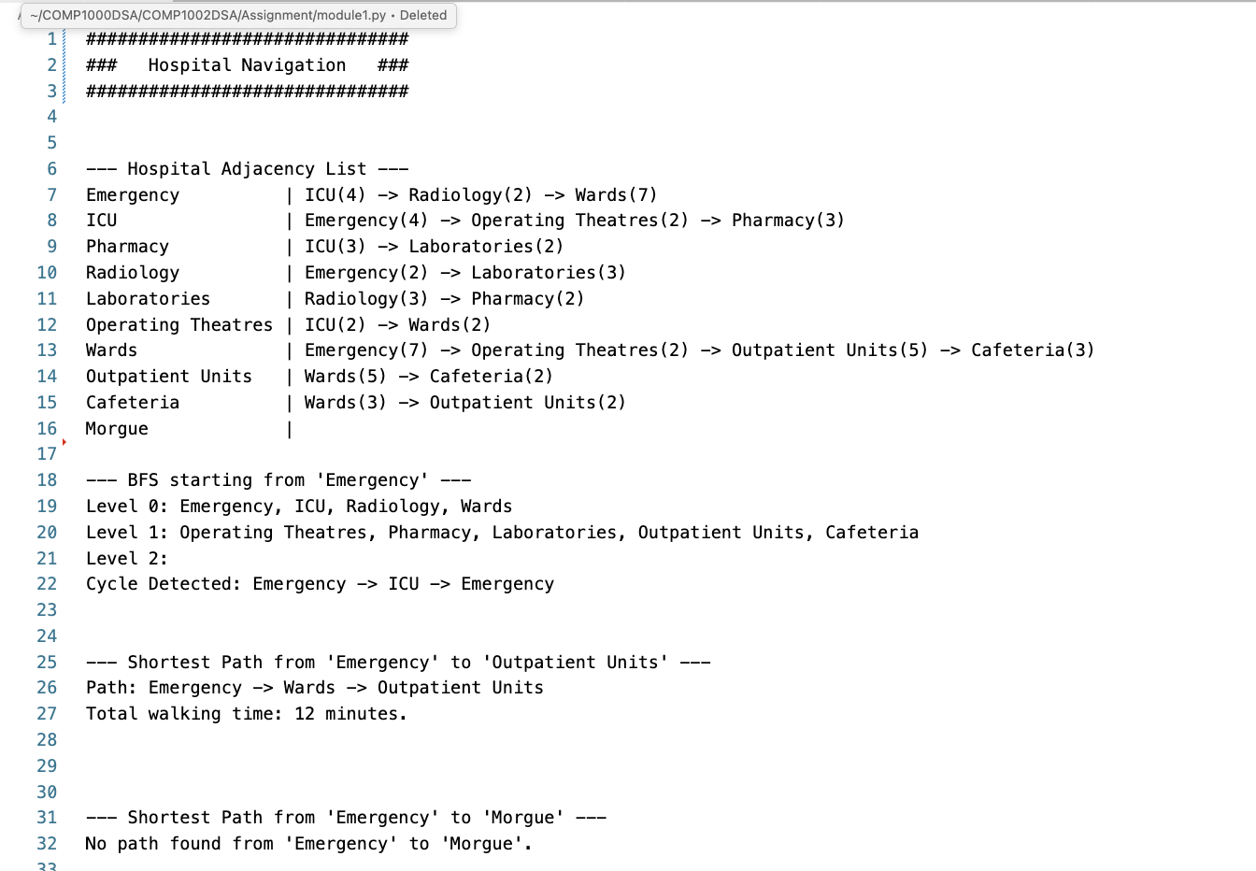
Module 2: Hash-based patient lookup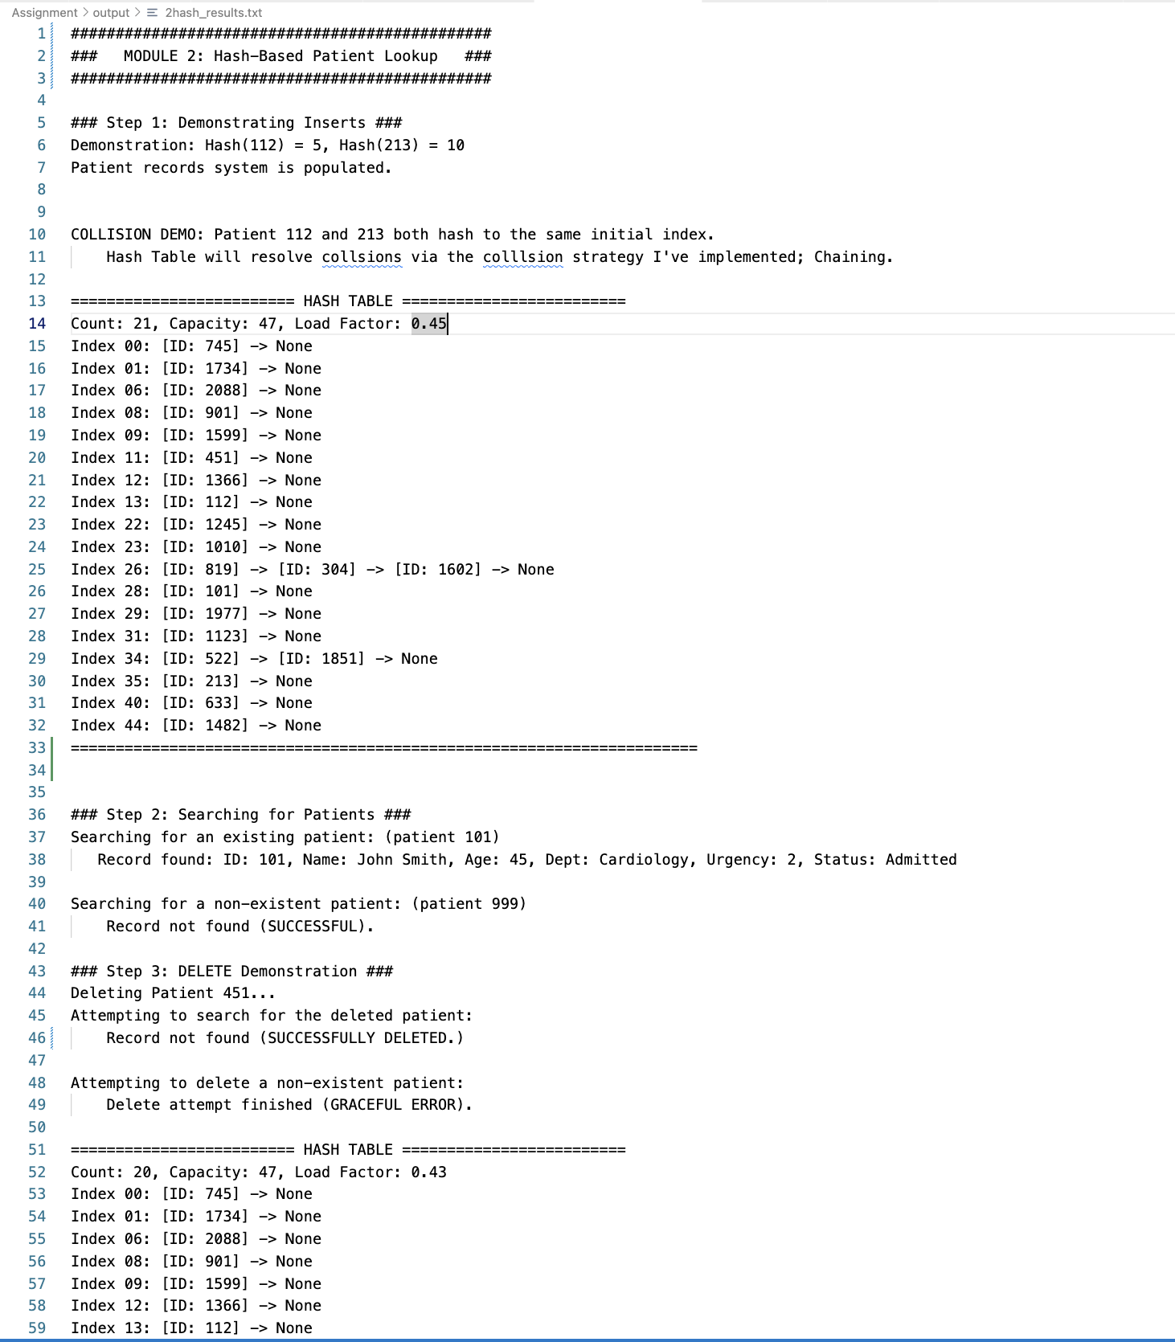
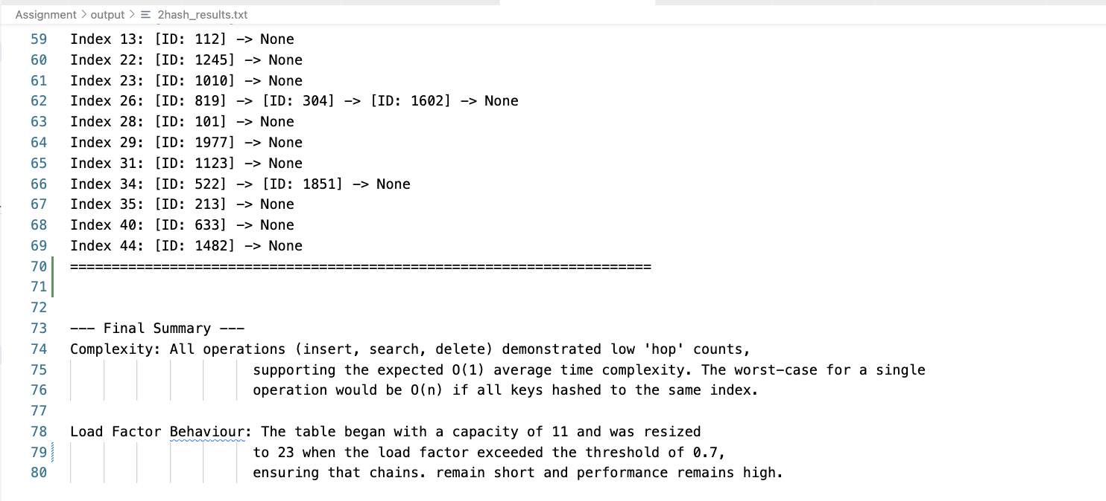
Module 3: Heap-based emergency scheduling. 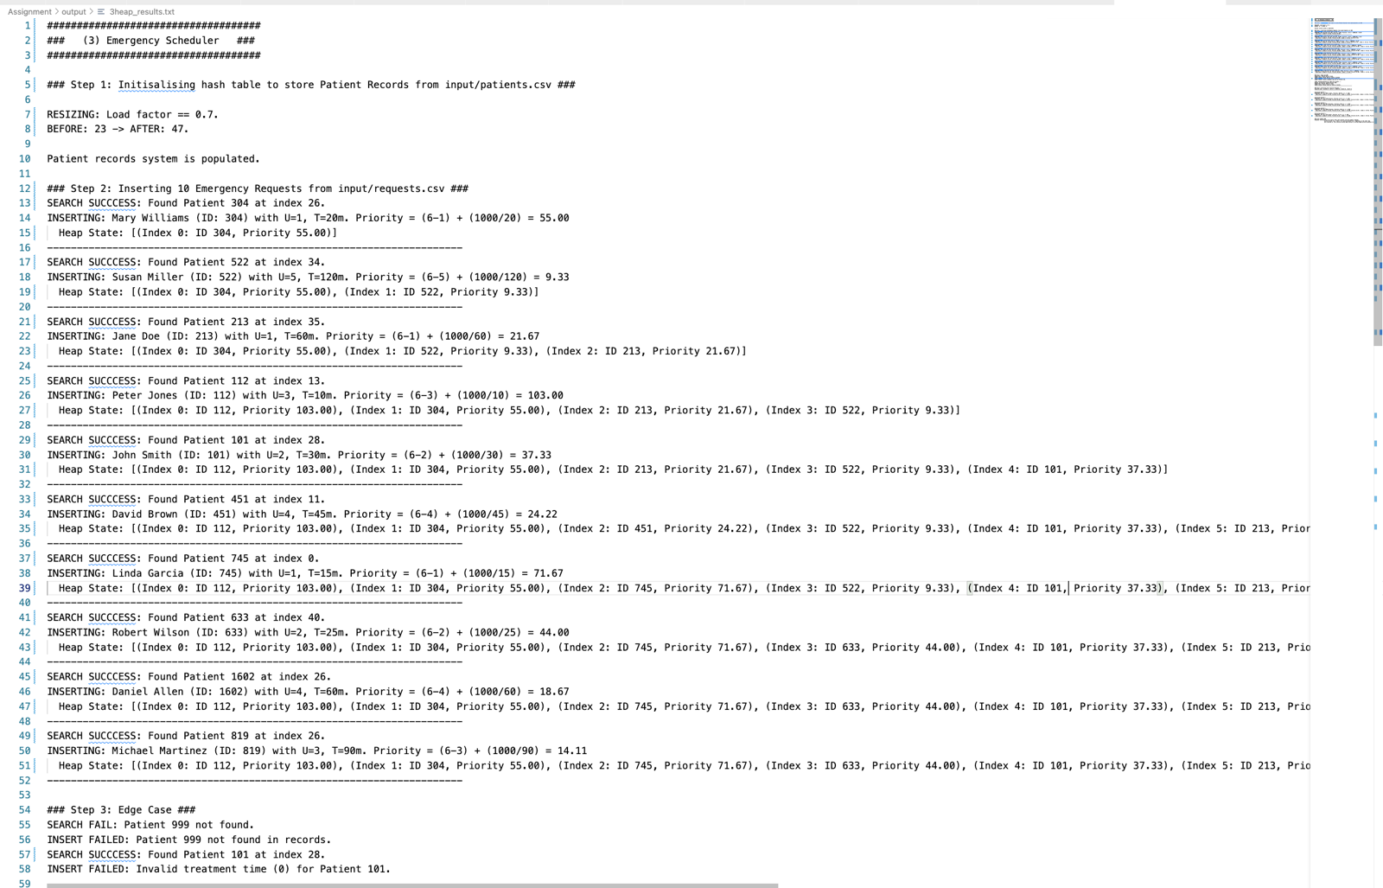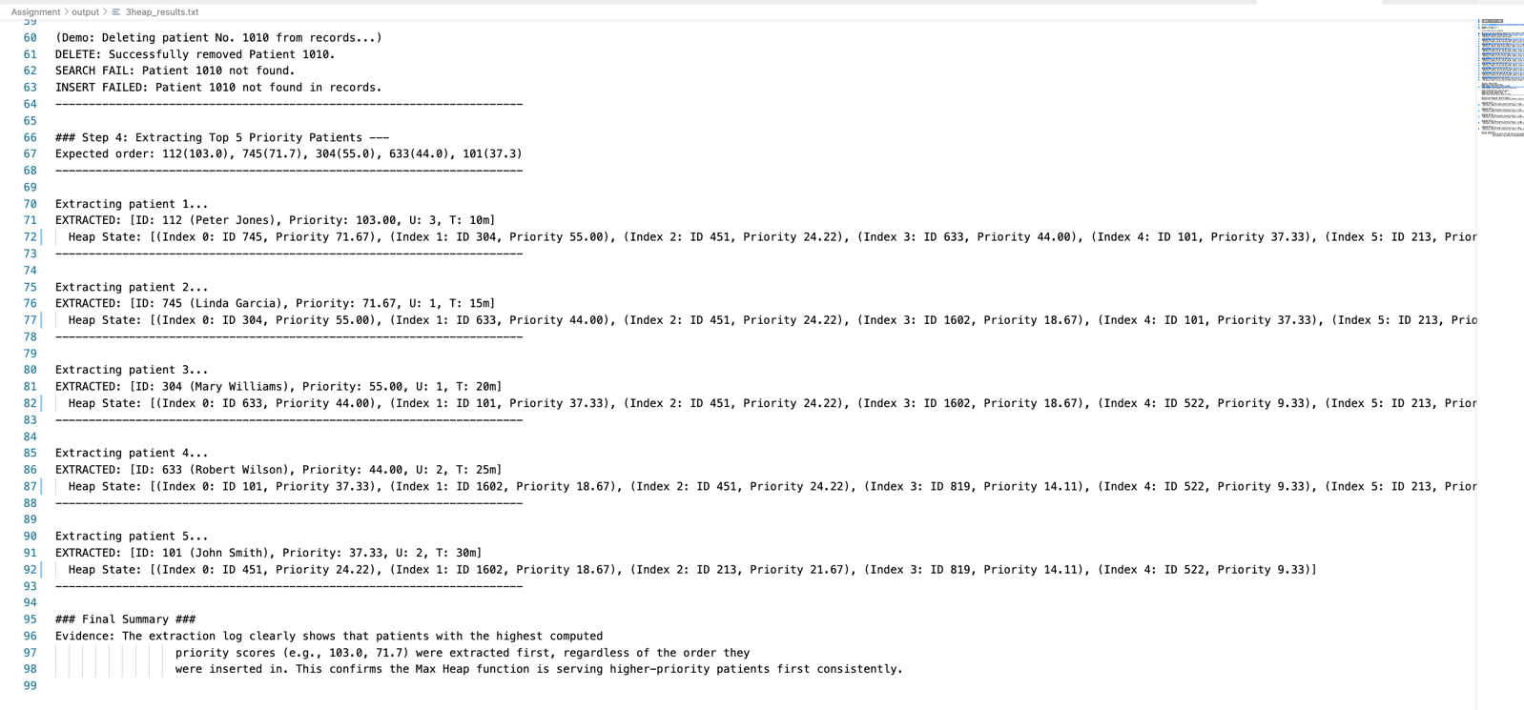
Module 4: Sorting Patients Records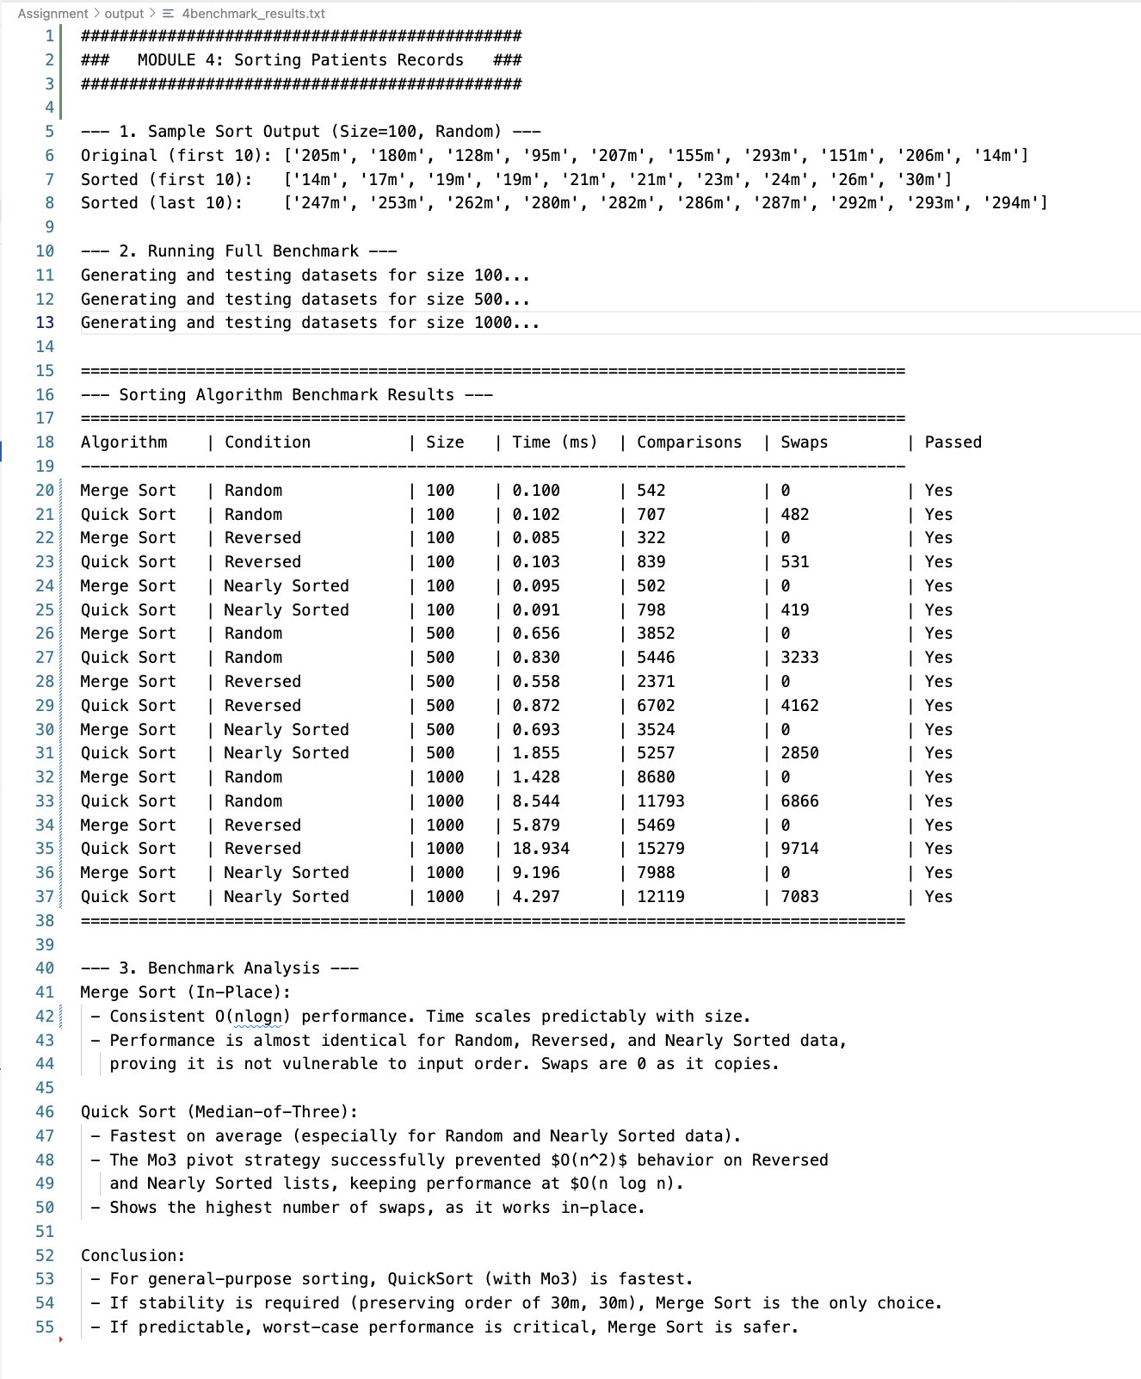

6) Reflection: Key learnings and design trade-offs.
The project demonstrated that there is no single best algorithm or data structure. Every design choice made will will have a trade-off. For example, average time for the hash table implemented in module 2 is a good example of trade-offs. Its great performance is only achieved because of computationally expensive, but rare resize() operation. Another example can be in module 3, ability to be fully sorted is is traded for ability to insert in O(logn) time. Moreover, in module 4, merge sort guarantees a time complexity of O(nlogn) at the cost of O(n) space complexity.

7) Limitations & Assumptions: Known issues and simplifications.

Things to do in the end:
1. (source code) Include inline comments and a header block for each file.
Time and space analysis for each module
2. Readme

- Include inline comments and a header block for each file.
- Attach each code and output and ask if I’d get all makrs for the module according to the marking ciriteria – done
- Code violations- done
- UML diagram - done
- Finally all modules are done README – done
- Time complexity analysis
- Output screenshots
- Overview, limitations, reflection

