Analyzing Energy Systems via a Novel System-level & Pathway-level LCA
Modeling Framework

Emre Gençer¹, Sarah Torkamani², Ian Miller¹, Francis O’Sullivan¹

¹ MIT Energy Initiative, Massachusetts Institute of Technology, 77 Massachusetts Avenue, Cambridge, MA, 02139 United States
² ExxonMobil Research and Engineering Company, Corporate Strategic Research, 1545 Route 22E, Annandale NJ, 08801 United States

Abstract

Globally, we face a dual challenge: satisfy growing energy demand while reducing greenhouse gas (GHG) emissions. A single analysis tool does not yet exist to allow for direct comparisons of life cycle GHG emissions based on energy decisions at the system-level. Therefore, we have developed a novel transparent energy-system assessment tool called Sustainable Energy System Analysis Modeling Environment (SESAME). It enables assessment of GHG emissions from approximately 80% of the economy. The tool is capable of analyzing various sectors such as power, road-transportation, industrial, and residential at both the pathway-level and system-level. In this paper, we provide examples of SESAME’s ability to calculate the effects of energy decisions on life cycle GHG emissions of the transportation and power sectors. These examples are only a small fraction of the tool’s capabilities. To the best of our knowledge, no other tool has been previously developed to assess life cycle emissions across the energy system.

Introduction
The global energy sector faces the dual challenge of meeting the increasing energy demand while simultaneously reducing greenhouse gas (GHG) emissions. Today’s energy sector is responsible for approximately 80% of the world’s total GHG emissions. The power, industrial, and transportation sectors constitute 33%, 22%, and 16% of the emissions from the energy sector, respectively [1]. The energy sector is transforming via the convergence of power, transportation, and industrial sectors and inter-sectoral integration. To assess the level of decarbonization achieved through this change, one needs to study the carbon footprint of the energy system as a whole. This requires a system-level analysis which incorporates pathway-level interactions and their resulting GHG emissions. [2]
Life Cycle Assessment (LCA) is a technique to addresses the environmental aspects and potential environmental impacts of a product throughout its life cycle from raw material acquisition through production, use, end-of-life treatment, recycling, and final disposal (i.e., cradle-to-grave) [3,4]. Traditionally, LCA has been used to assess a specific product throughout its life cycle pathway, which can be called a pathway-level analysis. Software and tools such as openLCA [5,6], SimaPro [6,7], GaBi [8], GHGeneius [9,10], and GREET [11] are designed to give users flexibility in conducting various pathway-level LCAs. To address the need for quantifying decarbonization level of the energy sector, one needs to explore the overall GHG emissions across the energy system, which can be called a system-level analysis. To address this need, we have developed a tool capable of both pathway-level and system-level life cycle analysis. We refer to the tool as SESAME (Sustainable Energy System Analysis Modelling Environment). The system-level analysis by SESAME is enabled by the embedded power systems and vehicle fleet models that capture market dynamics and explore dynamics of technology adoption and usage. SESAME incorporates the impacts of technological, operational, temporal, and geospatial characteristics of a pathway or system in its analysis.
SESAME is built as a MATLAB application that encapsulates LCA codes (MATLAB files), life cycle inventory databases (Excel and MATLAB files), and integrated process simulations (Aspen Plus Simulations). SESAME’s modular framework constitutes the underlying analytical engine that covers the life cycle steps of major energy conversion pathways. The first version of the tool contains more than 1300 individual pathways (as shown in Table 1), which are responsible for ~80% of US greenhouse gas (GHG) emissions. Detailed process simulation capabilities have been incorporated for in-depth analysis of the majority of conversion processes, such as power generation, biorefining, production of hydrogen, methanol, and dimethyl ether (DME).
This paper focuses on an overview of the tool, the modelling approach, as well as the results of case studies investigating transportation and power sectors.
Table 1 LCA pathways covered by SESAME
Feedstock to product | No. of options |  |  |  |  |  | No. of Pathways
Feedstock to product | Upstream | Midstream | Process | Gate to User | CCUS | End Use | No. of Pathways
Crude-to-gasoline | 3 | 3 | 2 | 4 | 2 | 2 | 288
Crude-to-diesel | 3 | 3 | 2 | 4 | 2 | 2 | 288
Coal-to-electricity | 3 | 3 | 3 | 1 | 2 | 1 | 54
Gas-to-hydrogen | 2 | 6 | 3 | 2 | 2 | 2 | 288
Gas-to-LNG (fuel) | 2 | 1 | 1 | 2 | 2 | 1 | 8
Gas-to-CNG (fuel) | 2 | 1 | 1 | 3 | 2 | 2 | 24
Crude-to-LPG | 3 | 3 | 2 | 4 | 2 | 1 | 144
Gas-to-LPG | 2 | 1 | 1 | 4 | 2 | 1 | 16
Gas-to-electricity | 2 | 6 | 4 | 1 | 2 | 1 | 96
Gas-to-dimethyl ether | 2 | 6 | 1 | 1 | 2 | 1 | 24
Gas-to-methanol | 2 | 6 | 1 | 1 | 2 | 1 | 24
Biomass-to-ethanol | 2 | 1 | 1 | 4 | 2 | 2 | 32
Iron & Steel production | 1 | 2 | 1 | 3 | 2 | 1 | 12
Cement production | 1 | 2 | 1 | 3 | 2 | 1 | 12
Renewables-to-electricity | 6 | 1 | 1 | 2 | 2 | 1 | 24
Nuclear power | 1 | 1 | 1 | 1 | 1 | 1 | 1
Biomass-to-electricity (agricultural residue) | 1 | 1 | 3 | 1 | 2 | 1 | 6
Biomass-to-electricity (Woody) | 1 | 3 | 3 | 1 | 2 | 1 | 18
Biomass-to-electricity (biogas) | 1 | 1 | 1 | 1 | 2 | 1 | 2
Crude-to-polyethylene | 3 | 3 | 1 | 1 | 2 | 1 | 18
Total |  |  |  |  |  |  | 1379

Material and Methods

2.1. LCA methodology, system boundaries, and functional units
To accurately represent the energy system, SESAME was developed a pathway-level and system-level LCA tool following the ISO 14040 and 14044 standards [3,12]. SESAME is designed to conduct attributional LCA for all the pathways and systems that can be defined via the modular architecture of the tool. For select products, e.g., corn ethanol and corn stover ethanol, and select systems, e.g., power system, SESAME enables conducting consequential LCA. For biofuels, published data on consequential elements (e.g., land use change) projected by various economic models such as Global Trade Analysis Project (GTAP), the Forestry and Agricultural Sector Optimization Model (FASOM), Food and Agricultural Policy Research Institute (FAPRI), and Global Change Assessment Model (GCAM), are pre-populated in the life cycle inventory of SESAME. For the power system, we can model and project the GHG emissions as a consequence of renewables penetration to the grid. To our knowledge, there is no previous publication on the consequential LCA of a power system. This analysis will be shared and discussed in detail in a subsequent publications.
We have specified system boundaries for the LCA of all the products of focus in SESAME. The system boundaries encompass all the life cycle steps (cradle-to-grave) which are upstream, midstream, process, Carbon Capture, Utilization and Storage (CCUS) as an optional step, gate to user, and end use. A few examples are depicted in Figure 1, which are the system boundaries for crude oil to gasoline, biomass to ethanol, coal to power, and natural gas (NG) to power.
Depending on the nature and function of the product, its functional unit could be different. For example, for biofuels, the functional unit could be one MJ of biofuel (calculated based on low heat value) or one mile driven by a car fueled by 100% biofuel. For power, the functional unit could be one Mwh (consumed by a car or a residential facility) or one mile driven by an electric vehicle.
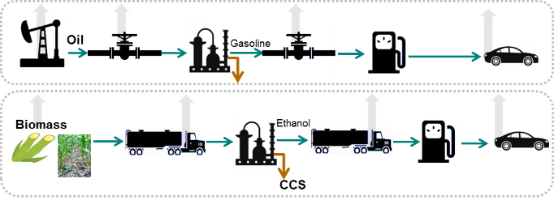 | 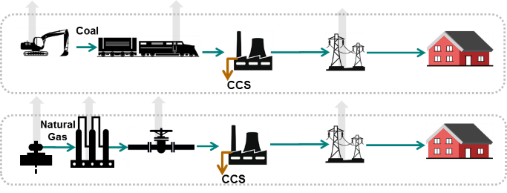
(a) | (b)
Figure 1 Examples of system boundaries for (a) products in transportation sector: crude oil to gasoline, and biomass to ethanol, and (b) products in the power sector: coal to power, and NG to power.

2.2. Modular Tool Architecture
SESAME is designed based on a matrix of modules comprising of six key vectors, each representing a life cycle step: upstream, midstream, process, Carbon Capture, Utilization and Storage (CCUS), gate to user, and end use (Figure 2).
Modules are shown with dashed red boxes in Figure 2. They represent a set of common operations, and may have several sub-modules. Users select one module from each column. The collective selected modules by the users will form a pathway to produce a specific product (listed in the green box on the top right-hand side of Figure 2). Depending on the pathway, skipping columns or selecting multiple modules from the same column is also possible. The modular structure allows for creating numerous individual pathways to conduct pathway-level LCA. To conduct a system-level LCA, we can group as many modules/sub-modules needed which represent a system (e.g., transportation system or power system). We can conduct the LCA of a transportation system by connecting each transportation fuel life cycle sub-module to our vehicle fleet model.
The upstream module in Figure 2 represents extraction and production of feedstock, key minerals, and also chemicals that are necessary for subsequent conversion processes. Feedstock could be fossil-based or renewable-based. Fossil feedstocks (and their major sub-modules) included in SESAME are natural gas (conventional, and shale gas), crude oil (conventional, tight oil, and oil sands), and coal (bituminous, sub-bituminous, lignite).
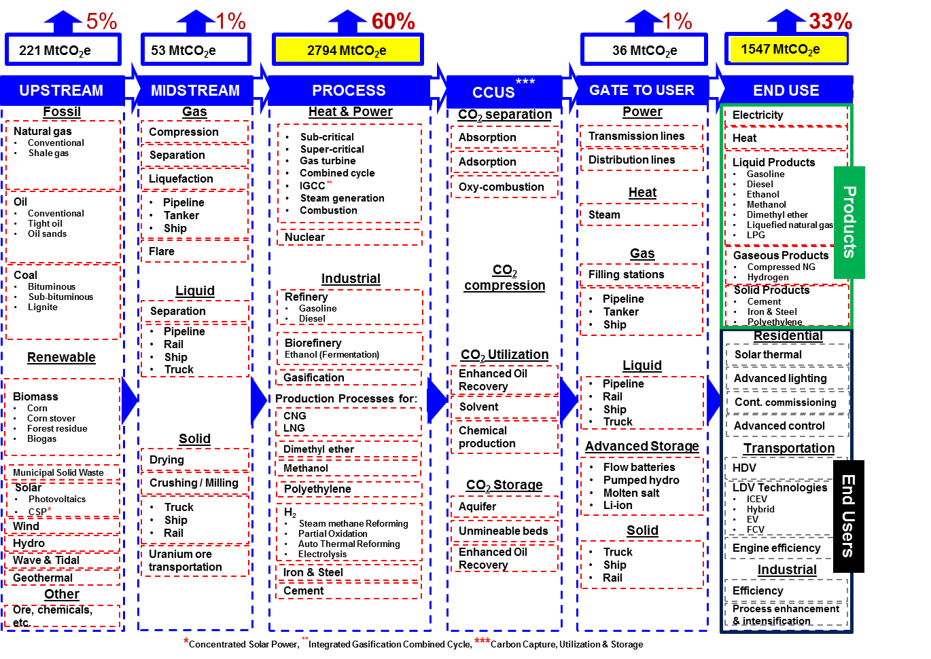
Figure 2 The modular representation of the energy system as defined in SESAME.
Renewable feedstock modules comprise biomass (corn, corn stover, forest residue, biogas), solar (photovoltaics, concentrated solar power), wind, hydropower, wave & tidal, and geothermal. The biomass upstream module contains production and harvesting related emissions. For other renewable modules, since there are no associated emissions during power generation step, all the life cycle emissions are included in their corresponding upstream modules. Depending on the resource, the impact of technology options, locations, etc. are included as a variable.
The midstream module represents the transportation of energy feedstocks to the processing step based on the phase of the feedstock: gas, liquid, and solid. The gas midstream module includes processes (compression, separation, liquefaction, flaring) that can be applied to any gaseous feedstock, e.g., natural gas and biogas. Additionally, common gas transportation modes such as pipeline, tank, and shipping are included. Modules within the same life cycle step can be stacked in case more than one module needs to be included for the operation. For example, in the case of natural gas as feedstock, a compression step will be required for almost any kind of transportation step; hence, the midstream step will include both compression and pipeline transportation. The liquid midstream module comprises separation and transportation via pipeline, rail, ship, and truck options. The solid midstream module contains various operations that are part of solid processing such as drying, crushing/milling, and transportation via truck, ship, and rail. For nuclear power generation, uranium ore transportation is included in the solid module.
The process module represents one of the key life cycle steps, in which Heat & Power and Industrial are the two main modules. All major thermal power generation options are represented as sub-modules such as sub-critical and super-critical steam turbines, gas turbine, combined cycle, and integrated gasification combined cycle. For heat supply options, steam generation, and combustion are included. Nuclear power plants are also included in this step. The industrial module includes all major industrial processes. The Petroleum Refinery Life Cycle Inventory Model (PRELIM) [13], was used to develop the refining module with gasoline, and diesel as primary products. Seventeen generic refinery configuration and three crude types (West Texas Sour, West Texas Intermediate, Venezuela Leona) are included as feedstock. Ethanol production (from corn or corn stover) was covered in the biorefinery module. We used NREL’s Aspen simulation for corn stover ethanol production. The gasification module is a general model to convert solid energy feedstocks to synthetic gas. Production of various fuels such as methanol, dimethyl ether (DME), hydrogen, and polyethylene chemicals are included within dedicated modules, and assessed by using Aspen plus simulations. For polyethylene production, the polymerization reactor was simulated using Aspen (not the rest of the process).
Technology options such as hydrogen production via steam methane reforming and auto-thermal reforming are defined as submodules. Natural gas stations for the production of compressed natural gas, and liquefied natural gas are also included in the process step although it does not involve a chemical conversion. Finally, heavy industry processes of iron and steel and cement modules are part of the process step.
We included CCUS as an optional life cycle step. CO₂ capture, compression, utilization, and storage are represented with separate modules. Capture technologies include absorption, adsorption and oxy-combustion options.
The gate to user module covers the transportation of products from the plant to the end user. The general structure is similar to midstream step with few differences including addition of electricity transmissions, advanced energy storage options, and distribution of heat (steam).
The end use module includes electric power, transportation, and industrial sectors. The electricity module can be a simple electricity demand function as well as connected to a power system model that represents hourly load profiles with changing generation mix. The heat module specifies heat demand and its temperature level. The liquid products module contains gasoline, diesel, methanol, ethanol, dimethyl ether (DME), Liquefied Petroleum Gas (LPG), and Liquefied Natural Gas (LNG). Gaseous products include Compressed Natural Gas (CNG) and hydrogen. Solid products in the model are cement, polyethylene, iron, and steel.
In addition to products, a few variables are included under end-use modules such as the adoption of different technologies for transportation, engine efficiency improvement, process intensification in industry, which enable conducting sensitivity analysis.
One of the advantages of the modularity design is that it allows layering regional variations with minimal intervention.

2.3. Modeling Framework
SESAME’s programming architecture is implemented in MATLAB by integration with Aspen Plus process simulation software using the methodology presented by Gençer, and Agrawal [14,15]. This approach allows complementing life cycle analysis with process simulation capabilities to capture the performance, and emission variations arising from technological, operational, and geospatial factors (by calculating energy and mass balance). The developed architecture provides a platform to implement simulations of process units with high emission rates, critical for the system design. As shown in Figure 3(a), Excel, MATLAB, and Aspen plus are used to feed input assumptions to the MATLAB core script. As needed, the tool can be equipped with more programming platforms and connected to various existing tools.
A novel aspect of this analytical framework is the ability to assess key systems interactions and couplings. This allows transition options to be comprehensively assessed on an apples-to-apples basis. SESAME’s modular design allows performing such comprehensive analyses, specifically it can be evolved as the complex energy system restructures.
The modular approach is composed of four main compartments at the very high-level: User Input, Control Panel, Life Step Modules, and Output, as depicted in Figure 3(b). Users select from default options to initiate the computation. The control panel module constitutes the core of the tool that takes users inputs and communicates with relevant life step modules to send and receive information. The results from each life step module are adjusted and combined in accord with the user’s selections. Finally, the results are reported as output in the desired form and units.

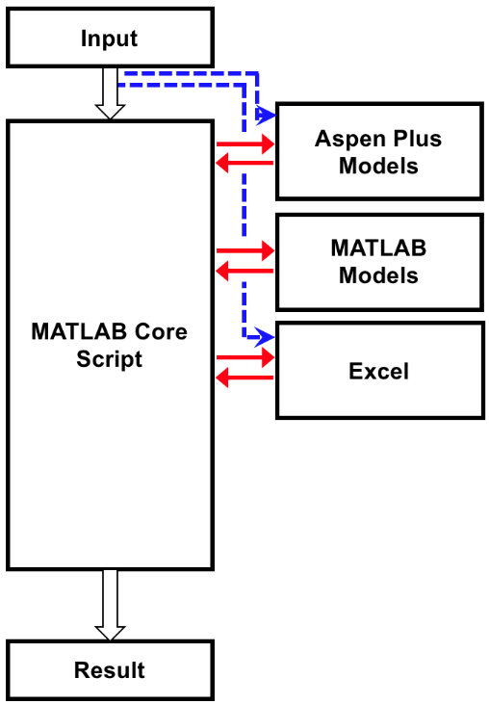 | 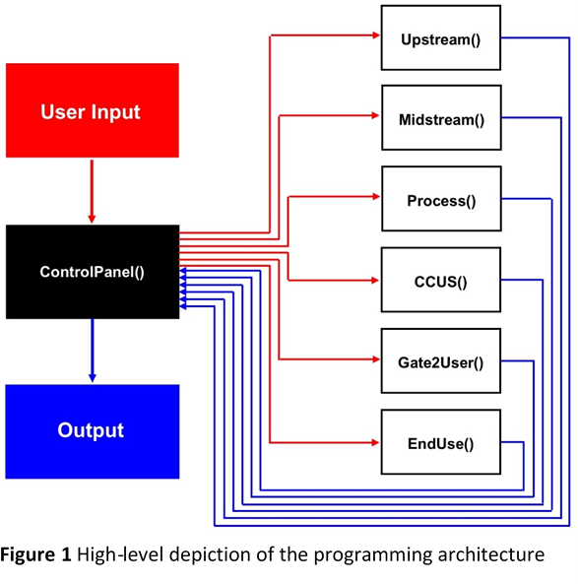
(a) | (b)
Figure 3 (a) The communication between MATLAB Core Script and auxiliary components: MATLAB Models, Aspen Plus Models, and Excel models and databases are shown. (b) MATLAB is used to develop life step modules, each one of which has its unique structure. Each module is composed of numerous custom developed MATLAB functions. Functions are designed to minimize the repetition of same scripts and framed separate different tasks.

2.4. Data Sources
The life cycle inventory for SESAME was developed by using publically available, peer-reviewed data. A few examples of our data sources were PRELIM (for estimating refining GHG emissions) [16], GREET (for calculating mid-stream, and gate to user emissions, carbon footprint of chemicals used at biorefineries, etc.) [17], IEA’s 2015 Report “Life Cycle Inventories & Life Cycle Assessments of PV Systems” [18] and ESU’s 2012 Report “Life Cycle Inventories of Photovoltaics” [19] (for developing an LCI for our PV solar LCA), NETL’s reports (for developing Aspen Simulation for calculating mass and energy balance at generic NG power plants) [20–23], NREL’s reports and Aspen Simulations (for calculating mass and energy balance at a generic corn stover ethanol biorefinery) [24–27]. Various peer-reviewed publications were utilized for emission intensities of shale gas production [28], tight oil production [29], corn stover conversion [30], integrated biofuel production [31], solar PV manufacturing [32], energy storage integration [33].

Modeling Details

Communication between MATLAB and Aspen Plus
The communication between MATLAB and Aspen Plus is established through Microsoft COM (Component Object Model) technology, which allows software components to communicate in the Microsoft Windows-family Operating Systems.
h = actxserver(‘progid’) command in MATLAB creates a local OLE (Object Linking and Embedding) automation server, where progid is the programmatic identifier of an OLE-compliant COM server. This returns h, a handle to the default interface of the server. The programmatic identifier of Aspen Plus, Apwn.Document, is used for the connection. Once the connection is established, a path to the Aspen Plus file should be specified to read from, and write to the simulation file. A single or multiple Aspen Plus simulation files should be prepared beforehand. A variable can be defined for the path or it can be directly input to invoke the function that will open the simulation file. The communication is two-way as shown in Figure 3.
The next step is to define input and output variables. These variables are used to assign values to the simulation file as well as to read values from the simulation. Similarly, the simulation file variables are read and their values are assigned to local MATLAB variables. To read from a simulation file, the path to the backup file should be used since the backup file has the values of the simulation variables from the previous run. Once the value exchange between Aspen Plus and MATLAB is complete, the simulation file can be run using a run command. The Run command will run the simulation file already opened before the command. The simulation results can be read and imported to MATLAB. The results of the performed run will not be saved to the backup file unless specified otherwise. However, to ensure the variables are back to the original, a close command can be used.

Life Step Modules in SESAME

Upstream Module
The upstream module is the first module called for cradle-to-grave pathway-level life cycle analysis. The only input to initiate the module is the fuel name (fuel). Upon completion, the upstream module returns the GHG emissions from upstream operations of fuel per energy unit base. The upstream function first accesses the properties of the fuel and performs a logic check to identify its phase and condition. Once the characterization of the fuel is complete, the Upstream function calls the exclusive upstream functions. Figure 4 demonstrates the information flow among sub-modules in the upstream module. The logic search launches the Crude_upstream, NG_upstream, Coal_upstream, Nuc_upstream, and Ren_upstream functions for liquid, gas, solid, nuclear, and non-biomass renewable energy sources, respectively. The differences among fuels/raw materials in the same first level classification are addressed in the submodule operation. Each submodule’s output is the GHG emissions, if available broken down into CO₂, CH₄, and N₂O per energy unit base. Hence, the results are collected in the same common emissions unit.
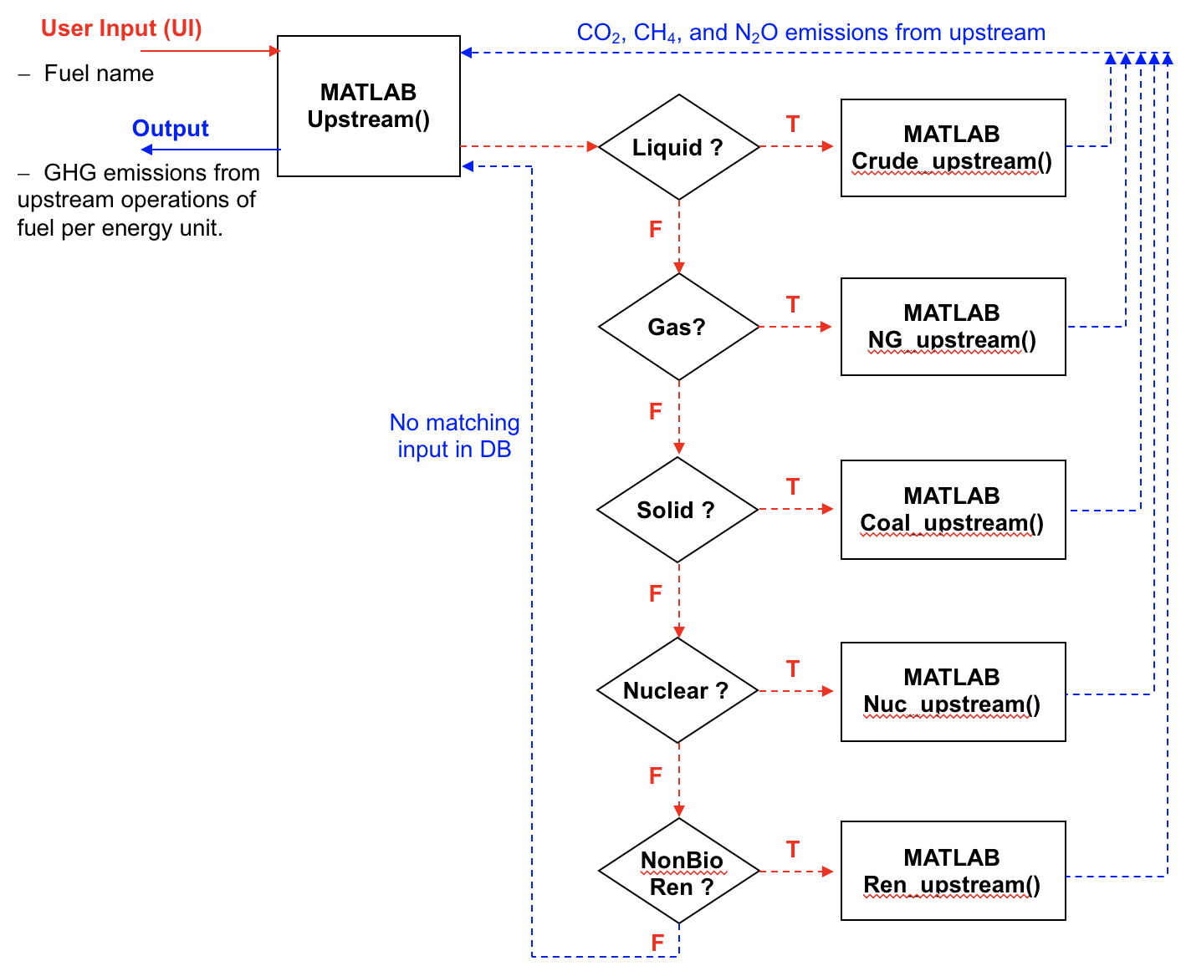
Figure 4 Information Flow Diagram of Upstream Module
An example of the upstream sub-module is the NG_upstream sub-module, which first reads the various energy consumption values for operations involved in upstream and their associated fuels from the Recovery database created using peer-reviewed articles and reports.[28,34]
For each energy source, a subsequent search is performed to classify the type of energy source as primary or derived. For primary fuels such as natural gas, oil, and coal, there is only raw fuel production energy and emission contributions, whereas derived fuels such as gasoline and diesel, undergo a conversion step from their raw primary form. For derived fuel, in addition to the raw fuel production contribution, the additional energy and emissions from the conversion steps are also included. Once the total fuel consumption is determined, the characteristics of fuels are gathered from the Fuels database, and emissions are calculated in GHG_calc function. This function also incorporates the leaking and flaring emissions for gaseous fuels. Finally, the emissions from various sources are fed to the Combine function, which calculates the combined GHG emissions for the upstream process. The NG_upstream sub-module returns the gas upstream related emissions to the Upstream module. An information flow diagram for the NG_upstream sub-module is depicted in Figure 5. The design basis for other upstream sub-modules is similar to that of the NG_upstream sub-module.
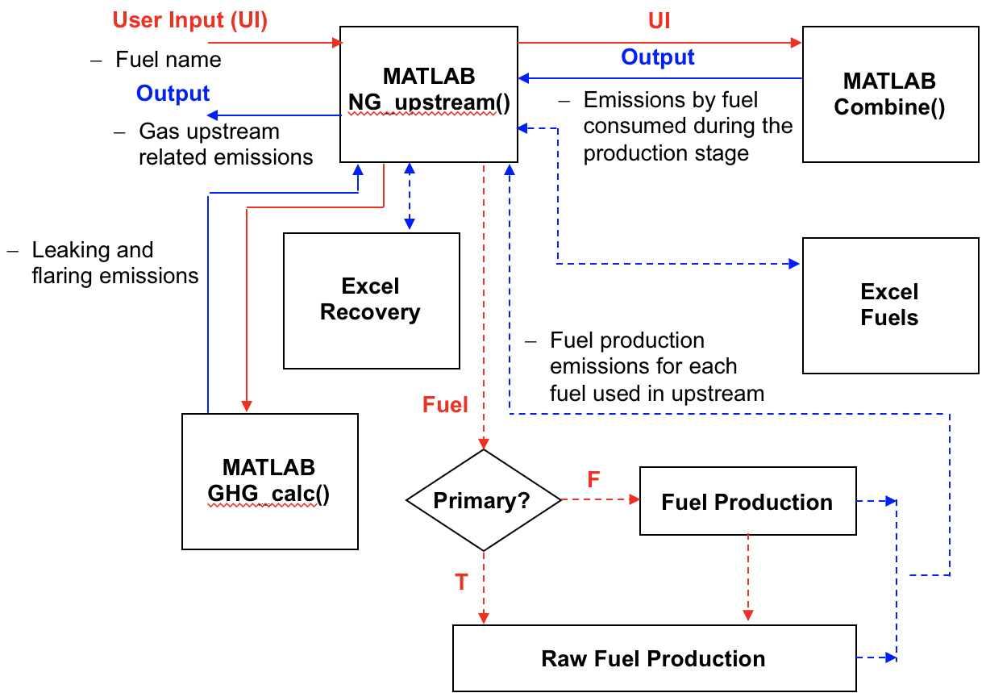
Figure 5 Information Flow Diagram for the Natural Upstream Sub-module

Midstream Module
The midstream module calculates the emissions associated with the transport from the feedstock extraction location to the processing location and conditioning of feedstock. Input parameters in addition to the fuel include feedstock properties, and conditions (phase, pressure, and temperature), and the share of each available transportation mode. The operation of the module starts with a logic search to check the availability of data in Midstream-Transportation database in desired conditions (Figure 6). At this step, if the relevant data is readily available, then it is read. If the base data is available but needs processing, then the Midstream-Processing database is checked and necessary information is collected if available. Once all the information is gathered, the emission values are calculated in the GHG_calc function. The Midstream module returns the midstream related emissions to the Control Panel.

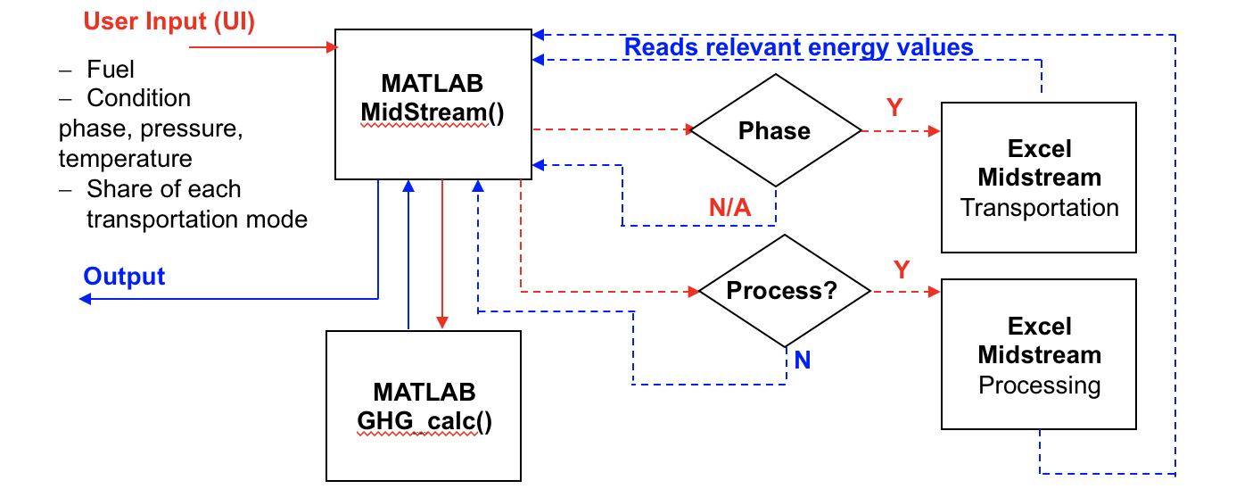
Figure 6 Midstream Module Information Flow Diagram

Process Module
The process module takes in the fuel, the process/end use information, and other relevant parameters to accurately calculate the emissions (Figure 7). The first step of the Process module’s operation is to query the Process database for the input specification. If the exact match is found in the Process database, then the information required to calculate the emissions are read.
The second step, if the exact match is not present, is to perform a simulation library database. Although process simulations are designed to cover a wide range of operating conditions, due to a rapid increase in the number of potential cases, it is not the best practice to include every possible combination. Therefore, we created a process simulation library that stores the available Aspen Plus simulations. The results of the process simulations built and run for the analysis are stored in the Process database. For the processes that exist in the process library with no results stored in the Process database, users can select to access and run the Aspen Plus simulations within the given process limits from the programming framework. The results of the newly created run will then be added to the Process database as a new entry. Hence, if the same conditions are called again, the results will be readily available instead of running a process simulation. Once this process is complete, the results are fed to the GHG_calc function to calculate the GHG emission from the process step. Finally, the Process module returns the process related emissions to the Control Panel. Process modules are developed for power plants, refineries, bio-refineries, chemical production plants (polyethylene), and heavy industry (iron, steel, and cement, plants producing hydrogen, methanol, DME, etc.).

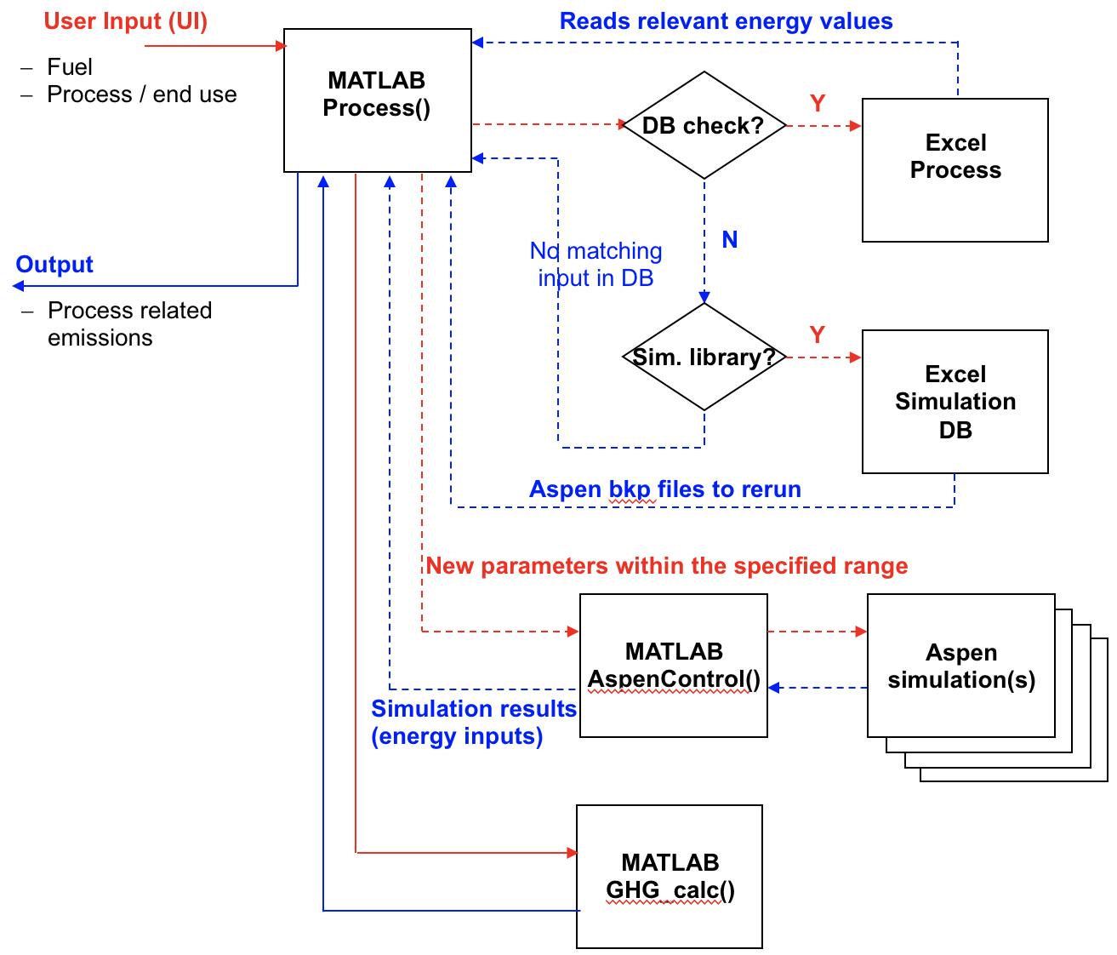
Figure 7 Process Module Information Flow Diagram

Carbon Capture, Utilization, and Storage (CCUS) Module
The CCUS module is designed to account for the effect of CCUS integration. The current version includes the available capture percentages for different processes. For example, the inclusion of capture to coal power plants will assume an amine based capture process with 90% capture rate. The addition of the capture option will also increase the total coal input to the process to account for the capture plant energy demand. The submodules for the CCUS module to form different value chains are currently under construction. A more complex and detailed version of the module will be included in the following versions of SESAME.

Gate-to-User Module
The gate-to-user module calculates the emissions associated with the product transport from the plant processing location to the end-use location. Input parameters, in addition to the product type, include a product’s properties and physical conditions (phase, pressure, and temperature), and the share of each available transportation mode. The operation of the module starts with a logic search to check the availability of data in the Gate-to-user-Transportation database in desired conditions. At this step, if the relevant data is readily available, then it is read. If the base data is available but needs processing, the Gate-to-user-Processing database is checked, and the necessary information is collected if available. Once all the information is gathered, the emission values are calculated in GHG_calc function. The Gate-to-user module returns the transportation related emissions of the product to the Control Panel.

End Use Module
The end use module fulfills two tasks; i) scale the total emissions (by providing the adjustment factor to Control Panel module that will affect all life step emissions), ii) calculate the end use related emissions for options that have utilization related emissions. The End use module plays a critical role in linking the systems-level analysis capabilities with pathway-level analysis. The vehicle and power fleet models included in the tool provide a list of pathways, each one of which is a component of the overall system. The aggregate effect of a system-level scenario is calculated based on the contribution of each pathway.

Results and Discussion

System-level LCA Results

GHG emissions of the U.S. energy system
Using our system-level assessment methodology, we screened more than 80% of the GHG emissions in the U.S. energy system (in 2018). It was performed by calculating and summing up GHG emissions from all the modules (dashed red boxes in Figure 1) listed in each life cycle step (dashed blue columns in Figure 2) using publically available data from the US EPA [35]. Our results show that process and end use steps represent a significant fraction of overall GHG emissions from the U.S. energy system, as shown in Figure 8. Depending on the selected pathway, the process step could be the most GHG intensive such as in power generation from fossil fuels pathways; the power generation process is the highest GHG emitter among all life cycle steps. For some other pathways, such as gasoline production from crude oil, the major GHG emitter is the end use (the vehicle tailpipe emissions). This high-level estimation demonstrates the emission hotspots in an overall pathway.
Figure 8 The U.S. energy system analysis was conducted by SESAME. All the GHG emissions (million tons of CO₂ equivalent) from all the modules listed in each life cycle step (in each column) were summed up. The current modules in the tool capture 80% of the overall GHG emissions from the entire U.S. economy. The results show that process & end use are GHG hotspots, emitting 60% and 33% of the total emissions respectively.

System-level LCA analysis for transportation sector
For a transportation case study, we estimated future GHG emissions from the U.S. passenger vehicle fleet, given car sales projections from the EIA [36]. Figure 9(b) and (c) show that, even as the operating fleet grows ~15% from today to 2050, fleet GHG emissions decline by ~23%. This is due primarily to projected improvements in car fuel economies (increased MPGs) and the carbon intensity of electricity. Lower-carbon electricity means lower-carbon car production and EV operation. EIA’s sales projections are shown in Figure 9(a). Car sales are a key input to SESAME’s fleet emissions module. The module utilizes Argonne National Laboratory’s VISION model [37], with several important adjustments, including: car production emissions are included, and fuel production emissions (what VISION labels “fuel carbon coefficients”) are based on our LCAs of transportation fuels (gasoline, diesel, electricity, hydrogen, etc.), described below in section 4.2.1. Car production is included because it is an important part of the vehicle travel lifecycle and contributes non-trivially to the emissions with respect to operation (~15% of total fleet emissions between today and 2050). In addition to car sales, other important inputs to the fleet emissions module include car fuel economies (MPGs) and a car lifetime distribution that assumes the average car lasts approximately 180,000 miles [38]. It should be emphasized that this example is provided to (a) demonstrate the analytical power of SESAME in converting fleet characteristics (such as EV market share) into resulting emissions.
(a)
(b)
(c)
Figure 9 SESAME’s vehicle fleet results for EIA Outlook 2019 baseline case. (a) LDV Sales (million), (b) Total LDV fleet (million), (c) GHG emissions (MMtons CO₂e).
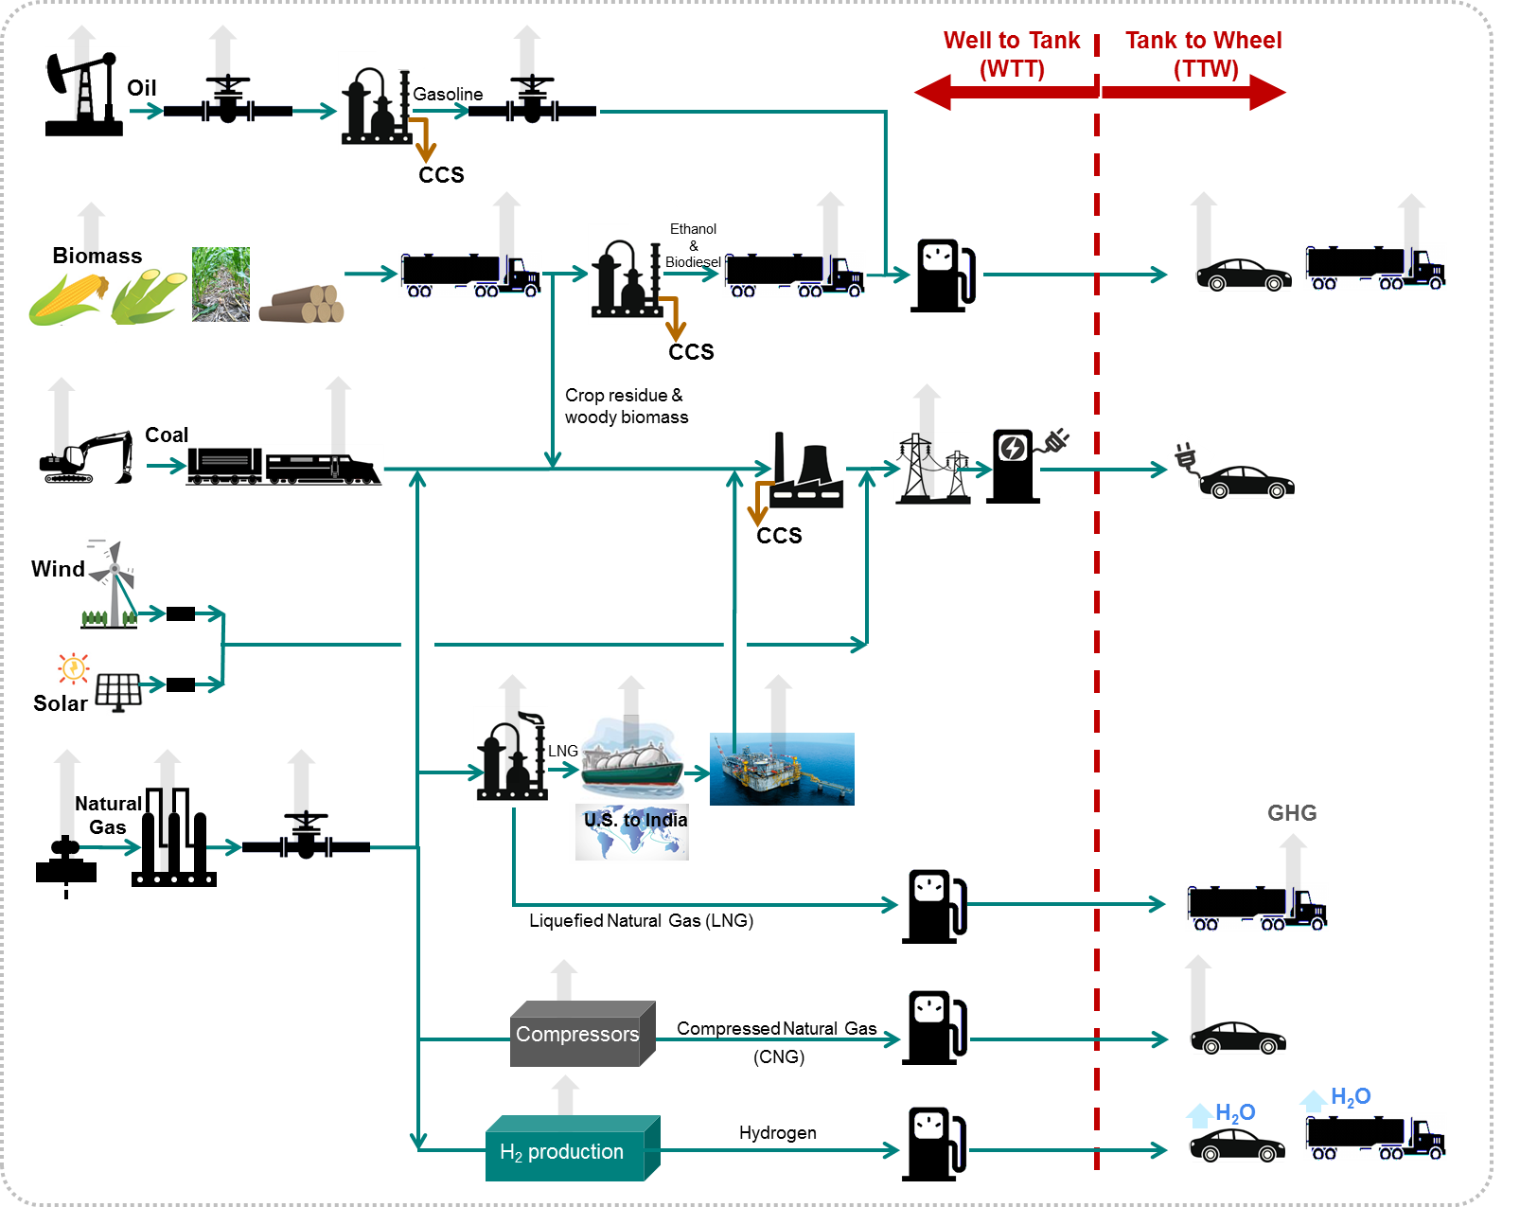
Figure 10 An example of a transportation system studied by SESAME (system-level LCA)

System-level LCA analysis for power sector
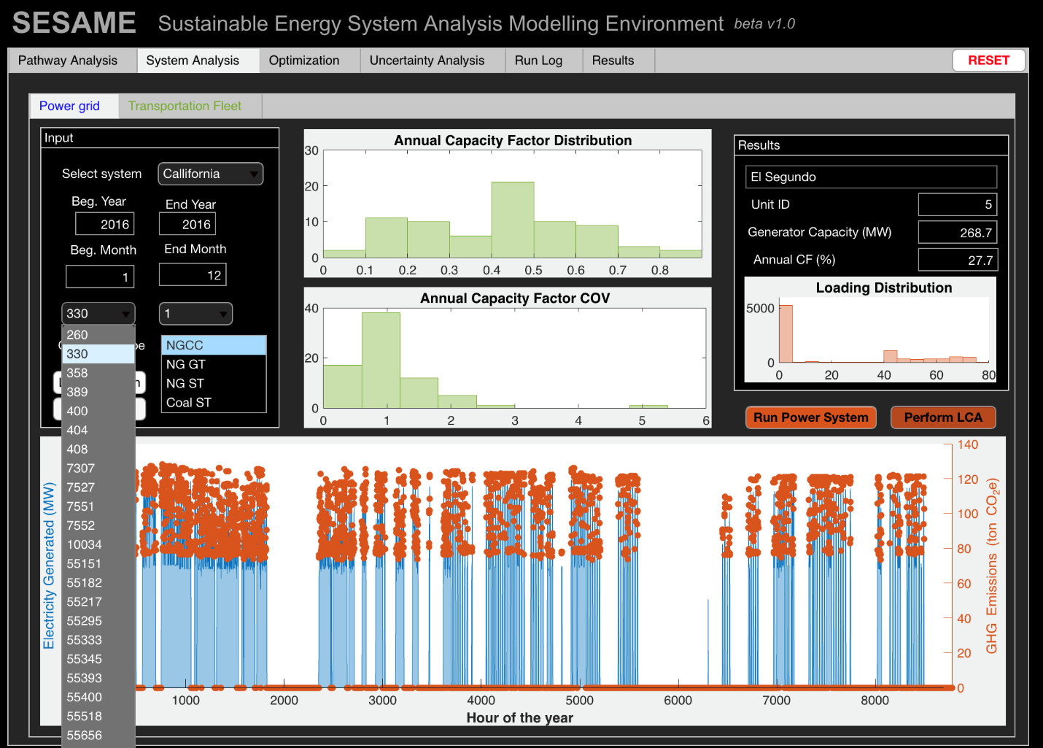
To represent the electric power system, we have included historic hourly generation profiles of every generator in the US [39] from 2004-2017. SESAME’s user interface allows users to display each unit’s hourly load profiles and important statistics such as annual capacity factor and coefficient of variance of different power generation technologies. Additionally, hourly life cycle analysis can be performed based on historic observations. As a case study, life cycle emissions of generators in the US have been calculated using the embedded hourly generation profiles of thermal generation units. Results for a combined cycle gas turbine unit in California (El Segundo Power Plant Unit 5) are shown in Figure 11. The lower graph shows the hourly electricity generation and dots are the calculated full life cycle emissions in tCO₂e. For this particular unit, we observe more than 40% fluctuations in total emissions. While one reason for this change is the lower net generation, the other reason is higher emission intensity operation due to operation at off peak mode.
Figure 11 LCA Results at hourly resolution from El Segundo combined cycle power plant unit 5 is estimated using SESAME’s power system database. The analysis is performed via the Power Grid Systems Analysis tab of the user interface.

Pathway-level LCA Results

Comparison of life cycle carbon footprint of various transportation fuel options
System-level transportation results, like those in Figure 9, are built upon pathway-level LCAs of different fuels and vehicle types, as shown in Figure 10. Figure 12 shows the pathway-level LCAs for a range of transportation fuels. “Fuel” here refers to any energy carrier that powers a vehicle, and thus includes liquid fuels and electricity. Emissions are divided into those from fuel production (well-to-tank, e.g., fossil fuel extraction, power plant operation) and fuel consumption (tank-to-wheel, e.g., burning gasoline in a car engine). Average emissions for different fuel types are shown in Figure 12.
As Figure 12 shows, gasoline has lower fuel cycle emissions than U.S. average electricity per unit of energy in the fuel (gCO₂e/MJ). However, ICEVs are much less efficient than BEVs at converting that fuel energy into wheel motion. In other words, ICEVs have much lower miles-per-gallon-gasoline-equivalent (MPGGE) than BEVs. For example, a 2018 mid-size Toyota Camry has an MPGGE of 34 mi/GGE, while a similarly-sized BEV (Honda Clarity) has an MPGGE of 116 mi/GGE [40]. As a result of this fuel economy difference, an ICEV generates roughly twice as much lifecycle carbon as a comparable BEV per distance traveled with this particular mix of electricity generation sources (for average US grid emission intensity of 453 gCO₂e/kWh). Figure 12 shows this lifecycle emission comparison across several powertrain types. These are some of the "micro" pathway LCAs that inform the "macro" fleet results shown in Figure 9 (c).

Figure 12 Lifecycle greenhouse gas emissions per mile for mid-size sedans with different powertrains, U.S. 2018
For each one of the transportation options many factors can be modified that will significantly impact the life cycle GHG emissions, Figure 13 displays the results of diesel passenger vehicle emissions from three different crude oils (WTI: West Texas Intermediate, WTS: West Texas Sour , VenLeona: Venezuela Leona) processed in eleven refinery configurations (Hydroskimming, Medium FCC Pre, Medium FCC Post, Medium GO-HC, Medium FCC Pre GO-HC, Medium FCC Post GO-HC, Deep FCC Pre, Deep FCC Post, Deep GO-HC, Deep FCC Pre GO-HC, Deep FCC Post GO-HC).

Figure 13 Fuel Cycle GHG Emissions
Figure 14 Well-to-wheel LCA GHG emissions (gCO₂e/mile driven) of various crude oil and refinery options included in SESAME for an average diesel light duty vehicle (fuel economy: 26.2 MPG).

Comparison of life cycle carbon footprint of various power sources
Numerous combinations for power generation can be defined and their life cycle emissions can be calculated. We present in Figure 15 base case results for common fossil fuel based power generation options, details of each case in the figure are listed in Table 2. In addition to technological variability, such as inclusion of various gas turbine models, capturing the impact of operation variation is very important.
Table 2 Life stage components of power generation pathways shown in Figure 15.
Figure 15 Summary of main power generation LCA results
Case | Upstream | Midstream | Process | CCUS | Gate to user | End use
1 | Coal | Default | Pow-Sub | No | Power dist | Electricity
2 | Coal | Default | Pow-Sup | No | Power dist | Electricity
3 | Coal | Default | Pow-Sub | Yes | Power dist | Electricity
4 | Coal | Default | Pow-Sup | Yes | Power dist | Electricity
5 | NG - Conventional | Default | Pow-GT-GE5371 | No | Power dist | Electricity
6 | NG - Conventional | Default | Pow-GT-GE6581 | No | Power dist | Electricity
7 | NG - Conventional | Default | Pow-GT-GE6101 | No | Power dist | Electricity
8 | NG - Conventional | Default | Pow-GT-GE7121 | No | Power dist | Electricity
9 | NG - Conventional | Default | Pow-GT-GE7241 | No | Power dist | Electricity
10 | NG - Conventional | Default | Pow-GT-GE7251 | No | Power dist | Electricity
11 | NG - Conventional | Default | Pow-GT-GE9171 | No | Power dist | Electricity
12 | NG - Conventional | Default | Pow-GT-GE9231 | No | Power dist | Electricity
13 | NG - Conventional | Default | Pow-GT-GE9351 | No | Power dist | Electricity
14 | NG - Conventional | Default | Pow-CC | No | Power dist | Electricity

Figure 16 Life cycle GHG emissions of gas turbine at various partial loadings.
To study the effect of partial load operation of power plants, which is increasingly relevant for a renewable-heavy power grid, we have developed Aspen Plus process simulations. Life cycle GHG emissions of a GE7251 gas turbine under 40% to 100% loading is shown in Figure 16. The sensitivity is performed for a shale gas case. The emission intensity increases by almost 47% when the same unit is turned down to 40% of its nameplate generation capacity. For a combined cycle unit the emissions intensity increase is approximately 15% shown in Figure 17 and Table 4. Though combined cycle units are less sensitive to the partial load operation, the emission intensity increase (efficiency drop) is not insignificant.
Table 3 Life stage components of power generation pathways shown in Figure 16.
Case | Upstream | Midstream | Process | CCUS | Gate to user | End use
1 | NG - Conventional | Default | Pow-GT-GE7251 | No | Power dist | Electricity
2 | NG - ShaleGas | Default | Pow-GT-GE7251 | No | Power dist | Electricity
3 | NG - ShaleGas | Default | Pow-GT-GE7251-0.9 | No | Power dist | Electricity
4 | NG - ShaleGas | Default | Pow-GT-GE7251-0.8 | No | Power dist | Electricity
5 | NG - ShaleGas | Default | Pow-GT-GE7251-0.7 | No | Power dist | Electricity
6 | NG - ShaleGas | Default | Pow-GT-GE7251-0.6 | No | Power dist | Electricity
7 | NG - ShaleGas | Default | Pow-GT-GE7251-0.5 | No | Power dist | Electricity
8 | NG - ShaleGas | Default | Pow-GT-GE7251-0.4 | No | Power dist | Electricity
Figure 17 Life cycle GHG emissions of a combined cycle unit at various partial loadings
Table 4 Life stage components of power generation pathways shown in Figure 17
Case | Upstream | Midstream | Process | CCUS | Gate to user | End use
1 | NG - ShaleGas | Default | Pow-CC-1.0 | No | Power dist | Electricity
2 | NG - ShaleGas | Default | Pow-CC-0.9 | No | Power dist | Electricity
3 | NG - ShaleGas | Default | Pow-CC-0.8 | No | Power dist | Electricity
4 | NG - ShaleGas | Default | Pow-CC-0.7 | No | Power dist | Electricity
5 | NG - ShaleGas | Default | Pow-CC-0.6 | No | Power dist | Electricity
6 | NG - ShaleGas | Default | Pow-CC-0.5 | No | Power dist | Electricity
7 | NG - ShaleGas | Default | Pow-CC-0.4 | No | Power dist | Electricity

Although emissions of renewable power generation are significantly lower than the fossil fuel based alternatives, they are not zero. Hence, we have developed and implemented extensive analysis capabilities for solar and wind conversion technologies in SESAME. A snapshot of results is shown in Table 5. Details of these modules and an analysis on solar PV [32,41] and integration of energy storage technologies with solar PV and wind power systems [33] are available in these publications.
Table 5 Solar PV and wind power life cycle GHG emissions for example cases.
Case | Tech | Location | Installation type | Life (yrs) | PV Efficiency (%) | Turbine maker | Lifecycle Emissions (gCO2e/kWh)
1 | PV, mc-Si | India SW | Utility scale, fixed-axis | 30 | 16 | N/A | 37
2 | PV, mc-Si | India SW | Utility scale, tracking | 30 | 16 | N/A | 34
3 | PV, sc-Si | China NE | Utility scale, fixed-axis | 30 | 17 | N/A | 73
4 | PV, sc-Si | China NE | Residential, rooftop | 30 | 17 | N/A | 77
5 | PV, CdTe | US SW | Utility scale, tracking | 30 | 15.6 | N/A | 14
6 | PV, CdTe | US NE | Utility scale, fixed | 30 | 16.6 | N/A | 20
7 | Wind | US MW | Onshore | 20 | N/A | Vestas | 7
8 | Wind | Germany | Onshore | 20 | N/A | Siemens | 5
9 | Wind | US NE | Offshore | 15 | N/A | Siemens | 13
10 | Wind | UK E | Offshore | 30 | N/A | Siemens | 7

Conclusion
Meeting the dual challenge of satisfying growing energy demand while effectively and efficiently reducing emissions requires a deep understanding of both the unit- and system-level responses that arise from the ongoing energy system evolution. An ongoing transition towards lower-carbon fuels, the expanded deployment of new low-carbon generation technologies, and an embracing of energy efficiency measures have all contributed to this dynamic. The widespread adoption of renewable generation technologies like wind and solar PV is of particular significance because as these technologies begin to play a meaningful role in meeting overall electricity demand, their presence on the system also introduces some challenges linked to their inherent intermittency and diurnal variability.
Here, we present a novel, system-scale energy analysis tool, the Sustainable Energy System Analysis Modelling Environment (SESAME), to assess the system-level GHG emission consequences of today’s changing energy system. The underlying analytic engine constitutes more than thousand individual energy pathways. SESAME, developed as a MATLAB application, provides a consistent platform to estimate life cycle GHG emissions of all stages of the energy sector. Furthermore, the system representation is embedded into the tool for power and transportation sectors. Pathway-level and system-level case studies on power and transportation sectors are presented. Various power generation technologies (coal fired power plants, natural gas combined cycle and gas turbine units, solar PV, and wind turbines) and transportation fuel options (gasoline, diesel, CNG, hydrogen, LNG, LPG, methanol, and DME) are compared based on their life cycle GHG footprints. The implications of energy choices for example scenarios (vehicle fleet projections for US and generator-level hourly power generation) are presented to demonstrate SESAME’s high resolution analysis capabilities. Impact of operational variations such as partial loading of power generation units and technology choices such as treatment of same crude oil in different refinery configurations is explored. Performing uncertainty analysis and energy system optimization based on environmental impacts is an indispensable part of any extensive analysis. The modules incorporating these features are not in the scope of this article, however, subsequent publications will discuss the methodological details as well as use cases.
In the midst of rapidly evolving energy system, making informed decisions to properly shape this change requires to understand the system and associated trade-offs. All the presented examples underline that GHG emissions are very sensitive to energy choices and a comprehensive systems-level analysis is essential for making informed decisions. The introduced SESAME platform is developed to address this pressing need and will continue to evolve to capture the emerging complexities.

Acknowledgement
The authors would like to thank:
Dr. Daniel Cherney, Dr. Mike Kerby, Dr. Vijay Swarup, Dr. Jennifer Feeley, Dr. Mike Harper, Dr. Aruna Ramkrishnan, Dr. Nagore Sabio, Dr. Mark Disko, Dr. Heather Elsen, Dr. Ian Laurenzi, from ExxonMobil Research and Engineering.
Prof. Robert C. Armstrong and Prof. Maria Zuber for their support and discussion.
This research was supported by ExxonMobil Research and Engineering and MIT Energy Initiative Low Carbon Energy Centers.

References

[1] EIA. Annual Energy Outlook 2018. 2018.
[2] Majumdar A, Deutch J. Research Opportunities for CO2Utilization and Negative Emissions at the Gigatonne Scale. Joule 2018;2:805–9. doi:10.1016/j.joule.2018.04.018.
[3] ISO 14040. The International Standards Organisation. Environmental management — Life cycle assessment — Principles and framework. ISO 14040 2006;2006:1–28. doi:10.1136/bmj.332.7550.1107.
[4] Frischknecht R, Heath G, Raugei M, Sinha P, de Wild-Scholten M, Fthenakis V, et al. Methodology Guidelines on Life Cycle Assessment of Photovoltaic Electricity, 3rd ed. IEA PVPS Task 12 Int Energy Agency Photovolt Power Syst Progr 2016.
[5] Ciroth A. ICT for environment in life cycle applications openLCA — A new open source software for life cycle assessment. Int J Life Cycle Assess 2007;12:209–10. doi:10.1065/lca2007.06.337.
[6] Herrmann IT, Moltesen A. Does it matter which Life Cycle Assessment (LCA) tool you choose? – a comparative assessment of SimaPro and GaBi. J Clean Prod 2015;86:163–9. doi:10.1016/J.JCLEPRO.2014.08.004.
[7] PRé Sustainability. Manual: SimaPro Tutorial n.d. https://support.simapro.com/articles/Manual/SimaPro-Tutorial/?l=en_US&c=Products%3ASimaPro%3ASP_Tutorials&fs=Search&pn=1 (accessed July 22, 2019).
[8] thinkstep. What is GaBi Software n.d. https://www.gabi-software.com/america/overview/what-is-gabi-software/ (accessed July 22, 2019).
[9] Stanciulescu V, Fleming J. Life Cycle Assessment of Transportation Fuels and GHGenius. 2006 IEEE EIC Clim. Chang. Conf., IEEE; 2006, p. 1–11. doi:10.1109/EICCCC.2006.277203.
[10] Squared Consultants Inc. GHGenius n.d. https://www.ghgenius.ca/index.php (accessed July 22, 2019).
[11] Wang MQ, Q M. GREET 1.5 - transportation fuel-cycle model - Vol. 1 : methodology, development, use, and results. Argonne, IL (United States): 1999. doi:10.2172/14775.
[12] ISO. Environmental management - Life cycle assessement - Requirements and guidelines, ISO 14044, International Organization for Standardization 2006;2006:652–68. doi:10.1007/s11367-011-0297-3.
[13] Abella JP, Bergerson JA. Model to Investigate Energy and Greenhouse Gas Emissions Implications of Refining Petroleum: Impacts of Crude Quality and Refinery Configuration. Environ Sci Technol 2012;46:13037–47. doi:10.1021/es3018682.
[14] Gençer E, Agrawal R. Strategy to synthesize integrated solar energy coproduction processes with optimal process intensification. Case study: Efficient solar thermal hydrogen production. Comput Chem Eng 2017;105:328–47. doi:10.1016/j.compchemeng.2017.01.038.
[15] Gençer E, Tawarmalani M, Agrawal R. Integrated Solar Thermal Hydrogen and Power Coproduction Process for Continuous Power Supply and Production of Chemicals. vol. 37. 2015. doi:10.1016/B978-0-444-63576-1.50076-5.
[16] Young B, Hottle T, Hawkins T, Jamieson M, Cooney G, Motazedi K, et al. Expansion of the Petroleum Refinery Life Cycle Inventory Model to Support Characterization of a Full Suite of Commonly Tracked Impact Potentials. Environ Sci Technol 2019;53:2238–48. doi:10.1021/acs.est.8b05572.
[17] Wang M, Elgowainy A, Benavides PT, Burnham A, Cai H, Dai Q, et al. Summary of Expansions and Updates in GREET 2018.
[18] Frischknecht R, Itten R, Sinha P, de Wild-Scholten M, Zhang J, Fthenakis V. Life cycle inventories and life cycle assessment of photovoltaic systems; Report IEA-PVPS T12-04:2015. Paris, France: 2015.
[19] Jungbluth N, Stucki M. Life cycle inventories of photovoltaics. ESU-Services Ltd, … 2012:250.
[20] DOE NETL. Cost and Performance Baseline for Fossil Energy Plants. vol. 1a. 2015.
[21] Coal B, Gas N, NETL. Cost and Performance Baseline for Fossil Energy Plants Volume 1: Bituminous Coal and Natural Gas to Electricity Revision 2. vol. 1. 2010.
[22] Netl DOE. Cost and Performance Baseline for Fossil Energy Plants Volume 3a : Low Rank Coal to Electricity : IGCC Cases 2011;3.
[23] Netl DOE. Cost and Performance Baseline for Fossil Energy Plants Volume 3c : Natural Gas Combined Cycle at Elevation 2011;3.
[24] Ruth M, Laffen M, Timbario TA. Hydrogen Pathways: Cost, Well-to-Wheels Energy Use, and Emissions for the Current Technology Status of Seven Hydrogen Production, Delivery, and Distribution Scenarios. National Renewable Energy Laboratory (NREL); 2013. doi:10.2172/966286.
[25] Wooley RJ, Putsche V. Development of an ASPEN PLUS physical property database for biofuels components. 1996.
[26] (NREL) NREL. Life Cycle Greenhouse Gas Emissions from Electricity Generation. Natl Renew Energy Lab 2013.
[27] Humbird D, Davis R, Tao L, Kinchin C, Hsu D, Aden A, et al. Process Design and Economics for Biochemical Conversion of Lignocellulosic Biomass to Ethanol- Dilute-Acid Pretreatment and Enzymatic Hydrolysis of Corn Stover. 2011.
[28] Laurenzi IJ, Jersey GR. Life cycle greenhouse gas emissions and freshwater consumption of Marcellus shale gas. Environ Sci Technol 2013;47:4896–903. doi:10.1021/es305162w.
[29] Laurenzi IJ, Bergerson JA, Motazedi K. Life cycle greenhouse gas emissions and freshwater consumption associated with Bakken tight oil. Proc Natl Acad Sci 2016:7672–80. doi:10.1073/pnas.1607475113.
[30] Locker CR, Torkamani S, Laurenzi IJ, Jin VL, Schmer MR, Karlen DL. Field-to-farm gate greenhouse gas emissions from corn stover production in the Midwestern U.S. J Clean Prod 2019;226:1116–27. doi:10.1016/J.JCLEPRO.2019.03.154.
[31] Gencer E, Mallapragada DS, Tawarmalani M, Agrawal R, Gençer E, Mallapragada DS, et al. Synergistic Biomass and Natural Gas Conversion to Liquid Fuel with Reduced CO2 Emissions. Comput Aided Chem Eng 2014;34:525–30. doi:http://dx.doi.org/10.1016/B978-0-444-63433-7.50072-9.
[32] Miller I, Gençer E, Vogelbaum HS, Brown PR, Torkamani S, O’Sullivan FM. Parametric modeling of life cycle greenhouse gas emissions from photovoltaic power. Appl Energy 2019;238:760–74. doi:10.1016/j.apenergy.2019.01.012.
[33] Miller I, Gençer E, O’Sullivan F. A General Model for Estimating Emissions from Integrated Power Generation and Energy Storage. Case Study: Integration of Solar Photovoltaic Power and Wind Power with Batteries. Processes 2018. doi:10.3390/pr6120267.
[34] Wang M. GREET Model: The Greenhouse Gases, Regulated Emissions, and Energy Use in Transportation Model. 2011.
[35] US EPA. Inventory of U.S. Greenhouse Gas Emissions and Sinks 1990-2017: Updates Under Consideration for Incorporating GHGRP Data. 2018.
[36] U.S. EIA. Annual Energy Outlook 2019 with projections to 2050. Annu Energy Outlook 2019 with Proj to 2050 2019;44:1–64. doi:DOE/EIA-0383(2012) U.S.
[37] Singh M, Vyas A, Steiner E. VISION Model: description of model used to estimate the impact of highway vehicle technologies and fuels on energy use and carbon emissions to 2050. 2004. doi:10.2172/822561.
[38] Federal Highway Administration (FHWA). National household travel survey. Washington, DC: 2009.
[39] U.S. EPA. Air Markets Program Data 2018.
[40] U.S. Environmental Protection Agency (EPA). Fuel Economy Data 2018. https://www.fueleconomy.gov/feg/download.shtml.
[41] Miller I, Gençer E, O’Sullivan FM. Modeling Impacts of Tracking on Greenhouse Gas Emissions from Photovoltaic Power. Comput Aided Chem Eng 2019;46:1057–62. doi:10.1016/B978-0-12-818634-3.50177-6.

Supporting Information

System Boundaries
Pathway level analysis constitutes the backbone of the computation engine. The platform is capable of calculating all the combinations of modules, presented in Figure 2 that form a meaningful pathway. The individual pathways can be further expanded with the addition of new modules. Cradle-to-grave system boundary for every complete pathway is set and the selections are limited to allowed components. Various system boundaries are shown here.
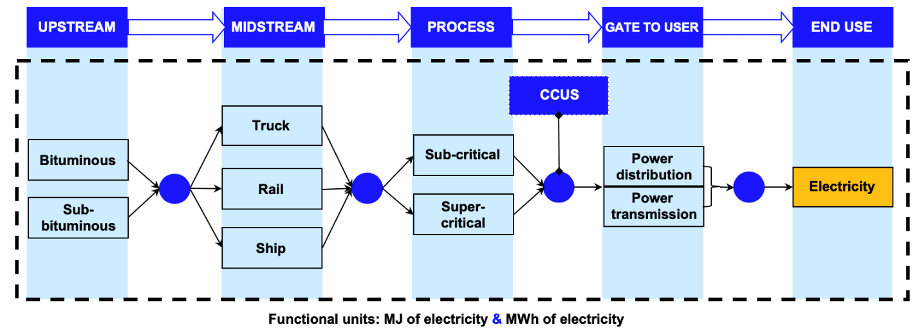
Figure S 1 System boundary of Coal to Power pathways

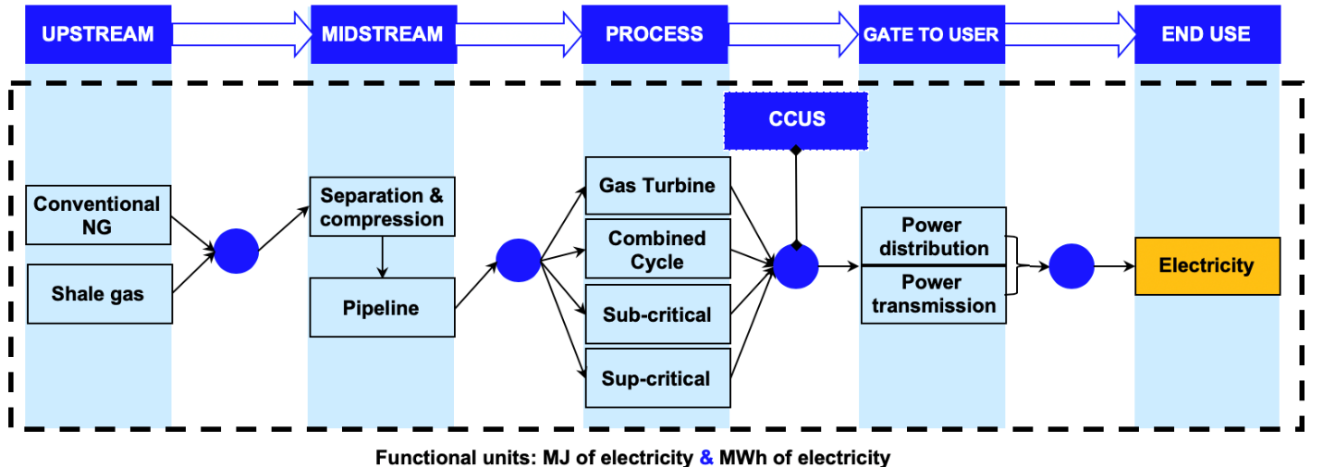
Figure S 2 System boundary of Natural Gas to Power pathways

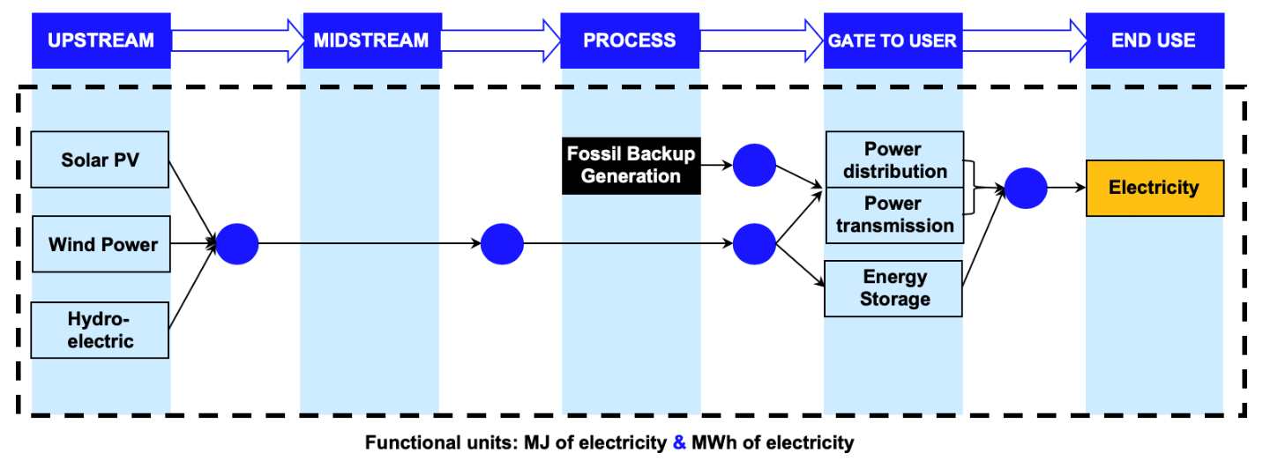
Figure S 3 System boundary of Renewable Power pathways

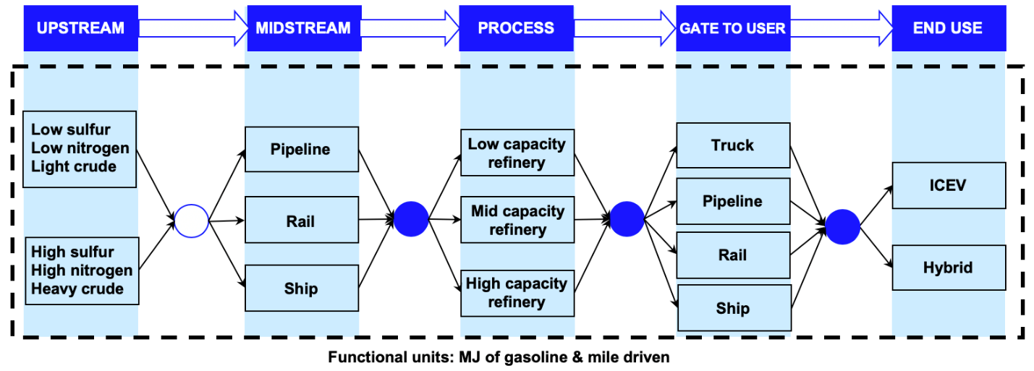
Figure S 4 System boundary of Crude oil to Gasoline pathways

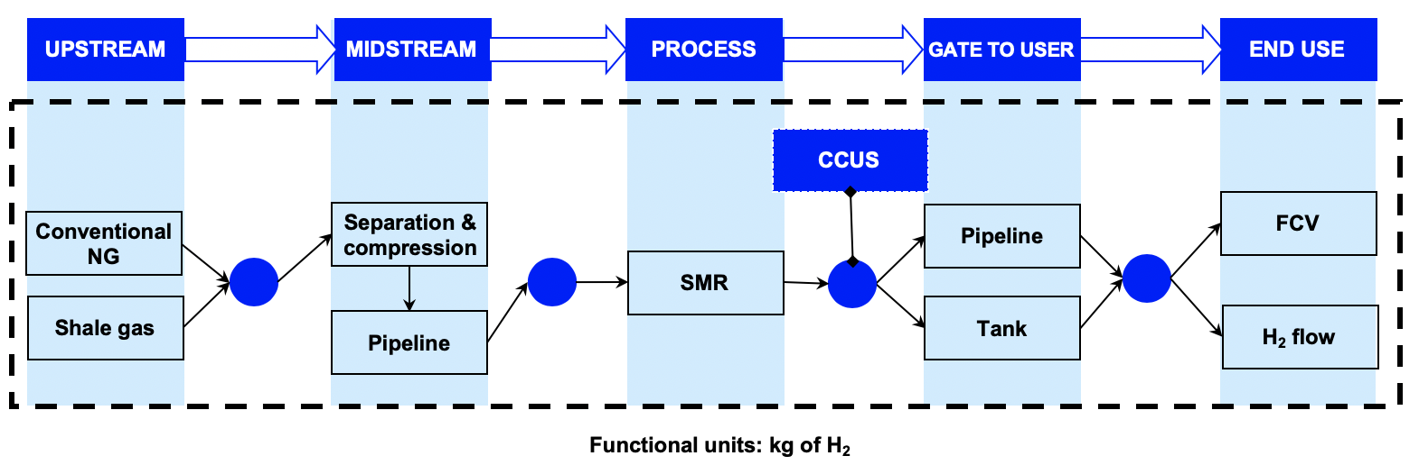
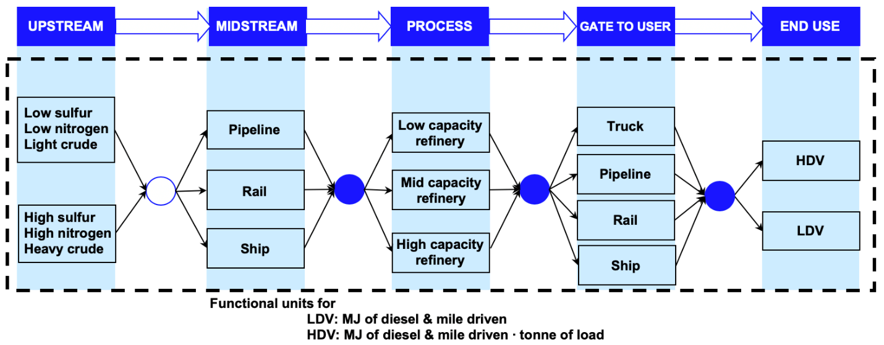
Figure S 5 System boundary of Natural gas to Hydrogen pathways
Figure S 6 System boundary of Crude oil to Diesel pathways
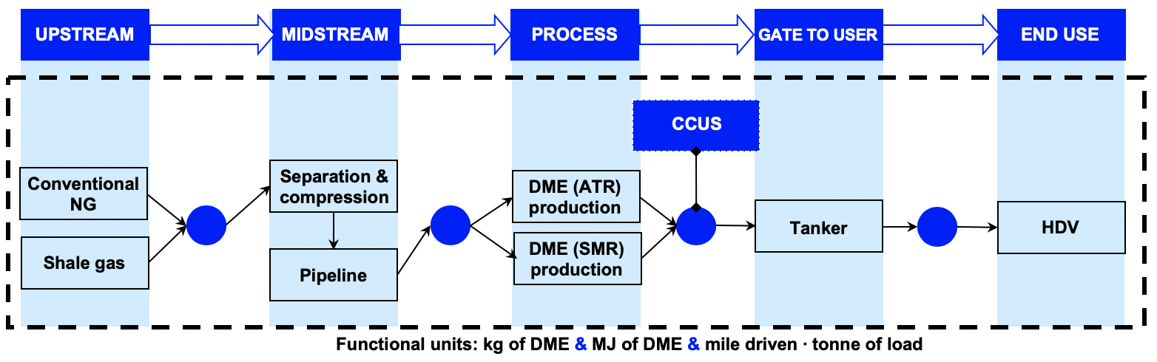
Figure S 7 System boundary of Natural gas to Dimethyl ether pathways

Figure S 8 System boundary of Biofuel pathways
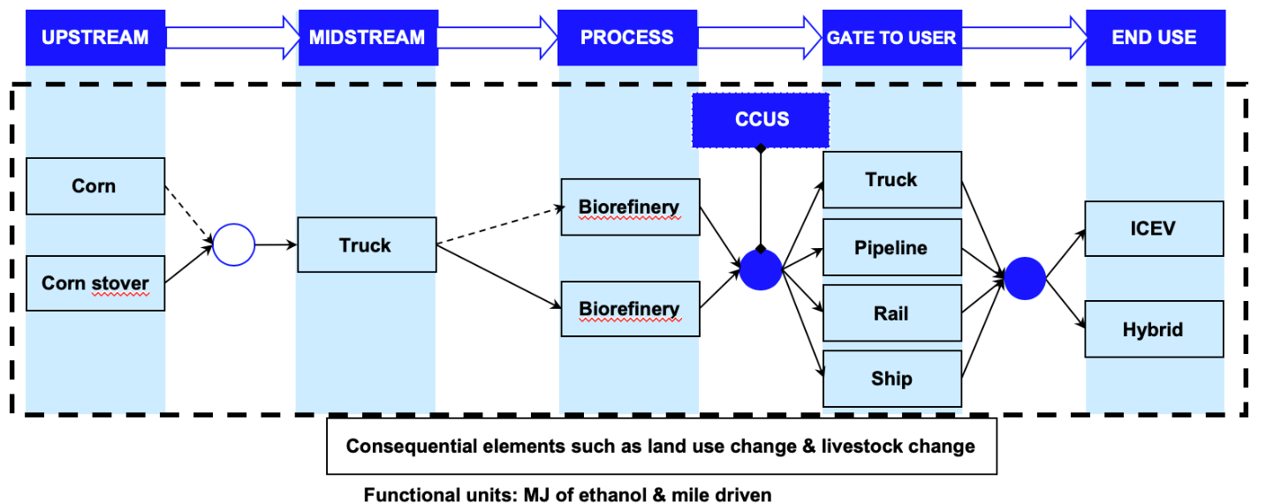

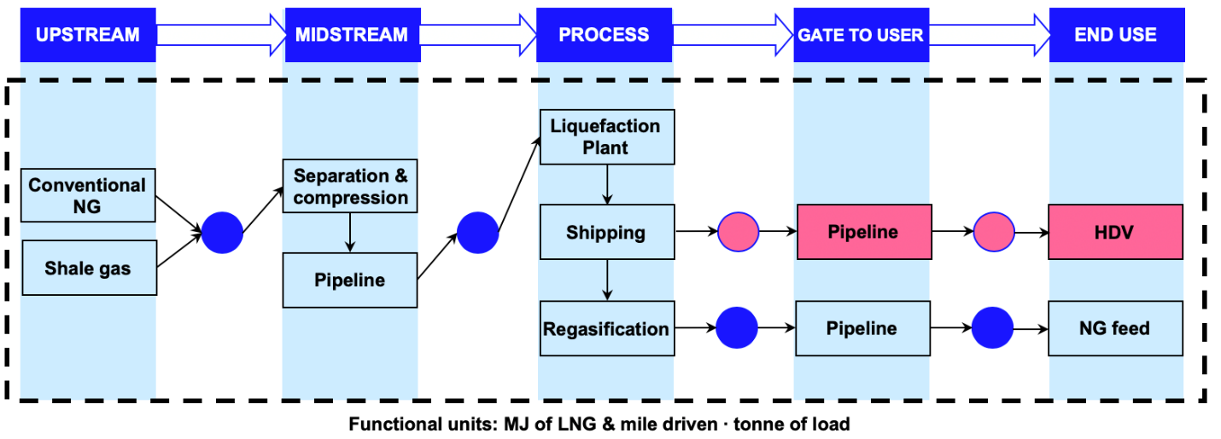
Figure S 9 System boundary of Natural gas to LNG pathways

