Town of Lunenburg

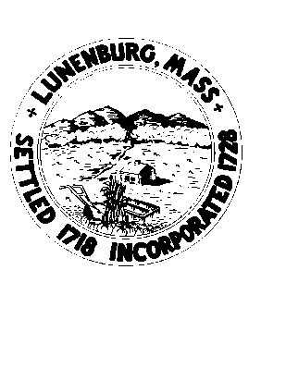

NOTICE OF MEETING
BYLAW REVIEW COMMITTEE
Thursday, June 11, 2026, 2026 6:45PM
Lunenburg Public Library– 1023 Massachusetts Avenue
Lunenburg, MA 01462

AGENDA

-Call to Order

-Public Comment

-Minutes

-Membership

-Feedback from Request to Town Committees and Stakeholders.

-Other suggested Bylaws, Public Safety

--Redline Bylaws: Status

-Discussion of possible articles for Special Town meeting, recommendations

-New Time line for Fall.

-Set next meeting(s) Date, Time, Place

-Public Comment

-Adjourn

