LUNENBURG CEMETERY COMMISSION
Mike Clark, Chair
David Dorren, Vice-Chair
Donna Landry, Clerk

DPW Department Director: Bill Bernard
Cemetery Superintendent: Todd Holman

17 Main Street, P. O. Box 135
Lunenburg, MA 01462
978-582-4144 Fax 978-582-4148

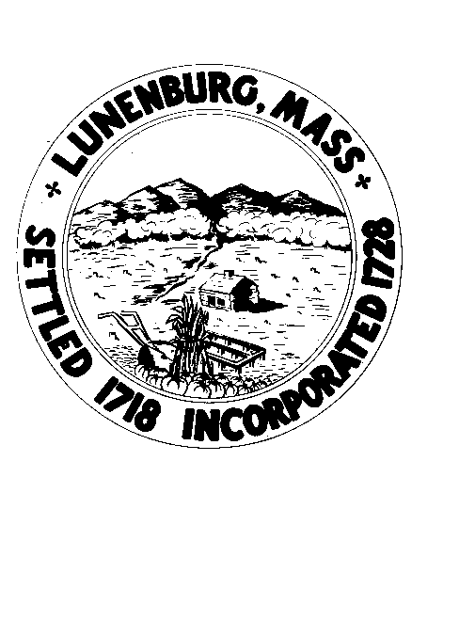

Meeting Notice
Wednesday, November 19, 2025 – 6:00PM
Lunenburg Public Library – Sudolnik Conference Room
Agenda

In accordance with the requirement of the Open Meeting Law, please be advised that this meeting is being recorded and will be uploaded to the LunenburgAccess YouTube after the meeting. This meeting will be held in-person at the location provided on this notice. Members of the public are welcome to attend this in-person meeting.
1. Stand for Pledge of Allegiance.
2. Review and Approve Minutes.
3. Warrant Article – Town Meeting Fund Transfer Approval
4. DPW Director & Superintendents reports
5. North Cemetery - Backlot Expansion Engineering progress & status
6. South Cemetery – Stone Straightening planning progress
7. Fish Street Cemetery – Walking Tour wrap-up
8. Future meeting Schedule
9. Public Comment
10. Adjourn

