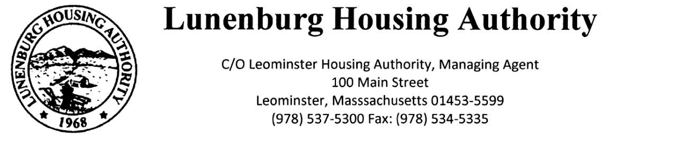
Town Clerk Received: 12:09 PM
6/23/25
EG

Lunenburg Housing Authority
C/O Leominster Housing Authority, Managing Agent
100 Main Street
Leominster, Massachusetts 01453-5599
Phone: (978) 537-5300 Fax: (978) 534-5335
North Central Mass Housing (ncmhousing.org)

NOTICE OF REGULAR MEETING
Submitted by: Benjamin Gold, Executive Director Date: 6/23/2025
Notice is hereby given in accordance with Section 23B of Chapter 39 of the General Laws that a regular meeting of the Lunenburg Housing Authority Board of Commissioners will be held at 2:00 P.M. on 6/26/2025, in the Community Room at 131 White Street, in the town of Lunenburg, Massachusetts.
The public is invited to call in to the meeting via phone. To do so, call the conference line at (888) 982-0015 and enter the code 234-080-203-4109. The Chair will conduct the meeting and instruct the public on the appropriate time and manner for comments.

AGENDA
- Opportunity for Public Comments
  - Keeping the main entrance door closed.

- Meeting Called to Order
a. Roll Call
b. Approval of Regular Minutes – 4/17/2025

- Executive Director Report
  - Election of Officers
  - Sea Crest

3. Financials
a. Approval of April and May 2025

4. Administration
a. Modernization/Work Order Report
b. State-Aided Housing Report

5. Unfinished Business – None

6. New Business
- Resolution 2025-5 Approval of Third Signatory to execute CFAs on Behalf of Board Members

7. Other Correspondence
- EOHLC PHN 2025-5 Revised Income Limits for Admission & FMRs for Continued Occupancy
- EOHLC PHN 2025-6 Preventative Maintenance Planning Year Criteria

8. Motion to Adjourn

