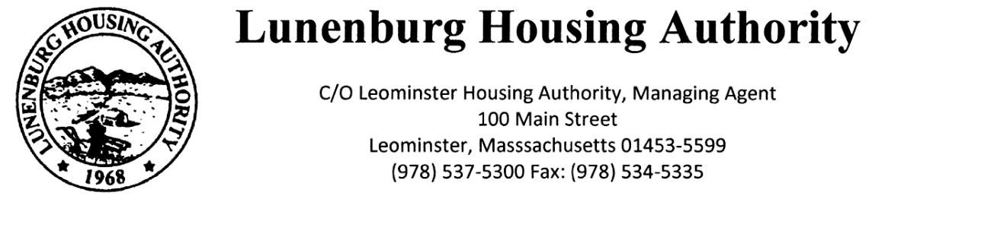
Town Clerk Received: 10/7/2025 11:30 AM
EG
Lunenburg Housing Authority
C/O Leominster Housing Authority, Managing Agent
100 Main Street
Leominster, Massachusetts 01453-5599
Phone: (978) 537-5300 Fax: (978) 534-5335
North Central Mass Housing (ncmhousing.org)

NOTICE OF REGULAR MEETING
Submitted by: Benjamin Gold, Executive Director Date: 10/7/2025
Notice is hereby given in accordance with Section 23B of Chapter 39 of the General Laws that a regular meeting of the Lunenburg Housing Authority Board of Commissioners will be held at 2:00 P.M. on 10/16/2025, in the Community Room at 131 White Street, in the town of Lunenburg, Massachusetts. The public is invited to log into the meeting via Teams. To do so, use the meeting ID: 217-596-144-176-5 and enter the passcode jB3m5Hc6. The Chair will conduct the meeting and instruct the public on the appropriate time and manner for comments.

AGENDA
- Meeting Called to Order
a. Roll Call
b. Approval of Regular Minutes – 8/21/2025

- Executive Director Report
a. Maintenance Personnel
b. Sea Crest Review

3. Financials
a. Approval of July, August and September 2025

4. Administration
a. Modernization/Work Order Report
b. State-Aided Housing Report

5. Unfinished Business – None

6. New Business
- Resolution 2025-8 Approval of Affirmative Action Plan

7. Other Correspondence
- EOHLC PHN 2025-11 FY2026 Budget Guidelines
- EOHLC PHN 2025-12 Seeking Pre-Qualified Candidates to Serve as Chief Administrative and Financial Officer (CAFO)
- EOHLC PHN 2025-13 Amendments to 760 CMR 5.00

8. Motion to Adjourn

