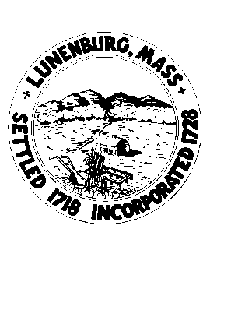
SEWER COMMISSION AGENDA
May 13th, 2025
7:00pm Hybrid Meeting via Remote Participation (Zoom)

In accordance with the requirements of the Open Meeting Law, please be advised that this meeting will be recorded and can be found on the Lunenburg Access YouTube channel (https://www.youtube.com/user/LunenburgAccess/videos) within 24 hours of the meeting.

This public meeting is being conducted from the DPW office. The following information is also provided for members of the public that would like to participate in the meeting remotely: To Participate Remotely: From a computer, please use this link to join the public meeting webinar: https://us02web.zoom.us/j/83187249940 or from a telephone, dial the toll-free number (888) 475-4499 and enter Webinar ID: 831 8724 9940. If you have not registered with Zoom you will be asked for your name and e-mail address. Note: No participant ID is needed, just press # when asked.
Telephone users may dial *9 to request to speak after joining the meeting. Computer and app users may use the
“raise hand” feature to request to speak.

- 7:00 PM CALL TO ORDER AND PLEDGE OF ALLEGIANCE

- PUBLIC COMMENT

- ANNOUNCEMENTS

- CURRENT BUSINESS
  - Commission Vacancies – Discussion
  - DPW Director/Sewer Business Manager Updates
    - Minutes from 4/29/25– Review/Vote to approve
    - Quarter 4 FY25 Billing – Update
    - Manhole Repair IFB – Update
    - Commitment Q4 FY25 – Discussion/vote
    - Asst. To Sewer Business Mgr. – Updates
  - Future agenda Items – Discussion

- OLD BUSINESS

- PUBLIC COMMENT

- UPCOMING SCHEDULED SEWER COMMISSION ACTIVITIES
May 27th, 2025, 6pm (Zoom) Meeting June 10th, 2025, 7 pm Regular (Hybrid) Meeting
June 24th, 2025, 6pm (Zoom) Meeting July 8th, 2025 7pm Regular (Hybrid) Meeting

2025.05.08

