Town of Lunenburg

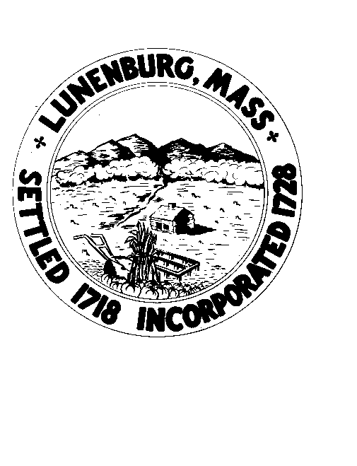

NOTICE OF MEETING

BYLAW REVIEW COMMITTEE
Wednesday, September 3, 2025 6:45PM
Lunenburg Public Library– 1023 Massachusetts Avenue
Lunenburg, MA 01462

AGENDA

-Call to Order

-Elect Officers

-General Discussion

-Set next meeting(s) Date, Time, Place

-Adjourn

