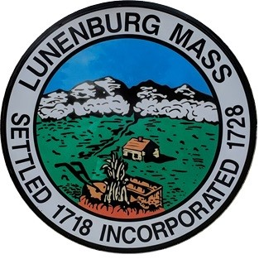

TOWN OF LUNENBURG
OFFICE OF THE SELECT BOARD

Public Hearing Notice

Pursuant to Chapter 140, Section 58 M.G.L. the Lunenburg Select Board will hold a public hearing on Tuesday, April 14, 2026 at 7:10 pm in the Bilotta Meeting Room at Town Hall, 17 Main Street, Lunenburg, MA on the application submitted by The Turkey Hill Family Lions Club for a Special Event License for use of Memorial Drive and TC Passios Yard, located at 1025 Massachusetts Avenue on May 20, 2026 from 4:00 PM to 7:00 PM for a Car Show.

If you have any questions, contact the Select Board Office at 978-582-4144

If you would like to participate remotely via ZOOM, please check the Select Board agenda posted on the Town website calendar at https://www.lunenburgma.gov/calendar for sign-in instructions. Agendas are posted 48 hours in advance of the meeting.

Caesar Nuzzolo, Chairman
Select Board

