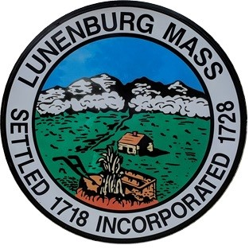

TOWN OF LUNENBURG
OFFICE OF THE SELECT BOARD

Public Hearing Notice

Pursuant to Chapter 140, Section 58 M.G.L. the Lunenburg Select Board will hold a public hearing on Tuesday, April 21, 2026 at 7:05pm in the Bilotta Meeting Room at Town Hall, 17 Main Street, Lunenburg, MA on the application submitted by CarXP Auto Group, Inc. d/b/a CarXP Auto Group, Inc. for a Class II License for the sale of motor vehicles as provided for under MGL c.140 § 58. This license is to be exercised at the premises located at 36 Summer Street.

If you have any questions, contact the Select Board Office at 978-582-4144

If you would like to participate remotely via ZOOM, please check the Select Board agenda posted on the Town website calendar at https://www.lunenburgma.gov/calendar for sign-in instructions. Agendas are posted 48 hours in advance of the meeting.

Caesar Nuzzolo, Chairman
Select Board

