VOR Simulator – Controller Instructions and Bindings

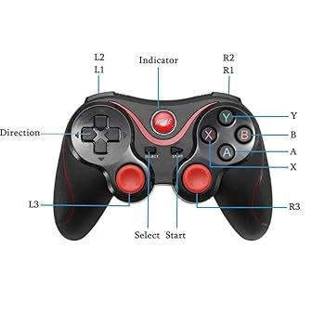
Controller Button Bindings
Button Name | Mapping Value
A | 0
B | 1
X | 3
Y | 4
R1 | 7
R2 | 9
L1 | 6
L2 | 8
START | 11
SELECT | 10
L3 | 13
R3 | 14

D-Pad Bindings
D-Pad Direction | Mapping Value | Function
Right | 1.0 | OBS +5° Clockwise
Left | -1.0 | OBS +5° Counter-Clockwise
Down | 0.-1 | OBS +1° Clockwise
Up | 0.1 | OBS +1° Counter-Clockwise

Instructions Per Screen

Landing Form Functions
Button | Function
A (0) | Open "About Project"
B (1) | Go Back from "About Project"
X (3) | Exit Application
Y (4) | Start Simulator

2. Main Form (Map Navigation)
Button | Function
A (0) | Load/Unload VOR Stations
B (1) | Toggle Radar Background
X (3) | Exit Application
Y (4) | Return to Landing Form
R1 (7) | Toggle vor_output_visible
R2 (9) | Toggle instruction_visible
L1 (6) | Select VOR Station 1
L2 (8) | Select VOR Station 2
START (11) | Reset the Simulation
SELECT (10) | Check/Uncheck All Radials

Joystick Bindings
- Left Joystick (Axis 0, 1, 2): Controls Aircraft Movement
- Right Joystick (Axis 3, 4, 5): Controls Aircraft Speed

Notes
- Use A again after loading VOR stations to exit loading.
- Pressing B again restores the default background after radar mode.
- The D-Pad allows precise OBS adjustments, while L1/L2 switch between VORs.

