Our prior work developed percentile growth curves for intelligibility in typically developing children between ages 2;6 and 9;11 [redacted] and percentile growth curves for articulation rate in this same cohort [redacted]. We found positive effects of age and utterance length on both measures: Older children had faster, more intelligible speech productions on average, and longer sentences prompted faster, more intelligible productions. Here we examine whether speaking rate influences intelligibility in this cohort. We examine two possible (compatible) relationships: 1) Speech-motor control as common cause of rate and intelligibility. Children with faster speaking rates have greater speech-motor control and thus higher intelligibility. 2) Speed-accuracy tradeoff. Some children might “trade” accuracy for speed, so increased rates are associated with reduced intelligibility.

## Methods

Participants included 538 children between ages 2;6 and 9;11 (years;months). Specifically, there were 105 children between ages 2;6-3;5, 111 between 3;6-4;5, 110 between 4;6-5;5, 96 between 5;6-6;5, 66 between 6;6-7;5, and 50 between 7;6-9;11. All children were typically developing per parent report and passed hearing, articulation and language screenings.

Speech samples were obtained using a picture-prompted utterance repetition task adapted from the TOCS+ (Hodge & Daniels, 2007). Utterances started at 2 words in length, increased to 3 words, and so on in batches of 10 utterances, up to 7 words in length. If a child could not reliably repeat at least 5 utterances at a given length, the task was halted and utterances of the final length were excluded.

Intelligibility was measured by having unfamiliar listeners transcribe speech samples for each child. Every child had transcriptions by two listeners and each listener heard only one child’s productions. Intelligibility was the proportion of words transcribed correctly (or with a homophone). To measure speaking rate, we aligned all samples using the Montreal Forced Aligner (McAuliffe et al., 2017) to determine the speech start/end in each sample, and we screened/corrected samples with excessive silence at the start/end. Speaking rate was the number of syllables per second of speech duration.

## Analysis

For each child and utterance length, we computed average speaking rate and intelligibility. We excluded 2-word utterances which encouraged a slower naming speech style. A Bayesian mixed-effects beta regression model estimated intelligibility using age (as a 3-d.f. natural cubic spline), utterance length (as a categorical variable), speaking rate, and a rate by length interaction. We included by-child random intercepts to handle repeated measures (multiple lengths per child) and to estimate between-child variability. Because model coefficients are difficult to interpret (log-odds for a statistically “typical” child with a random intercept of 0), we report results using population-average (marginal) means for intelligibility on the proportion scale (computed by integrating over the between-child variability estimated by the random-intercept variance).

## Results

For brevity, we focus on 4- and 7-word utterances, although all 3-7-word utterance lengths were analyzed. Figure 1 depicts observed intelligibility scores and model-estimated intelligibility means, and key results are shown. First, expected intelligibility increased with age, apparent in the vertical ordering of regression lines. Second, speaking rate increased with age, visually represented by rightward movement of midpoints on the lines. Finally, there was a negative effect of rate on expected intelligibility. For a 4-year-old, a change in rate from 3 to 3.5 syllables per second predicts a corresponding change in expected intelligibility of –1 percentage points [95% posterior interval: –3, 0] for 4-word utterances and –4 points [–6, –3] for 7-word utterances. (Similar decreases in intelligibility held for 5- and 6-word utterances.) This effect decreased at older ages: For a 6-year-old, this rate change predicts an intelligibility change of –1 percentage point [–2, –1] for 7-word utterances.

## Discussion

On average, speaking rate and intelligibility both increase with age, suggesting a simple shared-cause relationship where children with more developed speech-motor control speak more quickly and more accurately. However, we found a negative effect of rate where faster rates predicted lower expected intelligibility scores. This effect is small, practically negligible after age 5;0, and only evident in longer utterances. These results, being based on habitual speaking rates, partially support a speed-accuracy tradeoff between rate and intelligibility. Longer utterances are more demanding, especially for younger children, so it is under these conditions that speed increases lead to apparent decreases in accuracy. Implications will be discussed.

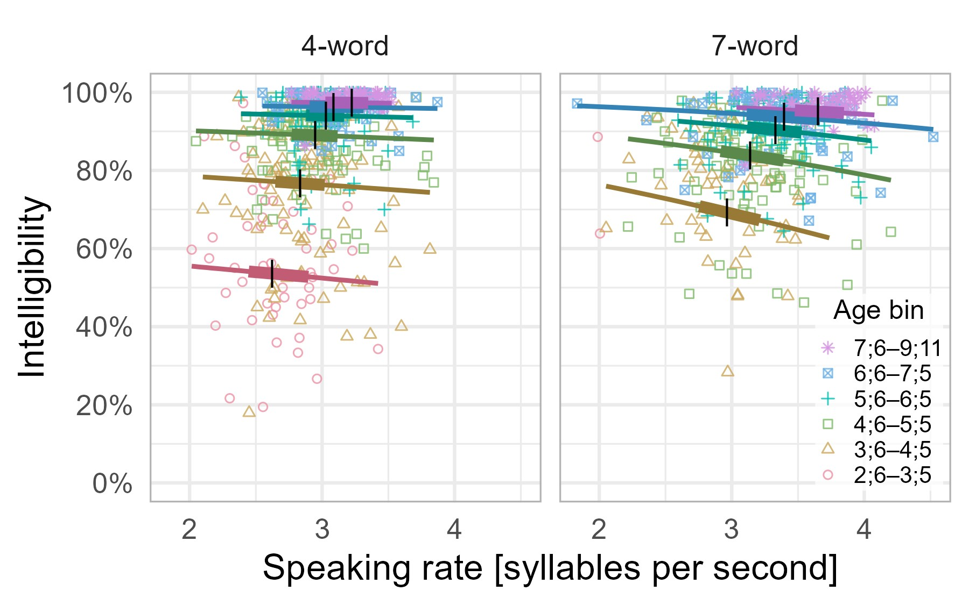

**Figure 1.** Intelligibility as a function of speaking rate and age for 4-word utterances (left) and 7-word utterances (right). Points represent observed data with 1 point per child per panel. Lines represent the expected marginal mean for the central age in each age bin (i.e., age 3;0 for the 2;6-3;5 bin). The 2;6-3;5 line is omitted in the 7-word panel because only two children in that bin produced 7-word utterances reliably. The marginal mean for intelligibility was computed by averaging over model predictions along the normal distribution implied the model’s fixed and random effects. The thicker portion of the line represents the interquartile range of speaking rate for that age bin, and the black vertical line marks the median speaking rate in that age bin. The rightward shifting of the median and quartile boundaries along age bins reflects how expected speaking rate increases with age. Similarly, the vertical ordering of the regression lines reflects how expected intelligibility increases with age. Finally, all the regression lines follow a flat or slightly negative slope, indicating that increases in speaking rate predict decreases in intelligibility. These effects are most apparent in the 3;6-4;5 and 4;6-5;5 age bins in the right panel. Elsewhere, the effect is negligible.

## References

Hodge, M. M., & Daniels, J. (2007). TOCS+ intelligibility measures [computer software]. Edmonton, Alberta: University of Alberta.

McAuliffe, M., Socolof, M., Mihuc, S., Wagner, M., & Sonderegger, M. (2017). Montreal forced aligner: Trainable text-speech alignment using Kaldi. *Interspeech*, *2017*,498–502. https://doi.org/10.21437/Interspeech.2017-1386