**Development of word recognition in preschoolers**

**Abstract [up to 180 words]**

Recent work suggests word recognition efficiency—how well children map incoming speech to words—may help identify early differences in children’s language trajectories. We administered a word recognition experiment during each year of a 3-year longitudinal study with 160 preschoolers. Ages were 2.5–3 years in year 1 and 4.5–5 years in year 3. In the experiment, four images of familiar nouns were presented onscreen followed by a prompt to view one of the images (e.g., find the bell!). Images included the target word (e.g., bell), a semantically related word (drum), a phonologically similar word (bee), and an unrelated word (swing). Early differences in word recognition were longitudinally stable so that children who were faster and more accurate at age 3 were relatively fast and accurate at age 5. Moreover, word recognition efficiency at age 3 was a much stronger predictor of age-5 vocabulary size than concurrent (age-5) word recognition efficiency. These results confirm that word recognition behavior provides an important early predictor of vocabulary growth. Research supported by R01 DC002932, R01 DC012513, T32 DC05359, and U54 HD090256.

**Summary [up to 600 words; figures don’t count]**

**Research questions.** Recent work suggests word recognition efficiency—that is, how well children map incoming speech to words—may help identify early differences in children’s language trajectories.[1],[2] We do not know, however, how word recognition itself develops over time or how individual differences in word recognition change over time. This submission reports preliminary findings from the first longitudinal analysis of word recognition in a cohort of preschoolers. Research questions included how word recognition performance developed each year, whether individual differences in word recognition were stable over time, and whether early word recognition differences predicted language outcomes up to two years later.

**Methods.** Participants were typically developing preschoolers recruited for a three-year longitudinal study of phonological development. There were 184 participants 28–39-months old (Mean: 33 ± SD: 3) during Year 1, 175 participants 39–52-months old (45 ± 4) during Year 2, and 160 participants 51–66-months old (57 ± 4) at Year 3. The experiment was an eyetracking task using the visual world paradigm. Four images of familiar nouns were presented onscreen followed by a prompt to view one of the images (e.g., find the bell!). The images included the target (e.g., bell), a semantically related word (drum), a phonologically similar word (bee), and an unrelated word (swing). This procedure measured a child’s real-time comprehension of words by capturing how the child’s gaze location changes over time in response to speech.

**Analysis and Results.** Analysis is ongoing; we describe three preliminary findings. We used Bayesian growth curve analysis (mixed effects logistic regression) to model how the probability of looking to the named image changes over the time course of a trial and how those time courses change over development. All reported results were credible; 90% uncertainty intervals for statistical effects excluded 0. Children’s accuracy and rate of looking to the target increased over the 3 years of the study (Fig. 1). To quantify individual differences, we derived individual-level lexical processing measures including slope of growth curve and peak looking probability. Variability among participants decreased with age. For example, although the peak looking probabilities increased each year, median: PeakYear1 = 0.55 [90% uncertain interval: 0.35–0.77], PeakYear2 = 0.69 [0.48–0.86], PeakYear3 = 0.78 [0.59–0.91], the width of the 90% uncertainty intervals narrowed each year: .42 for Year 1, .38 for Year 2, and .32 for Year 3. Individual differences were also consistent: Children who were faster and more accurate at Year 1 were faster and more accurate at Year 3 (Fig. 2). Finally, we found that word recognition measures from Year 1 were better predictors of Year 3 vocabulary size than measures from Year 2 or 3 (Fig. 3).

**Implications.** Children’s word recognition performance improved each year, and the range of performance decreased each year. Individual differences in word recognition, however, were stable over time, so that relatively fast children at Year 1 remained relatively fast at Year 3. Thus, early differences did not wash out even as children began to converge on a more mature level of performance. Individual differences were also highly predictive, as the best predictors of Year 3 vocabulary were measures of Year 1 word recognition efficiency. These results confirm that word recognition behavior is an important early predictor of vocabulary growth.

[599 words]

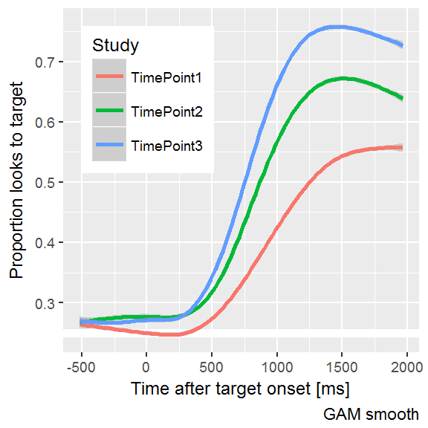

*Figure 1:* Average looking patterns by year of study. Lines start around .25 which is chance performance for this 4-image word recognition task. After the start of the target noun, the line move away from chance as children shift their gaze to the named image. Importantly, the lines rise more quickly and reach higher peak proportions with each year, so children become faster and more reliable at recognizing words. (GAM: Generalized Additive Model, a technique for modeling and smoothing time series.)

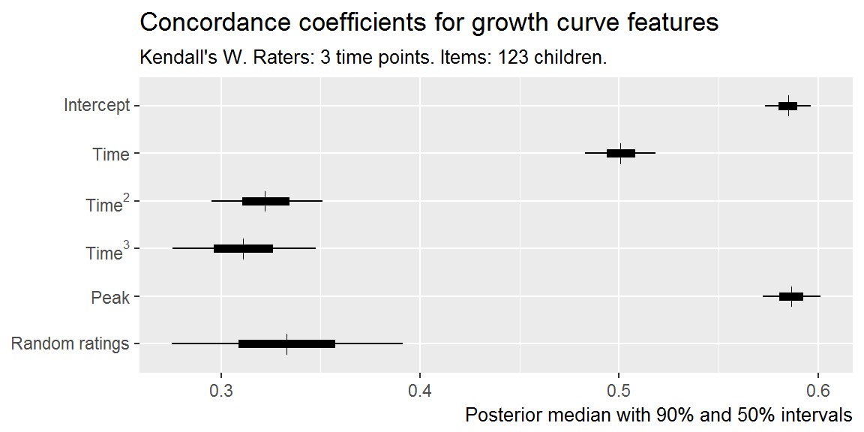

Figure 2: Uncertainty intervals for Kendall’s concordance coefficient when comparing 123 children who participated in all 3 years. Intuition: Each study year is a rater ranking the children, and each row of the plot shows how well these 3 raters agree when ranking children with a different growth curve feature. In row 1, for example, the rankings show high agreement, so we conclude individual differences in the intercept feature are consistent over the three years. The final row shows agreement when children are ranked using random values; this row illustrates the agreement values under the null hypothesis. Agreement for the intercept, time, and peak proportion features were decisively non-null.

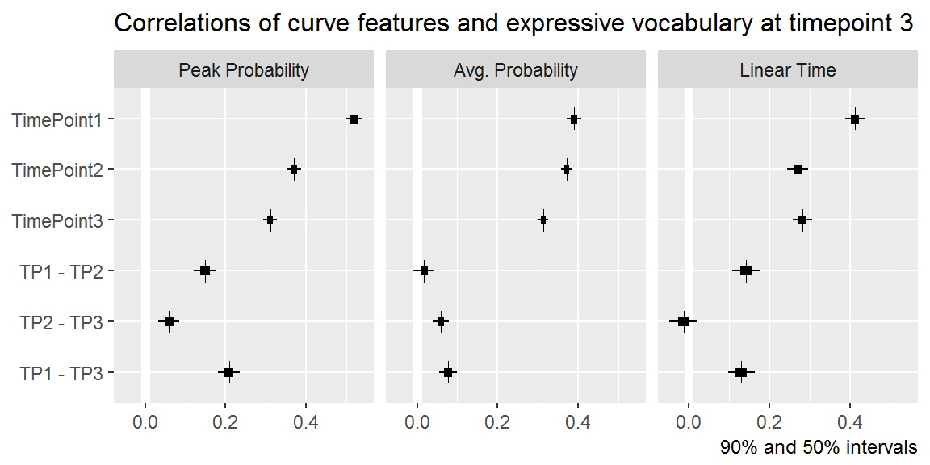

Figure 3: Uncertainty intervals for the correlations of growth curve features at each year with Year 3 EVT2 standard scores. Bottom rows provide intervals for pairwise differences in correlations. For all growth curve features, the best predictor of Year 3 vocabulary was the measurement from Year 1.

1. Marchman, V. A., & Fernald, A. (2008). Speed of word recognition and vocabulary knowledge in infancy predict cognitive and language outcomes in later childhood. *Developmental Science*, *11*(3), F9–16. doi:[10.1111/j.1467-7687.2008.00671.x](https://doi.org/10.1111/j.1467-7687.2008.00671.x)
2. Fernald, A., & Marchman, V. A. (2012). Individual differences in lexical processing at 18 months predict vocabulary growth in typically developing and late-talking toddlers. *Child Development*, *83*(1), 203–222. doi:[10.1111/j.1467-8624.2011.01692.x](https://doi.org/10.1111/j.1467-8624.2011.01692.x)